First Name:______________________________ Last Name:______________________________
L16 – Worksheet – Motor Effect, Generator Effect, and Mass Spectrometer
Textbook Questions
None
Diploma Worksheet Questions – Generator Effect
Use the following information to answer Q343:
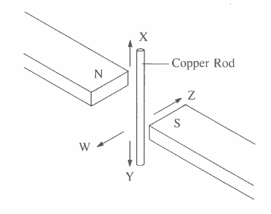

Q343: When the rod is stationary in the magnetic field, electrons in the rod will
- Move in the direction of W
- Move in the direction of X
- Move in the direction of Y
- Not move in any direction

Q344: A current may be induced in a loop of wire if the loop is
- At rest in a magnetic field
- Moved perpendicular to an electric field
- Moved parallel to a uniform magnetic field
- Rotated about an axis perpendicular to a magnetic field

Q346: A loop of wire is connected to a microammeter. When the loop is moved, the needle on the microammeter jumps. The MOST likely cause of this phenomenon is the presence of
- An electric field in the room
- A magnetic field in the room
- An electric charge in the room
- A magnetic charge in the room

Use the following information to answer Q349:
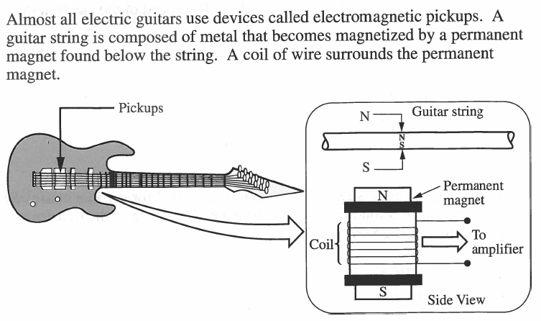

Q349: When the string is plucked, a small current is produced in the coil of wire because
- A potential difference is produced in the string
- There is a current in the string that can be amplified
- There is a charge buildup on the string
- The string behaves as a magnet moving toward and away from the coil

Diploma Worksheet Questions – Combination Questions (Mass Spectrometer)
Q350: An electron passes without deflection through perpendicular electric and magnetic fields of
10.0 kN/C and 11 mT respectively. The speed of the electron is
- 1.1 x 10⁻⁶ m/s
- 2.1 x 10⁻⁵ m/s
- 9.1 x 10⁵ m/s
- 4.8 x 10⁶ m/s

Q351: An electron travels at 2.5 x 10⁶ m/s perpendicular to a magnetic field with a strength of
2.0 x 10⁻³ T. The radius of curvature of its path is
- 1.4 x 10⁻³ m
- 7.1 x 10⁻³ m
- 1.4 x 10² m
- 7.1 x 10² m

Q352: The radius of curvature of the path of an ion with a charge of 2e in a magnetic field of strength 2.00 x 10⁻² T is 1.25 cm. If the speed of the ion is 3.00 x 10³ m/s, its mass is
- 2.67 x 10⁻²⁶ kg
- 2.67 x 10⁻²⁴ kg
- 3.84 x 10⁻¹⁴ kg
- 3.84 x 10⁻¹² kg

Q357: If a charged particle travelling at 3.00 x 10⁶ m/s at right angles to a magnetic field of 0.125 T experiences a deflecting force of 1.20 x 10⁻¹³ N, the particle could be
- A proton
- A neutron
- An electron
- An alpha particle

Q360: Alpha particles, trapped by a magnetic field, are in an orbit of radius 4.36 cm. If the velocity of the particles is exactly doubled, the new radius will be ____ cm.
(Record your three digit answer in the Numerical Response boxes below)

Use the following information to answer Q369 – Q371:
An experiment is designed to study the charge to mass ratio of hydrogen ions. Hydrogen ions, all moving in the same direction and with the same speed, v, are injected into a mass spectrometer. The magnitude of the magnetic field is varied, and the resulting radii of the path of the hydrogen ions are measured.

Q369: The equation that describes the radius of curvature of an ion’s path is
- $r=\frac{qB_{˔}}{mv}$
- $r=\frac{mv}{qB_{˔}}$
- $r=\frac{qv}{mB_{˔}}$
- $r=\frac{mB_{˔}}{qv}$

Q370: A graph that shows the relationship between the radius of curvature of a hydrogen ion’s path and the strength of the magnetic field is graph
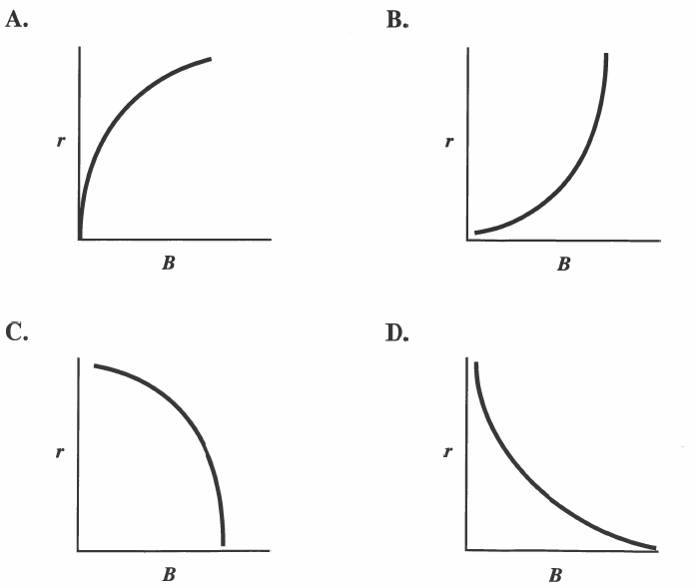

Diploma Worksheet Questions – Combination Questions (Cathode Ray Tube)
Use the following information to answer Q378:
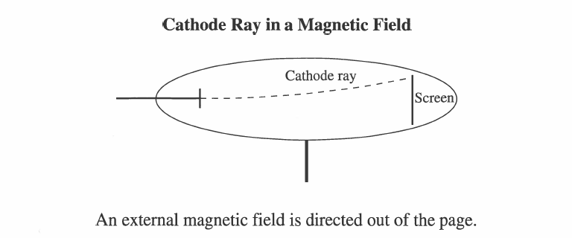

Q378: A magnetic field directed out of the page caused the cathode rays to move up the screen. What arrangement of electric plates would cause them to return to the center?
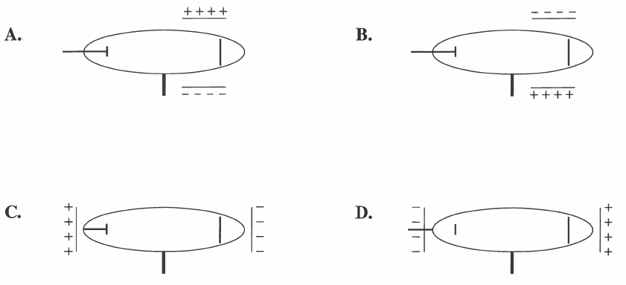

Diploma Worksheet Questions – Combination Questions (Cyclotron)
Use the following information to answer Q380 – Q381:
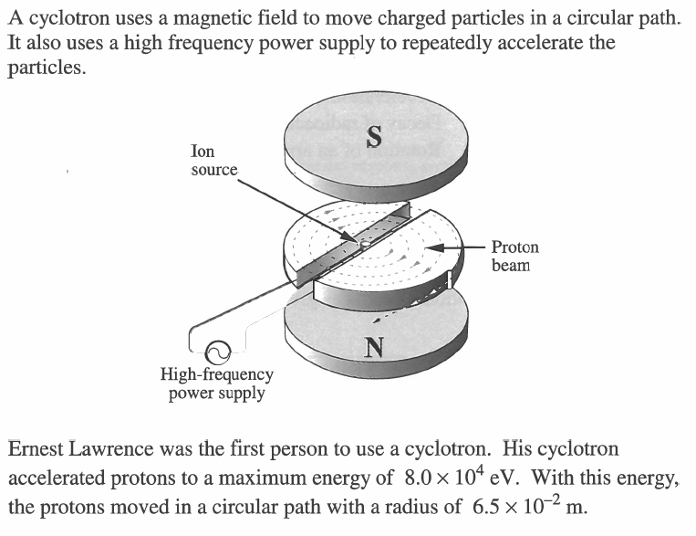

Q380: The maximum speed of the protons in Lawrence’s cyclotron was
- 1.5 x 10¹³ m/s
- 1.7 x 10⁸ m/s
- 3.9 x 10⁶ m/s
- 9.8 x 10¹⁵ m/s

Q381: The magnitude of the magnetic field used by Lawrence was
- 6.3 x 10⁻¹ T
- 2.7 x 10¹ T
- 2.4 x 10⁶ T
- 1.6 x 10⁹ T

Challenge Questions
Use the following information to answer Q1:
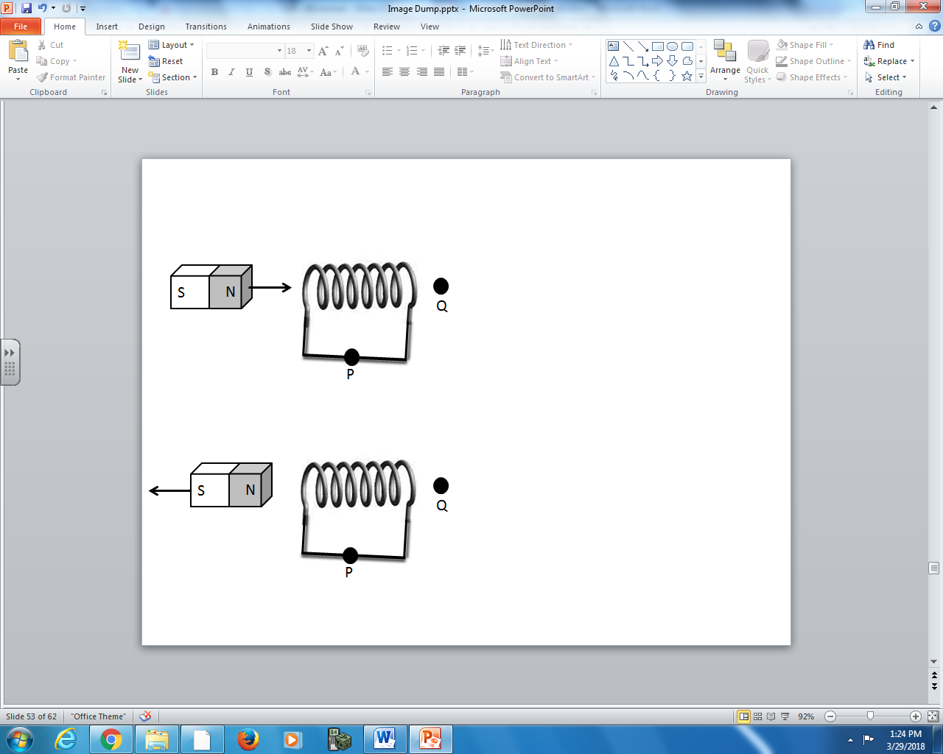

Q1: The induced current at Point P is directed to the __i__. The induced magnetic field at Point Q is directed to the __ii__.
 | i. | ii.
A. | left | left
B. | left | right
C. | right | left
D. | right | right

Use the following information to answer Q2:

Q2: The induced current at Point P is directed to the __i__. The induced magnetic field at Point Q is directed to the __ii__.
 | i. | ii.
A. | left | left
B. | left | right
C. | right | left
D. | right | right

Use the following information to answer Q3-Q4:
A magnet is moved towards a loop of wire that is connected to two parallel plates. A positively charged pith ball is suspended on an insulated thread between the two plates.
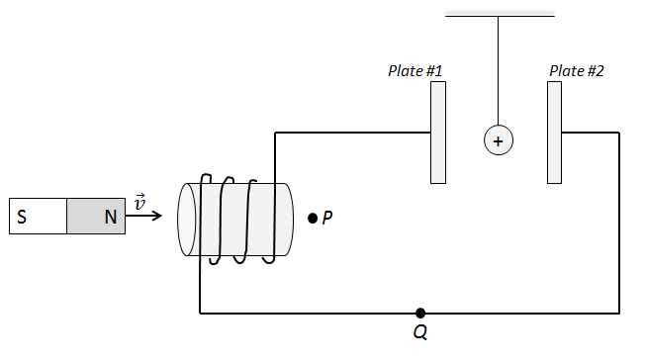

Q3: The direction of the magnetic field at Point P is __i__ and the direction of current flow at Point Q is __ii__.
 | i. | ii.
A. | to the left | to the left
B. | to the left | to the right
C. | to the right | to the left
D. | to the right | to the right

Q4: The direction of the electric field between the plates is __i__, and the pith ball is electrostatically attracted to __ii__.
 | i. | ii.
A. | to the left | Plate #1
B. | to the left | Plate #2
C. | to the right | Plate #1
D. | to the right | Plate #2

Use the following information to answer Q5:
A wire is moved upward through a magnetic field.
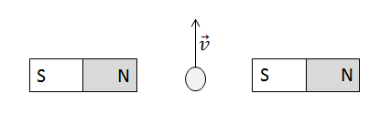
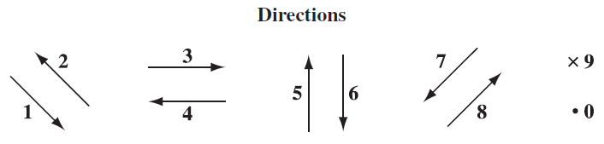

Q5: The directions of the current in the wire can be described using the numbers given above.
Direction: __________
Field: Direction of
induced current
in the wire
(Record your one digit answer in the Numerical Response boxes below)

Use the following information to answer Q6-Q7:
A loop of wire is rotated in a magnetic field, per the diagram below.
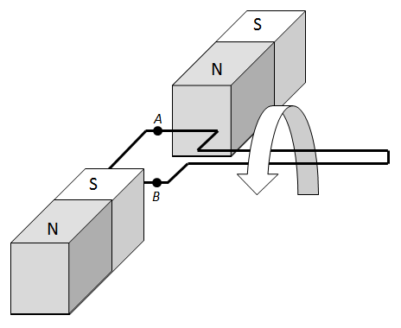

Q6: The directions of the motion of the wire, the magnetic field, and the induced current can be described using the numbers given above.
Direction: ____________ ____________ ____________
Field: Direction of Direction of the Direction of the
magnetic field motion of the induced current
at Position A wire at Position A at Position A
(Record your three digit answer in the Numerical Response boxes below)

Use the following information to answer Q6-Q7:
A loop of wire is rotated in a magnetic field, per the diagram below.

Q7: The directions of the motion of the wire, the magnetic field, and the induced current can be described using the numbers given above.
Direction: ____________ ____________ ____________
Field: Direction of Direction of the Direction of the
magnetic field motion of the induced current
at Position B wire at Position B at Position B
(Record your three digit answer in the Numerical Response boxes below)

Cumulative Review from Previous Units
None

