First Name:_____________________________ Last Name:______________________________

L16 – Worksheet – Unit Review /12 marks

Part 1: Work and Energy
Use the following information to answer Q1-Q2:
A rollercoaster car of mass 2000kg is originally stationary at Position A. As the rollercoaster descends to Position B, it loses approximately 30% of its mechanical energy due to thermal energy loss, and arrives at Position B travelling at 15 m/s.
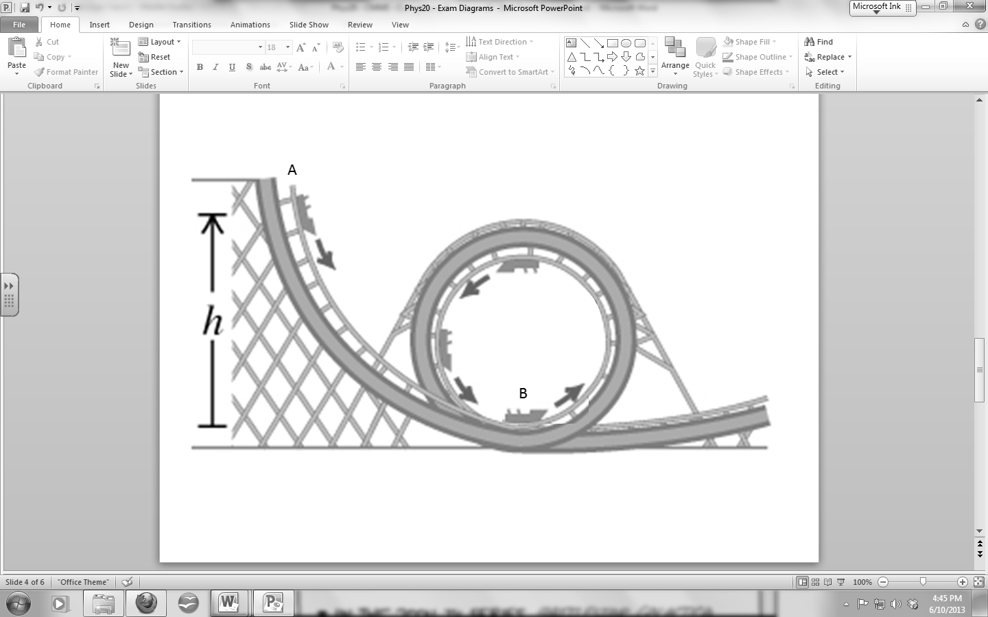

Q1: At Position B, the rollercoaster has a.bc x 10^{d} Joules of kinetic energy, where a, b, c, and d are ___, ___, ___, and ___.
(Record your four digit answer in the Numerical Response boxes below)

Q2: (Long Answer) From what height did the rollercoaster descend? (2 marks)

Use the following information to answer Q3-Q6:
A spring with a 200g mass is attached to a wall, pulled 15cm to the right of its equilibrium position (Position A), released and allowed to complete one full oscillation, as depicted below from a top-view.
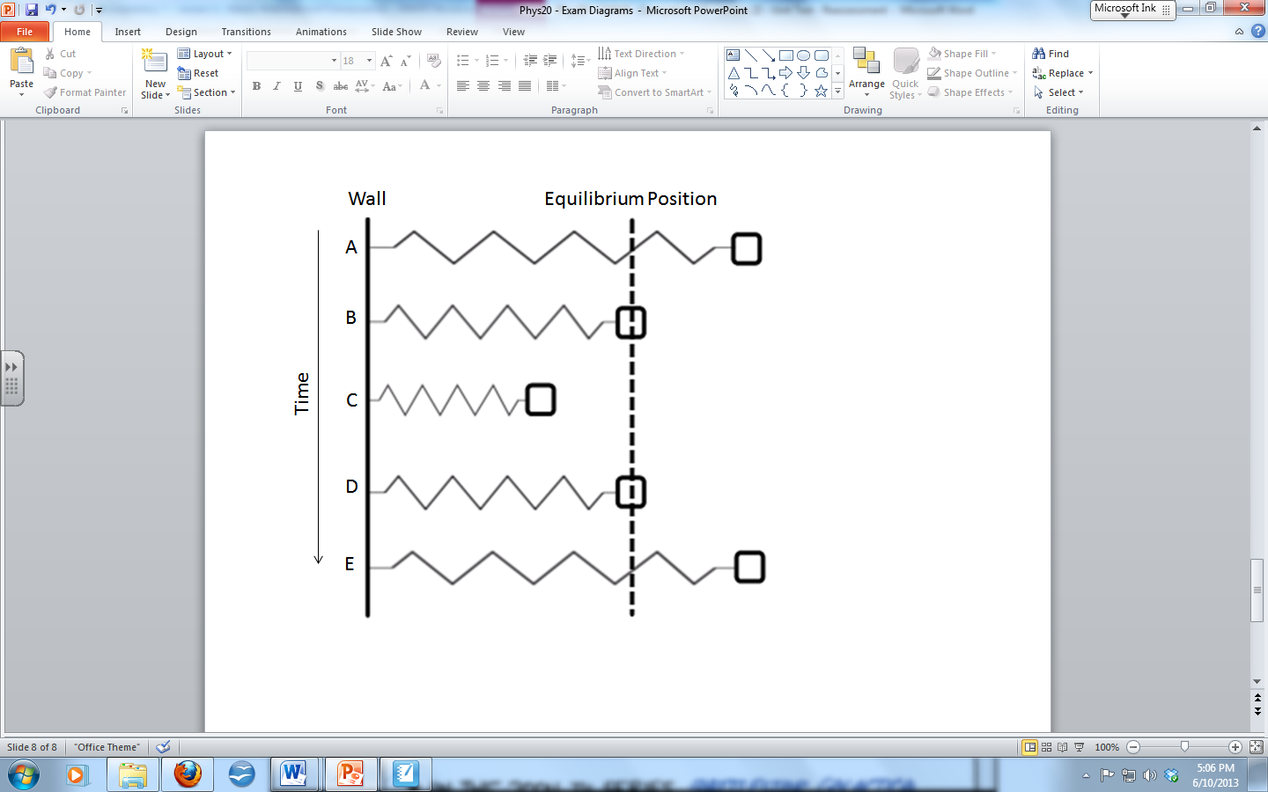
Magnitude
1 – Maximum
2 – Minimum

Q3: Use the Numerical Response numbers to identify whether each quantity is a maximum or minimum.
Magnitude: __________ __________ __________ __________
Quantity: Speed at Acceleration at Speed at Restoring Force
Position A Position A Position B Position C
(Record your four digit answer in the Numerical Response boxes below)

Q4: (Long Answer) Draw a Free-Body-Diagram for the object while it is at Position C. Label all relevant forces. (1 mark)

Q5: If there is 2.25J of energy while the spring is in Position A, how much force is the person exerting to hold it in place?
- 1.7 x 10⁻³ N
- 1.7 x 10⁻¹ N
- 3.0 x 10⁻¹ N
- 3.0 x 10¹ N

Q6: What is the speed of the 200g mass while it passes through Position D?
- 0.15 m/s
- 4.74 m/s
- 15.0 m/s
- 17.3 m/s
Part 2: Oscillatory Motion
Use the following information to answer Q7-Q8:
A pendulum arm of length 3.2m is pulled 50° to the right of its equilibrium position and released, as shown in Diagram 1 below.
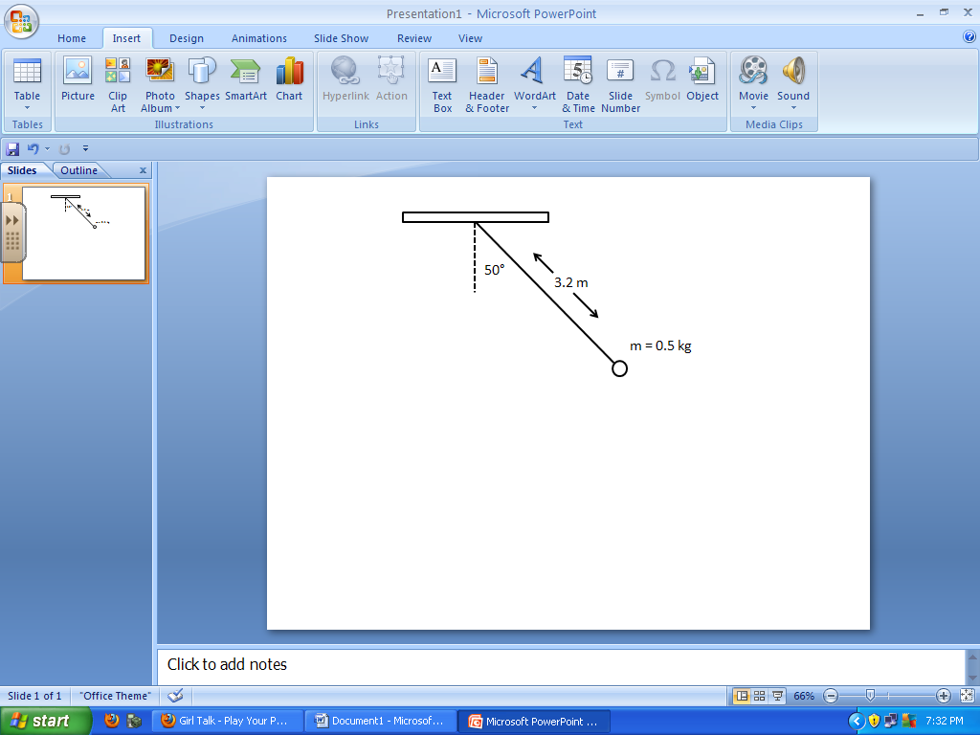

Q7: What is the tension in the rope when momentarily 50° from equilibrium, a split second after being released?
- 3.15 N
- 3.76 N
- 4.91 N
- 5.85 N

Q8: How many cycles does the pendulum make in 600 seconds?
- 5.98 x 10⁻³
- 2.79 x 10⁻¹
- 3.59
- 1.67 x 10²

Use the following information to answer Q9-Q10:
A 5.4kg mass suspended from a spring of spring constant 8.6 N/m, and is originally stationary. The spring is then stretched 1.3m [down] and released, causing the mass to oscillate, as seen below in Diagram 2.
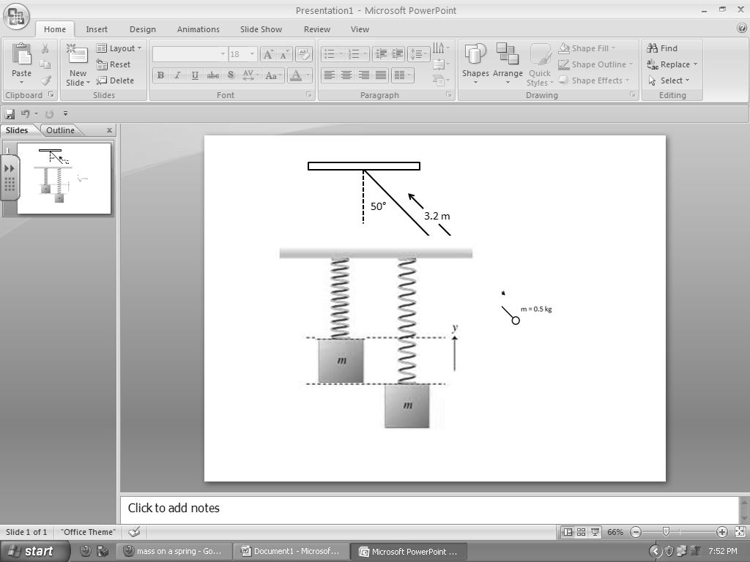

Q9: (Long Answer) What is the maximum speed of the oscillating mass? (2 marks)

Q10: What is the instantaneous acceleration of the mass, in m/s², when it is travelling at maximum velocity?
(Record your three digit answer in the Numerical Response boxes below)

