First Name:_______________________________ Last Name:______________________________

L16&17 – Worksheet –Unit Review /30 marks

Part 1: Gravitational Forces & Fields in 1-Dimension
Part 2: Gravitational Forces & Fields in 2-Dimensions
Part 3: Algebraic and Graphical Gravity Questions
Part 4: Centripetal Speed and Acceleration
Part 5: Circular Motion (Horizontal Systems)
Part 6: Circular Motion (Vertical Systems)
Part 7: Kepler’s Laws
Part 8: Algebraic and Graphical Circular Motion Questions

Part 1: Gravitational Forces & Fields in 1-Dimension
Q1: If a 5000kg object was located 3m from a 10,000kg object, what is the gravitational force between these two objects?
- 3.71 x 10⁻⁴ N
- 5.56 x 10⁻⁴ N
- 1.11 x 10⁻³ N
- 5.45 x 10⁷ N

Q2: Two identical objects of mass 5000kg are placed a distance apart. They experience a gravitational force of attraction of 1.00 x 10⁻⁶ N. The distance between their center of masses is a.bc x 10^{d} m, where a, b, c, and d are ___, ___, ___, and ___.
(Record your four-digit answer in the Numerical Response boxes below)

Q3: If r₁ = 20m, and r₂ = 45m, calculate the acceleration (magnitude and direction) of the 500kg block.
(2 marks)
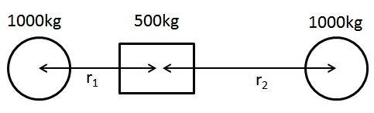

Part 2: Gravitational Forces & Fields in 2-Dimensions
Use the following information to answer Q4:
Three objects are arranged at right angles to each other, as depicted below.
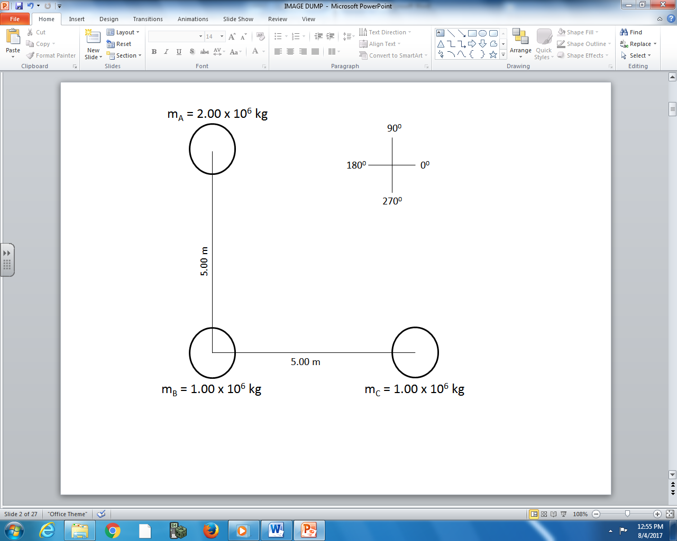

Q4: The net force acting on m_{B} is a.b Newtons [ef degrees], where a, b, e, and f are ___, ___, ___, and ___.
(Record your four-digit answer in the Numerical Response boxes below)

Q5: What is the net force acting on m_{B}? (3 marks)
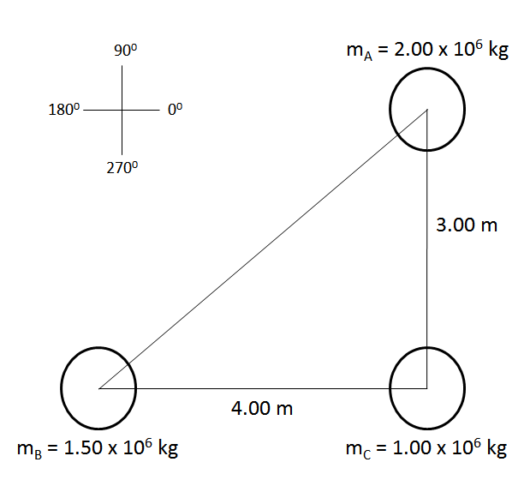

Part 3: Algebraic and Graphical Gravity Questions
Use the following information to answer Q6-Q7:
An Astronaut of mass 80kg is located at Point B. If the gravitational field strength experienced by the Astronaut at this location is 30 N/kg.
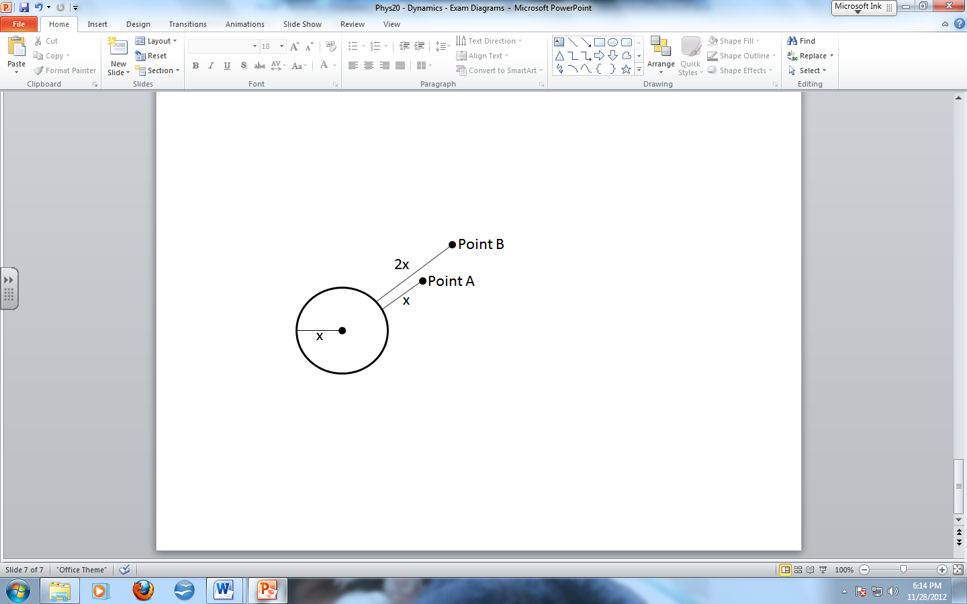

Q6: The Force of Gravity acting on the Astronaut at Point B is a.bc x 10^{d} N, where a, b, c, and d are ___, ___, ___, and ___.
(Record your four-digit answer in the Numerical Response boxes below)

Q7: What is the acceleration due to gravity on the surface of the planet, in m/s²?
(Record your three-digit answer in the Numerical Response boxes below)

Use the following information to answer Q8-Q9:
An Astronaut of mass 60kg is located at Point A. The gravitational field strength experienced by the Astronaut at this location is 0.85 N/kg.
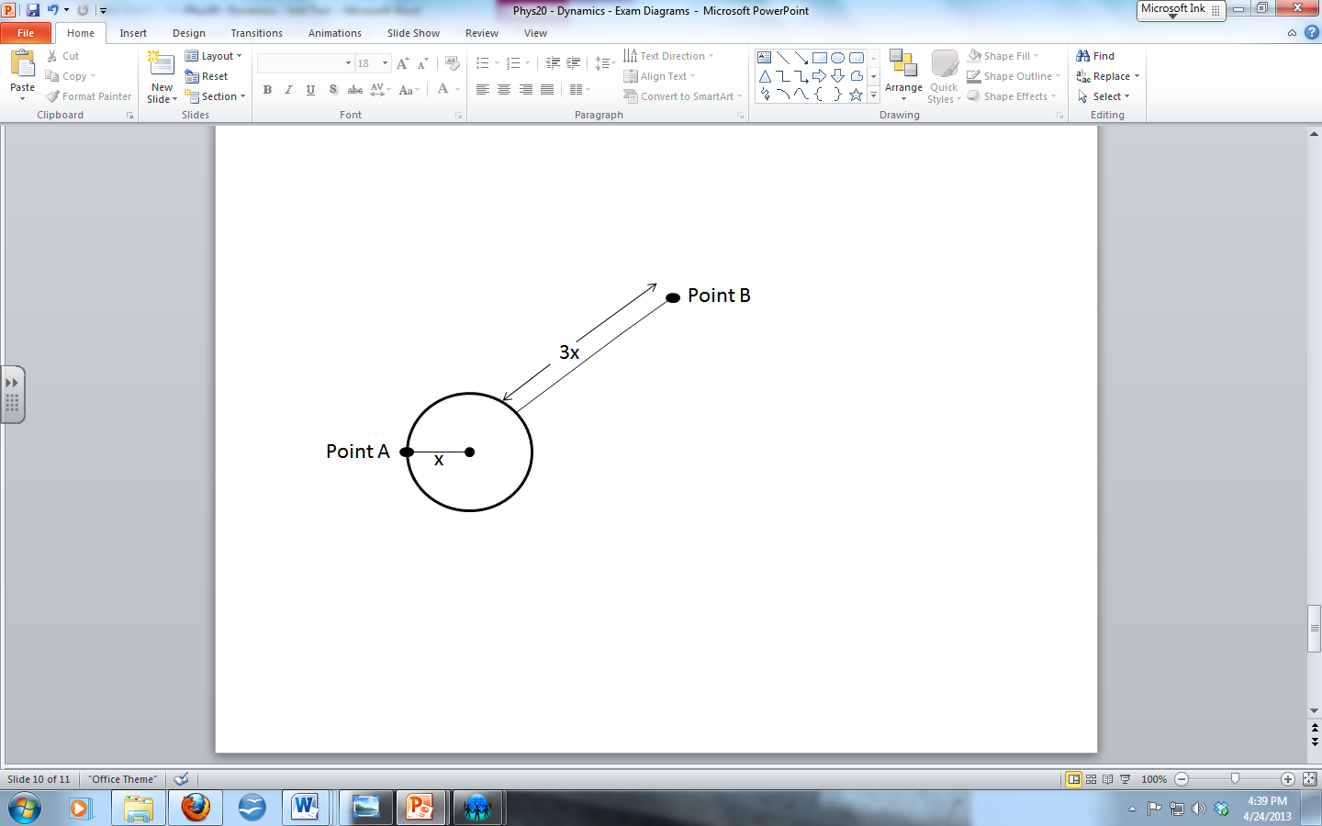

Q8: What is the Force of Gravity acting on the Astronaut at Point A?
(Record your three-digit answer in the Numerical Response boxes below)

Q9: The acceleration due to gravity at Point B is a.bc x 10^{-d} m/s², where a, b, c, and d are ___, ___, ___, and ___.
(Record your four-digit answer in the Numerical Response boxes below)

Q10: The gravitational force of attraction between a 10kg object and another object of unknown mass is plotted below for various distances. Linearize the data, graph it, and use the slope to determine the magnitude of the unknown mass. (2 marks)
Radius, r  (meters) | Force of Gravity, F_{g}  (Newtons) | Inverse radius squared, 1/r²  (1/m²)
0.1 | 19.5 x 10⁻⁷
0.2 | 5.3 x 10⁻⁷
0.3 | 2.1 x 10⁻⁷
0.4 | 1.2 x 10⁻⁷
0.5 | 0.7 x 10⁻⁷

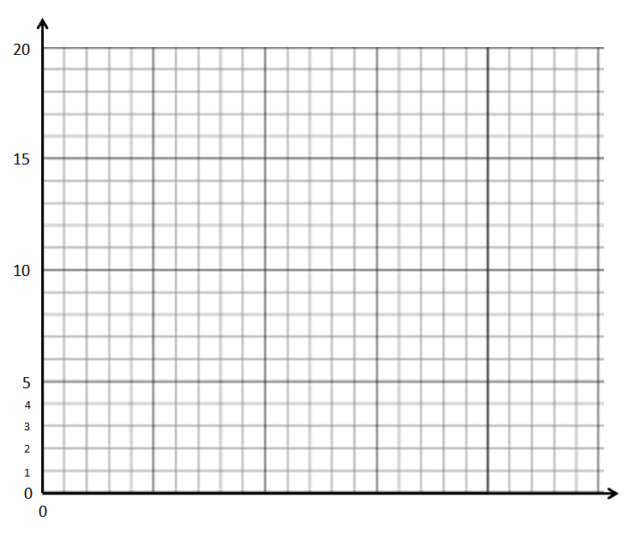

Part 4: Centripetal Speed and Acceleration
Use the following information to answer Q11-Q12:
The Vitamix © 5200 Blender, depicted below, is rated at 1380W. It has a blade of radial length 3.8cm (0.038m), where the tip of the blade can spin up to 240mph (107m/s).
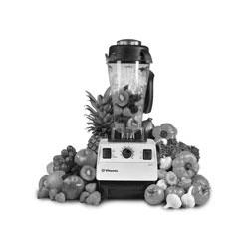

Q11: What is the frequency of the blade rotation?
- 4.48 Hz
- 10.1 Hz
- 448 Hz
- 1005 Hz

Q12: In different blender the blade tip also moves at 107m/s, but the blade length is longer. Is the frequency of rotation larger or smaller? Explain. (1 mark)

Part 5: Circular Motion (Horizontal Systems)
Q13: A car of mass 1200kg is rounding a horizontal corner of radius 15m. The coefficient of static friction between the road and the car tires is 0.85. What is the maximum speed the car can round the corner at, in m/s?
(Record your three-digit answer in the Numerical Response boxes below)

Q14: A car is travelling in a circle of radius 15m, and has a period of 4.25 seconds. If the car is barely able to maintain circular motion, what is the coefficient of friction? (2 marks)
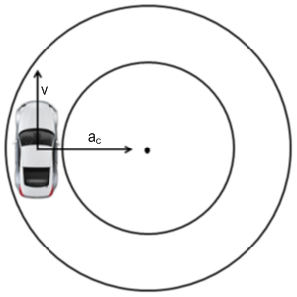

Part 6: Circular Motion (Vertical Systems)
Use the following information to answer Q15-17:
The mass of a rollercoaster car is 200kg and it turns through a loop of radius 4m at a constant 20m/s.
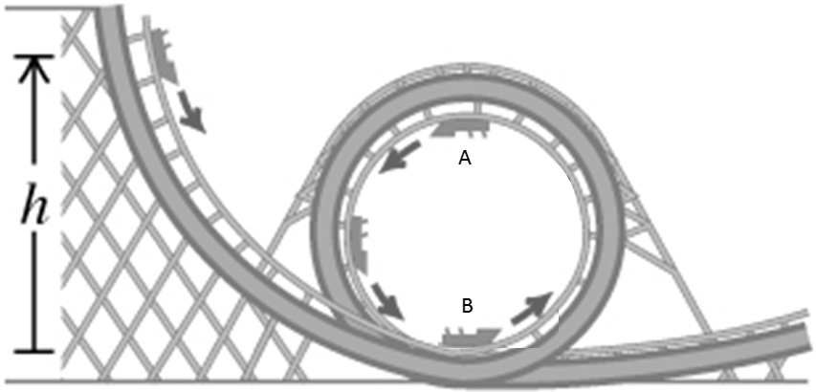

Q15: The roller coaster is experiencing a centripetal force of a.bc x 10^{d} N while in the loop, where a, b, c, and d are ___, ___, ___, and ___.
(Record your four-digit answer in the Numerical Response boxes below)

Q16: The normal force acting on the rollercoaster while at the top of the loop is a.bc x 10^{d} N, where a, b, c, and d are ___, ___, ___, and ___.
(Record your four-digit answer in the Numerical Response boxes below)

Q17: The normal force acting on the rollercoaster while at the bottom of the loop is a.bc x 10^{d} N, where a, b, c, and d are ___, ___, ___, and ___.
(Record your four-digit answer in the Numerical Response boxes below)

Use the following information to answer Q18:
A plane of mass 5500kg is making a loop with a diameter of 50m. 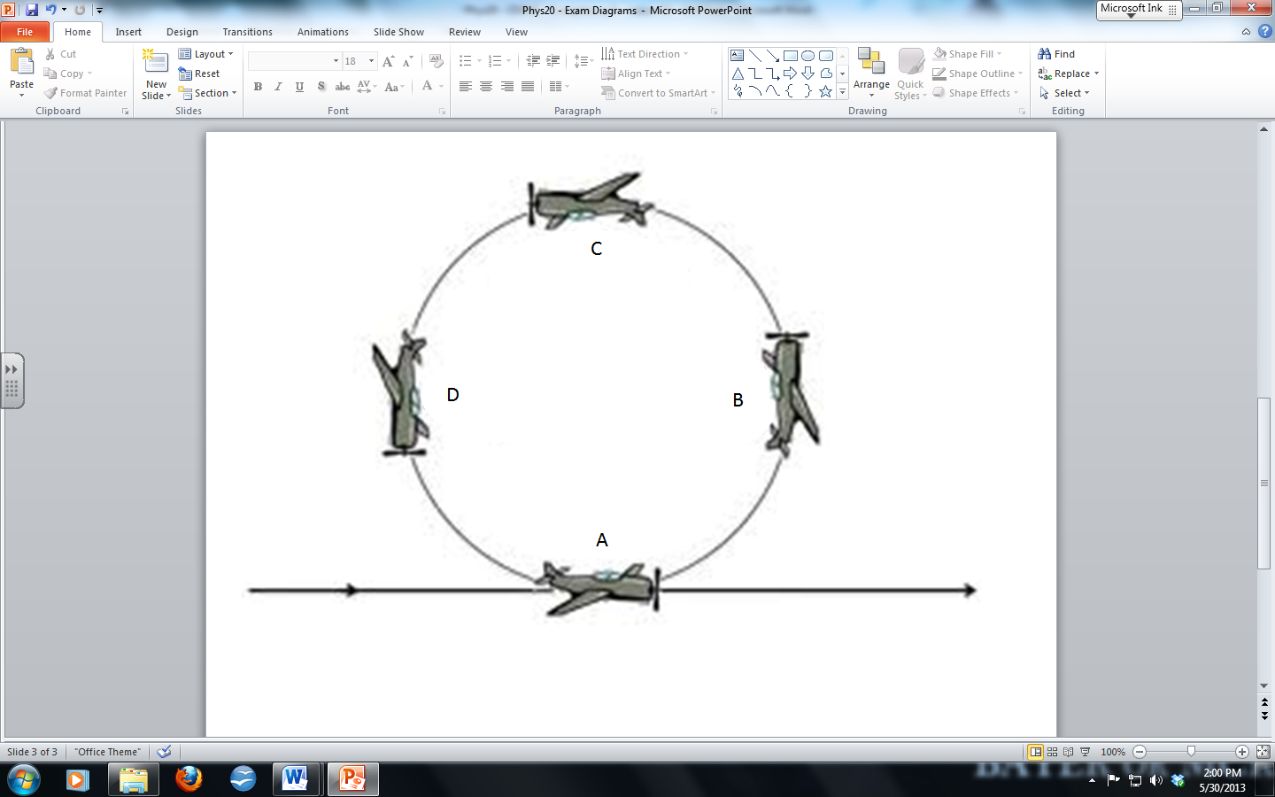

Q18: What is the minimum speed the plane needs to make the loop, in m/s?
(Record your three-digit answer in the Numerical Response boxes below)

Part 7: Kepler’s Laws
Q19: Use the diagram of an elliptical orbit and use it to describe Kepler’s Laws. (1 mark)
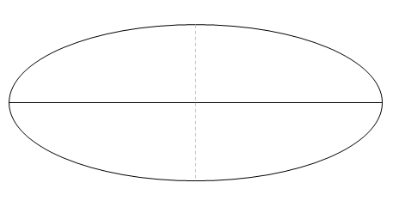

Q20: Earth’s mean orbital radius is 1.50 x 10¹¹ m. Neptune is a planet in our solar system with a mean orbital radius of 4.50 x 10¹² m. Neptune’s orbital period is a.bc x 10^{d} days, where a, b, c, and d are ___, ___, ___, and ___.
(Record your four-digit answer in the Numerical Response boxes below)

Part 8: Algebraic and Graphical Circular Motion Questions
Use the following information to answer Q21-Q24:
A mass of 0.15 kg is swing in a circle with a constant speed. It’s height is recorded and graphed as a function of time.
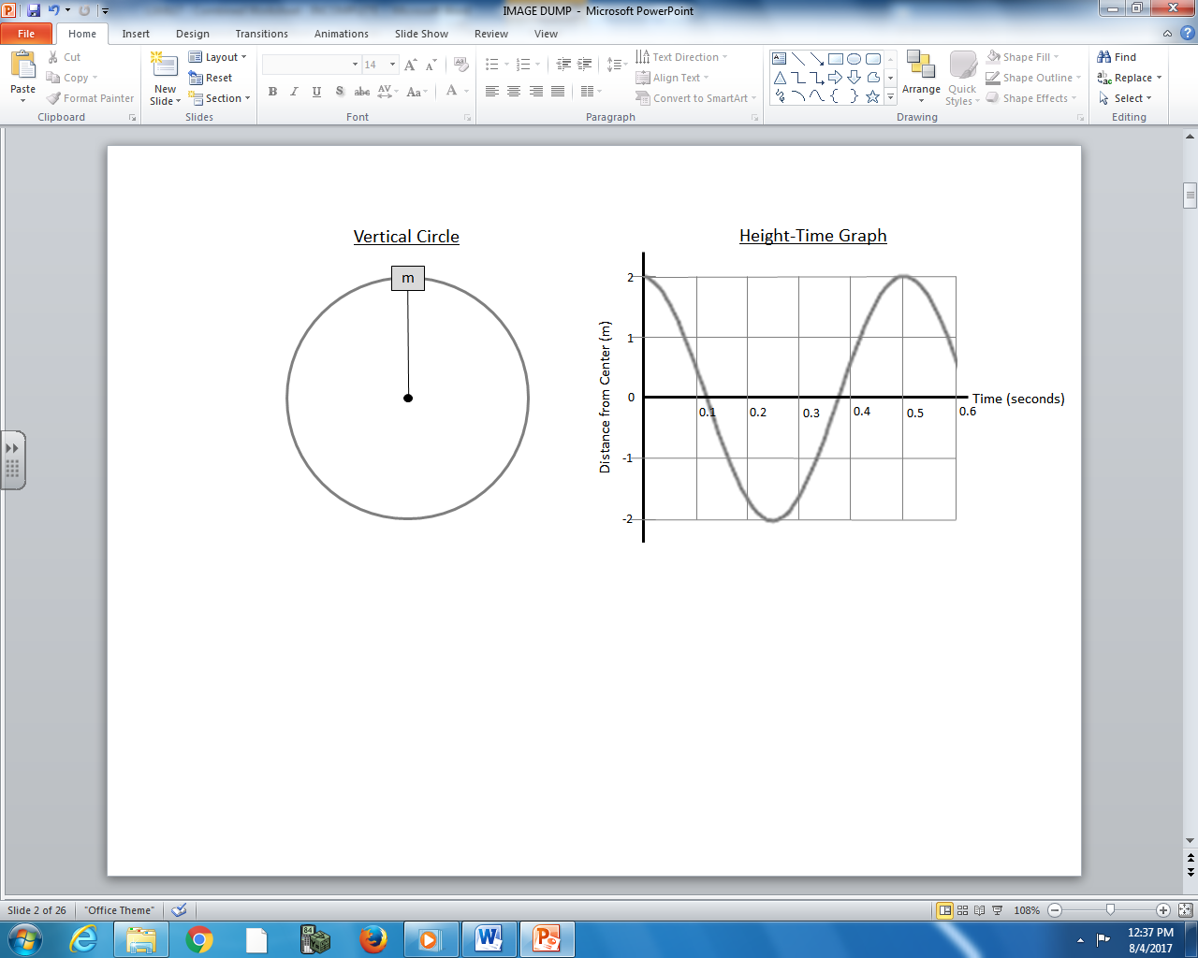

Q21: How much time does it take the mass to make 10 revolutions, in seconds?
(Record your three-digit answer in the Numerical Response boxes below)

Q22: What is the frequency of rotation of the object?
- 0.2 Hz
- 0.5 Hz
- 2.0 Hz
- 5.0 Hz
Q23: The object is moving at a constant speed of a.bc x 10^{d} m/s, where a, b, c, and d are ___, ___, ___, and ___.
(Record your four-digit answer in the Numerical Response boxes below)

Q24: What is the tension in the rope when the mass is at the top of the vertical loop? (2 marks)

