First Name:__________________________________ Last Name:______________________________

L17 – FQ – Motor Effect, Generator Effect, and Mass Spectrometer

Q1: A wire is raised upward through a magnetic field, as detailed below. Label the direction of current flow in the diagram below. (1 mark)
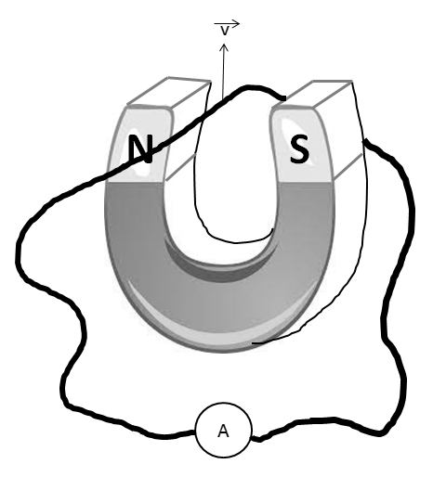

Q2: A magnet is pulled away from a solenoid, as diagrammed below. In what direction would the induced current flow through the solenoid? Label the diagram. (1 mark)
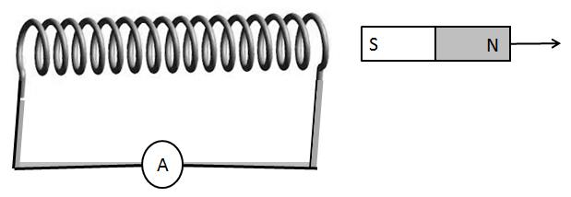

Use the following information to answer Q3-Q5:
A mass spectrometer accelerates electrons at the “Acceleration Plates” to a speed of 4.00 x 10⁵ m/s. The electrons then go through a “Velocity Selector” with an electric field strength of 1.80 kN/C [up]. Finally the electrons enter a “Detection Chamber” with a magnetic field of 2.50 mT [into the page].
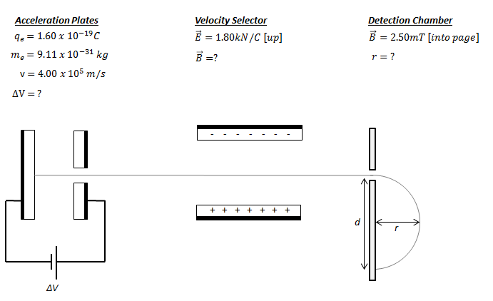

Q3: The voltage across the Acceleration Plates is a.bc x 10^{-d} V, where a, b, c, and d are ___, ___, ___, and ___.
(Record your four digit answer in the Numerical Response boxes below)

Q4: The magnetic field across the Velocity Selector is
- 4.50 x 10⁻³ T [into page]
- 4.50 x 10⁻³ T [out of page]
- 7.20 x 10⁸ T [into page]
- 7.20 x 10⁸ T [out of page]

Q5: The radius of curvature in the detection chamber is
- 9.11 x 10⁻⁷ m
- 9.11 x 10⁻⁴ m
- 1.10 x 10³ m
- 1.10 x 10⁶ m

Use the following diagram to answer Q6:
An electric generator is depicted below:
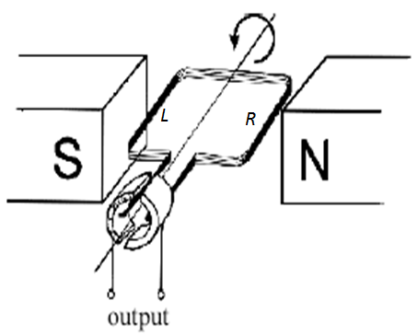
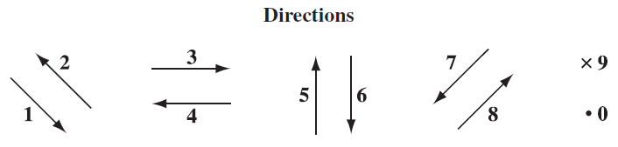

Q6: The directions of the motion of the wire, the magnetic field, and the induced current can be described using the numbers given above.
Direction: ____________ ____________ ____________ ____________
Field: Direction of Direction of the Direction of the Direction of the
motion of wire induced current motion of wire induced current
at Position L at Position L at Position R at Position R
(Record your four digit answer in the Numerical Response boxes below)

MARKING:
Beginning 0.0 – 2.5
Progressing 3.0 – 4.0
Competent 4.5 – 5.5
Exemplary 6.0

