First Name:____________________________ Last Name:______________________________

L17 - Lab – EMR as Particles at Colorado PhET /13 marks

_____ _____ _____
Part 5 Part 6 Part 7
7 marks 2 marks 4 marks

Part 5: Calculating Plank’s Constant using Calcium /7
Instructions:
- Go to http://phet.colorado.edu/en/simulation/photoelectric
- Program Settings:
  - Target: Calcium
  - Toggle on “Show only highest energy electrons”.
  - Graphs: All toggled to “off”
  - Initially start with V = 0.00 V.
- By varying frequency and using Stopping Voltage, determine Plank’s Constant.
The only equations you will need to use for this section are:
$$c=fλ$$
$${E_{k}}_{max}=q_{e}V_{stop}$$
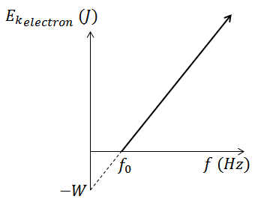

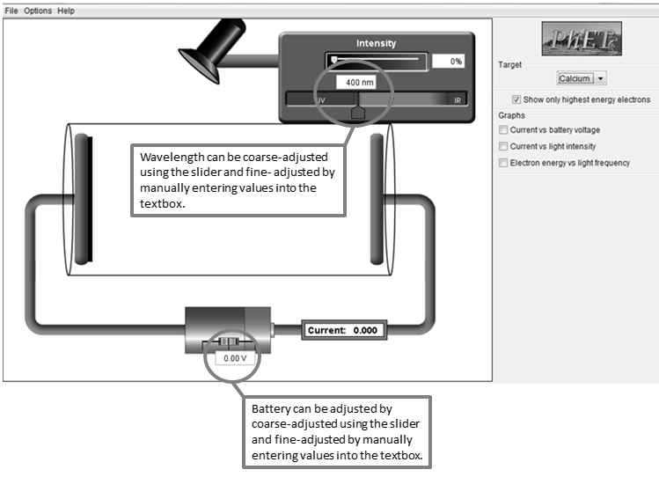
Q13: First determine the maximum wavelength that is capable of causing photoemission from a Calcium target. Second, select three additional wavelengths greater than 350nm and experimentally determine the stopping voltage for each by adjusting the battery in the simulation. (4 marks)
Wavelength (m)  (Manipulated Variable) | Frequency (Hz)  (Calculated) | Stopping Voltage (V)  (Responding Variable) | Kinetic Energy of Electron (J)  (Calculated)
 | f₀ = | V_{stop} = 0 | E_{k} = 0

Q14: Plot ${E_{k}}_{electron}$ versus $f$ for photoelectrons emitted from a Calcium target. (1 mark)
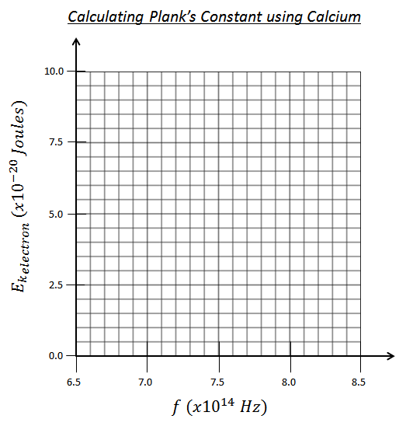

Q15: Using your graph, determine Plank’s Constant. (1 mark)

Q16: Determine the Work Function of Calcium. (1 mark)

Part 6: Comparing Work Functions of Sodium and Copper Targets /2
Instructions:
- Go to http://phet.colorado.edu/en/simulation/photoelectric
- Program Settings:
  - Targets: Sodium and Copper
  - Toggle on “Show only highest energy electrons”.
  - Graphs: All toggled to “off”
  - Keep V = 0.00 V.
- Compare the Work Functions of Sodium and Copper

Q17: Create an experiment to determine which has the largest Work Function, Sodium or Copper. Detail your procedure below. (1 mark)

Q18: Which has the largest Work Function, Sodium or Copper? Explain. (1 mark)

Part 7: Examining Graphs of the Photoelectric Effect /4
Instructions:
- Go to http://phet.colorado.edu/en/simulation/photoelectric
- Program Settings:
  - Targets: Sodium
  - Toggle on “Show only highest energy electrons”.
  - Graphs:
    - Current vs battery voltage: Toggled to “off”
    - Current vs light intensity: Toggled to “on”
    - Electron energy vs light frequency: Toggled to “on”
  - Wavelength: Set to 200nm.
- Vary the light intensity to examine relationship between intensity, current, and electron energy.

Q19: Graph and explain the relationship between Intensity and Current. (2 marks)

Q20: Graph and explain the relationship between Intensity and Electron Energy. (2 marks)


