First Name:__________________________________ Last Name:______________________________

L17 – Worksheet – Electromagnetism Review

First and Second Hand Rules
Use the following information to answer Q1:
A solenoid is given a current per the diagram below:
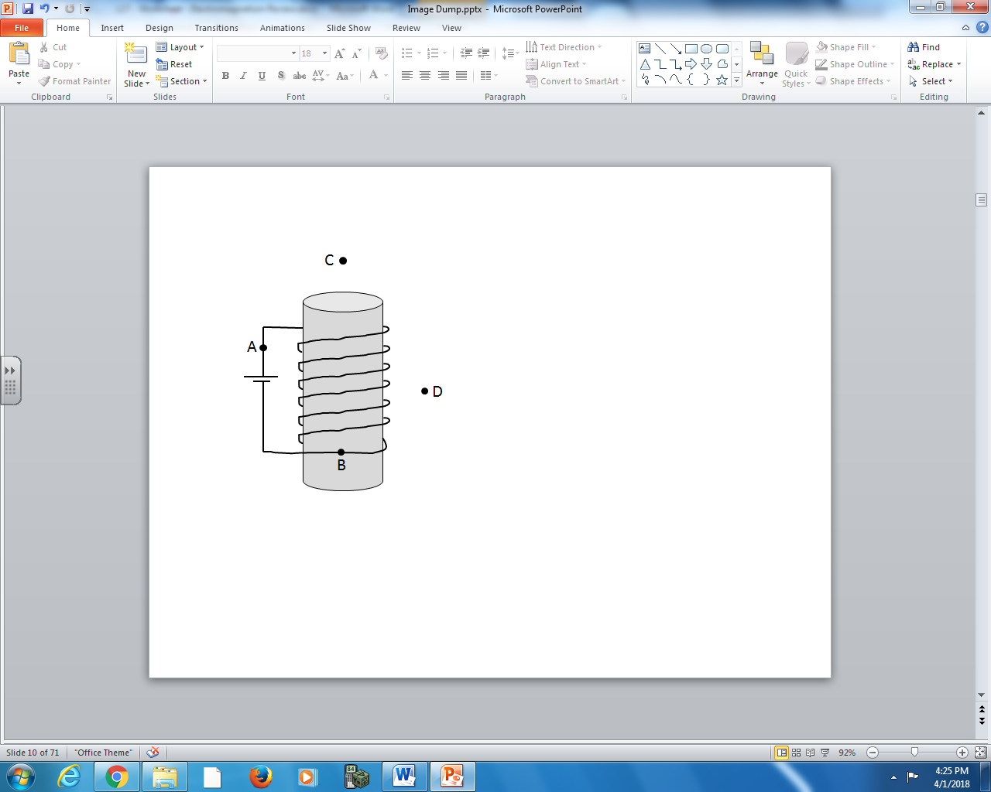
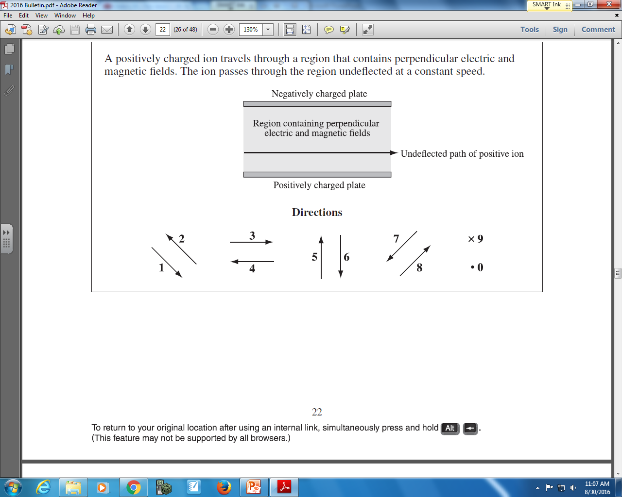

Q1: The directions of the current and the magnetic field can be described using the numbers given above.
Direction: ____________ ____________ ____________ ____________
Field: Direction of Direction of Direction of Direction of
current at current at magnetic field at magnetic field at
Position A Position B Position C Position D
(Record your four digit answer in the Numerical Response boxes below)

Use the following information to answer Q2:
A solenoid is given a current per the diagram below:
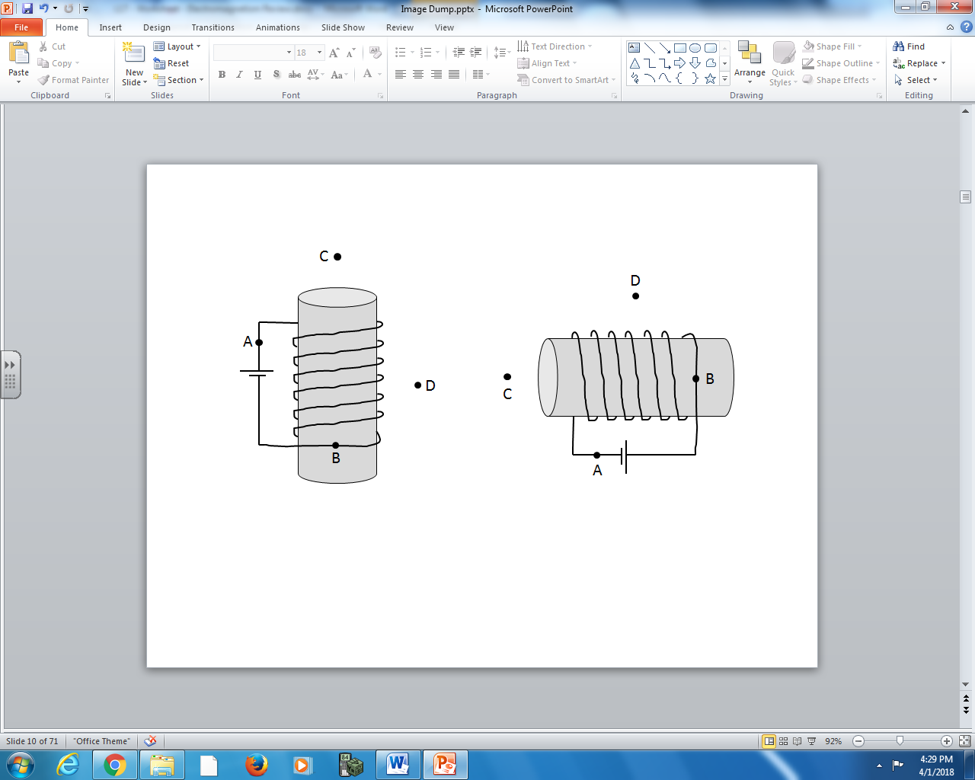

Q2: The directions of the current and the magnetic field can be described using the numbers given above.
Direction: ____________ ____________ ____________ ____________
Field: Direction of Direction of Direction of Direction of
current at current at magnetic field at magnetic field at
Position A Position B Position C Position D
(Record your four digit answer in the Numerical Response boxes below)

Use the following diagram to answer Q3:
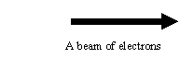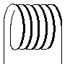

Q3: A beam of electrons pass through a solenoid connected to a power supply. The effect on the beam passing through a current-carrying solenoid is:
- a deflection of the beam path
- an increase in speed
- a decrease in speed
- no effect at all
Motor Effect (Third Hand Rule) on a Point Charge
Use the following diagram to answer Q4-Q5:
A chlorine ion (Cl ⁻¹) with a mass of 5.85 x 10⁻²⁶ kg is projected with an energy of 8.50 keV perpendicularly into a magnetic field with a strength of 0.650 T.
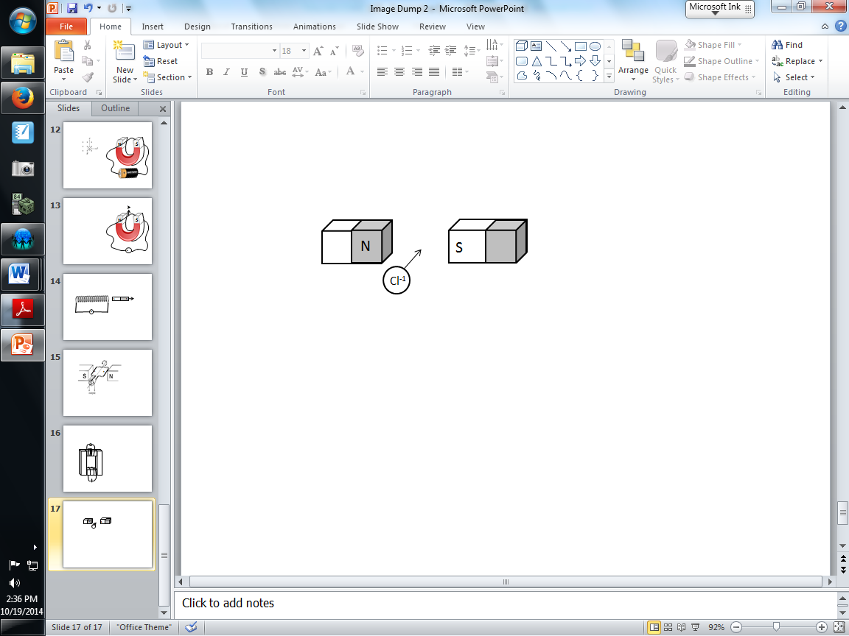

Q4: Based on the information above, the magnetic force of deflection on the chlorine ion will be towards:
- the left
- the right
- the top of the page
- the bottom of the page

Q5: The magnitude of the magnetic force experienced by the Chlorine ion (Cl ⁻¹) is a.b x 10^{-cd} N, where a,b,c and d are ___, ___, ___, and ___.
(Record your three digit answer in the Numerical Response boxes below)

Motor Effect (Third Hand Rule) on a Current Carrying Wire
Use the following diagram to answer Q6-Q7:
Two parallel wires, A and B, carry currents in the same direction.
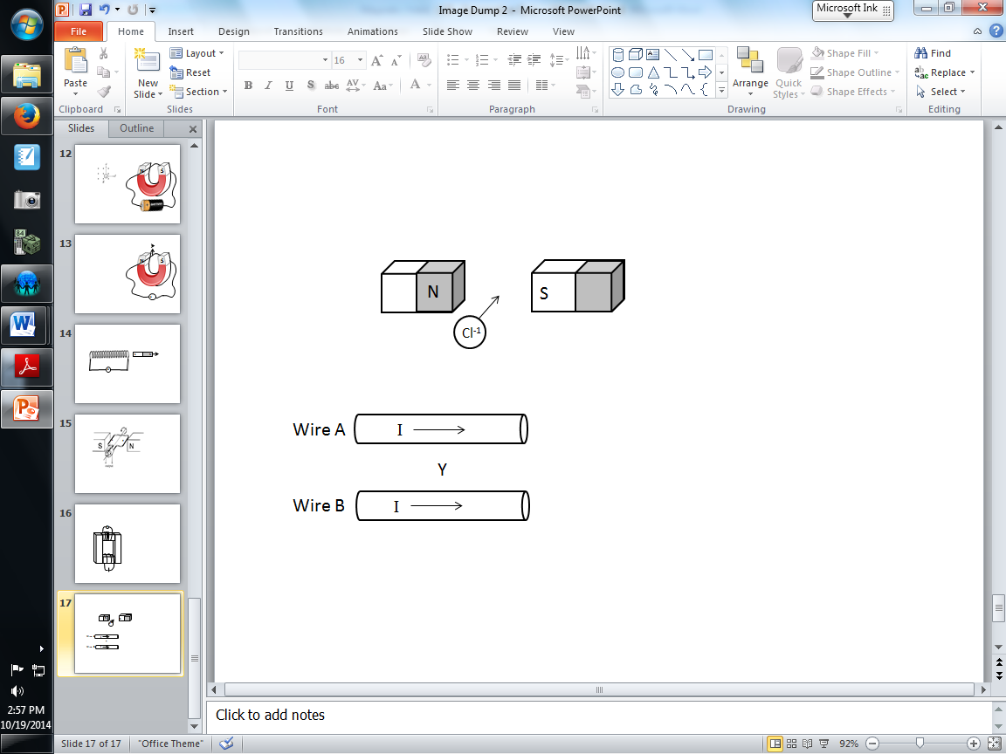

Q6: Refer to the diagram above. At position Y, between the two current carrying wires, the direction of the magnetic field of wire A is __i__ and the magnetic field of wire B is __ii_.
 | i | ii
A | out of the page | out of the page
B | into the page | out of the page
C | out of the page | into the page
D | into the page | into the page

- A b) B c) C d) D
Q7: The force on Wire A will be __i__, and the force on Wire B will be __ii_.
 | i | ii
A | upward | upward
B | downward | upward
C | upward | downward
D | downward | downward

- A b) B c) C d) D
Q8: A copper wire is connected to a battery so that is has a current in it. A segment of the wire is perpendicular to a horizontal 1.5 T magnetic field. The length of the wire in the magnetic field is 3.0 cm, and the mass of the wire affected by the magnetic field is 20g. In order to suspend the segment of wire, the minimum current in the wire must be
- 0.044 A
- 0.23 A
- 4.4 A
- 44 A
Motor Effect and Circular Motion
Use the following diagram to answer Q9:
Below is an image of a Mass Spectrometer. A charged ion can be accelerated, then enter a uniform magnetic field. By measuring the radius of curvature, the mass of the ion can be determined.
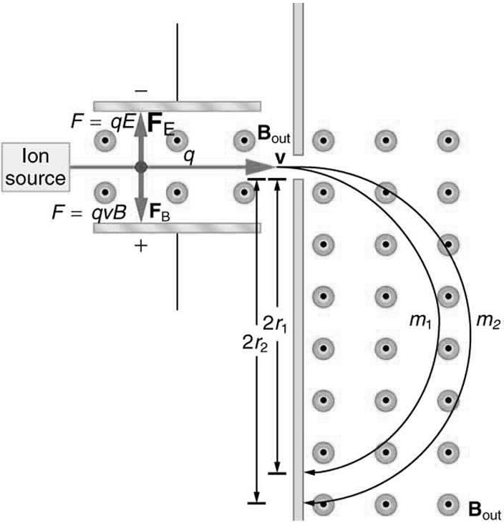
A sodium ion (Na ⁺¹) with a mass of 2.32 x 10⁻²⁶ kg and a charge of +1.60 x 10⁻¹⁹C is projected with a speed of 3.00 x 10⁵ m/s into the uniform magnetic field of 1.250 T.

Q9: What is the radius of curvature, r, of the sodium ion in the magnetic field, measured in centimeters?
(Record your three digit answer in the Numerical Response boxes below)

Generator Effect
Use the following information to answer Q10:
A loop of wire is rotated in a magnetic field, per the diagram below.
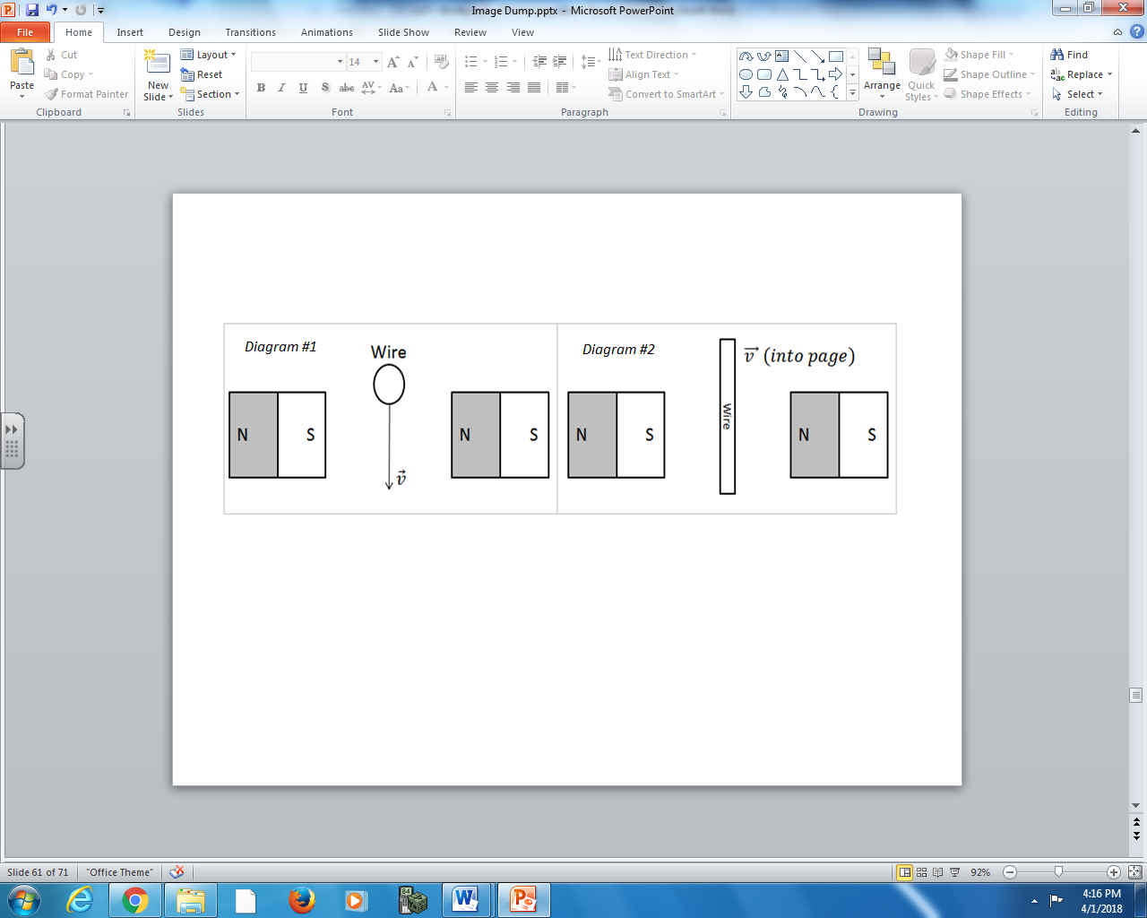

Q10: The directions of the motion of the electrons in the wire can be described using the numbers given above.
Direction: ____________ ____________
Current: Direction of Direction of
current in current in
Diagram #1 Diagram #2
(Record your two digit answer in the Numerical Response boxes below)

Use the following information to answer Q11:
A loop of wire is rotated in a magnetic field, per the diagram below.
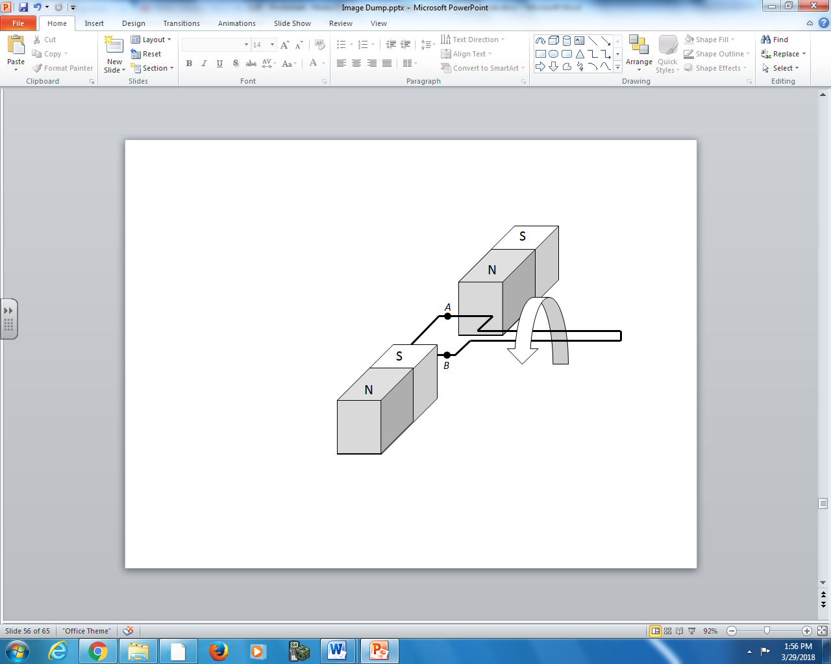

Q11: The directions of the motion of the wire, the magnetic field, and the induced current can be described using the numbers given above.
Direction: ____________ ____________ ____________
Field: Direction of Direction of the Direction of the
magnetic field motion of the induced current
at Position A wire at Position A at Position A
(Record your three digit answer in the Numerical Response boxes below)

Use the following information to answer Q12:
A loop of wire is rotated in a magnetic field, per the diagram below.
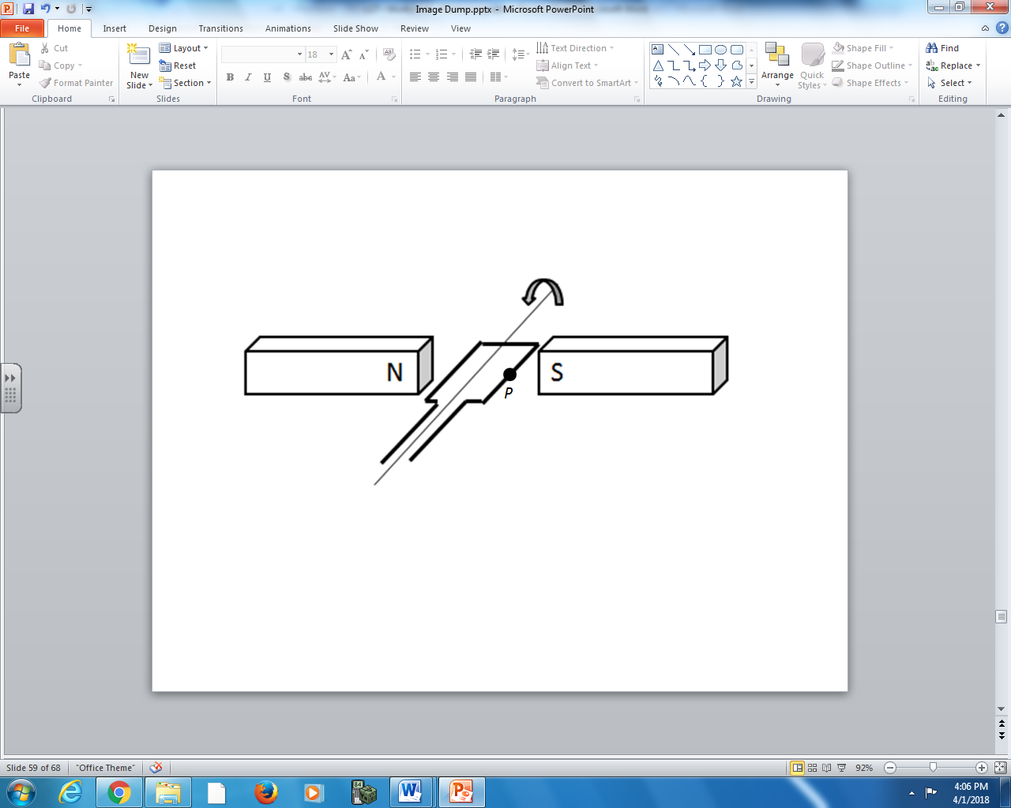

Q12: The directions of the motion of the wire, the magnetic field, and the induced current can be described using the numbers given above.
Direction: ____________ ____________ ____________
Field: Direction of Direction of the Direction of the
magnetic field motion of the induced current
at Position P wire at Position P at Position P
(Record your three digit answer in the Numerical Response boxes below)

Use the following information to answer Q13:
A loop of wire is rotated in a magnetic field, per the diagram below.
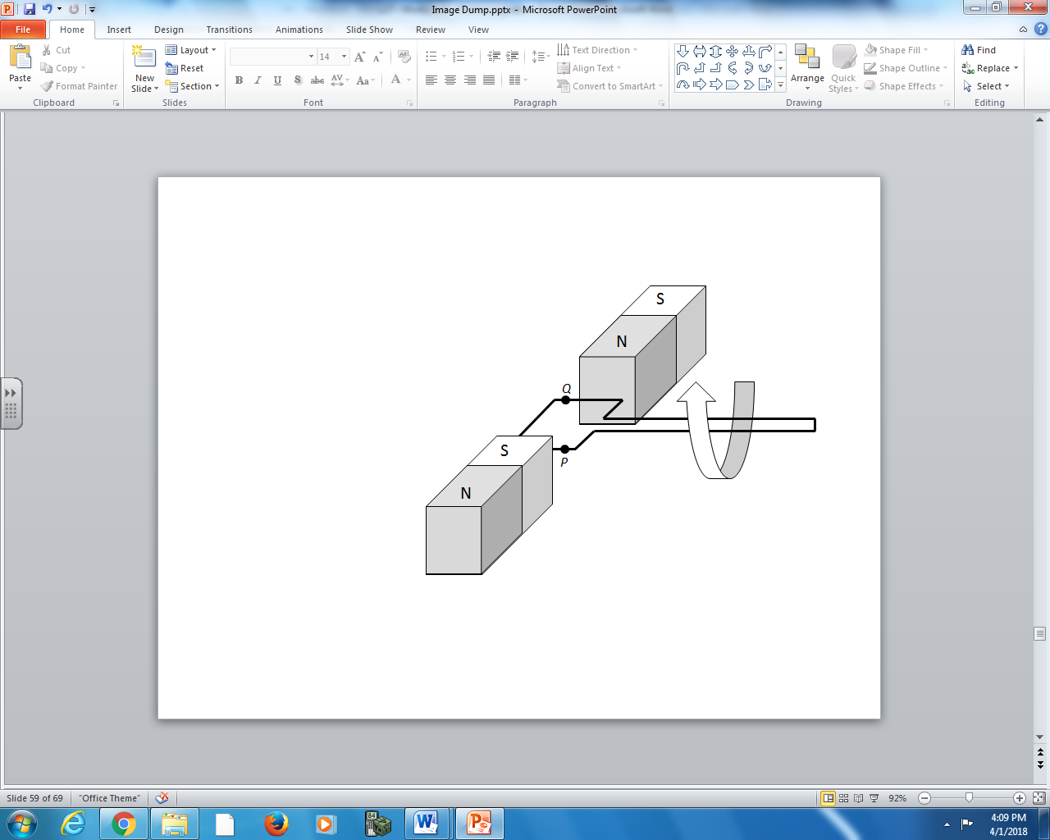

Q13: The directions of the motion of the wire, the magnetic field, and the induced current can be described using the numbers given above.
Direction: ____________ ____________ ____________ ____________
Field: Direction of Direction of the Direction of the Direction of the
magnetic field motion of the induced current induced current
at Position P wire at Position P at Position P at Position Q
(Record your four digit answer in the Numerical Response boxes below)

Use the following information to answer Q14:
A loop of wire is rotated in a magnetic field, per the diagram below.
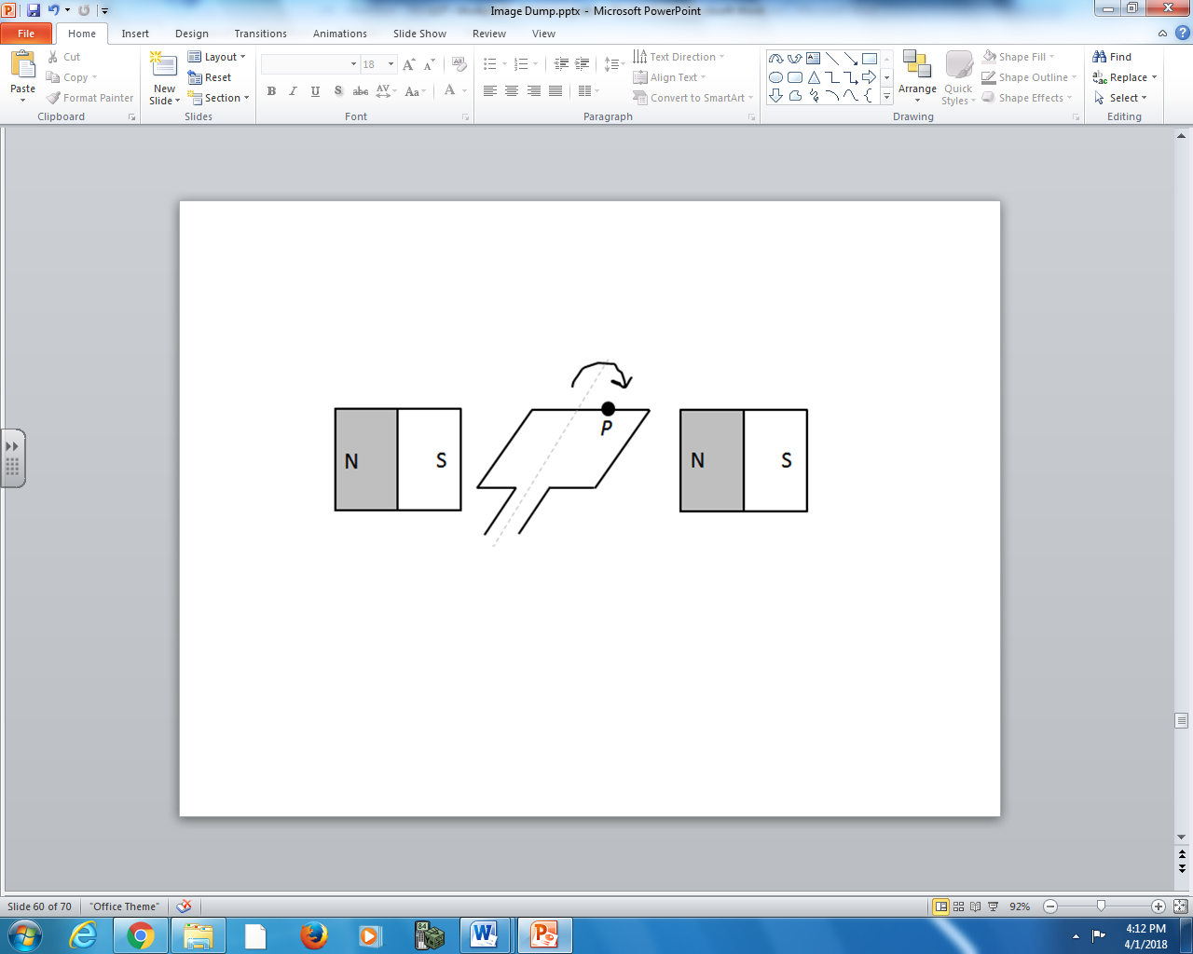

Q14: The directions of the motion of the wire, the magnetic field, and the induced current can be described using the numbers given above.
Direction: ____________ ____________
Field: Direction of Direction of the
magnetic field induced current
at Position P wire at Position P
(Record your two digit answer in the Numerical Response boxes below)

Lenz’s Law
Use the following information to answer Q15:
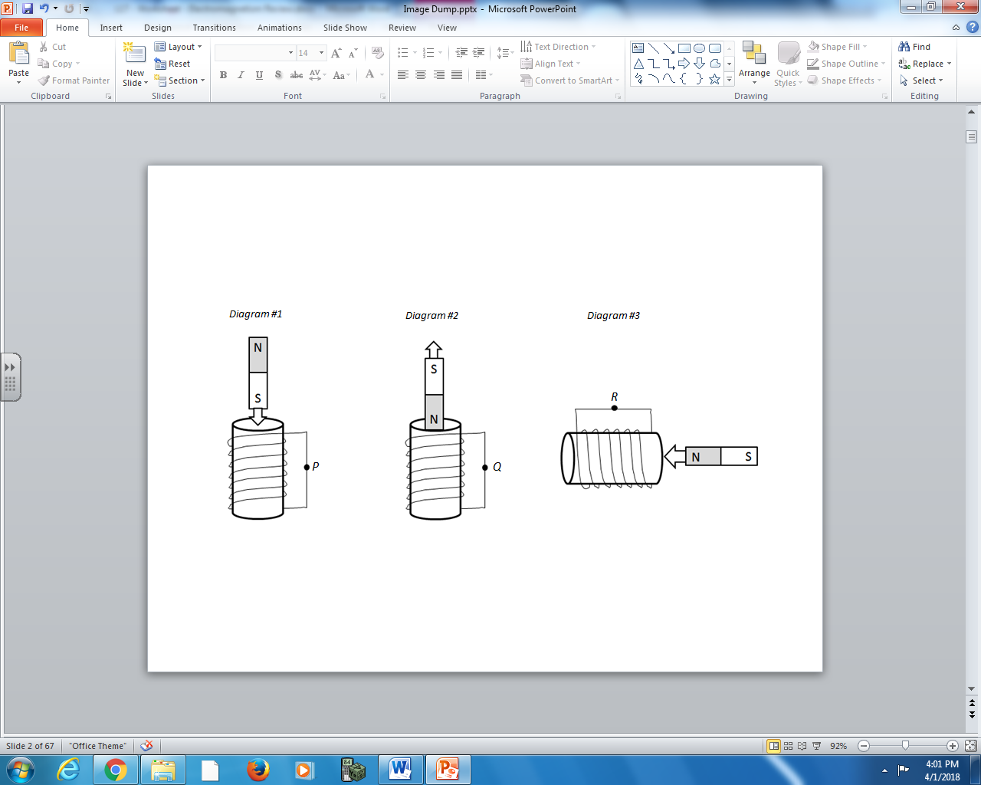

Q15: The direction of current at various points in the wire can be described using the numbers given above.
Direction: ____________ ____________ ____________
Field: Direction of Direction of Direction of
current in wire current in wire current in wire
at Position P at Position Q at Position R
(Record your three digit answer in the Numerical Response boxes below)

Use the following diagram to answer Q16:
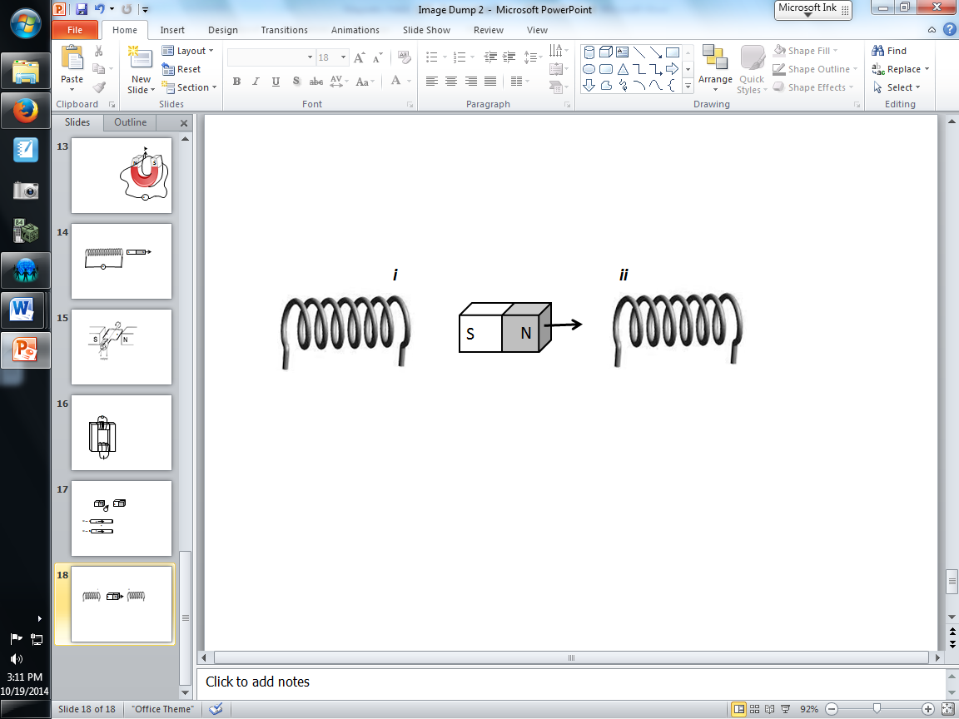

Q16: Refer to the diagram above. A magnet is moved at uniform speed between two solenoids. The magnetic polarities at positions i and ii, respectively, are:
 | i | ii
A | north | north
B | north | south
C | south | north
D | south | south

- A b) B c) C d) D

Millikan Experiment
Q17: In Millikan’s oil drop experiment, what magnitude of electric field would be required to suspend a 1.5g oil drop of -3e charge in the air?
- 3.1 x 10¹⁶ N/C
- 9.2 x 10¹⁶ N/C
- 3.1 x 10¹⁹ N/C
- 9.2 x 10¹⁹ N/C

Use the following information to answer Q18:
A 2.60 x 10⁻⁴ kg oil drop is suspended in between parallel plates, as depicted below.
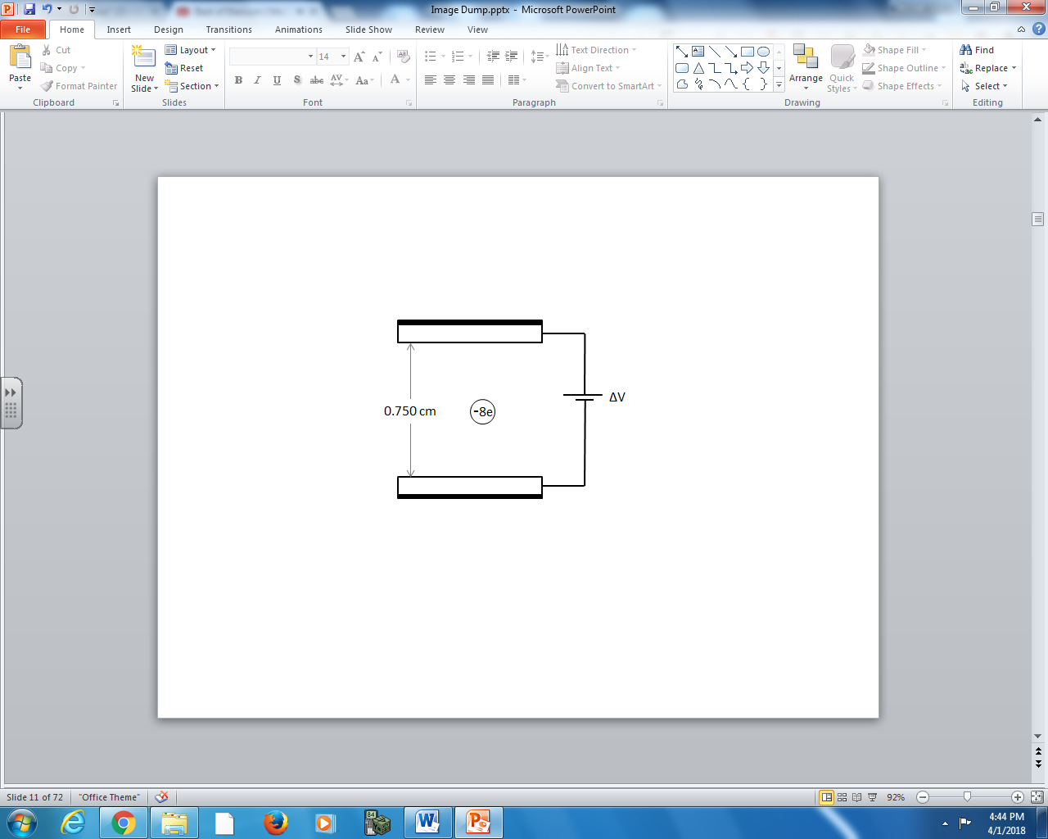

Q18: The voltage applied between the plates is a.b x 10^{cd} V, where a , b, c, and d are ___, ___, ___, and ___.

(Record your four digit answer in the Numerical Response boxes below)

