First Name:______________________________ Last Name:______________________________
L18 – Worksheet – EMR as Particles
L13 - Photons
Q1: Atoms in the phosphorescent screen absorb the energy of the cathode ray particles. They re-emit this energy in the form of photons of energy 4.11 x 10⁻¹⁹ J. One of these photons has a wavelength, expressed in scientific notation, of
- 1.61 x 10⁻¹⁵ m
- 4.84 x 10⁻⁷ m
- 2.07 x 10⁶ m
- 6.20 x 10¹⁴ m

Q2: Which of the following lists has selected regions of the electromagnetic spectrum arranged in order of increasing photon energy?
- Radio, microwave, X-rays, visible
- Infrared, ultraviolet, X-rays, gamma
- Gamma, visible, infrared, microwaves
- Microwaves, ultraviolet, visible, infrared

Q3: A 2.50 W flashlight emitting a 600nm wavelength emits a.b x 10^{cd} photons per second, where a, b, c, and d are ___, ___, ___, and ___.
(Record your four digit answer in the Numerical Response boxes below)

Q4: The rate at which solar energy reaches Earth’s surface at the equator is 800 W/m². If all of the energy were in the form of yellow light, which has a wavelength of 520 nm, then the number of photons that would reach 1.00 m² of Earth’s surface at the equator in 3.00 s is
- 6.27 x 10²¹ photons
- 2.09 x 10²¹ photons
- 6.27 x 10¹⁸ photons
- 2.09 x 10¹⁸ photons

L13 – X-Ray Production
Use the following information to answer Q5:
Forms of Energy
1 – Kinetic Energy, $E_{k}=\frac{1}{2}mv^{2}$
2 – Photon Energy, $E=hf$
3 – Potential Energy, ${∆E}_{p}=q∆V$

Q5: During X-Ray production, energy exists in three different forms.
Direction: __________ __________ __________
Force: First Form Second Form Third Form
(Record your three digit answer in the Numerical Response boxes below)

Q6: An X-ray tube operates with a potential difference of 4.5 x 10⁴ V. The minimum wavelength of X-rays being produced, expressed in scientific notation, is a.b x 10^{-cd} m. The values of a, b, c, and d are ___, ___, ___, and ___.
(Record your four digit answer in the Numerical Response boxes below)

Use the following information to answer Q7:
An electron travelling at 2.50 x 10⁵ m/s enters a parallel plate apparatus with a potential difference of 200mV. Upon reaching Plate B, the electron decelerates, generating a photon.
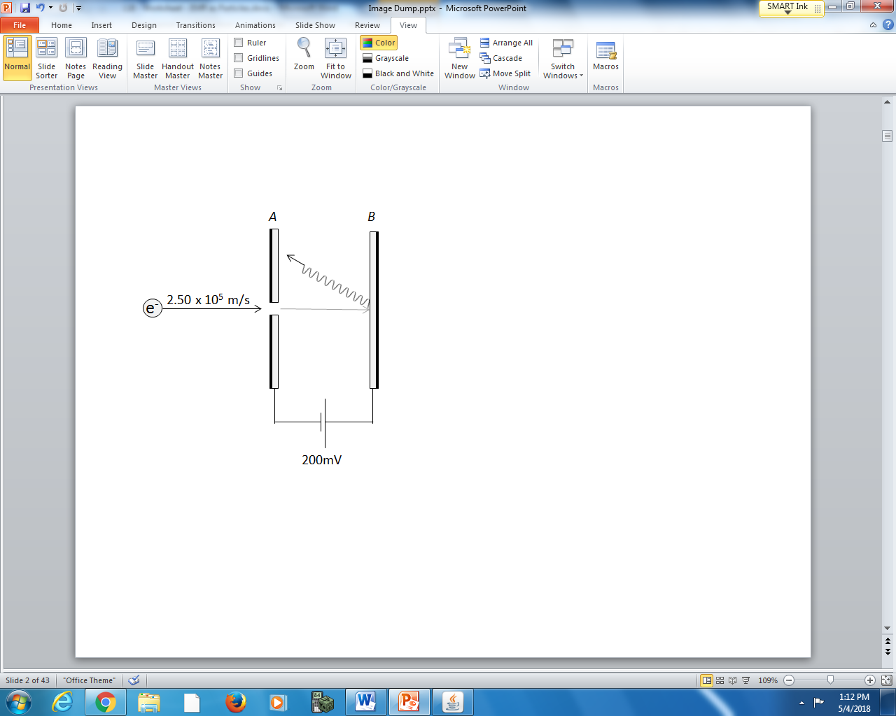

Q7: The frequency of the photon generated is a.b x 10^{cd} Hz, where a, b, c, and d are ___, ___, ___, and ___.
(Record your four digit answer in the Numerical Response boxes below)

L14&15 – Photoelectric Effect 1&2
Q8: Which equation best models the Photoelectric Effect?
- $q∆V=hf$
- $\frac{1}{2}mv^{2}=hf$
- $hf=W+\frac{1}{2}mv^{2}$
- $hf=-W+\frac{1}{2}mv^{2}$

Q9: The work function of silicon is 7.76 x 10⁻¹⁹ J. The maximum wavelength of electromagnetic radiation that will cause photoelectrons to be emitted from a silicon surface, expressed in scientific notation, is a.bc x 10^{-d} m. The values of a, b, c, and d are ____, ____, ____, and ____. (2 marks)
((Record your four digit answer in the Numerical Response boxes below)

Use the following information to answer Q10:
A photon that had a frequency of 7.20 x 10¹⁴ Hz struck a polished metal surface and caused a single electron to be released. The released electron had a kinetic energy of 1.00 eV.

Q10: The work function of the metal surface was
- 1.00 eV
- 1.98 eV
- 2.98 eV
- 3.98 eV

Q11: A photocathode that has a threshold frequency of 5.6 x 10¹⁴ Hz is illuminated with light that has a frequency of 8.2 x 10¹⁴ Hz. The maximum kinetic energy of the ejected photoelectrons is
- 1.7 x 10⁻¹⁹ J
- 3.7 x 10⁻¹⁹ J
- 5.4 x 10⁻¹⁹ J
- 9.1 x 10⁻¹⁹ J

Use the following information to answer Q12:
Classical wave theory and quantum physics make different predictions about the effect of incident electromagnetic radiation on a photoelectric surface.
Four Photoelectric Effect Predictions
- Low-intensity electromagnetic radiation incident on a photoelectric surface for long periods of time will cause photoemission.
- High-intensity electromagnetic radiation will not cause photoemission unless its frequency is greater than the photoelectric surface’s threshold frequency.
- The energy of the emitted photoelectrons will increase if the intensity of the incident electromagnetic radiation is increased.
- The energy of the emitted photoelectrons is independent of the intensity of the incident electromagnetic radiation.

Q12: Match each of the predictions above with the appropriate theory of physics as labelled below. (There is more than one correct answer.)
Prediction: _______ _______ _______ _______
Appropriate Theory: Classical wave theory Quantum physics
(Record your four digit answer in the Numerical Response boxes below)

Use the following information to answer Q13:
In a classroom investigation, a student observes that when an ultraviolet radiation source is on, and the ultraviolet radiation is incident on a polished metal surface, the metal leaves of a charged electroscope collapse, indicating that the charge has decreased.
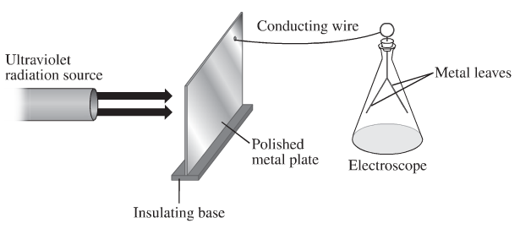

Q13: Based on the student’s observation, it can be inferred that the phoenomenon that is occuring is
- Compton scattering
- Rutherford scattering
- Charging by induction
- The photoelectric effect

Q14: A photocathode that has a threshold frequency of 5.6 x 10¹⁴ Hz is illuminated with light that has a frequency of 8.2 x 10¹⁴ Hz. The maximum kinetic energy of the ejected photoelectron is
- 1.7 x 10⁻¹⁹ J
- 3.7 x 10⁻¹⁹ J
- 5.4 x 10⁻¹⁹ J
- 9.1 x 10⁻¹⁹ J

Q15: Which of the following equations represents the relationship among the stopping voltage, the photon frequency, and the threshold frequency for the photoelectric effect?
- $V_{stop}=\frac{hf-hf_{0}}{q_{e}}$
- $V_{stop}=(hf-hf_{0})q_{e}$
- $f=\frac{h}{q_{e}V_{stop}+hf_{0}}$
- $f=hq_{e}V_{stop}-hf_{0}$

Use the following information to answer Q16:
A satellite in orbit around Earth is exposed to radiation from the Sun. This radiation may cause the satellite to become positively charged.
Some Wavelengths Incident on a Satellite
I 2.25 x 10⁻⁷ m
II 2.33 x 10⁻⁷ m
III 3.24 x 10⁻⁷ m
IV 4.28 x 10⁻⁷ m
Platinum is commonly used to coat satellites and has a work function of 8.5 x 10⁻¹⁹ J.

Q16: Which of the wavelengths listed above would cause a satellite with a platinum coating to become positively charged?
- Wavelength I only
- Wavelength IV only
- Wavelengths I and II
- Wavelengths III and IV

Use the following information to answer Q17-Q21:
A student performed a photoelectric effect experiment in which they exposed an unidentified metal to various frequencies of incident electromagnetic radiation and measured the stopping voltage of the emitted photoelectrons.
They calculated the maximum kinetic energy of the emitted photoelectrons.
Their results are given in the table below.
Frequency of incident electromagnetic radiation (x10¹⁵ Hz) | 1.3 | 1.4 | 1.5 | 1.6 | 1.7 | 1.8
Maximum kinetic energy of emitted photoelectrons (x10⁻¹⁹ J) | 1.0 | 1.8 | 2.4 | 3.1 | 3.8 | 4.4
The teacher provided the student with the following table of work functions for selected metals.
Metal | Na | Co | Pb | Zn | Fe | Ag | Pt
Work Function (eV) | 2.28 | 3.90 | 4.14 | 4.31 | 4.50 | 4.73 | 6.35

Q17: (Long Answer) Graph the relationship. (2 marks)
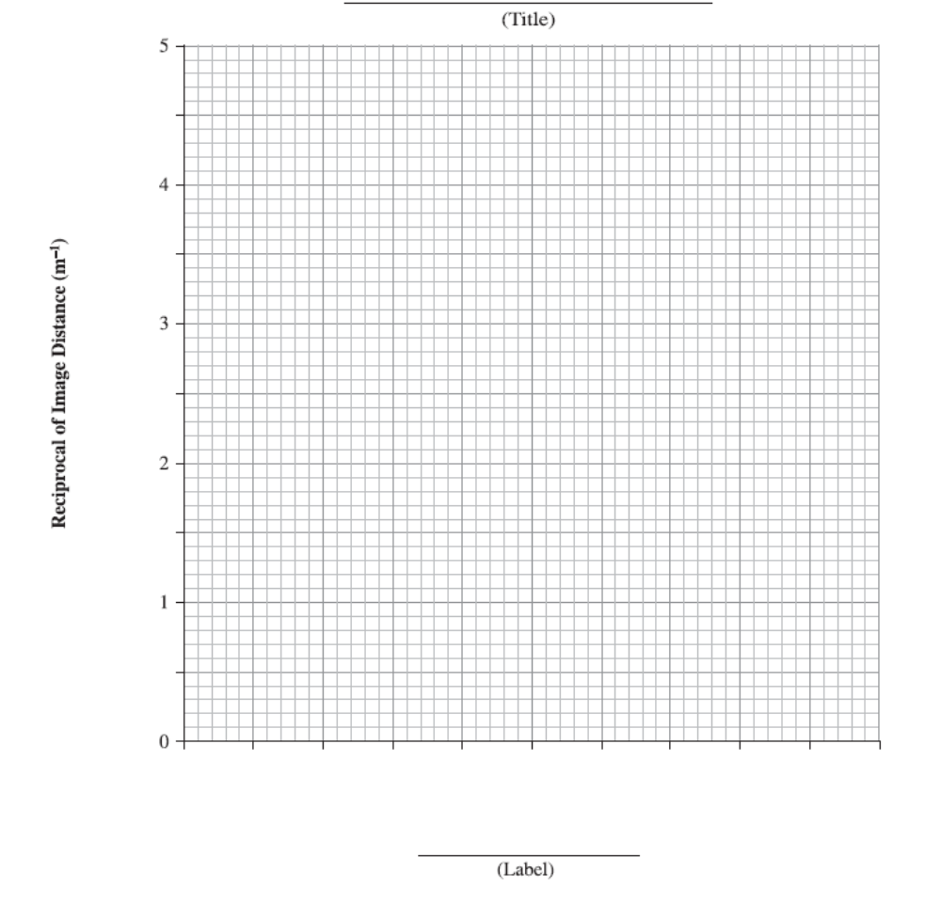
Q18: Which region of the electromagnetic spectrum does the incident radiation belong?
  - Infrared
  - Microwave
  - Ultraviolet
  - Visible
Q19: The significance of the x-intercept is the __i__, and the significance of the y-intercept is the __ii__.
 | i. | ii.
A. | Threshold Frequency | Work Function
B. | Threshold Frequency | Negative Work Function
C. | Work Function | Threshold Frequency
D. | Negative Work Function | Threshold Frequency

Q20: The value of the slope should be
  - 6.63 x 10⁻³⁴
  - 4.14 x 10⁻¹⁵
  - 6.67 x 10⁻¹¹
  - 3.00 x 10⁸
Q21: (Long Answer) Identify the metal. Justify your answer. (2 marks)

L16 – Compton Effect
Q22: A photon of X-ray radiation is incident on a metal surface and is scattered when it strikes an electron. During this process some of the photon’s energy and momentum are transferred to the electron. Compared to the initial X-ray photon’s characteristics, the scattered photon will have a
- Shorter wavelength and a slower speed
- Longer wavelength and a slower speed
- Shorter wavelength and the same speed
- Longer wavelength and the same speed

Q23: An X-Ray of frequency 3.8 x 10¹⁷ Hz strikes an electron and then the photon scatters at an angle of 42°. The X-Ray lost b x 10^{-w} Ns of momentum during the collision. The value of b, written in scienfitic notation, is _______. (2 marks)
(Record your three digit answer in the Numerical Response boxes below)

Cumulative Review
Use the following information to answer Q24:
A 12g airsoft pellet strikes a 0.2 kg mass on the end of a 1.0m string. The pendulum arm swings 30⁰ after the impact.
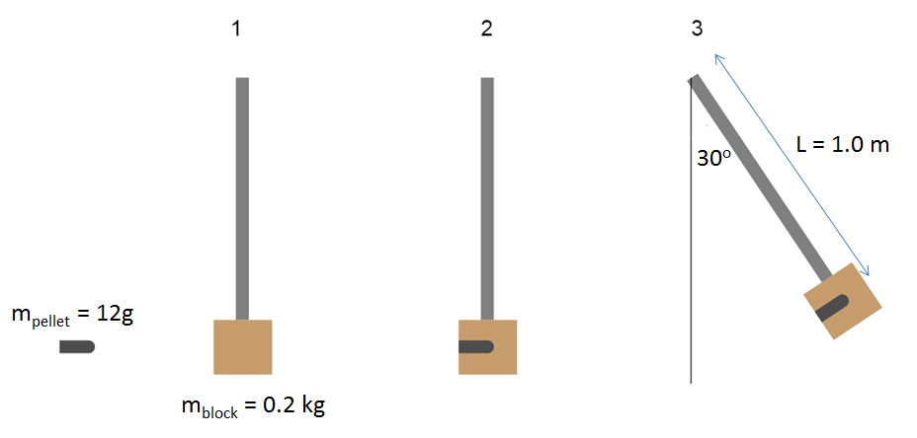

Q24: The initial speed of the airsoft pellet, prior to impact, is a.bc x 10^{d} m/s, where a, b, c, and d are ___, ___, ___, and ___.
(Record your four digit answer in the Numerical Response boxes below)

Use the following information to answer Q25-30:
An incident photon of wavelength 400nm strikes a polished metal plate, B, and an electron is ejected.
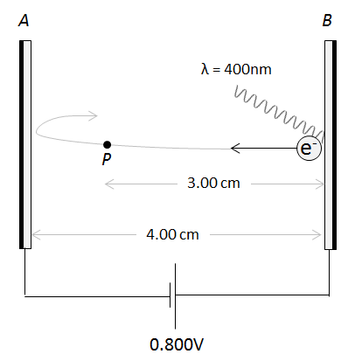

Q25: The frequency of the incident photon is a.b x 10^{cd} Hz, where a, b, c, and d are ___, ___, ___, and ___.
(Record your four digit answer in the Numerical Response boxes below)

Q26: The work function of the polished metal plate, B, is ____ eV.
(Record your three digit answer in the Numerical Response boxes below)

Q27: The electric field at Point P is directed
- Towards Plate A
- Towards Plate B
- Into the page
- Out of the page
Q28: Which diagram represents the magnetic field of the electron as it moves from Plate B to Plate A?
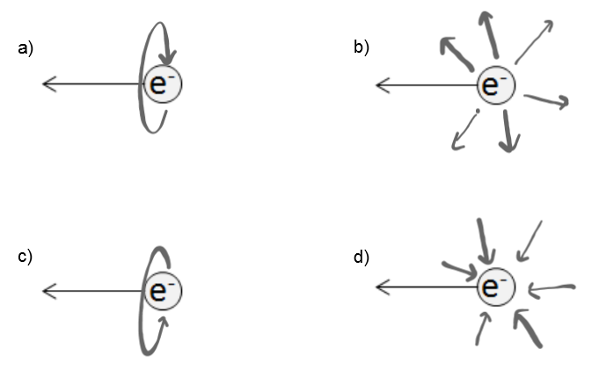
Q29: The electric field strength at Point P is
- 0.20 N/C
- 2.00 N/C
- 20.0 N/C
- 200 N/C
Q30: While at Point P, the electron is moving with a speed of a.bc x 10^{d} m/s, where a, b, c, and d are ___, ___, ___, and ___.
(Record your three digit answer in the Numerical Response boxes below)

