First Name:_______________________________ Last Name:______________________________

L19 – Lab Stations Assignment /11 marks

This lab consists of multiple individual stations. At each station…
- The student will follow the instructions in the next few pages. This is them “performing” the lab.
  - Students are assessed on safety (0-2 marks) according to a marking rubric.
- The student will determine which vocabulary words would be necessary to describe the physics principles behind the experiment. They will then check the necessary words on the “Lab Stations Assignment” sheet.
  - Students get marks for including REQUIRED terminology.
  - Students get marks for including OPTIONAL terminology.
  - Students lose marks for not including REQUIRED terms or including INCORRECT terms.
  - Students total number of marks are checked against a rubric to determine their overall score (0-4 marks).
  - Students will additional tasks (diagrams) as necessary (0-3 marks).
- The student will reflect on the lab, answering several questions about the lab, including:
  - Reflection on areas of strength and weakness.
  - Comparing and contrasting lab stations. (0-2 marks)
- The entire lab is out of 11 marks.
  - Initiate and Plan – Not applicable
  - Perform and Record – 2 marks
  - Analyze and Interpret – 9 marks
- There are several safety concerns in this lab:
  - Some stations have an extremely high current (120V stepped down to 5V means that we have a VERY high current. DO NOT TOUCH WIRES OR LEADS.
  - The power supplies are connected to extension cords. While these cords are run from the ceiling using hooks to minimize tripping hazards, tugging on them will result in them coming loose and falling.
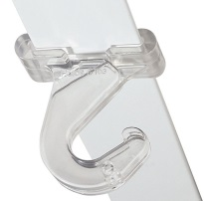
Station 1
Materials: Van Der Graff Generator & Balloon
Instructions: A string is attached to a balloon, which is hanging against the Van Der Graff generator. Turn on the Van Der Graff generator and observe the behavior of the balloon. Turn off when done.
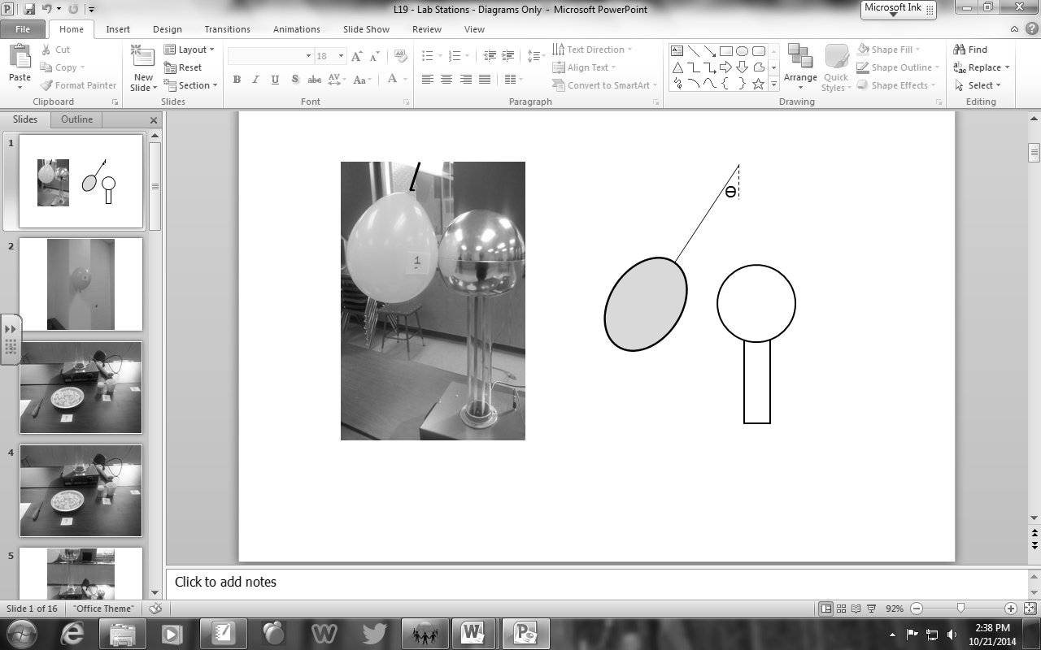
Station #1: Van Der Graff Generator & Balloon (Pick 2 Terms)
□ Charge by Conduction □ Charge by Induction □ Electrostatic Attraction
□ Electrostatic Repulsion □ Electron Affinity □ Grounding
□ First and/or Second Hand Rule □ Third Hand Rule (Motor Effect) □ Generator Effect
□ Induced Current □ Induced Magnetic Field □ Magnetic Field Lines
_____________________________________________________________________________________________________________________
Station 2
Materials: Balloon, Hair, & Wall
Instructions: Inflate a balloon and rub it against your hair (or the hair of a willing volunteer). Hold
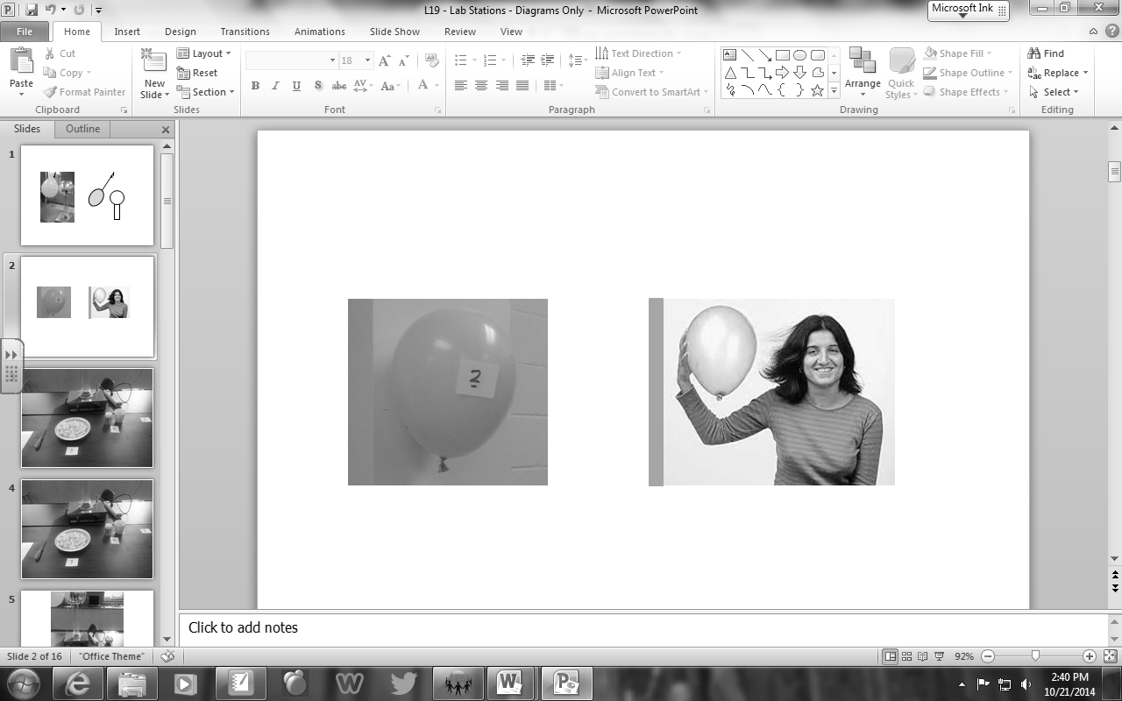
Station #2: Balloon, Hair, & Wall (Pick 2-4 Terms)
□ Charge by Conduction □ Charge by Induction □ Electrostatic Attraction
□ Electrostatic Repulsion □ Electron Affinity □ Grounding
□ First and/or Second Hand Rule □ Third Hand Rule (Motor Effect) □ Generator Effect
□ Induced Current □ Induced Magnetic Field □ Magnetic Field Lines

Station 3
Materials: Van Der Graff Generator & Packing Peanuts
Instructions: With the Van Der Graff generator in the “off” position, tape the tinfoil plate full of Styrofoam packing peanuts on top of the Van Der Graff generator, as depicted below. Turn the Van Der Graff generator on and observe the behavior of the Styrofoam packing peanuts. Turn off when done.
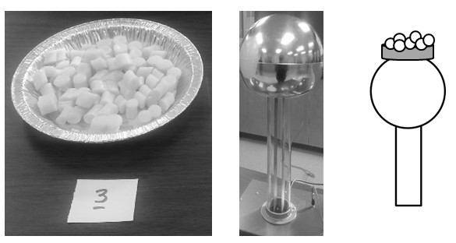
Station #3: Van Der Graff Generator & Packing Peanuts (Pick 2 Terms)
□ Charge by Conduction □ Charge by Induction □ Electrostatic Attraction
□ Electrostatic Repulsion □ Electron Affinity □ Grounding
□ First and/or Second Hand Rule □ Third Hand Rule (Motor Effect) □ Generator Effect
□ Induced Current □ Induced Magnetic Field □ Magnetic Field Lines
_____________________________________________________________________________________________________________________
Station 4
Materials: Van Der Graff Generator & Toothpicks
Instructions: With the Van Der Graff generator in the “off” position, tape the Styrofoam cup full of toothpicks on top of the Van Der Graff generator, as depicted below. Turn the Van Der Graff generator on and observe the behavior of the toothpicks. Turn off when done.
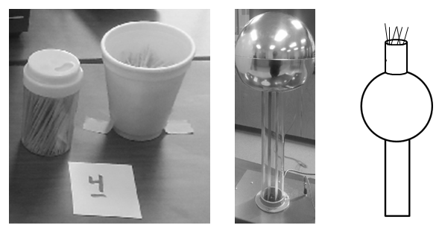
Station #4: Van Der Graff Generator & Toothpicks (Pick 2 Terms)
□ Charge by Conduction □ Charge by Induction □ Electrostatic Attraction
□ Electrostatic Repulsion □ Electron Affinity □ Grounding
□ First and/or Second Hand Rule □ Third Hand Rule (Motor Effect) □ Generator Effect
□ Induced Current □ Induced Magnetic Field □ Magnetic Field Lines

Station 5
Materials: Van Der Graff Generator & Sphere
Instructions: With the Van Der Graff generator in the “on” position and holding onto the transparent rod attached to the metal sphere, slowly bring the metal sphere close to the top of the Van Der Graff generator. Observe. Turn off when done.
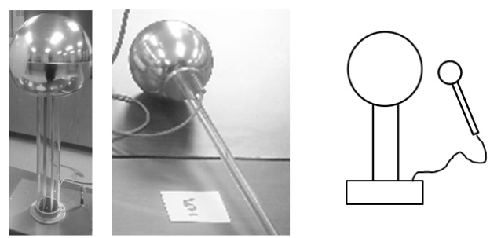
Station #5: Van Der Graff Generator & Sphere (Pick 1 Term)
□ Charge by Conduction □ Charge by Induction □ Electrostatic Attraction
□ Electrostatic Repulsion □ Electron Affinity □ Grounding
□ First and/or Second Hand Rule □ Third Hand Rule (Motor Effect) □ Generator Effect
□ Induced Current □ Induced Magnetic Field □ Magnetic Field Lines
_____________________________________________________________________________________________________________________
Station 6 Danger: Iron shavings! Do not rub your eyes, and wash your hands after use.
Materials: Magnet and Iron Shavings
Instructions: Hold a magnet up to the bottom of the petri dish (using both orientations of the magnet, as depicted below). Observe the behavior of the iron shavings.
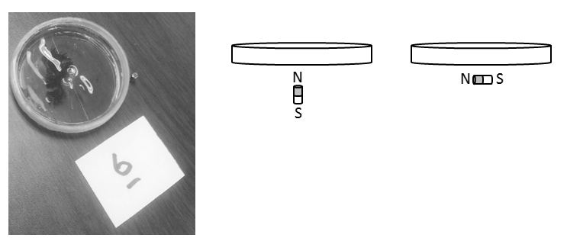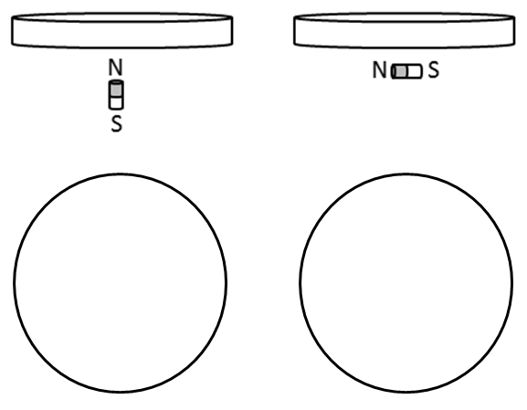
Station #6: Magnet and Iron Shavings (Pick 1 Term)
□ Charge by Conduction □ Charge by Induction □ Electrostatic Attraction
□ Electrostatic Repulsion □ Electron Affinity □ Grounding
□ First and/or Second Hand Rule □ Third Hand Rule (Motor Effect) □ Generator Effect
□ Induced Current □ Induced Magnetic Field □ Magnetic Field Lines
Additional Task: Sketch your observations of the iron shavings for each of the magnet orientations in the space provided above.
Station 7 Danger: High Current!
Materials: Large Solenoid & Compass
Instructions: Turn on the power supply and record the orientation of the compass at various points around the solenoid. Turn off when done.
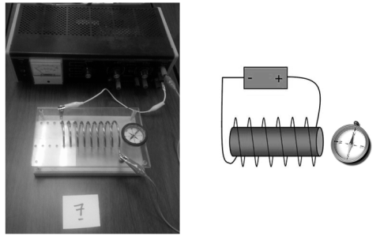
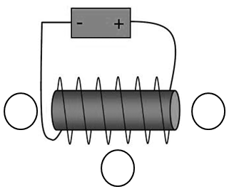
Station #7: Large Solenoid & Compass (Pick 2-3 Terms)
□ Charge by Conduction □ Charge by Induction □ Electrostatic Attraction
□ Electrostatic Repulsion □ Electron Affinity □ Grounding
□ First and/or Second Hand Rule □ Third Hand Rule (Motor Effect) □ Generator Effect
□ Induced Current □ Induced Magnetic Field □ Magnetic Field Lines
Additional Task: Sketch your observations of the orientation of the compass in each location in the space provided above.
_____________________________________________________________________________________________________________________
Station 8 Danger: High Current!
Materials: Power Supply, Bar Magnets, & Spinning Coils of Wire
Instructions: Starting with the coil of wires in the correct starting position (see diagram below), turn the power supply on and observe the behavior of the coil of wires.
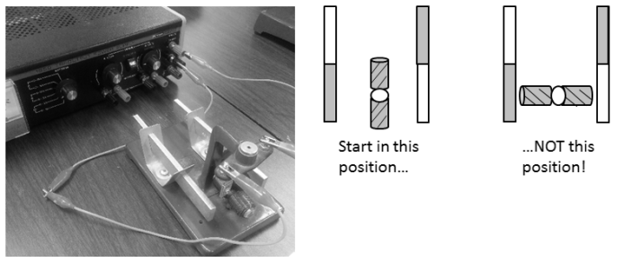
Station #8: Power Supply, Bar Magnets, & Spinning Coils of Wire (Pick 1-4 Terms)
□ Charge by Conduction □ Charge by Induction □ Electrostatic Attraction
□ Electrostatic Repulsion □ Electron Affinity □ Grounding
□ First and/or Second Hand Rule □ Third Hand Rule (Motor Effect) □ Generator Effect
□ Induced Current □ Induced Magnetic Field □ Magnetic Field Lines

Station 9
Materials: Hand Crank & Light
Instructions: Crank the wheel on the right side and observe the behavior of the light bulb.
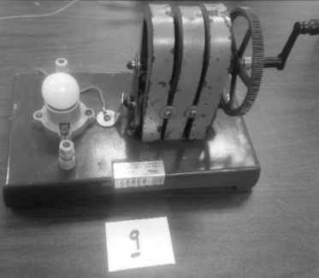
Station #9: Hand Crank & Light (Pick 2-3 Terms)
□ Charge by Conduction □ Charge by Induction □ Electrostatic Attraction
□ Electrostatic Repulsion □ Electron Affinity □ Grounding
□ First and/or Second Hand Rule □ Third Hand Rule (Motor Effect) □ Generator Effect
□ Induced Current □ Induced Magnetic Field □ Magnetic Field Lines
_____________________________________________________________________________________________________________________
Station 10 Danger: High Current!
Materials: Power Supply, Small Solenoid & Magnet
Instructions: Turn on the power supply, and use the magnet to explore around the center of the solenoid. Reverse the orientation of the magnet and repeat. If you accidentally let go of the magnet, turn off the power supply before attempting to retrieve it. Turn off when done.
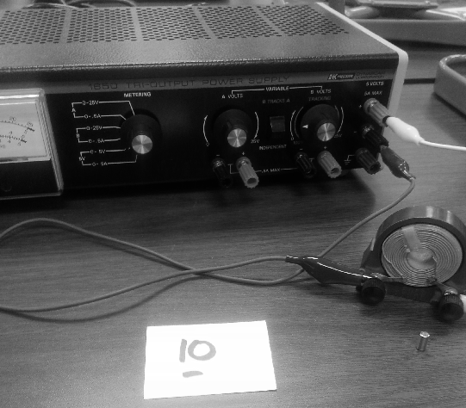
Station #10: Power Supply, Small Solenoid & Magnet (Pick 2-3 Terms)
□ Charge by Conduction □ Charge by Induction □ Electrostatic Attraction
□ Electrostatic Repulsion □ Electron Affinity □ Grounding
□ First and/or Second Hand Rule □ Third Hand Rule (Motor Effect) □ Generator Effect
□ Induced Current □ Induced Magnetic Field □ Magnetic Field Lines
Station 11
Materials: Van Der Graff Generator & Tinsel Cans
Instructions: With the Van Der Graff generator in the “on” position and holding onto the Styrofoam cup portion of the apparatus, carefully hold it up to the Van Der Graff generator so that it touches. Observe the behavior of the tinsel. Carefully break contact and observe the behavior of the tinsel. Turn off when done.
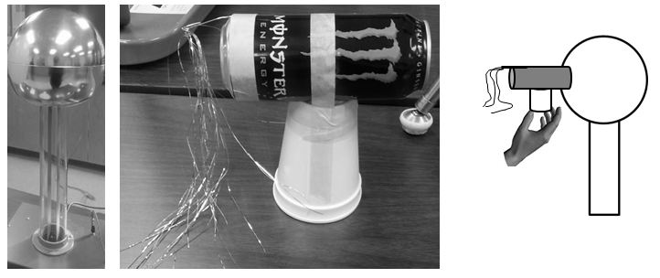
Station #11: Van Der Graff Generator & Tinsel Cans (Pick 1-2 Terms)
□ Charge by Conduction □ Charge by Induction □ Electrostatic Attraction
□ Electrostatic Repulsion □ Electron Affinity □ Grounding
□ First and/or Second Hand Rule □ Third Hand Rule (Motor Effect) □ Generator Effect
□ Induced Current □ Induced Magnetic Field □ Magnetic Field Lines
_____________________________________________________________________________________________________________________
Station 14
Materials: Copper Tube and Magnet
Instructions: Drop the weight through the copper tube, and then drop the magnet through the copper tube. Observe the behavior of the magnet in contrast to the non-magnetic weight.
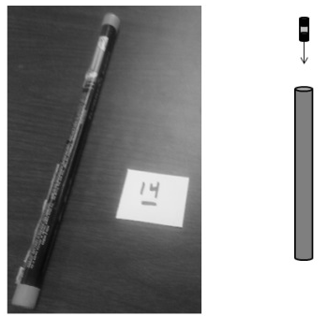
Station #14: Copper Tube and Magnet (Pick 2-4 Terms)
□ Charge by Conduction □ Charge by Induction □ Electrostatic Attraction
□ Electrostatic Repulsion □ Electron Affinity □ Grounding
□ First and/or Second Hand Rule □ Third Hand Rule (Motor Effect) □ Generator Effect
□ Induced Current □ Induced Magnetic Field □ Magnetic Field Lines

Station 16
Materials: Small Solenoid, Magnet & Ammeter
Instructions: Move the magnet into and out of the center of the solenoid. Observe the behavior of the ammeter.
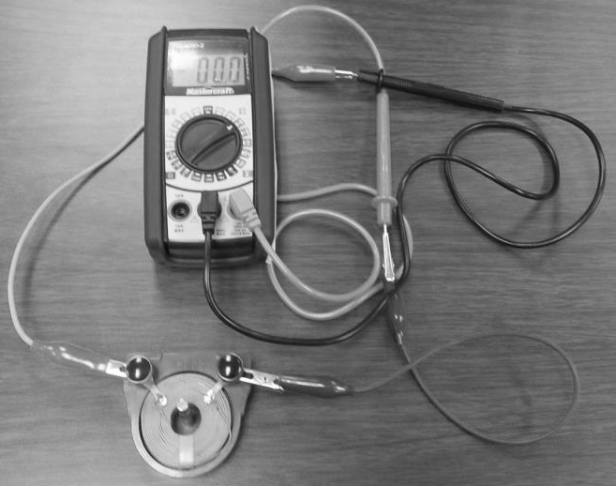
Station #16: Small Solenoid, Magnet & Ammeter (Pick 1-4 Terms)
□ Charge by Conduction □ Charge by Induction □ Electrostatic Attraction
□ Electrostatic Repulsion □ Electron Affinity □ Grounding
□ First and/or Second Hand Rule □ Third Hand Rule (Motor Effect) □ Generator Effect
□ Induced Current □ Induced Magnetic Field □ Magnetic Field Lines
_____________________________________________________________________________________________________________________
Station 17
Materials: Electroscope, pyrex rod, cloth.
Instructions: Rub the pyrex rod with the cloth, then bring the pyrex rod close to the top of the electroscope (without touching).
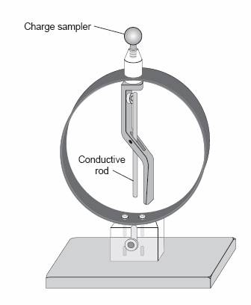
Station #17: Electroscope, Pyrex Rod, and Cloth (Pick 2-3 Terms)
□ Charge by Conduction □ Charge by Induction □ Electrostatic Attraction
□ Electrostatic Repulsion □ Electron Affinity □ Grounding
□ First and/or Second Hand Rule □ Third Hand Rule (Motor Effect) □ Generator Effect
□ Induced Current □ Induced Magnetic Field □ Magnetic Field Lines
Q1: In what ways were Station #1 and Station #2 the same? In what ways were they different?
Station #1 | Station #2
Similarities | Differences

Q2: In what ways were Station #8 and Station #9 the same? In what ways were they different?
Station #8 | Station #9
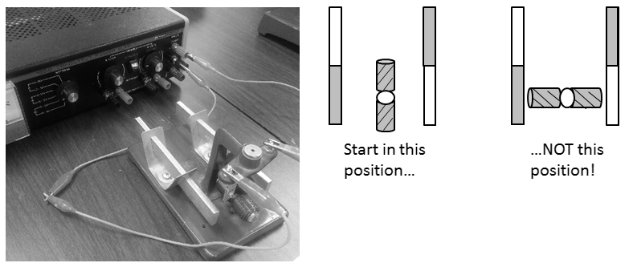 | 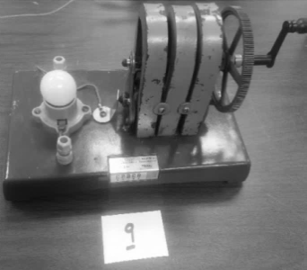
Similarities | Differences

Q3: In what ways were Station #10 and Station #16 the same? In what ways were they different?
Station #10 | Station #16
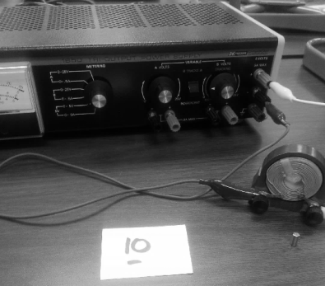 | 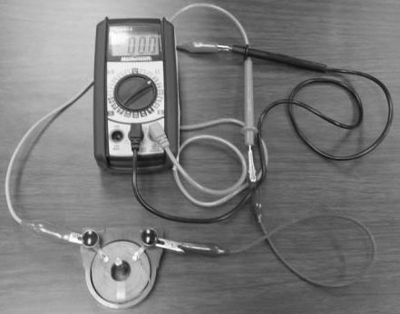
Similarities | Differences

Q4: Reflect on this lab.
- In what ways has this lab helped you understand the concepts covered in this class?
- Which concepts do you feel you strongly understand?
- Which concepts do you still struggle with?
- How would you like to see this lab changed in the future to further enhance the understanding of students?
_____________________________________________________________________________________________________________________________________________________________________________________________________________________________________________________________________________________________________________________________________________________________________________________________________________________________________________________________________________________________________________________________________________________________________________________________________________________________________________________________________________________________________________________________________________________________________________________________
First Name:_______________________________ Last Name:______________________________

“Perform and Record” Marking Rubric

 | 2 | 1 | 0
Select and use apparatus safely, and apply WHMIS standards to handle and dispose of materials. | Student required no prompts from the teacher to conduct themselves safely in the lab. | Student needed prompts from the teacher to conduct themselves safely in the lab. | Student was unsafe, resulting in them not being able to complete the experiment.

“Analyze and Interpret” Marking Rubric

 |  | 4 | 3 |  |  | 2 |  | 1 |  |  | 0
Student is able to select the correct terminology necessary to describe the physics of each lab station in full detail. |  | Student correctly totaled 25-38 correct terms. | Student correctly totaled 19-24 correct terms. |  |  | Student correctly totaled 13-18 correct terms. |  | Student correctly totaled 7-12 correct terms. |  |  | Student correctly totaled 0-6 correct terms.
 |  | 3 |  | 2 |  |  | 1 |  |  | 0
Student is able to correctly interpret and sketch orientations of magnetic fields and current. |  | Student correctly completed 2 of 2 additional tasks. |  | Student correctly completed 1 of 2 additional tasks. |  |  | N/A |  |  | Student correctly completed 0 of 3 additional tasks.
 | 2 |  |  |  | 1 |  |  |  | 0
Student is able to compare and contrast different lab stations, and reflect on their understanding. | Student is able to correctly compare and contrast different lab stations.  Student has demonstrated the ability to insightfully reflect on their understanding of this lab. |  |  |  | Student has shown small misunderstandings when comparing and contrasting different lab stations.  Student has demonstrated an adequate ability to reflect on their understanding of this lab. |  |  |  | Student has shown significant misunderstandings when comparing and contrasting different lab stations.  Student has demonstrated a minimal ability to reflect on their understanding of this lab.

