First Name:______________________________ Last Name:______________________________
L20 – Worksheet – EMR Unit Review
L01 - EMR
Q1: An ultraviolet source emits electromagnetic waves with a frequency of 2.47 x 10¹⁵ Hz. Its wavelength, expressed in scientific notation, is b x 10^{-w} m. The value of b is ____.
(Record your three digit answer in the Numerical Response boxes below)

Use the following information to answer Q2:
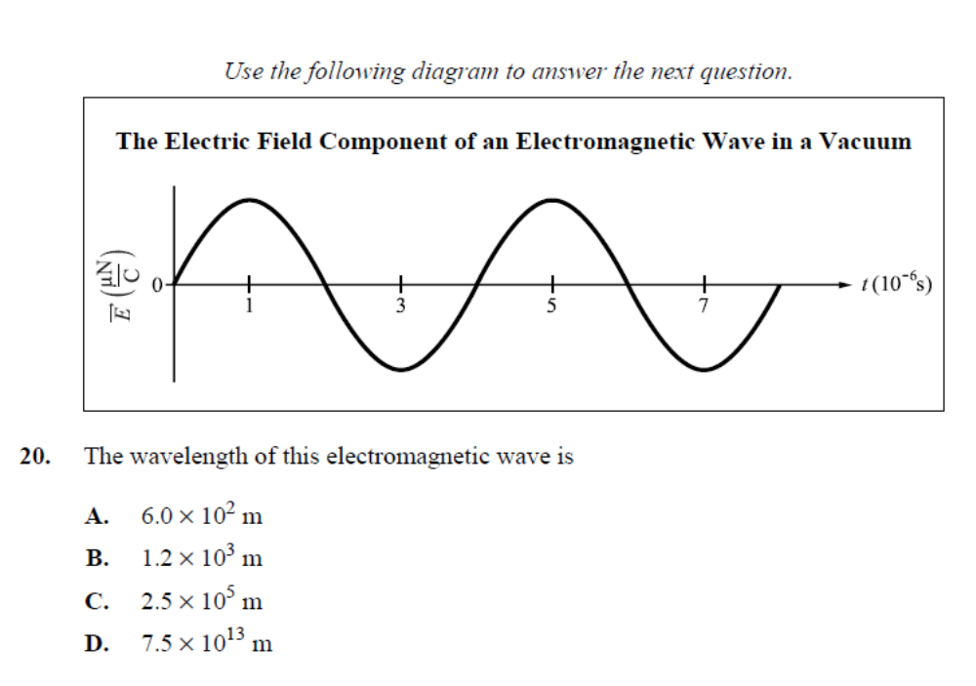
Q2: The wavelength of this electromagnetic wave is
- 6.0 x 10² m
- 1.2 x 10³ m
- 2.5 x 10⁵ m
- 7.5 x 10¹³ m

Q3: Electromagnetic radiation is produced by charged particles that are moving
- At the speed of light
- With zero acceleration
- With a changing velocity
- Parallel to a fixed magnetic field

Q4: An electromagnetic wave is sent from Earth to the Moon and reflected back to Earth. If the total time taken is 2.48 s, then the distance from Earth to the Moon, expressed in scientific notation, is
b x 10^{w} m. The value of b is ____.
(Record your three digit answer in the Numerical Response boxes below)

Q5: Which of the following types of radiation has the longest period?
- Radio waves
- Infrared light
- Ultraviolet light
- Gamma radiation

Q6: Which of the following properties is a property of X-rays not of radio waves?
- Reflection
- Refraction
- Interference
- Gas ionization

L02 – Speed of Light
Use the following information to answer Q7:
A student is curious about how far away a distant mountain is. She drives to the distant mountain, climbs to the top, and sets up a reflecting mirror. Back at her residence, the student recreates Michelson’s experiment, per the diagram below.
The student finds that light is able to successfully travel from the light source to her eye when the octagonal mirror has a rotational frequency of 525 Hz.
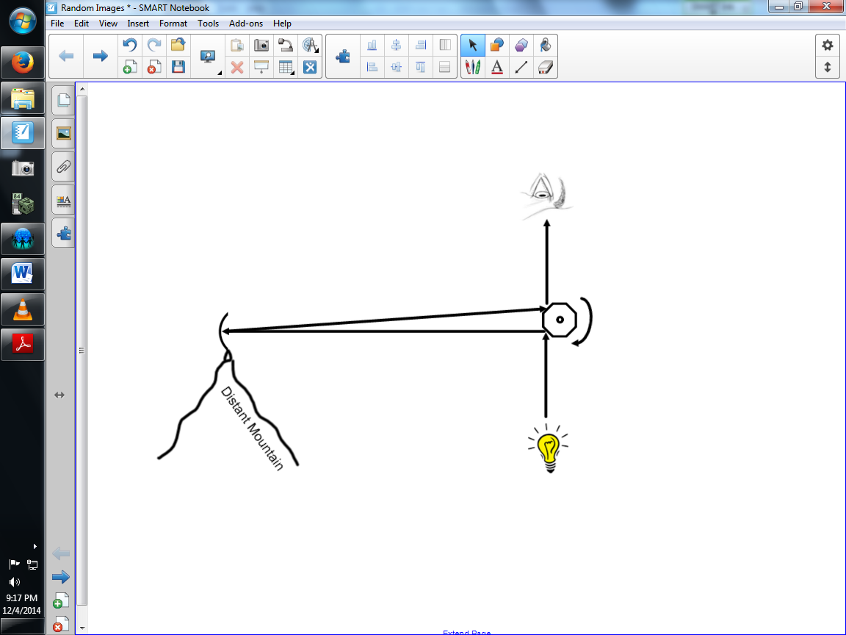

Q7: Using the experiment described above, how far away is the mountain from the student’s household?
- 35.7 km
- 71.4 km
- 142.9 km
- 571.4 km

L03&04 – Reflection Ray Diagrams and Equations
Use the following information to answer Q8-Q10:
A 2cm tall object is placed 15cm from the vertex of a concave mirror. A real image appears 20cm from the vertex.

Q8: The focal length of the concave mirror is ____cm.
(Record your three digit answer in the Numerical Response boxes below)

Q9: Which best describes he image formed?
- 1.5 cm tall and erect
- 1.5 cm tall and inverted
- 2.7 cm tall and erect
- 2.7 cm tall and inverted

Q10: Sketch a ray diagram for this question.
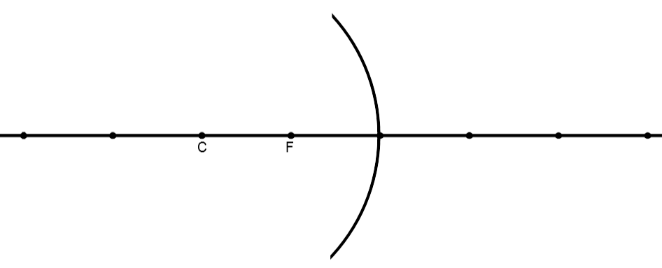
L05 - Refraction
Q11: When light passes from air into a ruby (n = 1.54), the wavelength of the light __i__ and the frequency of the light __ii__.
 | i | ii
A | increases | decreases
B | increases | stays the same
C | decreases | decreases
D | decreases | stays the same

- A
- B
- C
- D

Q12: Visible light that has a wavelength of 6.00 x 10⁻⁷ m in air is directed into fused quartz. The index of refraction of fused quartz is 1.46. The wavelength of this light inside the fused quartz, expressed in scientific notation, is ____ x 10^{-w} m.
(Record your three digit answer in the Numerical Response boxes below)

L06 – Refraction Lenses
Use the following information to answer Q13:
An object is placed 1.5f from a diverging lens, as diagrammed below.
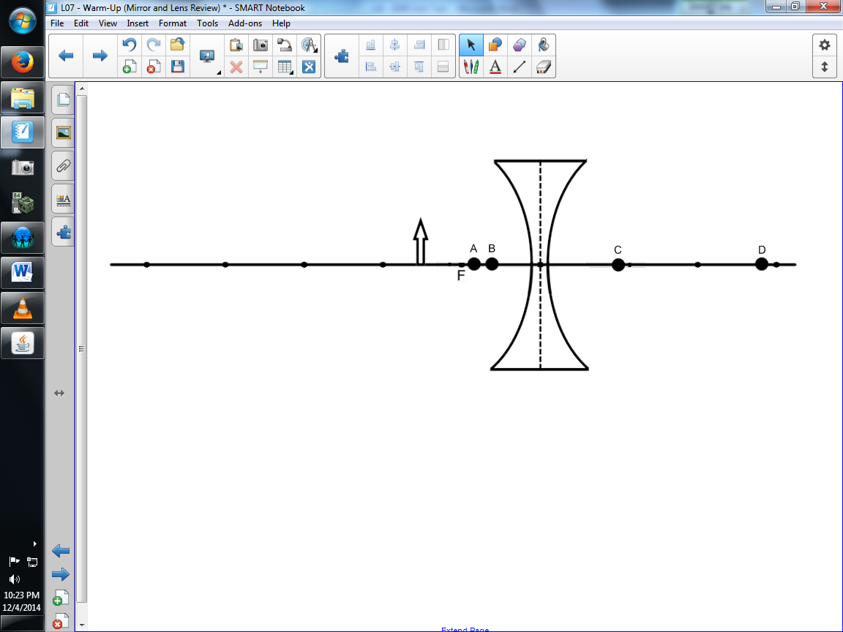

Q4: Text

Part 2: EMR as Particles /12 marks
Q13: Which of the following best described the image that is formed?
- Position A, Virtual, Inverted, and Enlarged
- Position B, Virtual, Erect, and Diminished
- Position C, Real, Erect, and Diminished
- Position D, Real, Inverted, and Enlarged

Q14: At what distance above this page would a convex magnifying lens that has a focal length of 10.0 cm have to be held for the image of the letters to appear upright and 3 times as tall?
- 3.33 cm
- 6.67 cm
- 13.3 cm
- 15.0 cm

L07 – Refraction Lenses Graphing and Optics Rails
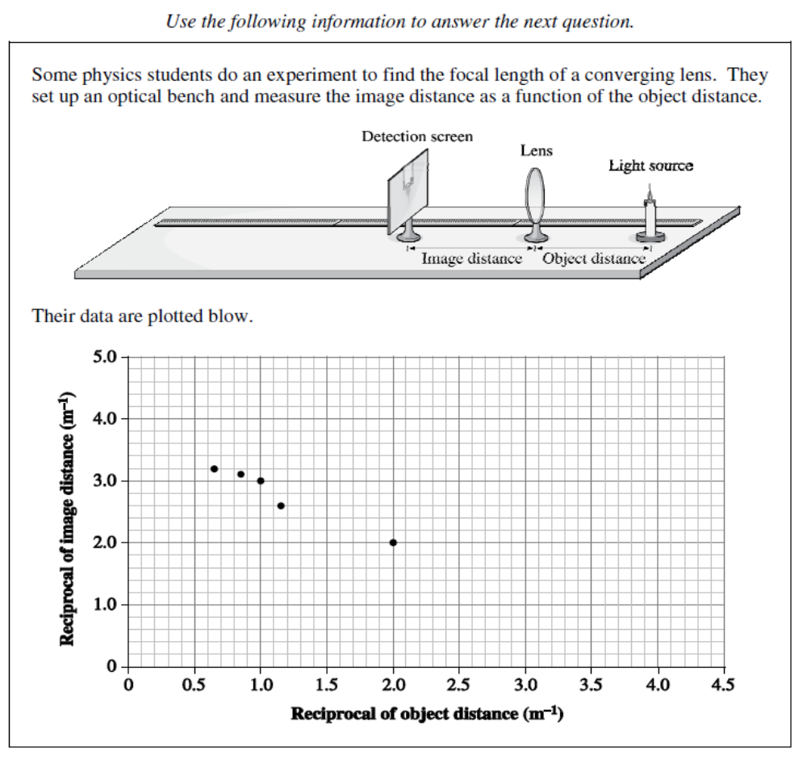

Q15: The slope of the line is –a.b. You will need to record the values of a and b.
Using the y-intercept, the experimental value of the focal length of the lens, expressed in units of centimeters, is ef cm. You will need to record the values of e and f.
The values of a, b, e, and f are ___, ___, ___, and ___.
(Record your four digit answer in the Numerical Response boxes below)

L09 – Diffraction, Interference, and Polarization
Use the following information to answer Q16:
An infrared EMR source of unknown wavelength is incident on a double slit. The diffraction pattern intensity is plotted out, as seen in the diagram below.
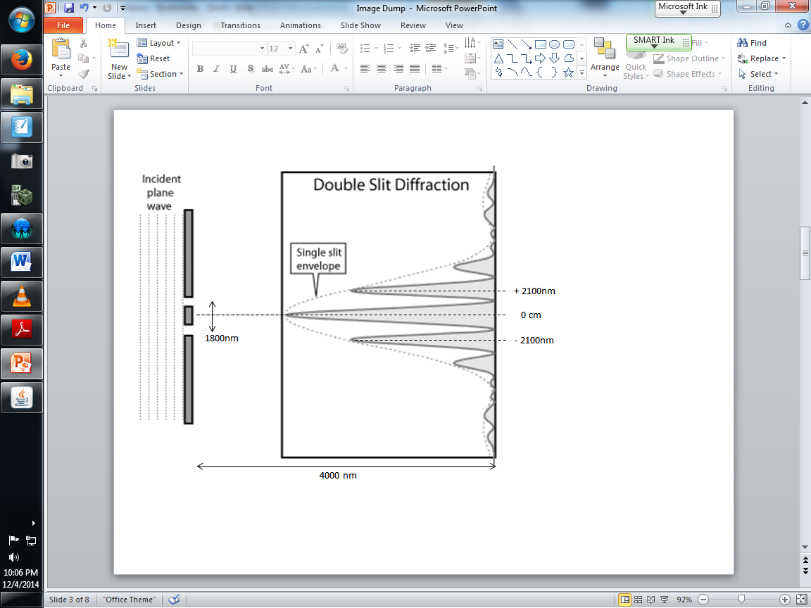

Q16: In the above experiment, the wavelength of the infrared EMR wave is a.bc x 10^{-d} m, where the values of a, b, c, and d are ___, ___, ___, and ___. (2 marks)
(Write your four-digit numerical response answer in the boxes below)

L13 - Photons
Use the following information to answer Q17:
The different colors seen in exploding fireworks are produced using different elements.
Element Predominant Color
Strontium Red
Barium Green
Copper Blue-Green
Sodium Yellow-Orange

Q17: Given the information above, the element that emits the lowest energy photon of visible light is
- Strontium
- Barium
- Copper
- Sodium

Use the following information to answer Q18:
Chlorophyll in plants absorbs photon energy of electromagnetic radiation and converts them into chemical potential energy. Chlorophyll a is one of the main types of chlorophyll. The graph below shows the relationship between the absorption of photons by chlorophyll a and the wavelength of the photons striking the plants.
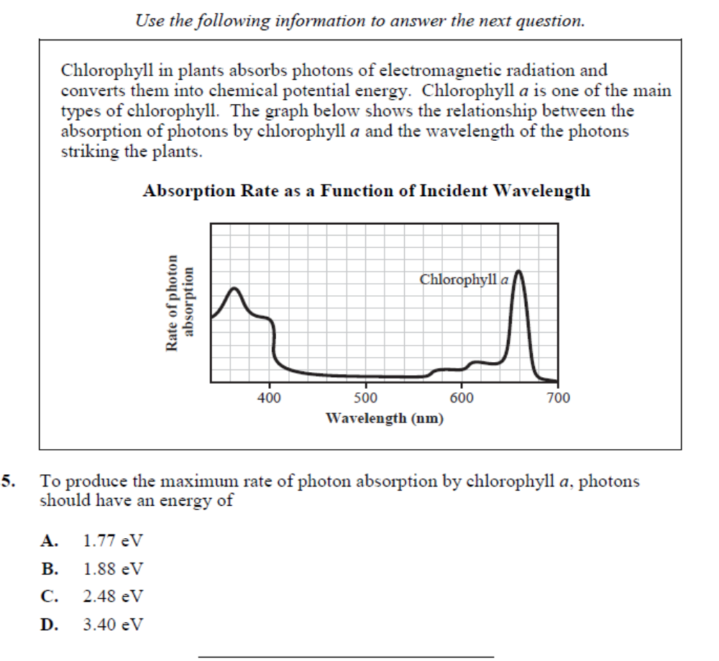

Q18: To produce the maximum rate of photon absorption by chlorophyll a, photons should have an energy of
- 1.77 eV
- 1.88 eV
- 2.48 eV
- 3.40 eV
L13 – X-Ray Production
Use the following information to answer Q19-Q20:
X-Rays for medical diagnostic procedures or for research purposes are produced in a standard way: by accelerating electrons with a high voltage and allowing them to collide with a metal target. X-Rays are produced when the electrons are suddenly decelerated upon collision with the metal target.
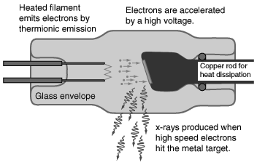

Q19: Which Physics Principle(s) is/are needed to describe the above phenomena?
(Record your two digit answer in the Numerical Response boxes below)

Q20: If the emitted X-Rays have a frequency of 3.2 x 10¹⁶ Hz, how fast did the electrons strike the metal target?
- 1.33 x 10² m/s
- 3.41 x 10⁶ m/s
- 6.82 x 10⁶ m/s
- 1.71 x 10¹⁶ m/s

Use the following information to answer Q21:
X-rays were discovered in 1895 by Roentgen. In the cathode ray tube that he used, a high electrical potential difference between the anode and the cathode accelerated the electrons. The electrons then collided with a copper target.
Three Types of Energy
1 electrical potential energy
2 electromagnetic energy
3 kinetic energy

Q21: In the production of X-rays, the three types of energy listed above occur in order from ___ to ___ to ___.
(Record your four digit answer in the Numerical Response boxes below)

Q22: The minimum accelerating voltage necessary to produce an X-ray with a wavelength of 6.25 x 10⁻¹¹ m, expressed in scientific notation, is a.bc x 10^{d} V. The values of a, b, c, and d are ___, ___, ___, and ___.
(Record your four digit answer in the Numerical Response boxes below)

L14&15 – Photoelectric Effect 1&2
Use the following information to answer Q23:
Light of varying frequency is incident on a photoelectron emitting surface. Maverick Wilford has attempted to plot out the relationship between the two, but Mr. Bayer is still upset about Maverick trying to feed him cookies with the consistency of particle board, so Mr. Bayer vindictively draws additional lines on Maverick’s graph to confuse him.
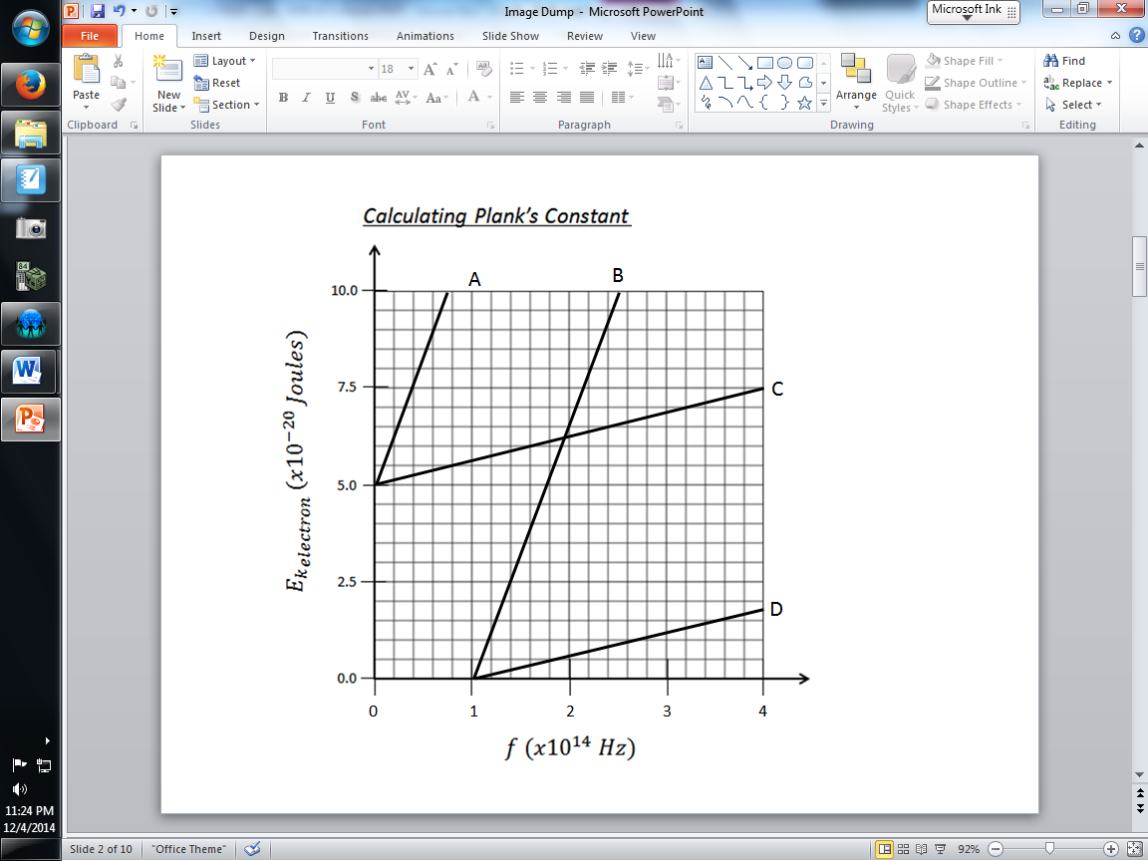

Q23: In the above graph, which of the following lines best shows the relationship between the incident light frequency and the kinetic energy of the emitted photoelectrons?
- Line A
- Line B
- Line C
- Line D

Q24: The energy that is required to remove the electron from the photoelectric surface in the phototube is called the
- Work function
- Threshold frequency
- Electric potential energy
- Maximum kinetic energy

Q25: In one second, 1.45 x 10¹⁶ photons are incident on the phototube. If each of the photons has a frequency greater than the threshold frequency, then the maximum current to the amplifier, expressed in scientific notation, is a.bc x 10^{-d} A. The values of a, b, c, and d are ___, ___, ___, and ___.
(Record your four digit answer in the Numerical Response boxes below)

Q26: If the stopping potential of a photocell is 5.60 V, then the maximum kinetic energy of the photoelectrons emitted is
- 3.50 x 10¹⁹ J
- 5.60 J
- 8.96 x 10⁻¹⁹ J
- 2.90 x 10⁻²⁰ J

Q27: If a metal with a threshold frequency of 1.1 x 10¹⁵ Hz is illuminated by light with a wavelength of 1.70 x 10⁻⁷ m, then the maximum kinetic energy of the emitted photoelectrons will be
- 4.4 x 10⁻¹⁹ J
- 7.3 x 10⁻¹⁹ J
- 1.2 x 10⁻¹⁸ J
- 1.5 x 10⁻¹⁸ J

L16 – Compton Effect
Use the following information to answer Q28 and Q29:
An x-ray of frequency 4.2 x 10¹⁸ Hz is incident on an electron, as shown below.
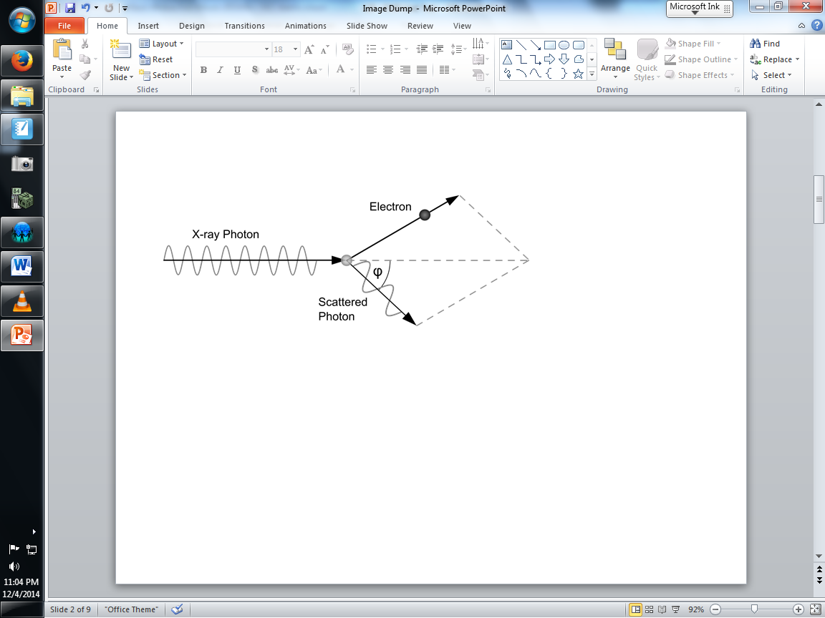

Q28: If the wavelength of the scattered photon is 7.18 x 10⁻¹¹ m, what angle was it scattered at? (2 marks)
(Write your 3-digit numerical response answer in the boxes below)

Q29: The momentum of the incident photon is:
- 9.234 x 10⁻²⁴ Newton Seconds (Ns)
- 9.234 x 10⁻²⁴ Joule Seconds (Js)
- 9.282 x 10⁻²⁴ Newton Seconds (Ns)
- 9.282 x 10⁻²⁴ Joule Seconds (Js)

Challenge Question
Use the following information to answer Q30:
Photon #1 is in the ultraviolet spectrum, and has an energy of 6.21 eV. It strikes a polycrystalline silver target, Plate A, which has a work function of 4.26 eV. An ejected electron then travels horizontally, striking Plate B, which in turn generates Photon #2.
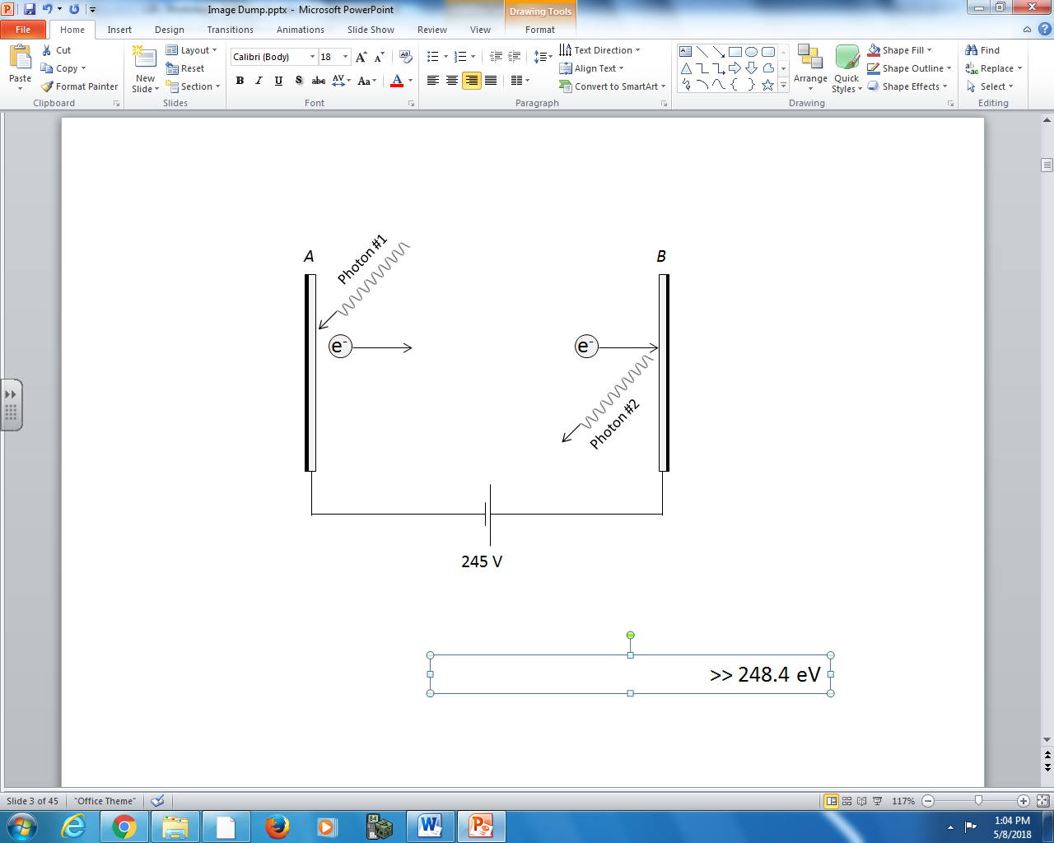

Q30: The energy of Photon #2 is ____eV.
(Record your three digit answer in the Numerical Response boxes below)

