First Name:__________________________________ Last Name:______________________________

L20 – Worksheet – Forces and Fields Unit Review

L01 – Electrical Interactions and Electroscopes
Use the following information to answer Q1.
A student places a positively charged sphere near a metal rod. Both are on insulated stands and the rod is grounded.
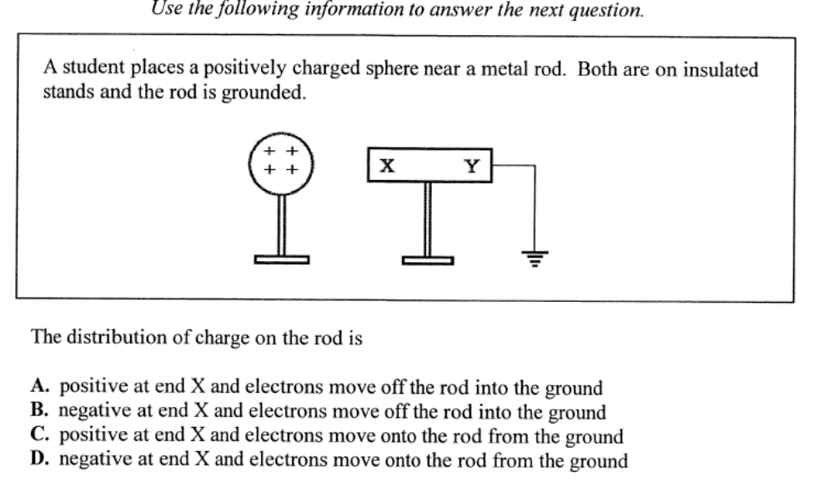

Q1: The distribution of charge on the rod is
- Positive at end X and electrons move off the rod into the ground
- Negative at end X and electrons move off the rod into the ground
- Positive at end X and electrons move onto the rod from the ground
- Negative at end X and electrons move onto the rod from the ground

L02 – Coulomb’s Law in 1-D
Q2: A spherical object of mass 0.35kg and charge +1.60μC is temporarily brought into contact with an identical object of charge -6.00μC, then separated again. The objects are then separated to a distance of 2.00m. The electrostatic force of __i__ between the two spheres is __ii__ N.
 | i | ii
A | attraction | 1.09 x 10⁻²
B | attraction | 2.16 x 10⁻²
C | repulsion | 1.09 x 10⁻²
D | repulsion | 2.16 x 10⁻²

Q3: The force between two positive charges that are 5.0 m apart is 1.8 x 10⁻² N. If one charge is twice as large as the other charge, the magnitude of the smaller charge is
- 2.5 x 10⁻¹¹ C
- 5.0 x 10⁻¹¹ C
- 5.0 x 10⁻⁶ C
- 7.0 x 10⁻⁶ C

Q4: Coulomb started with two identically charged spheres separated by a distance r. The force between the spheres was F. If he changed the separation to $\frac{2}{3}r$, then the force between the spheres would have become
- $\frac{4}{9}F$
- $\frac{2}{3}F$
- $\frac{3}{2}F$
- $\frac{9}{4}F$

Use the following information to answer Q5:
Two charged spheres are positioned on a horizontal, frictionless insulating surface, as shown below.
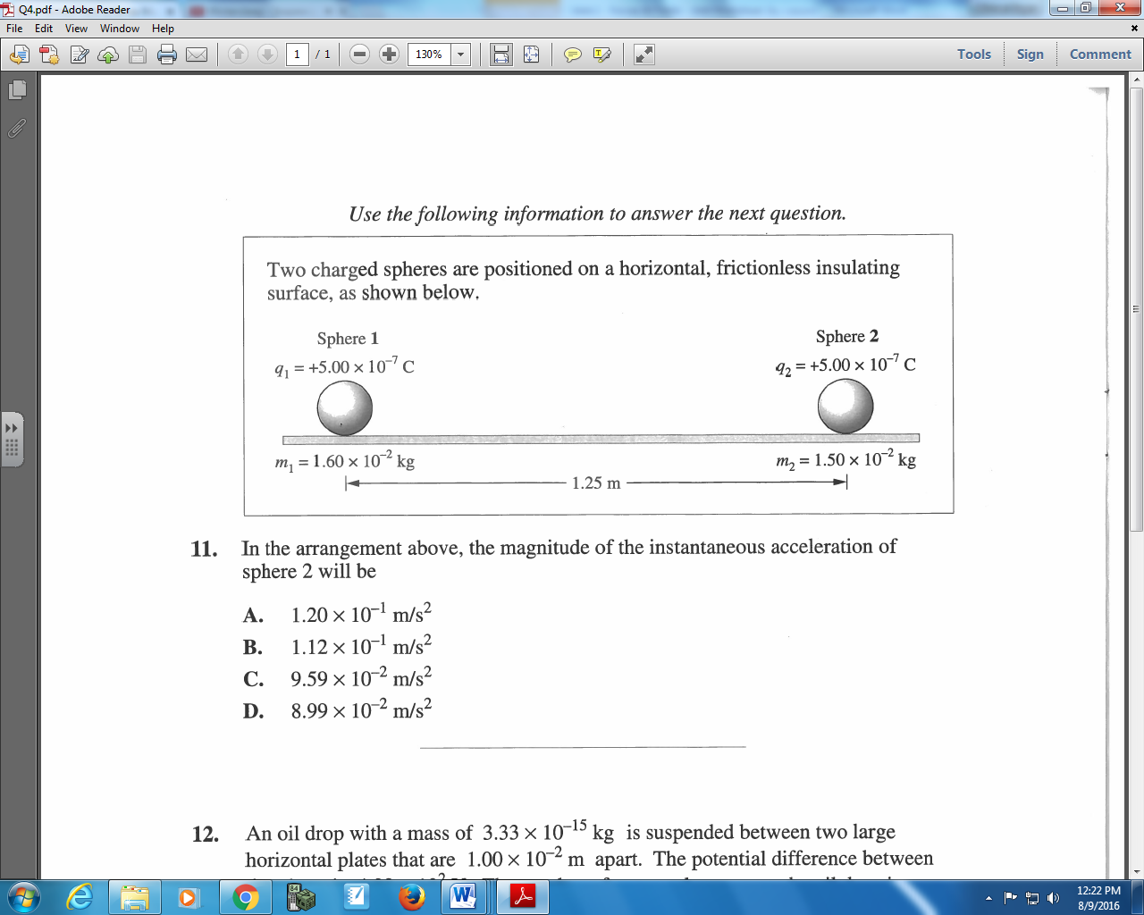

Q5: In the arrangement above, the magnitude of the instantaneous acceleration of sphere 2 will be
- 1.20 x 10⁻¹ m/s²
- 1.12 x 10⁻¹ m/s²
- 9.59 x 10⁻² m/s²
- 8.99 x 10⁻² m/s²

L03 – Coulomb’s Law in 2-D
Use the following information to answer Q6.
Two identically charged objects are placed near a point, P, as shown below.
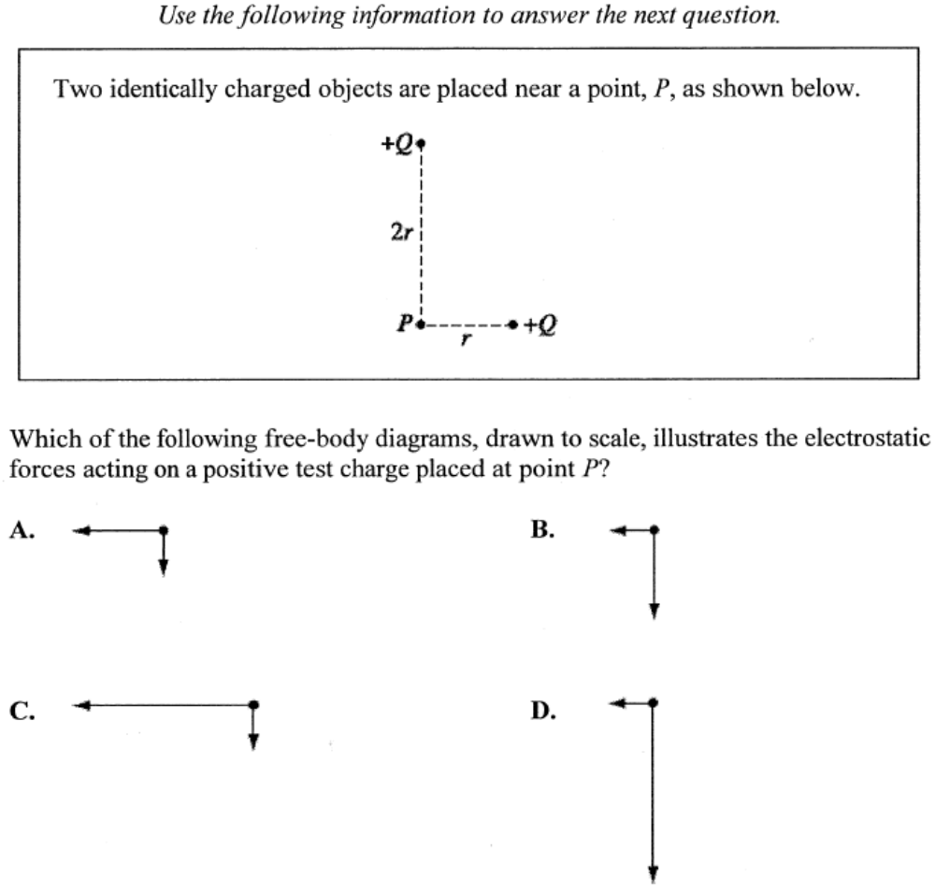

Q6: Which of the following free-body diagrams, drawn to scale, illustrates the electrostatic forces acting on a positive test charge placed at point P?

L04 – Coulomb’s Law Examined Graphically and Algebraically
Use the following diagram to answer Q7:
The electric field strength of an unknown charge is measured at various distances from the source. The data is linearized and plotted below.
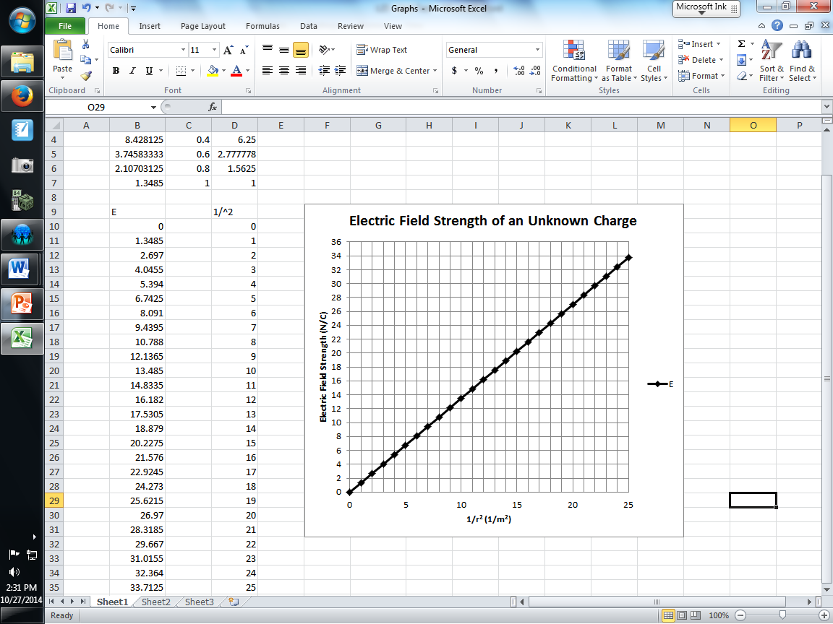

Q7: Using the graph above, what is the magnitude of the unknown charge?
- 1.50 x 10⁻¹⁰ C
- 2.36 x 10⁻⁶ C
- 5.50 x 10⁻¹ C
- 1.35 C

Q8: Which of the following graphs represents the relationship that Coulomb determined between force and the distance between two charged metal spheres?
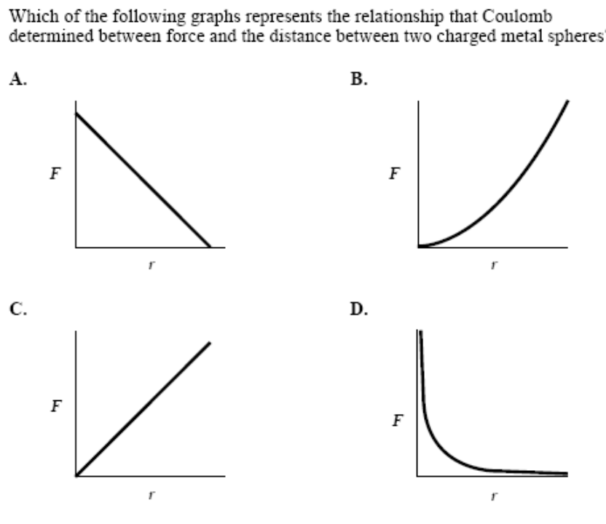

L05 – Electric Fields
Use the following information to answer Q9:
Vector Fields
I Gravitational
II Electrical
III Magnetic

Q9: Which of the vector fields above are produced by a charged particle at rest?
- I, II, and III
- I and II only
- I and III only
- II and III only

Use the following information to answer Q10:
Four point charges are arranged as shown.
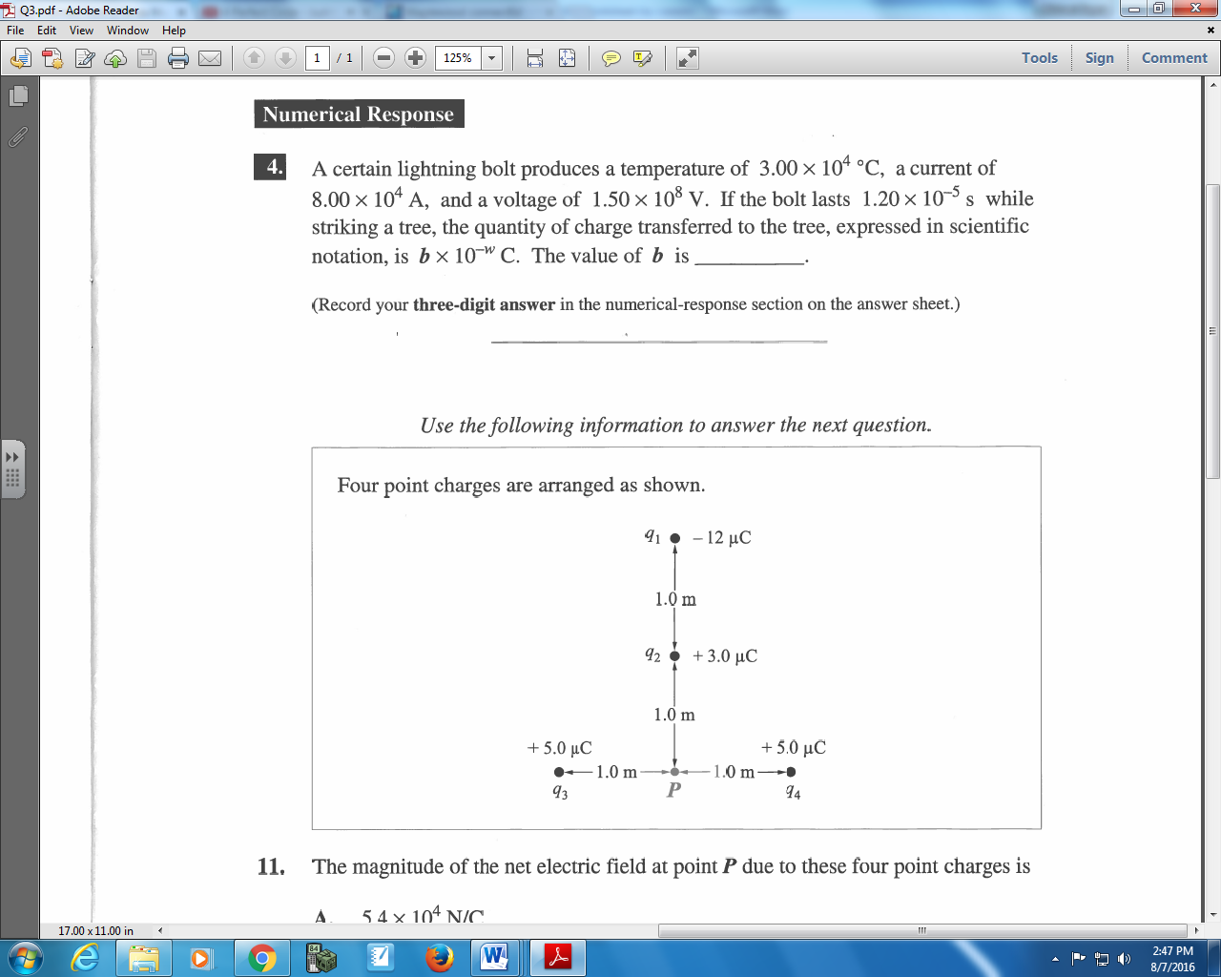

Q10: The magnitude of the net electric field at point P due to these four point charges is
- 5.4 x 10⁴ N/C
- 4.5 x 10⁴ N/C
- 2.7 x 10⁴ N/C
- 0.0 N/C

L07 – Parallel Plates
Use the following information to answer Q11-Q12 and Q18:
One of the methods used to link a person to a crime scene is DNA fingerprinting. DNA fingerprints are as unique as the patterns on fingertips. The laboratory procedure used to produce a DNA fingerprint is called gel electrophoresis.
The apparatus used in gen electrophoresis consists of two parallel plates that have an electrical potential different between them. A layer of thick gel is placed in the region between the parallel plates such that the electric field direction is parallel to and inside the layer. In one step in creating a DNA fingerprint, molecules from a sample are given an electrical charge turning them into ions. These ions are placed at one end of the gel layer next to the negatively charged plate. As a result of the electrostatic repulsion, the electrical force does work moving the ions through the thick gel. Ions with a smaller size or a larger charge move farther through the gel layer.
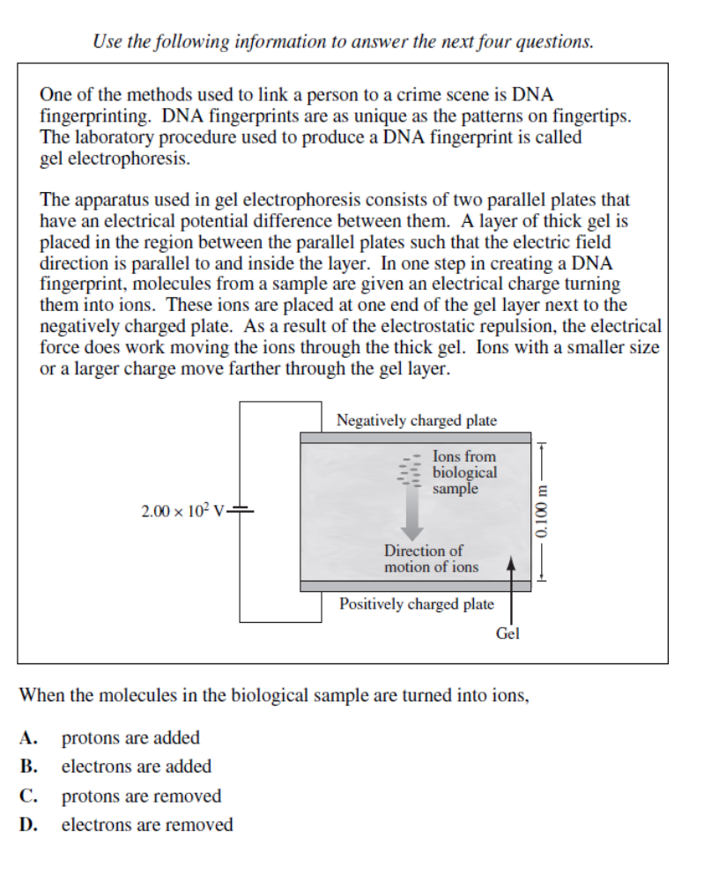

Q11: As an ion moves toward the positively charged plate, the magnitude of the electrical force experienced by the ion
- Increases as the distance decreases
- Is constant as the distance decreases
- Increases as the square of the distance decreases
- Decreases as the square of the distance decreases

Q12: The magnitude of the electric field between the plates, expressed in scientific notation, is a.bc x 10^{d} N/C. The values of a, b, c, and d are ____, ____, ____, and ____. (1 mark)
(Record your four-digit answer in the numerical-response section on the answer sheet.)

Q13: The direction of the electric field between two charged, parallel, metal plates is shown by
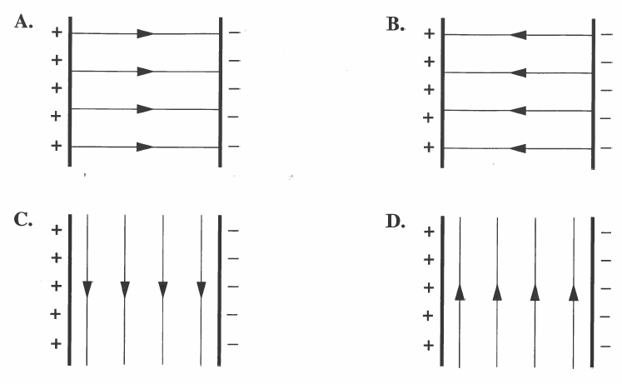

Use the following information to answer Q14-Q15:
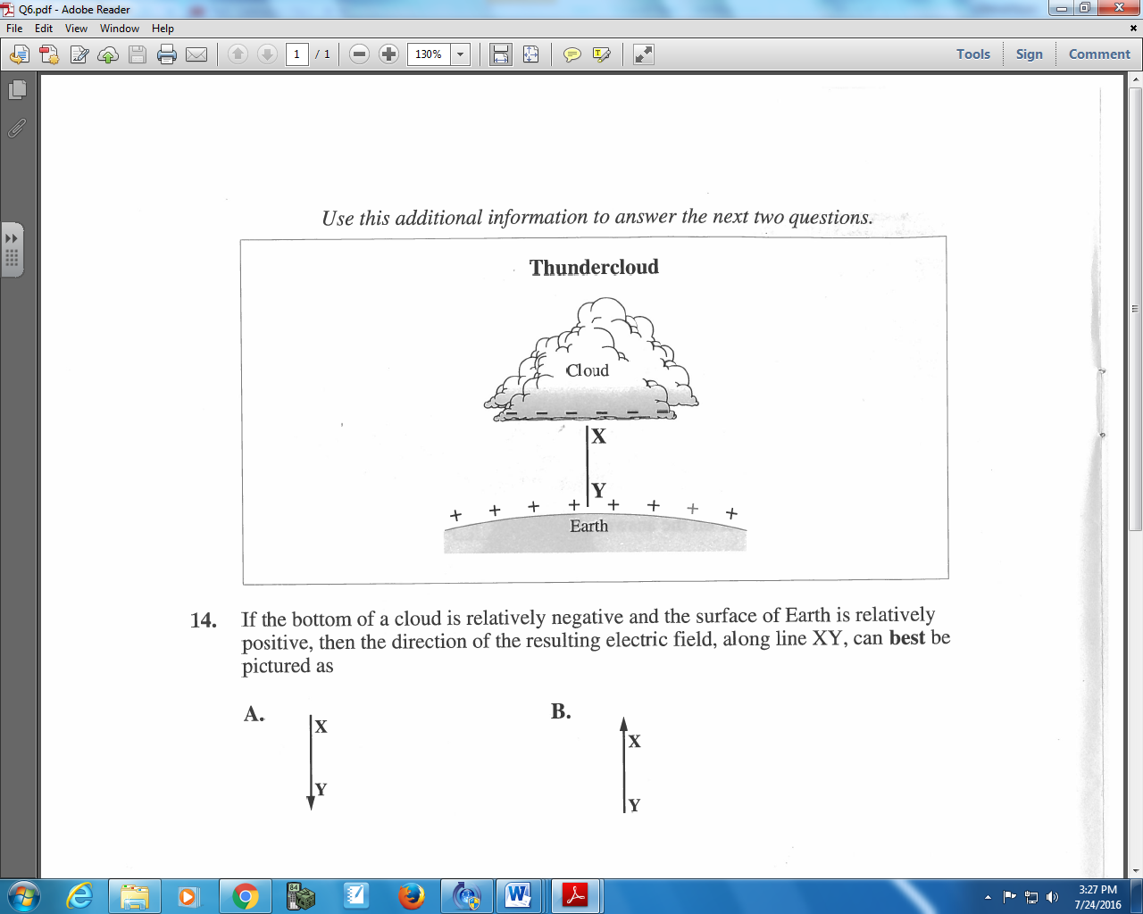

Q14: If the bottom of the cloud is relatively negative and the surface of Earth is relatively positive, then the direction of the resulting electric field, along line XY, can best be pictured as
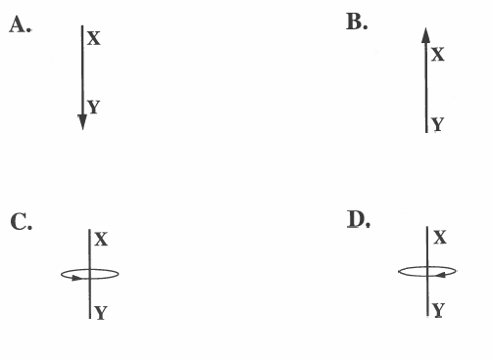
Q15: Assume the bottom of the cloud and the surface of Earth are parallel and that they are separated by a distance of 2.00 km. If a potential difference of 5.00 x 10⁸ V is created between the bottom of the clouds and the surface of Earth, the magnitude of the electric field created is
- 2. 50 x 10⁵ V/m
- 2.50 x 10⁸ V/m
- 1.00 x 10⁹ V/m
- 1.00 x 10¹² V/m

L08 – Parallel Plates and Projectile Motion
Use the following diagram to answer Q16:
Two horizontal plates are separated by a distance of 5.00 cm. A beam of electrons is directed, horizontally, into the region between the plates. The path of the beam is deflected as shown below. Electrons in the beam have a speed of 9.00 x 10⁶ m/s as they enter the region between the parallel plates. The electric field strength in the region between the plates is 3.10 x 10³ N/C.
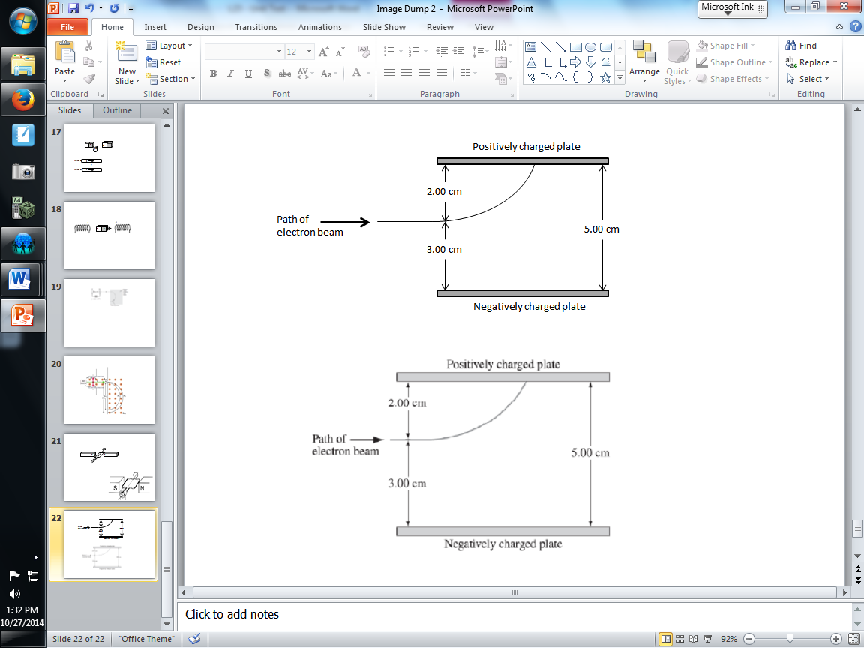

Note: This diagram is not drawn to scale.

Q16: The horizontal distance travelled by an electron in the beam in the region between the horizontal plates is ______ cm.
(Record your three-digit answer in the numerical-response section below)

L09 – Parallel Plates and Conservation of Energy
Use the following diagram to answer Q17
Two oppositely charged parallel plates are separated by 0.20 m and have an electric potential difference of 1.20 x 10³ V across them. Locations I and II are in the region between the two plates, as shown below.
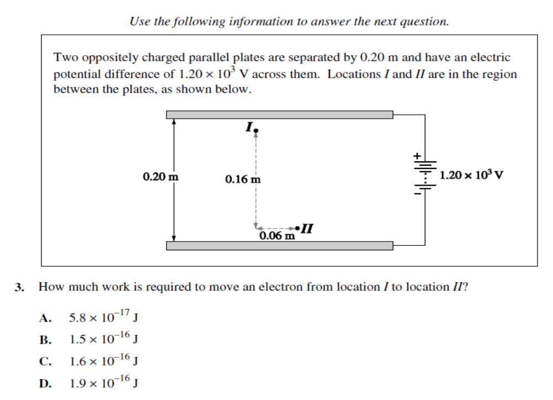

Q17: The work required to move an electron from location I to location II is a.b x 10^{-cd} J, where a, b, c, and d are ___, ___, ___, and ___.
(Record your four-digit answer in the numerical-response section below)

Use the following information to answer Q11-Q12 and Q18:
One of the methods used to link a person to a crime scene is DNA fingerprinting. DNA fingerprints are as unique as the patterns on fingertips. The laboratory procedure used to produce a DNA fingerprint is called gel electrophoresis.
The apparatus used in gen electrophoresis consists of two parallel plates that have an electrical potential different between them. A layer of thick gel is placed in the region between the parallel plates such that the electric field direction is parallel to and inside the layer. In one step in creating a DNA fingerprint, molecules from a sample are given an electrical charge turning them into ions. These ions are placed at one end of the gel layer next to the negatively charged plate. As a result of the electrostatic repulsion, the electrical force does work moving the ions through the thick gel. Ions with a smaller size or a larger charge move farther through the gel layer.

Q18: In forming a DNA fingerprint, a particular ion has been moved 3.00 cm through the gel. The magnitude of the charge of the ion is 2e. The work done by the electrostatic force to move the ion this distance is
- 1.20 x 10² eV
- 1.20 x 10² J
- 4.00 x 10² eV
- 4.00 x 10² J

Use the following information to answer Q19.
An electron is initially at rest at the negative charged plate. At the instant illustrated below, the electron has 50.0 eV of kinetic energy.
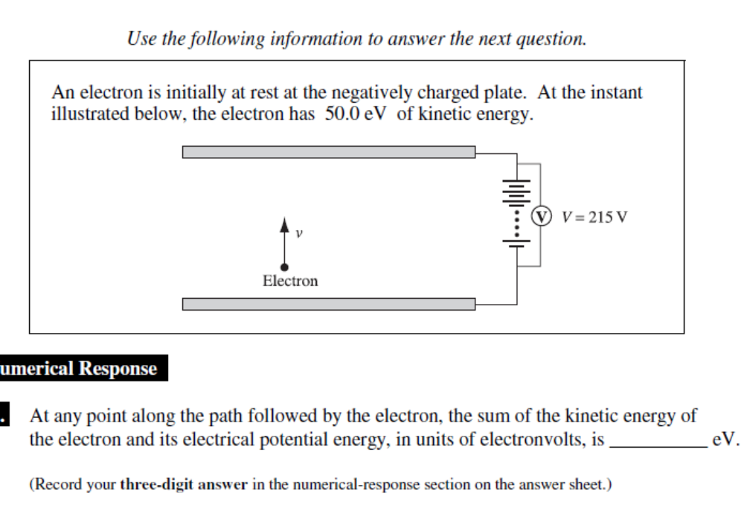

Q19: At any point along the path followed by the electron, the sum of the kinetic energy of the electron and its electrical potential energy, in units of electronvolts, is _________ eV. (1 mark)
(Record your three-digit answer in the numerical-response section on the answer sheet.)

L12 – Magnetic Forces and Fields
Q20: If the source of Earth’s magnetic field were a bar magnet, then the best diagram to show this field would be
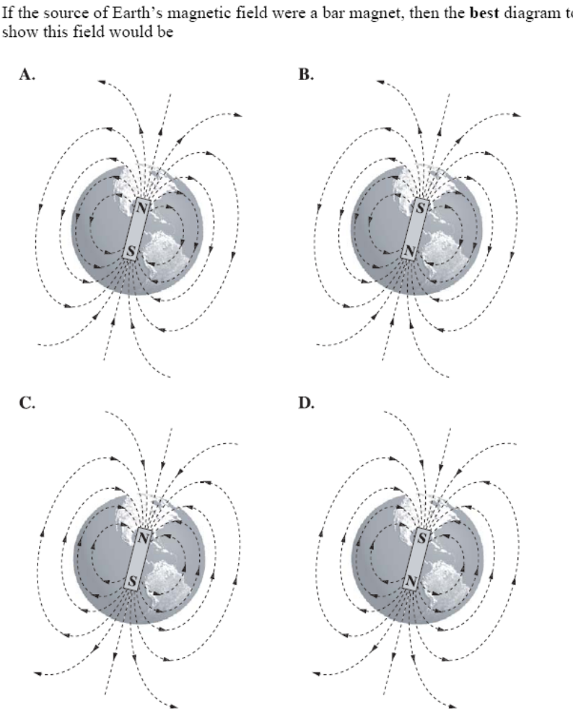

Q21: Which of the following diagrams best illustrates the magnetic field near a wire that carries an electron current out of the plane of the page?
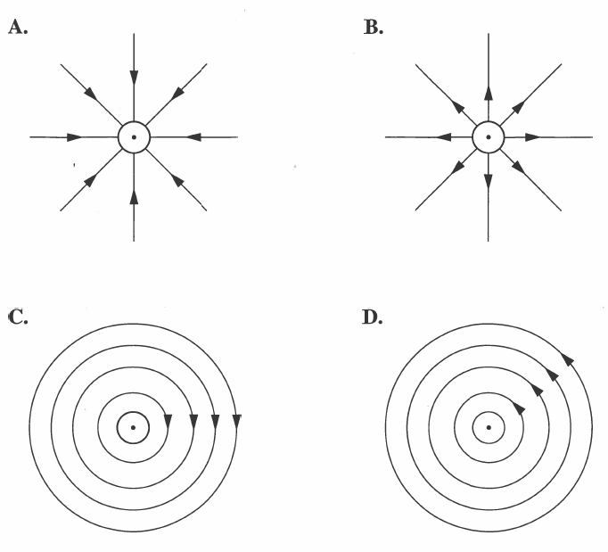
Use the following information to answer Q22:
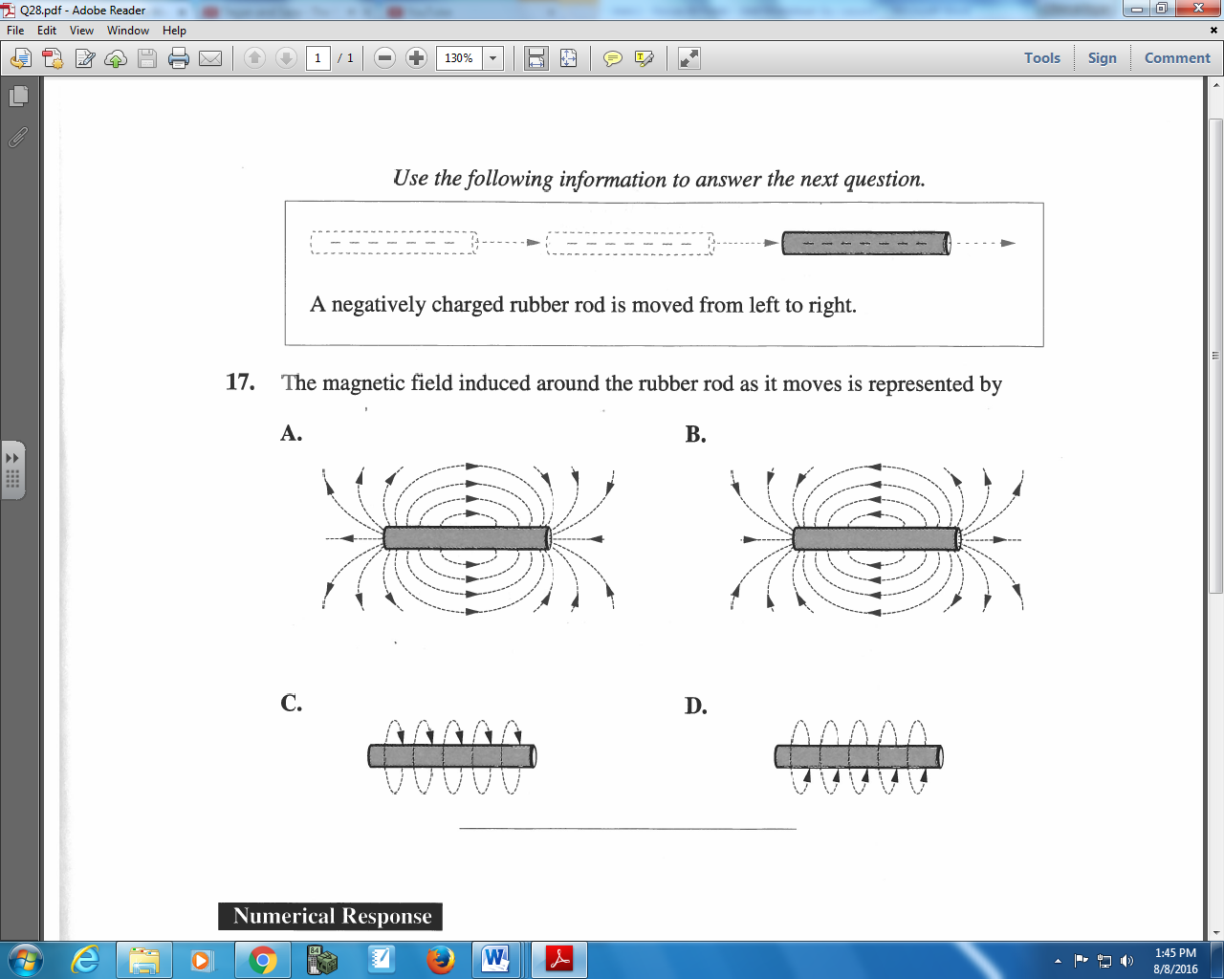

Q22: The magnetic field induced around the rubber rod as it moves is represented by

Use the following information to answer Q23:
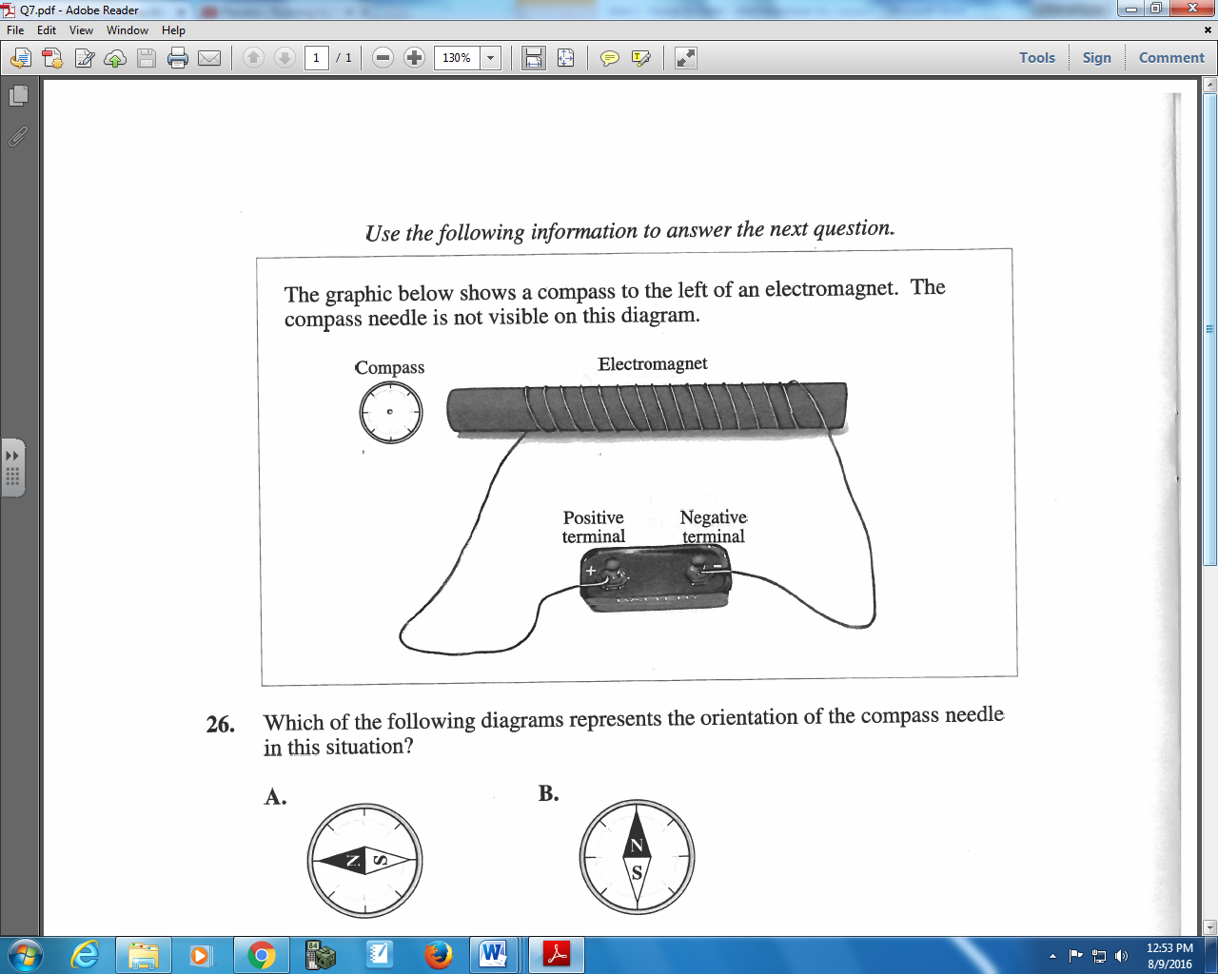

Q23: Which of the following diagrams represents the orientation of the compass needle in this situation?
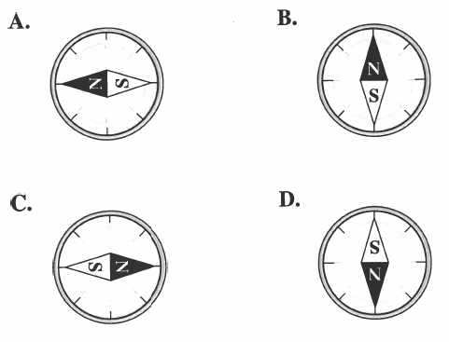

L13 – Motor Effect on a Point Charge
Use the following information to answer Q24and Q34:
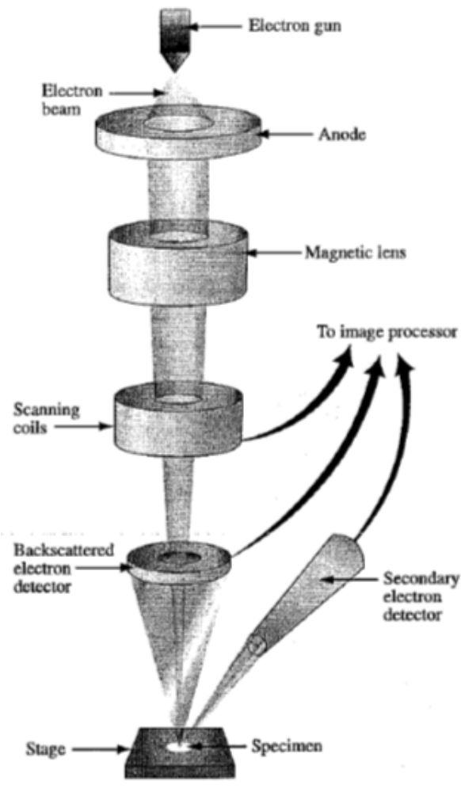
A scanning electron microscope (SEM) is a microscope that uses a beam of electrons rather than visible light to produce images of specimens.
Description of the Operation of an SEM
Electrons are accelerated from the electron gun to the anode. The electric potential difference between the electron gun and the anode accelerates the electrons to a speed of 2.65 x 10⁷ m/s. After this acceleration, the electrons pass through an opening in the anode and enter the magnetic lens.
The magnetic lens focuses the beam of electrons. A particular electron experiences a magnetic force of 3.31 x 10⁻¹² N while in the magnetic lens. As a result of this magnetic force, the path of the electrons spirals and the beam of electrons become focused.
Scanning coils deflect that beam of electrons back and forth across the specimen.
Some electrons from the beam reflect off the specimen at the same speed at which they hit. The backscattered electron detector picks up these electrons. These backscattered electrons provide information about the composition and surface characteristics of the specimen.
The electron beam causes the specimen to emit electrons from its surface. The secondary electron detector picks up these electrons.
Information collected from the scattering coils and the two detectors is sent to the image processor. This processor produces a three-dimensional image of the specimen.

Q24: The magnitude of the magnetic field in the magnetic lens, expressed in scientific notation, is ____________ x 10^{-w} T.
(Record your three-digit answer in the numerical-response section below)

Q25: The diagrams below show the direction of the magnetic field relative to a set of coordinate axes. A negatively charged particle travels across the page in the positive x direction. The magnetic configuration that will cause the particle to bend in the positive z direction is
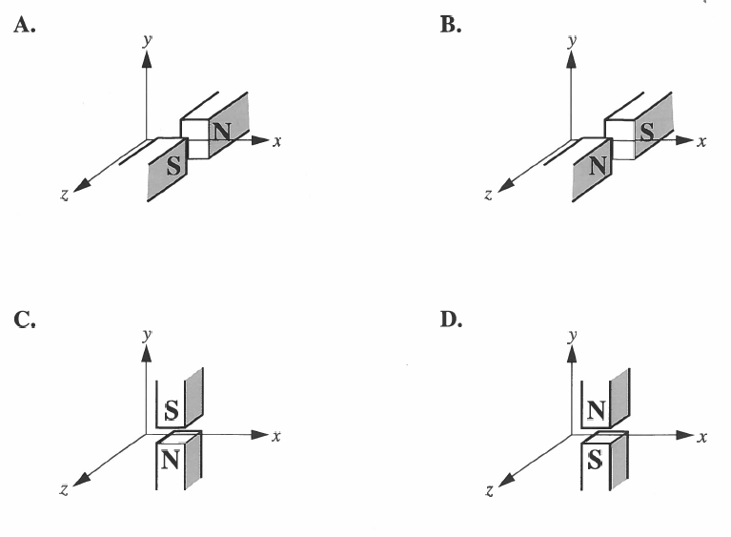
Q26: An electron moving at 2.5 x 10⁷ m/s perpendicularly through a magnetic field of 0.60 T experiences an acceleration of
- 1.5 x 10¹¹ m/s²
- 4.2 x 10¹³ m/s²
- 2.4 x 10¹⁶ m/s²
- 2.6 x 10¹⁸ m/s²

Use the following information to answer Q27:
Moving electrons can be deflected by electric fields, gravitational fields, and magnetic fields. One electron is allowed to enter each type of field, as shown below.
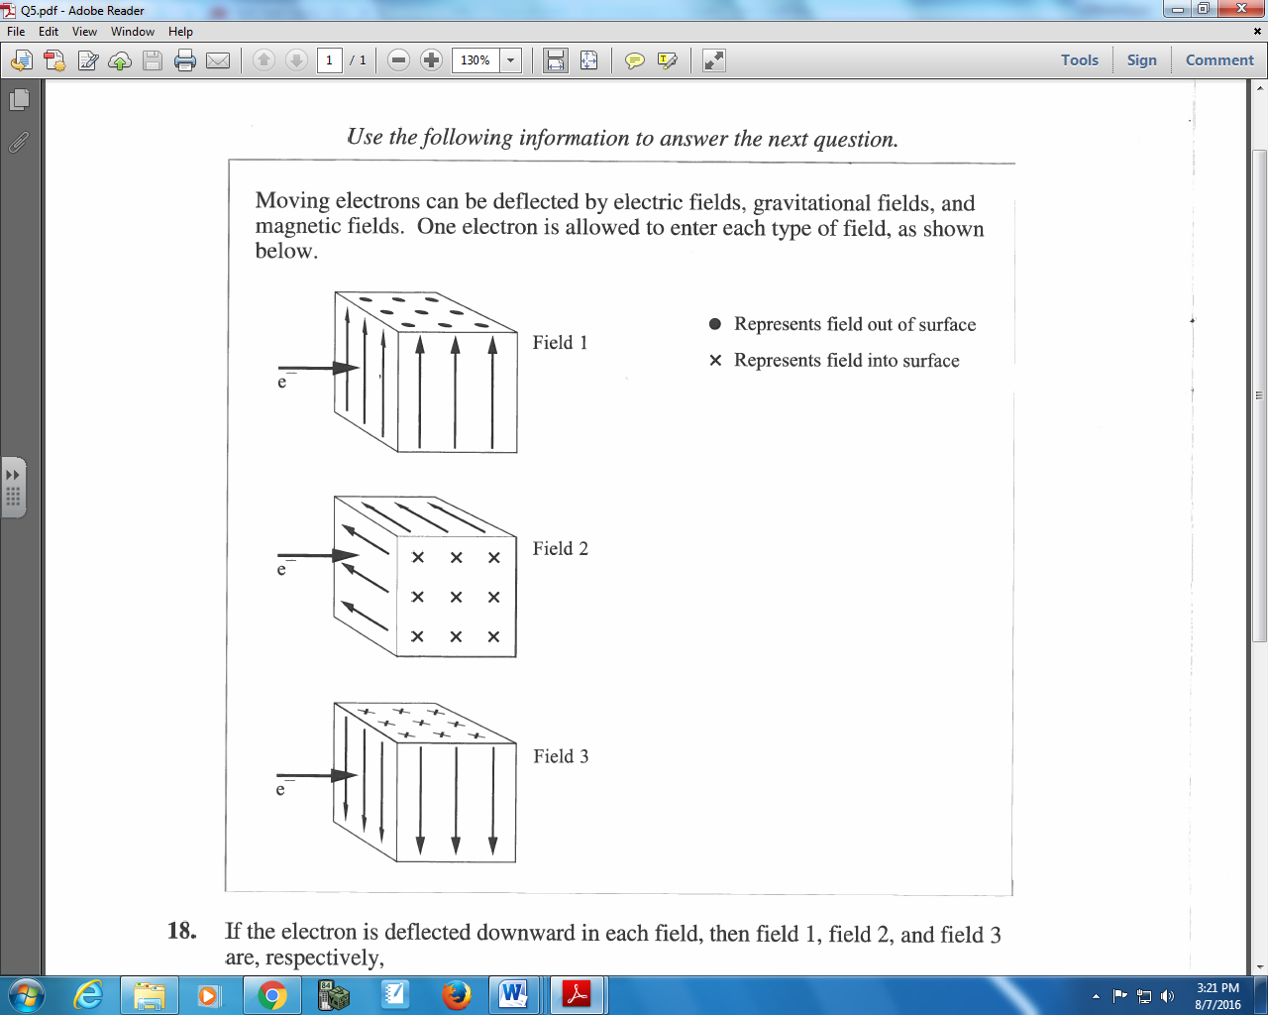

Q27: If the electron is deflected downward in each field, then field 1, field 2, and field 3 are, respectively,
- Electric, magnetic, and gravitational
- Gravitational, magnetic, and electric
- Magnetic, gravitational, and electric
- Magnetic, electric, and gravitational

L14 – Motor Effect on a Wire
Use the following diagram to answer Q28:
A styrofoam cup is placed on a scale, and the scale is initially zeroed out. When the power supply is turned on, a magnetic field of unknown strength influences 3cm of a wire with a current of 1.25A, creating a downward force. The scale reads 0.12 grams.
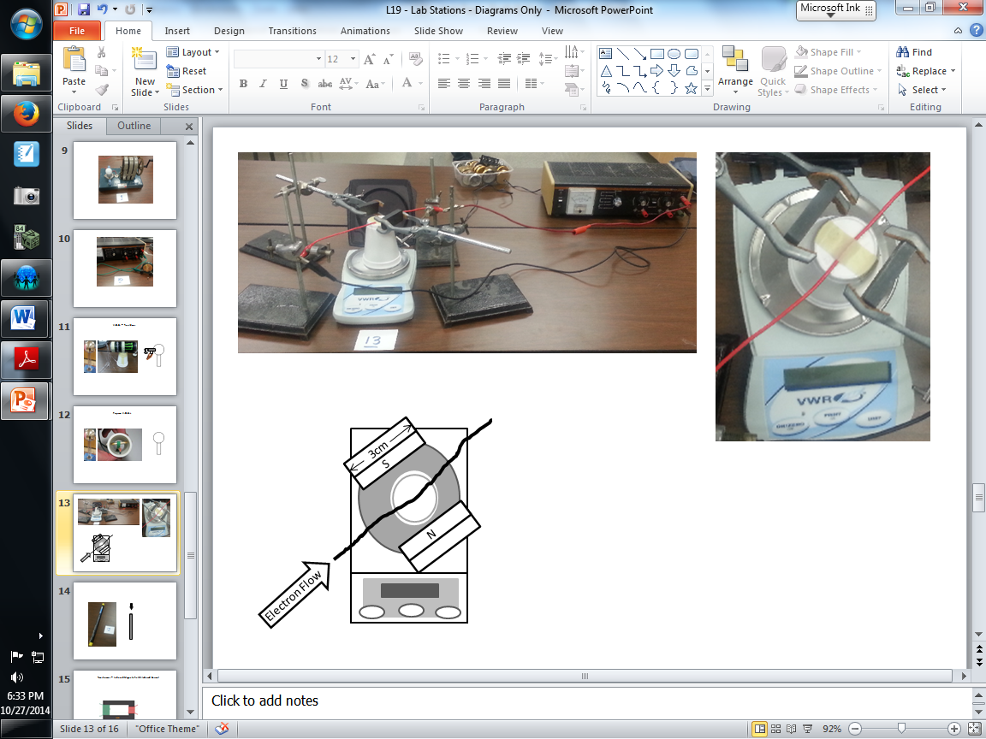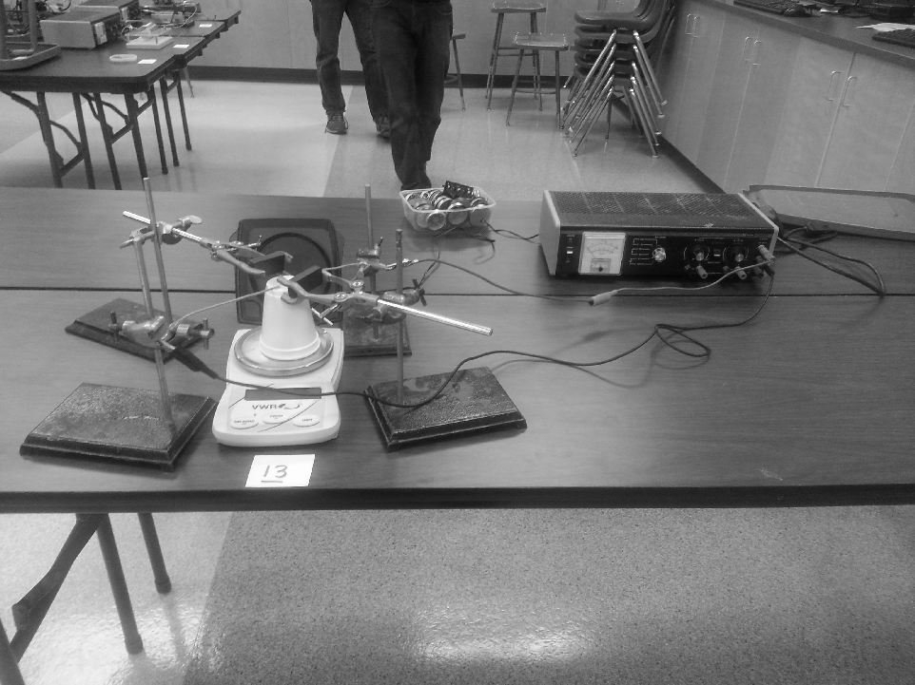

Q28: The strength of the magnetic field acting on the wire is a.bc x 10^{-d} T, where a, b, c, and d are ____, ____, ____, and ____.
(Record your four-digit answer in the numerical-response section below)

Use the following diagram to answer Q29:
A styrofoam cup is placed on a scale, and the scale is initially zeroed out. When the power supply is turned on, a magnetic field of unknown strength influences 3 cm of a wire with a current of 2.50 A, creating a downward force. The scale reads 0.16 grams.

Q29: The strength of the magnetic field acting on the wire is a.bc x 10^{-d} T, where a, b, c, and d are ____, ____, ____, and ____.
(Record your four-digit answer in the numerical-response section below)

Use the following information to answer Q30:
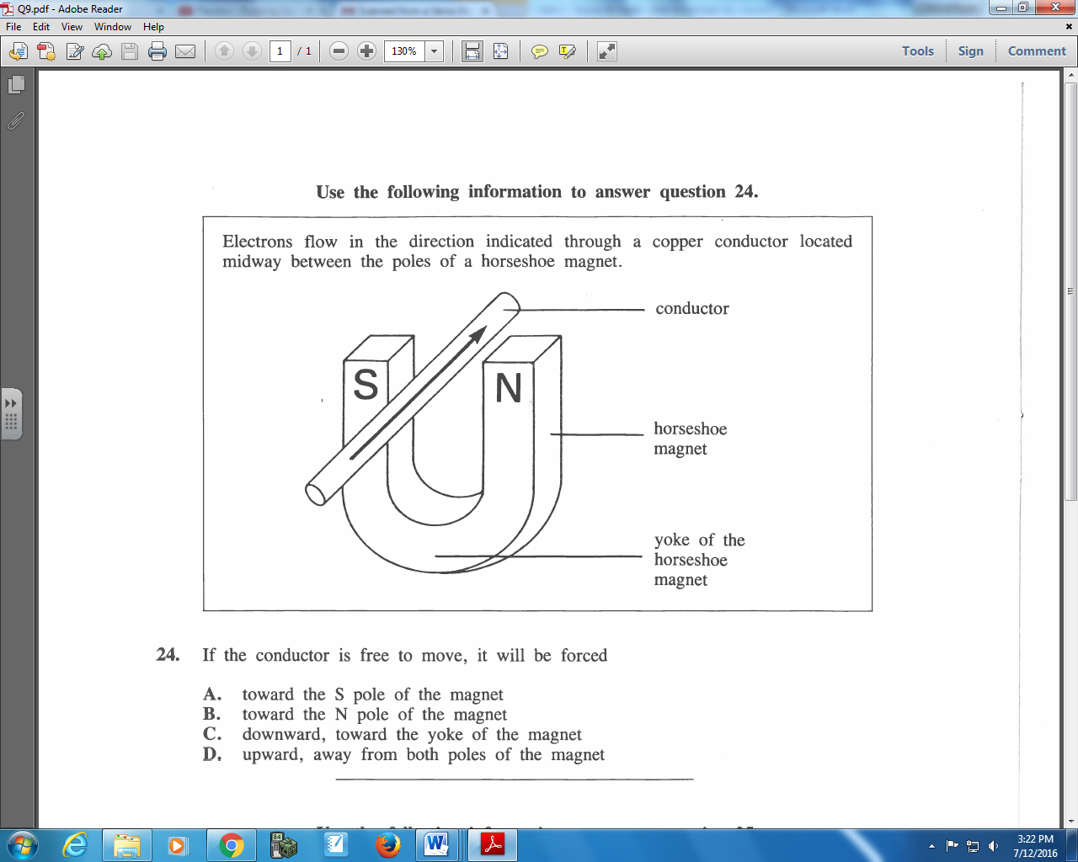

Q30: If the conductor is free to move, it will be forces
- Toward the S pole of the magnet
- Toward the N pole of the magnet
- Downward, toward the yoke of the magnet
- Upward, away from both poles of the magnet

Q31: A 0.50 m length of copper wire is perpendicular to a magnetic field that has a strength of 0.30 T. When a magnetic force of 4.0 N acts on the wire, the current in the wire is equal to
- 27 A
- 2.4 A
- 0.60 A
- 0.15 A

L15 – Motor Effect and Circular Motion
Use the following diagram to answer Q32-Q33:
A cyclotron uses a magnetic field to move charged particles in a circular path. It also uses a high frequency power supply to repeatedly accelerate the particles.
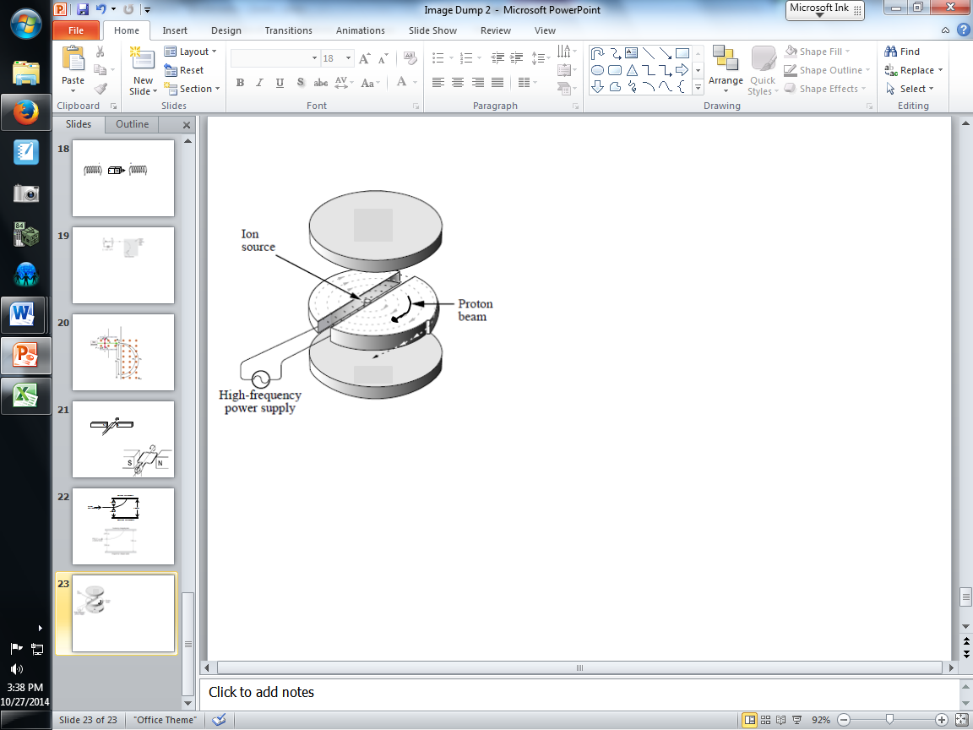
Ernest Lawrence was the first person to use a cyclotron. His cyclotron accelerated protons to a maximum energy of 8.0 x 10⁴ eV. With this energy, the protons moved in a circular path with a radius of 6.5 x 10⁻² m.

Q32: The magnitude of the magnetic field used by Lawrence was
- 3.4 x 10⁻⁴ T
- 1.3 x 10⁻² T
- 6.3 x 10⁻¹ T
- 1.6 x 10⁹ T

Q33: The direction of the magnetic field is __i__, causing a force directed __ii__ on the proton.
 | i | ii
A | upward | towards the center
B | upward | away from the center
C | downward | towards the center
D | downward | away from the center

Use the following information to answer Q24 and Q34.
A scanning electron microscope (SEM) is a microscope that uses a beam of electrons rather than visible light to produce images of specimens.
Description of the Operation of an SEM
Electrons are accelerated from the electron gun to the anode. The electric potential difference between the electron gun and the anode accelerates the electrons to a speed of 2.65 x 10⁷ m/s. After this acceleration, the electrons pass through an opening in the anode and enter the magnetic lens.
The magnetic lens focuses the beam of electrons. A particular electron experiences a magnetic force of 3.31 x 10⁻¹² N while in the magnetic lens. As a result of this magnetic force, the path of the electrons spirals and the beam of electrons become focused.
Scanning coils deflect that beam of electrons back and forth across the specimen.
Some electrons from the beam reflect off the specimen at the same speed at which they hit. The backscattered electron detector picks up these electrons. These backscattered electrons provide information about the composition and surface characteristics of the specimen.
The electron beam causes the specimen to emit electrons from its surface. The secondary electron detector picks up these electrons.
Information collected from the scattering coils and the two detectors is sent to the image processor. This processor produces a three-dimensional image of the specimen.

Q34: The instantaneous radius of the resulting spiral of the electron’s path in the magnetic lens is
- 5.17 x 10³ m
- 3.54 x 10⁻¹ m
- 1.93 x 10⁻⁴ m
- 7.29 x 10⁻¹² m

L16 – Motor Effect, Generator Effect, and Mass Spectrometer (and Lenz’s Law)
Use the following diagram to answer Q35:
A copper ring is suspended by insulating string. The north pole of a bar magnet is brought toward the ring.
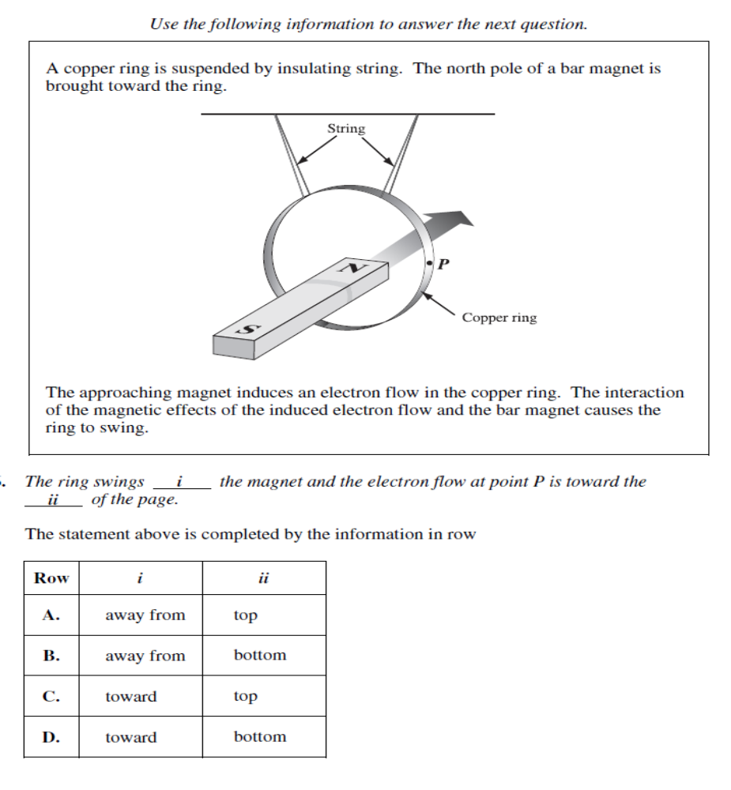
The approaching magnet induces an electron flow in the copper ring. The interaction of the magnetic effects of the induced electron flow and the bar magnet causes the ring to swing.

Q35: The ring swings __i__ the magnet and the electron flow at point P is toward the __ii_ of the page.
Row | i | ii
A | away from | top
B | away from | bottom
C | toward | top
D | toward | bottom

Q36: A beam of alpha particles is directed with a horizontal speed of 2.0 x 10⁷ m/s into a mass spectrometer that has a vertical magnetic field strength of 3.0 T. What is the radius of the path of the beam in the spectrometer?
- 0.072 m
- 0.14 m
- 0.28 m
- 7.2 m

Q37: An alpha particle passes without deflection through perpendicular electric and magnetic fields. The magnitude of the magnetic field is 2.20 x 10⁻² T. The electric field is maintained by a 3.00 x 10² V potential difference across plates that are 4.00 cm apart. The speed of the alpha particle is
- 7.50 x 10³ m/s
- 1.36 x 10⁴ m/s
- 1.20 x 10⁵ m/s
- 3.41 x 10⁵ m/s

L17 – Millikan Oil Drop Experiment
Use the following information to answer Q38:
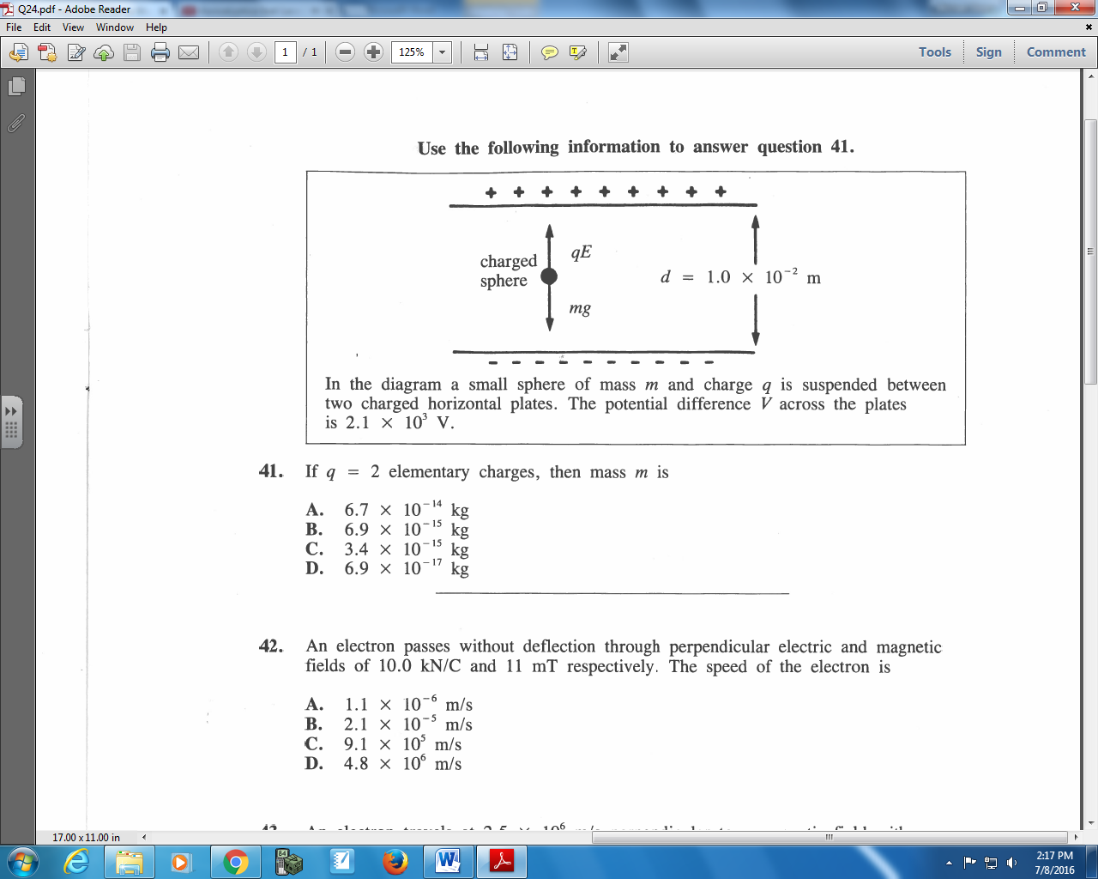
In the diagram a small sphere of mass m hand charge q is suspended between two charged horizontal plates. The potential difference V across the plates is 2.1 x 10³ V.

Q38: If q = 2 elementary charges, then mass m is
- 6.7 x 10⁻¹⁴ kg
- 6.9 x 10⁻¹⁵ kg
- 3.4 x 10⁻¹⁵ kg
- 6.9 x 10⁻¹⁷ kg

Q39: An oil drop of mass 6.6 x 10⁻¹⁴ kg is suspended in an electric field of 2.0 x 10⁶ N/C between horizontal plates that are 4.0 x 10⁻² m apart. The number of excess electrons on the oil drop is
- 1
- 2
- 5
- 20

Q40: An oil drop with a mass of 3.33 x 10⁻¹⁵ kg is suspended between two large horizontal plates that are 1.00 x 10⁻² m apart. The potential difference between the plates is 4.08 x 10² V. The number of excess electrons on the oil drop is
- 4
- 5
- 6
- 8

