First Name:__________________________________ Last Name:______________________________

L24 – Worksheet – Buffer Day – Cumulative Review /59 marks
Unit 1 – Momentum and Impulse ___ / 13 marks
Use the following information to answer Q1:
A hole is drilled in a boulder that has a mass of 250.0kg. An explosive charge is placed in the hole. The boulder explodes into three main pieces that have masses of 110.0kg, 50.0kg, and 90.0kg. The 110.0kg piece and the 50.0kg piece fly off at right angles to each other at speeds of 4.00 m/s and 10.00 m/s, respectively.

Q1: The magnitude of the momentum of the 90.0kg piece is
- 7.40 kg*m/s
- 60.0 kg*m/s
- 666 kg*m/s
- 940 kg*m/s

Q2: In an inelastic collision, the energy that appears to be missing is converted into
- sound and momentum
- force and momentum
- sound and heat
- heat and force

Q3: A 1575kg car, initially travelling at 10.0 m/s, collides with a stationary 2250kg car. The bumpers of the two cars become locked together. The speed of the combined cars immediately after impact is _______ m/s.
(Record your three digit answer in the Numerical Response boxes below)

Use the following information to answer Q4-Q5:
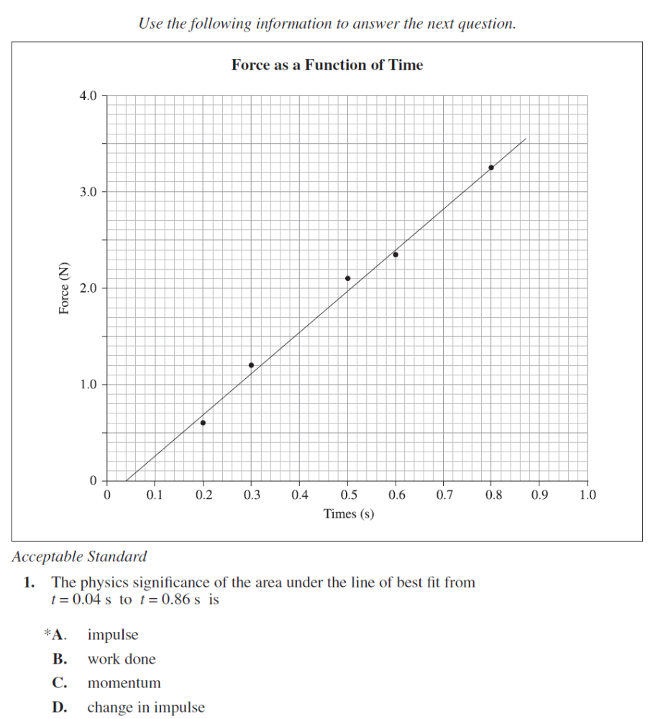

Q4: The physics significance of the area under the line of best fit from t = 0.04s to t = 0.86s is
- impulse
- work done
- momentum
- change in impulse
Q5: If the mass of the object was 0.500 kg and it started from rest, then the object’s final speed at the end of 0.86s would be _______ m/s.
(Record your three digit answer in the Numerical Response boxes below)

Use the following information to answer Q6:
Two carts, travelling at the same initial speed, move toward each other on a table, as shown below. Cart I has a total mass of 500 g and Cart II has a total mass of 250 g.
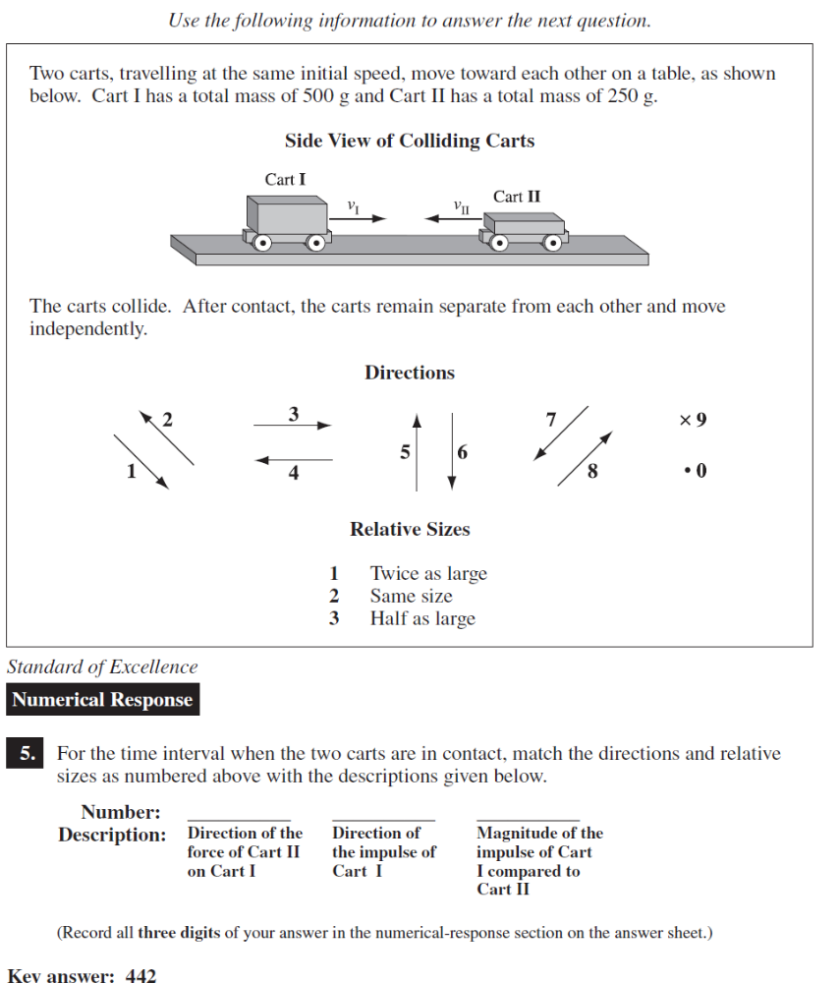
The carts collide. After contract, the carts remain separate from each other and move independently.

Q6: For the time interval when the two carts are in contact, match the directions and relative sizes as numbered above with the descriptions given below.
(Record your four digit answer in the Numerical Response boxes below)

Use the following information to answer Q7:
Two laboratory carts are placed on a frictionless surface. A spring is attached to both carts and compressed. A string holds the two carts together so that they are motionless. Cart I has a mass of m and cart II has a mass of 2.5m.
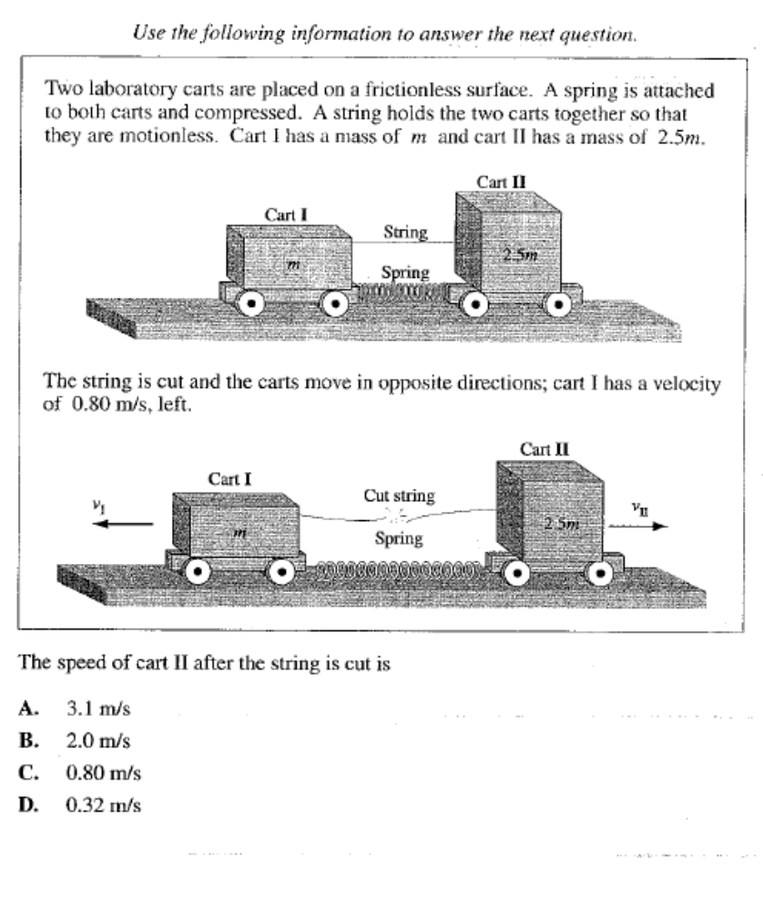
The string is cut and the carts move in opposite directions; cart I has a velocity of 0.80 m/s, left.

Q7: The speed of cart II after the string is cut is
- 3.1 m/s
- 2.0 m/s
- 0.80 m/s
- 0.32 m/s

Use the following information to answer Q8-Q9:
A 0.50 kg mass is travelling 1.00 m/s [East] when it collides with a 1.50 kg mass travelling 0.50 m/s [West]. Immediately after the collision the 0.50 kg mass is travelling at 1.25 m/s [West].

Q8: What is the final velocity of the 1.50 kg mass after the collision?
- 0.25 m/s [East]
- 0.25 m/s [West]
- 1.75 m/s [East]
- 1.75 m/s [West]

Q9: Which of the following statements is correct?
- Momentum is conserved and the collision is inelastic.
- Momentum is conserved and the collision is elastic.
- Momentum is not conserved and the collision is inelastic.
- Momentum is not conserved and the collision is elastic.

Q10: A 1.50 x 10³ kg car travelling at 30.0 km/h [North] collides with a 2.30 x 10³ kg truck travelling at 15.0 km/h [East]. The vehicles stick together and travel together after the impact. How fast are the vehicles travelling together immediately after the impact?
- 14.92 km/h
- 22.76 km/h
- 28.78 km/h
- 45.0 km/h

Q11: A stationary 200.0g firework explodes into three pieces. The first 80.0 g piece travels at 15m/s [90⁰], the second 45.0 g piece travels at 18.0 m/s [180⁰]. What is the speed of the third piece?
- 1.45 m/s
- 6.28 m/s
- 19.3 m/s
- 23.4 m/s

Use the following graph to answer Q12:
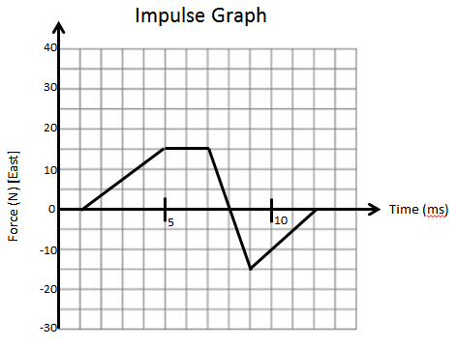
Q12: An object of mass 15kg experiences a varying force, as depicted above. The total impulse the object experiences is a.bc x 10^{–d} kg m/s. The values of a, b, c, and d are ___, ___, ___, and ___.
(Record your four digit answer in the Numerical Response boxes below)

Use the following information to answer Q13:
The graph below depicts the forces acting on an initially stationary 3kg mass.
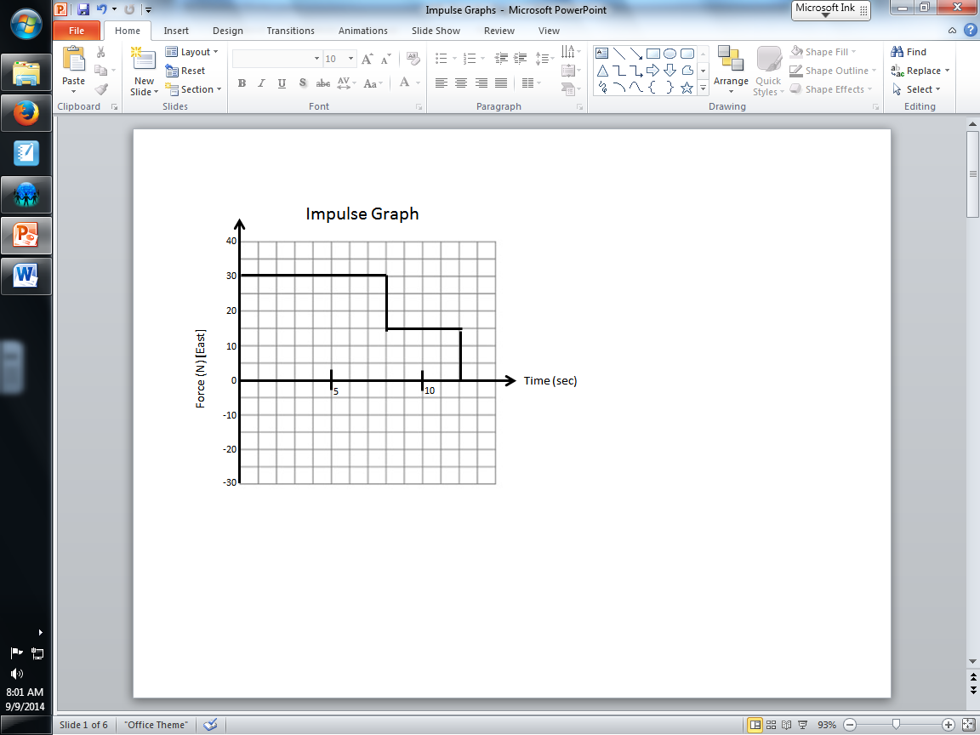

Q13: What is the velocity of the 3kg mass at 8 seconds?
- 10 m/s
- 80 m/s
- 120 m/s
- 240 m/s

Unit 2 – Forces & Fields ___ / 22 marks
Q14: A current-carrying conductor that is 4.00 x 10⁻² m long is placed perpendicular to a magnetic field that has a strength of 6.00 x 10⁻² T. During a 20.0 second time interval, 7.00 x 10¹⁹ electrons pass a point in the conductor. The magnitude of the average magnetic force exerted on the conductor, expressed in scientific notation, is a.bc x 10^{-d} N. The values of a, b, c, and d are ____, ____, ____, and ____.
(Record your four digit answer in the Numerical Response boxes below)

Q15: In a Millikan-type apparatus, a plastic sphere that has a mass of 6.0 x 10⁻¹⁵ kg is suspended in an electric field that has a strength of 2.0 x 10⁴ N/C. The charge on the sphere is
- 1.6 x 10⁻¹⁹ C
- 3.0 x 10⁻¹⁹ C
- 2.9 x 10⁻¹⁸ C
- 2.8 x 10⁻¹⁷ C

Use the following information to answer Q16:
Two oppositely charged parallel plates have an electric potential difference of 1.2 x 10² V across them. The plates are 4.5 x 10⁻² m apart. An alpha particle enters the region between the plates through a hole in the negatively charged plate and comes to rest just before it reaches the positively charged plate.
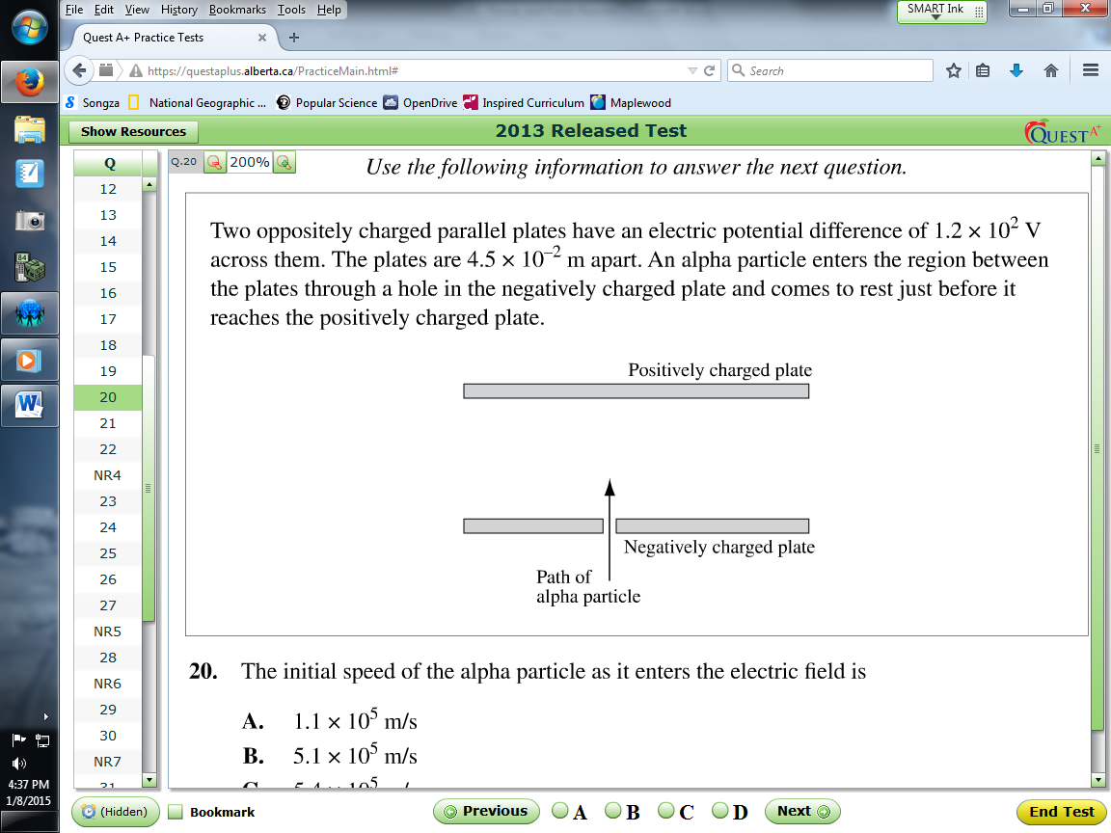

Q16: The initial speed of the alpha particle as it enters the electric field is
- 1.1 x 10⁵ m/s
- 5.1 x 10⁵ m/s
- 5.4 x 10⁵ m/s
- 7.6 x 10⁵ m/s

Q17: One charged object exerts a force, F, on a second charged object. If the distance between the two charged objects is doubled, and the charge on one of the objects is doubled, then the electric force that one charge exerts on the other is
- $\frac{1}{4}F$
- $\frac{1}{2}F$
- $F$
- $2F$
Use the following information to answer Q18:
A magnet moves into a coil of wire, as shown below.
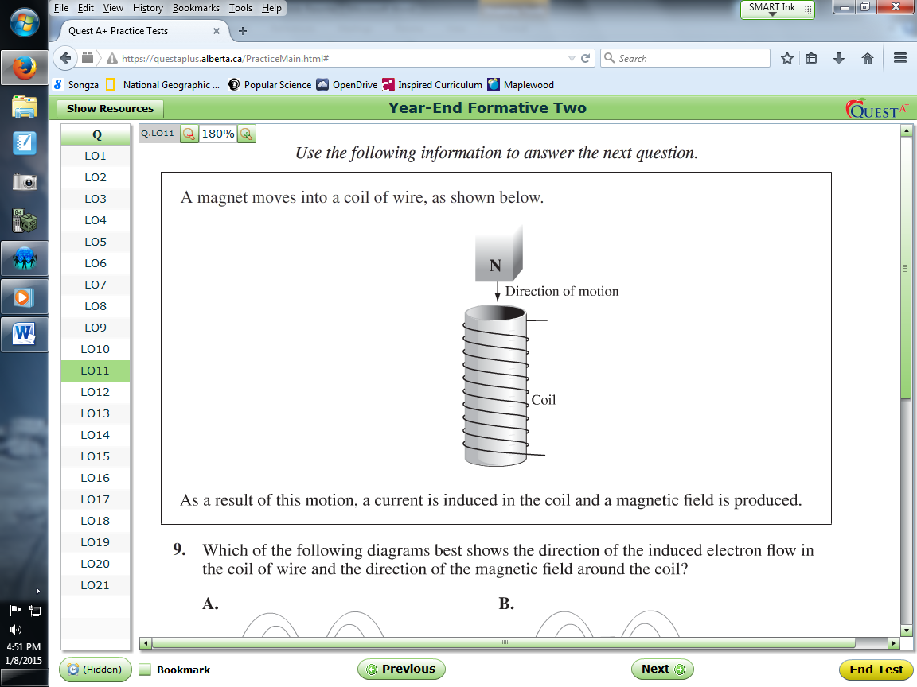
As a result of this motion, a current is induced in the coil and a magnetic field is produced.

Q18: Which of the following diagrams best shows the direction of the induced electron flow in the coil of wire and the direction of the magnetic field around the coil?
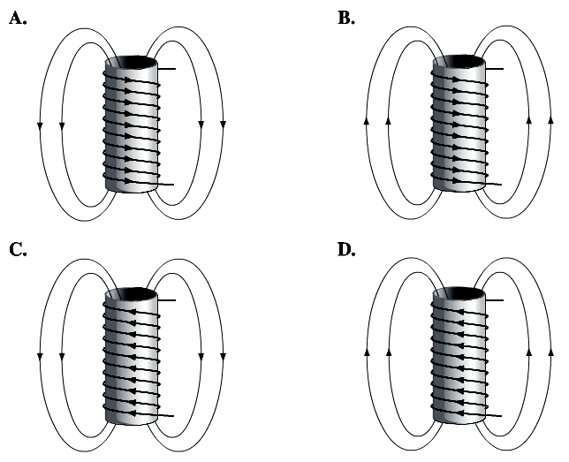

Use the following information to answer Q19:
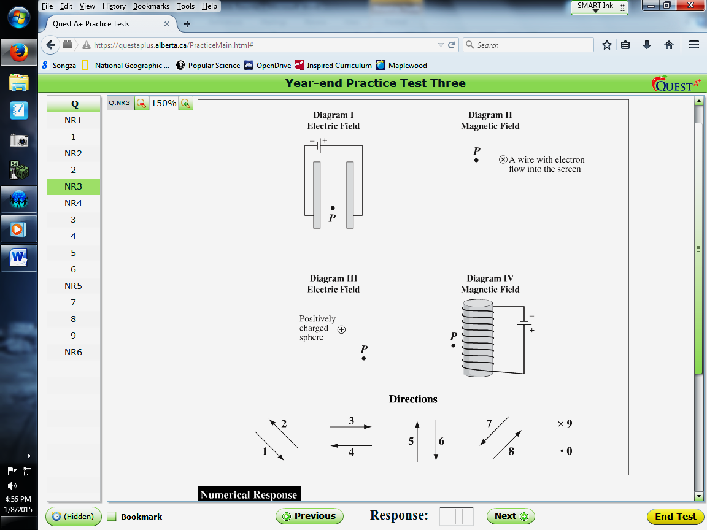

Q19: Using the numbers of the directions as given above, match the direction of the field at Point P in each diagram as described below.
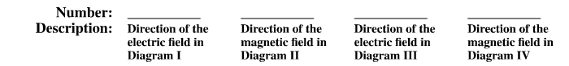
(Record your four digit answer in the Numerical Response boxes below)

Use the following diagram to answer Q20:
A cyclotron uses a magnetic field to move charged particles in a circular path. It also uses a high frequency power supply to repeatedly accelerate the particles.
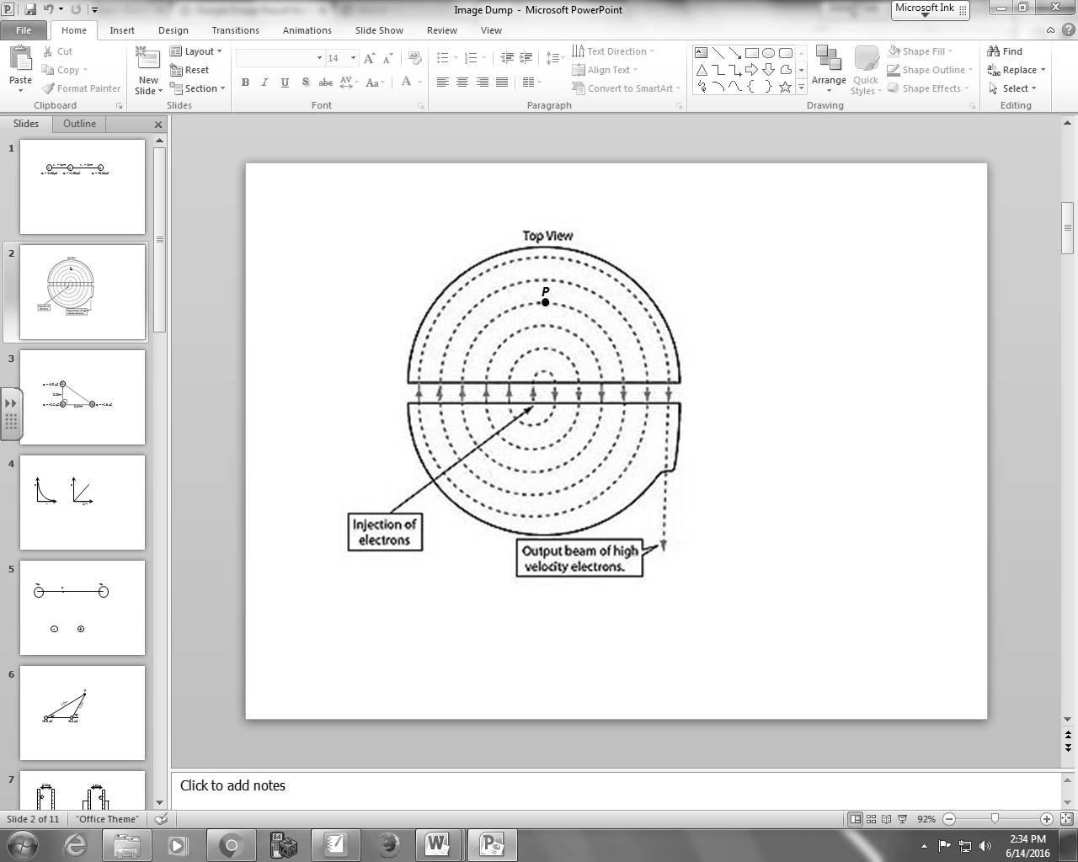

Q20: Use the Numerical Response numbers corresponding with directions above to determine the direction of each of the following vector quantities at Point P.

Direction: __________ ___________ __________ __________
Quantity: Velocity Magnetic Magnetic Acceleration
Field Force
(Record your four digit answer in the Numerical Response boxes below)

Use the following diagram to answer Q21-Q22:
A chlorine ion (Cl ⁻¹) with a mass of 5.85 x 10⁻²⁶ kg is projected with an energy of 8.50 keV perpendicularly into a magnetic field with a strength of 0.650 T.
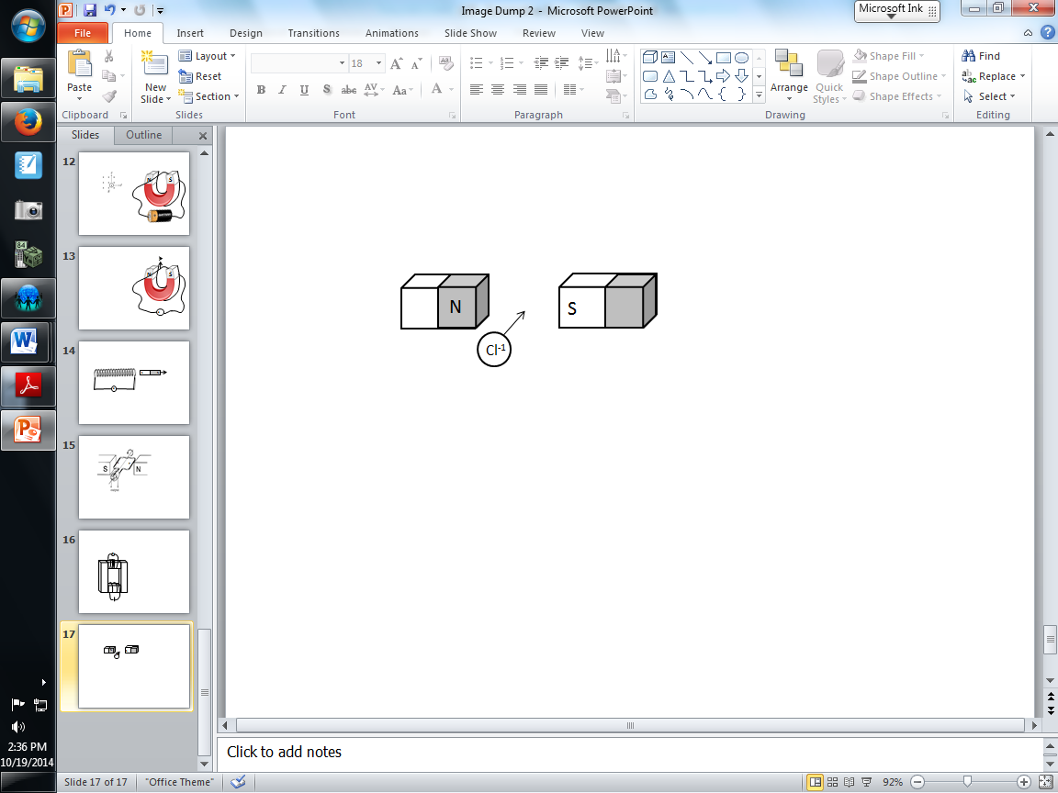

Q21: Based on the information above, the magnetic force of deflection on the chlorine ion will be towards:
- the left
- the right
- the top of the page
- the bottom of the page

Q22: The magnitude of the magnetic force experienced by the Chlorine ion (Cl ⁻¹) is a.b x 10^{-cd} N, where a,b,c and d are ___, ___, ___, and ___.
(Record your four digit answer in the Numerical Response boxes below)

Use the following information to answer Q23:
Three Types of Vector Fields
I – Electric
II – Gravitational
III – Magnetic

Q23: An electron is moving through empty space at a constant speed. The vector fields for which the electron is a source are
- I and II only
- I and III only
- II and III only
- I, II, and III

Use the following information to answer Q24:
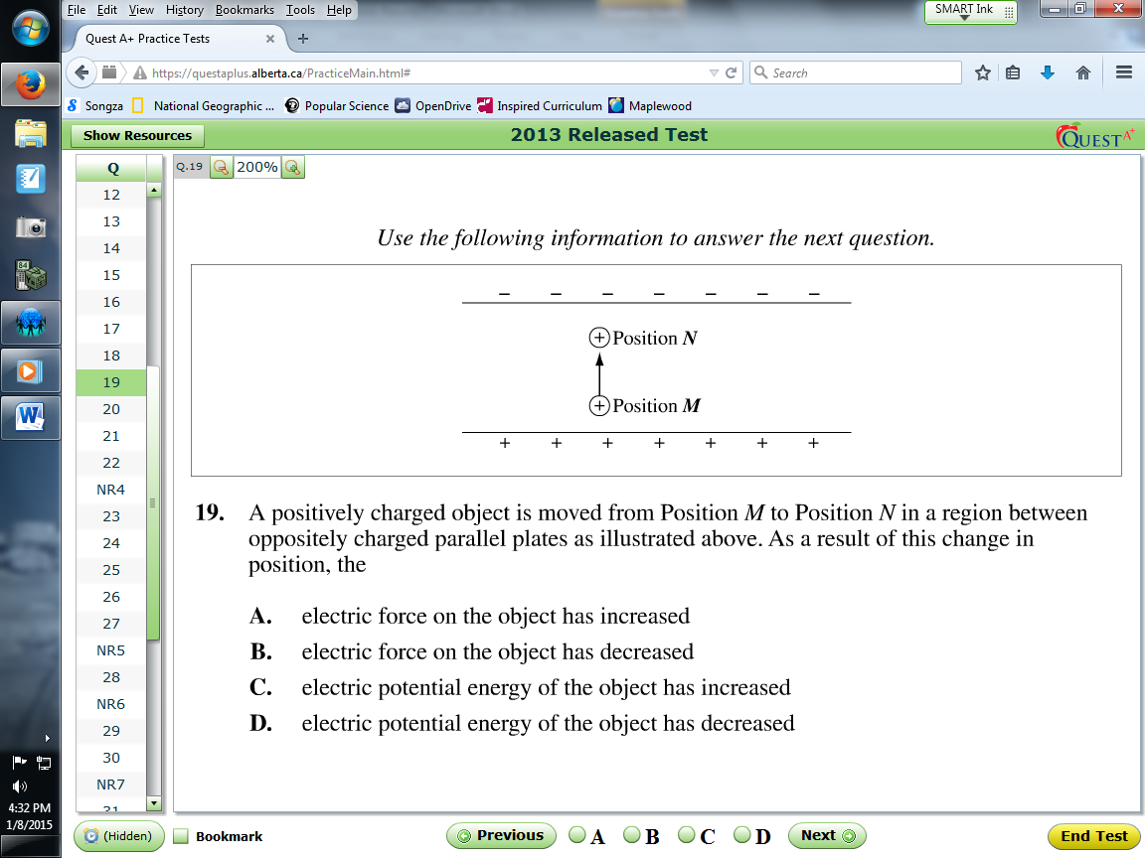

Q24: A positively charged object is moved from Position M to Position N in a region between oppositely charged parallel plates as illustrated above. As a result of this change in position, the
- Electric force on the object has increased
- Electric force on the object has decreased
- Electric potential energy of the object has increased
- Electric potential energy of the object has decreased

Q25: An oil drop with a mass of 7.20 x 10⁻¹⁶ kg moves upward at a constant speed of 2.50 m/s between two horizontal, parallel plates. If the electric field strength between these plates is 2.20 x 10⁴ V/m, the magnitude of the charge on the oil drop is a.b x 10^{-cd} C, where a, b, c, and d are ___, ___, ___, and ___.
(Record your four digit answer in the Numerical Response boxes below)

Use the following information to answer Q26:
Two parallel plates are 0.45m apart, with a Potential Difference of 13.5V, as shown below. An electron is fired horizontally at 2.4 x10⁵ m/s through the plates 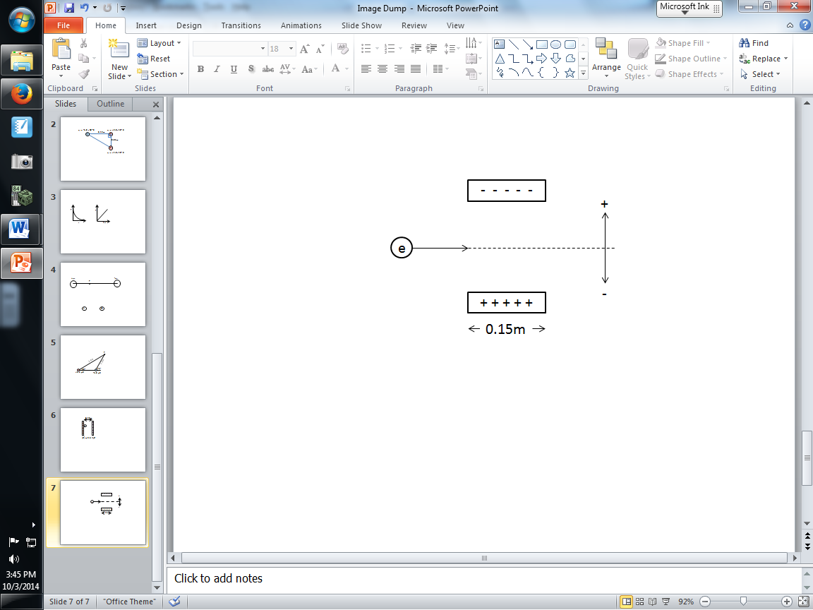

Q26: As it passes through the plates, it experiences a vertical deflection of _____ m.
(Record your four digit answer in the Numerical Response boxes below)

Use the following diagram to answer Q27:
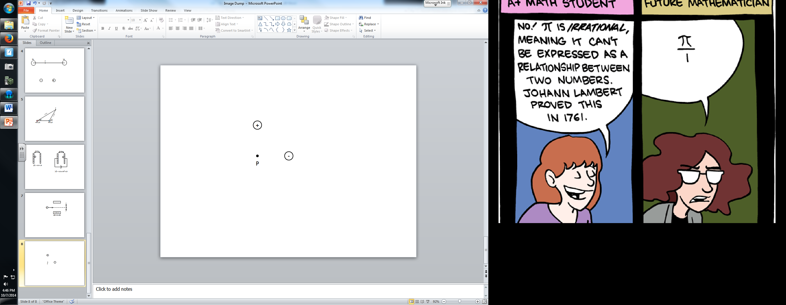

Q27: A positively charged object of charge +q and a negatively charged object of charge –q are placed equal distances from a point, P, as per the diagram above. The electric field at point P is:
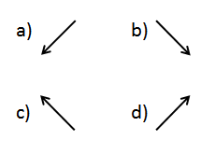

Q28: Two charged spheres, separated a certain distance, attract each other with an electrostatic force of 8N. What will be the new force if the charge on both spheres is halved and the separation distance is halved?
- 2 N
- 4 N
- 8 N
- 16 N

Use the following information to answer Q29:
Acceleration Plates in a Mass Spectrometer
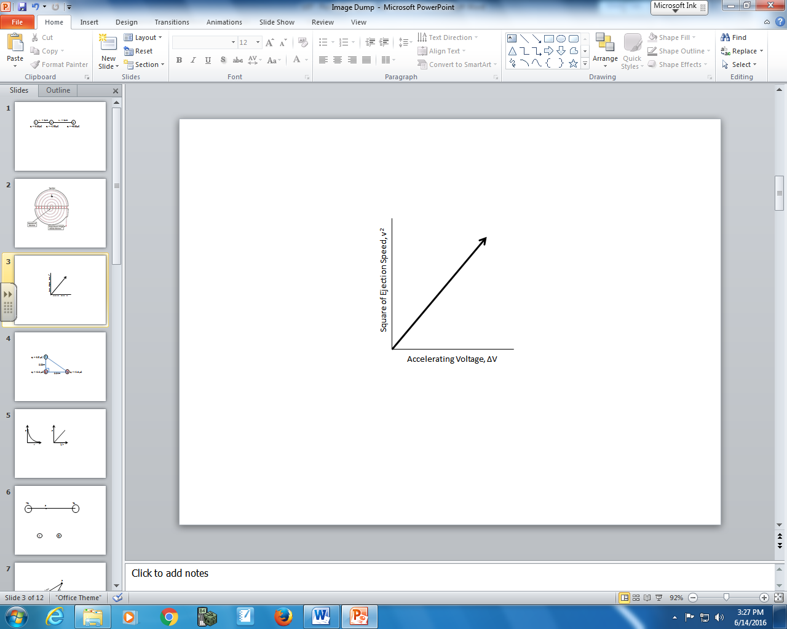

Q29: Which of the following expressions best describes the slope of the graph above?
- $\frac{2q}{m}$ b. $\frac{2m}{q}$ c. $\frac{q}{2m}$ d. $\frac{m}{2q}$

Q30: Two parallel plates are 0.50m apart. The magnitude of the uniform electric field is 2.5x10³ N/C. If an electron is pulled to the far right terminal and released, then the electron is moving at a.bc x 10^{d} m/s when it strikes the left terminal, where a, b, c, and d are ___, ___, ___, and ___.
(Record your four digit answer in the Numerical Response boxes below)

Use the following information to answer Q31:
A positively charged ion travels through a region that contains perpendicular electric and magnetic fields. The ion passes through the region undeflected at a constant speed.
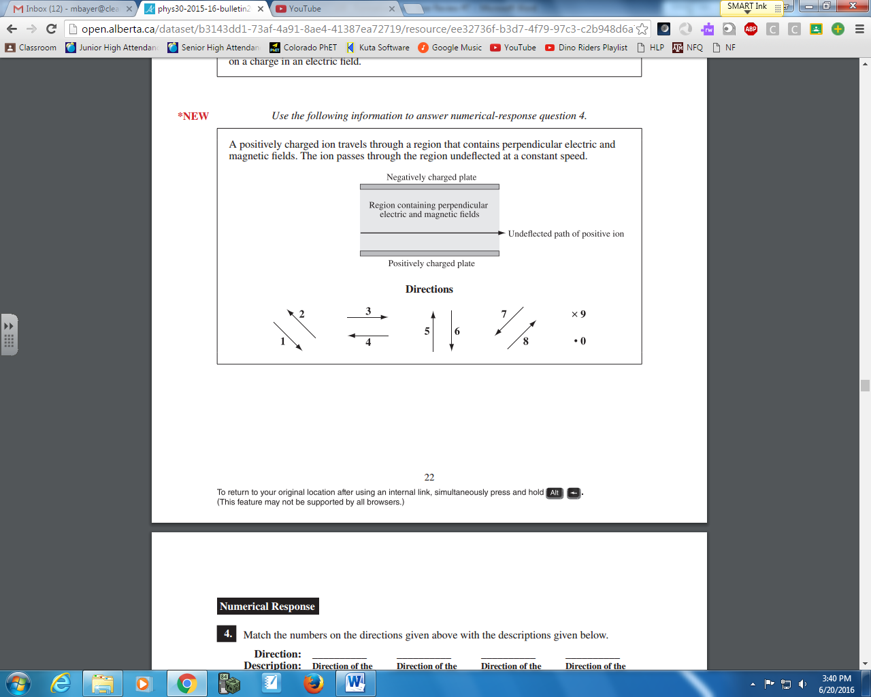

Q31: Match the numbers on the directions given above with the descriptions given below.
Direction: __________ ___________ ___________ ___________
Description: Direction of the Direction of the Direction of the Direction of the
electric force on electric field in the magnetic force on magnetic field in
the ion region the ion the region
(Record your four digit answer in the Numerical Response boxes below)

Use the following information to answer Q32-34:
Top view of a Cyclotron
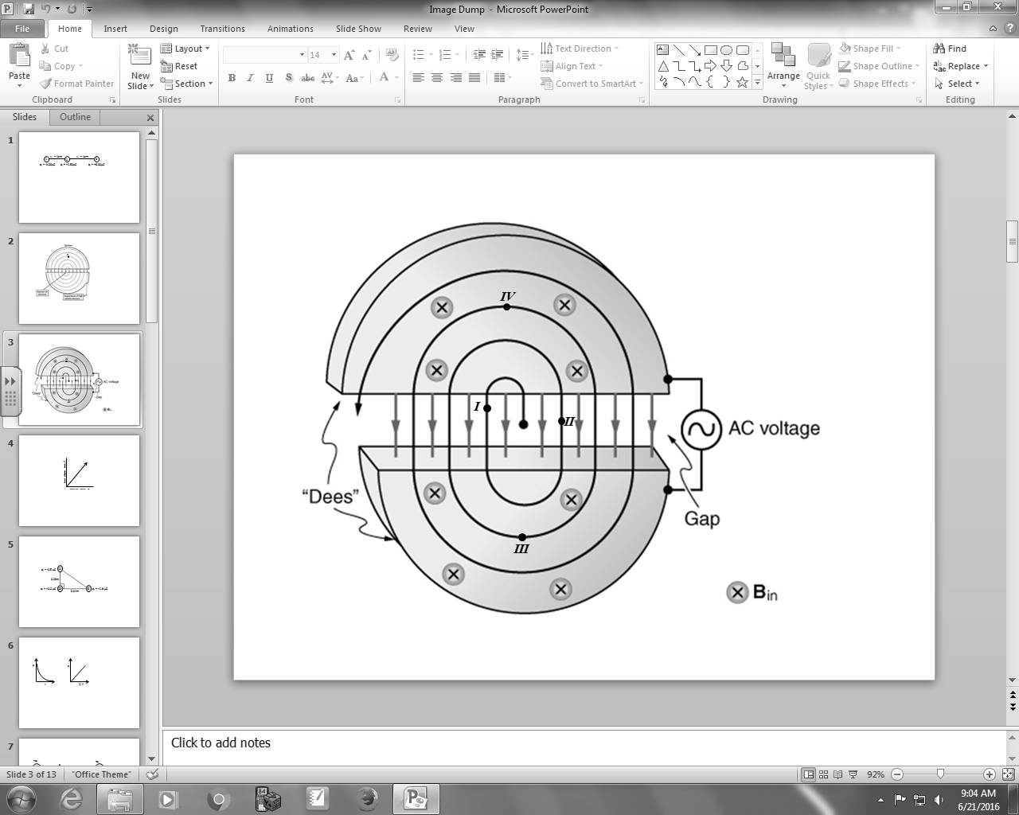
A uniform magnetic field of 3.40mT is directed into the page. At an instance in time, the electric field between the plates is directed downward.

Q32: At the instance shown above, a __i__ particle is currently at __ii__.
 | i | ii
A. | Positive | Position I
B. | Positive | Position II
C. | Negative | Position I
D. | Negative | Position II

Q33: If a proton were travelling at 7.50 x 10⁵ m/s while at Position III, and the potential difference between the plates is 6.25 x 10² V, what is the speed of the proton while at Position IV?
- 7.50 x 10⁵ m/s
- 8.26 x 10⁵ m/s
- 1.67 x 10⁶ m/s
- 1.48 x 10⁷ m/s

Q34: If the proton is at Position III and travelling at 7.50 x 10⁵ m/s, the radius of curviture is
- 1.26 x 10⁻³ m
- 4.34 x 10⁻¹ m
- 2.30 m
- 4.60 m

Use the following information to answer Q35:
The Venn diagram below can be used to compare gravitational fields, electric fields, and magnetic fields.
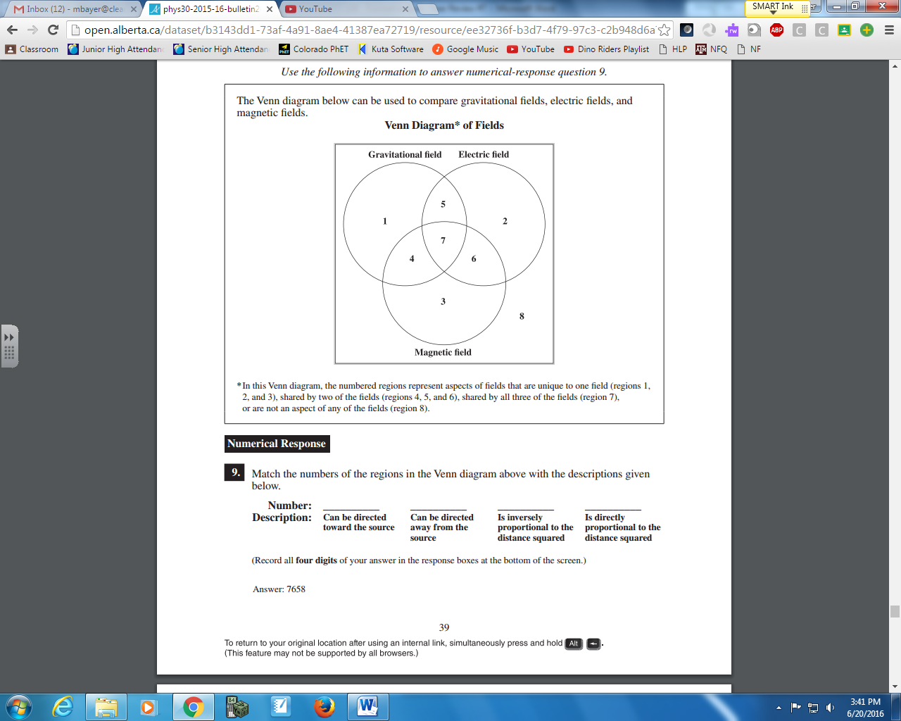
*In this Venn diagram, the numbered regions represent aspects of fields that are unique to one field (regions 1, 2, and 3), shared by two of the fields (regions 4, 5, and 6), shared by all three of the fields (region 7), or are not an aspect of any of the fields (region 8).

Q35: Match the numbers of the regions in the Venn diagram above with the descriptions given below.
Number: __________ __________ __________ __________
Description: Can be directed Can be directed Is inversely Is directly
toward the source away from the proportional to the proportional to the
source distance squared distance squared
(Record your four digit answer in the Numerical Response boxes below)

Unit 3 – EMR ___ / 24 marks
Q36: Which of the following types of electromagnetic radiation has photons that have the greatest energy?
- X-ray
- Infrared
- Ultraviolet
- Microwave

Q37: In a Michelson-type experiment, a stationary mirror and a rotating mirror are separated by 10.0 km. The lowest frequency at which a 12-sided rotating mirror must rotate to provide measurements useful in determining the speed of light, expressed in scientific notation, is a.bc x 10^{d} Hz. The values of a, b, c, and d are ____, ____, ____, and ____. (2 marks)
(Record your four digit answer in the Numerical Response boxes below)

Q38: The image formed by an object placed 12.0 cm in front of a convex mirror, which has a focal length of 10.0 cm, is
- Real, erect, and smaller
- Real, inverted, and larger
- Virtual, erect, and smaller
- Virtual, inverted, and larger

Use the following information to answer Q39:
A light ray is incident on a right angled prism in air as shown below.
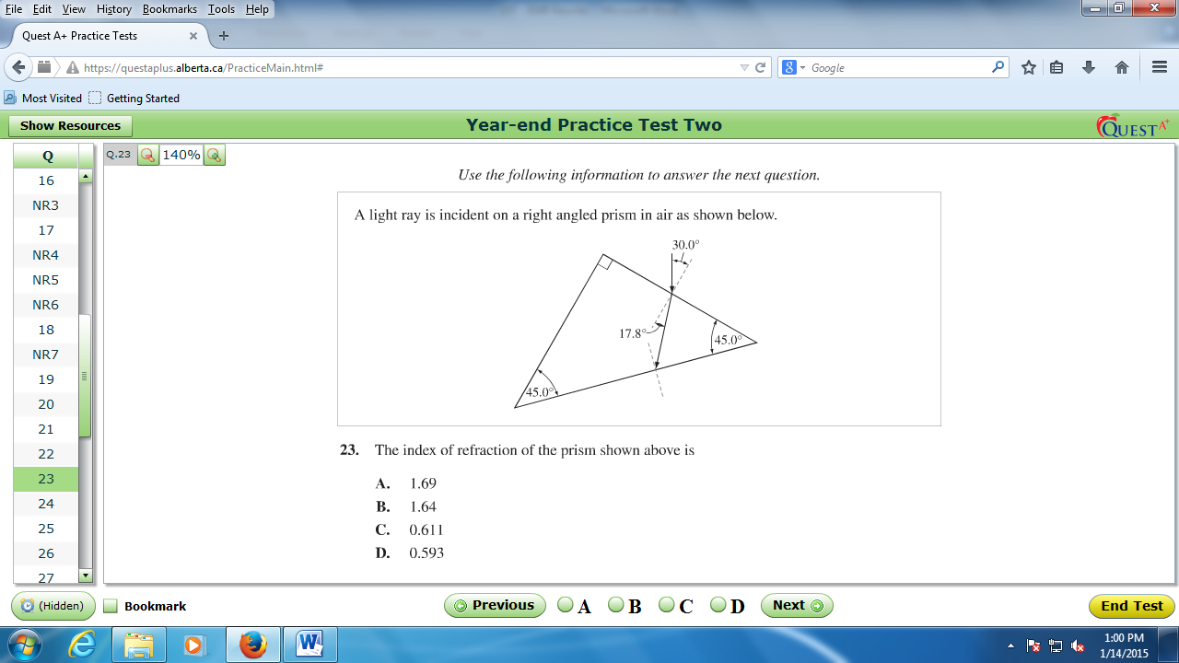

Q39: The index of refraction of the prism shown above is
- 1.69
- 1.64
- 0.611
- 0.593

Use the following information to answer Q40:
A refractometer is a device that can be used to identify gemstones by determining their index of refraction.
In one type of refractometer, a gemstone is located against the flat edge of a semi-spherical prism, as shown below. The index of refraction of the prism is 1.60.
Monochromatic yellow light that has a wavelength of 589 nm is directed so that it passes through the prism and meets the prism-gemstone interface. When the angle of incidence, ϴ_{i}, is large enough, the light does not refract into the gemstone, and is reflected. This light leaves the prism through a curved edge and is incident on a calibrated scale. The yellow light illuminates the scale, indicating the index of refraction of the gemstone.
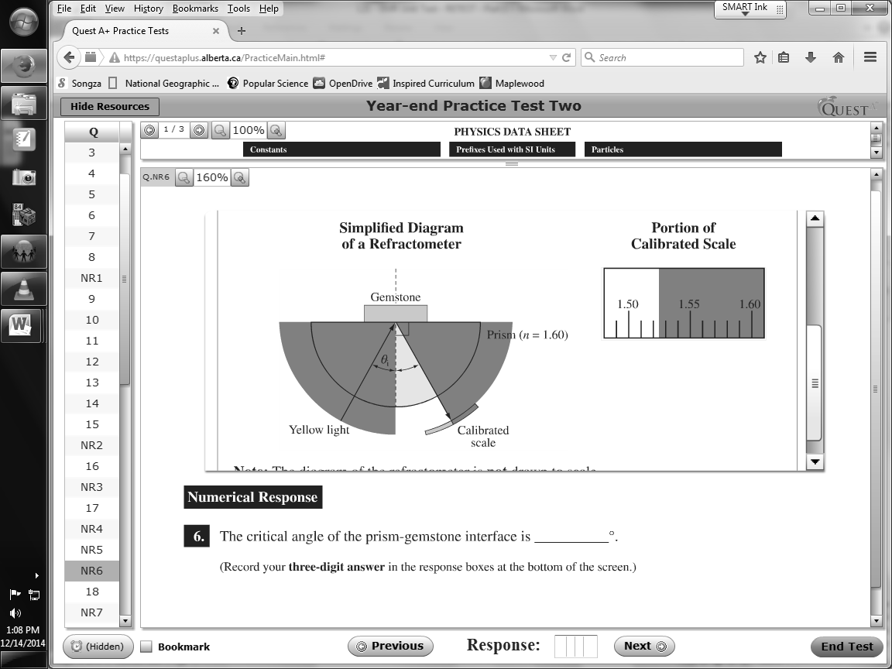
Note: The diagram of the refractometer is not drawn to scale.

Q40: The critical angle of the prism-gemstone interface is
- 2.44°
- 17.6°
- 72.4°
- 90.0°
Use the following information to answer Q41:
A laser pointer emits red light that has a wavelength of 6.50 x 10⁻⁷ m. A different laser pointer emits green light that has a wavelength of 4.80 x 10⁻⁷ m. Light from both lasers is incident on a diffraction grating, and interference patterns are produced on a screen 1.00 m from the diffraction grating. The angle of diffraction to the second order maximum for the red light is 13.3°.

Q41: The angle of diffraction to the first order maximum for the green light is
- 2.44°
- 4.87°
- 9.78°
- 13.3°

Q42: An object is placed 20.0 cm in front of a curved mirror. The image that forms is inverted and larger than the object. The type of mirror used and its focal length are, respectively,
- Convex and 15.0 cm
- Convex and 30.0 cm
- Concave and 15.0 cm
- Concave and 30.0 cm

Q43: The longest wavelength of electromagnetic radiation that will cause electrons to be emitted by a particular surface is 2.70 x 10⁻⁷ m. If radiation that has a wavelength of 1.50 x 10⁻⁷ m is incident on the surface, the maximum kinetic energy of an emitted electron is
- 1.66 x 10⁻¹⁸ J
- 1.33 x 10⁻¹⁸ J
- 7.37 x 10⁻¹⁹ J
- 5.89 x 10⁻¹⁹ J

Use the following information to answer Q44:
Phenomena Demonstrated by Electromagnetic Radiation
I Diffraction
II Interference
III Compton Scattering
IV Photoelectric Effect

Q44: Which of the following rows matches the phenomena, as numbered above, with the model of electromagnetic radiation supported by the phenomena?
Row | Particle Model | Wave Model
A. | I and II | III and IV
B. | I and III | II and IV
C. | II and IV | I and III
D. | III and IV | I and II

Use the following information to answer Q45:
In a photoelectric effect experiment, electromagnetic radiation that has a wavelength of
4.00 x 10⁻⁷ m is incident on a photocathode that has a work function of 2.50 eV.
The photocurrent produced in the experiment is 2.0 x 10⁻⁶ A.

Q45: The maximum speed of a photoelectron emitted in the experiment is
- 4.61 x 10⁵ m/s
- 9.37 x 10⁵ m/s
- 1.04 x 10⁶ m/s
- 1.40 x 10⁶ m/s

Use the following information to answer Q46:
Light from a source passes through a glass prism and the following spectrum is observed.
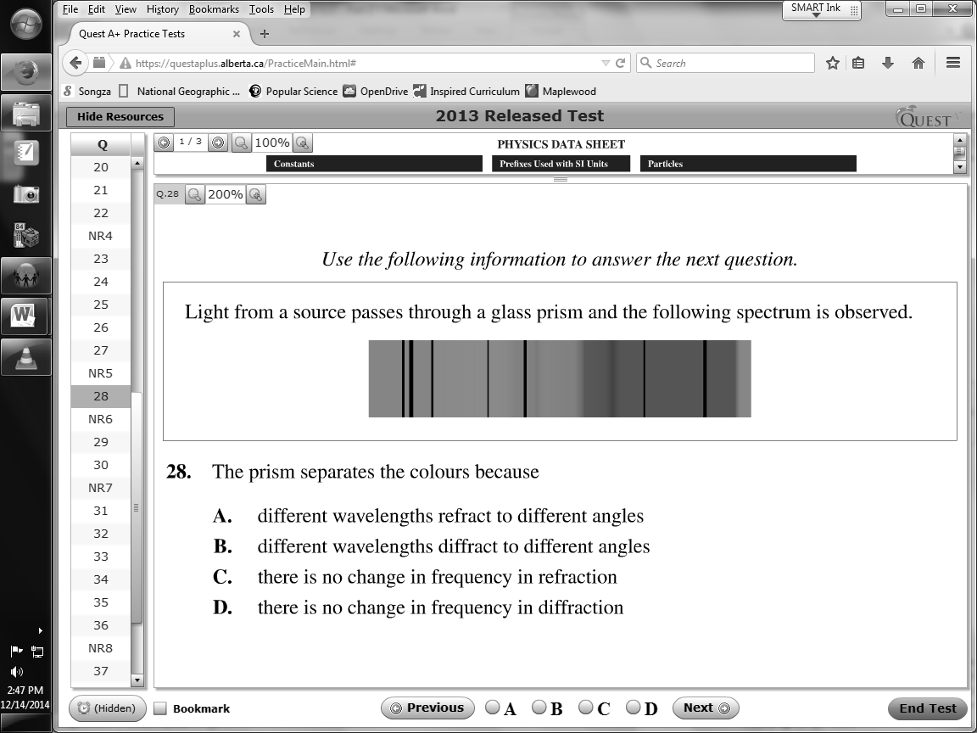

Q46: The prism separates the colors because
- Different wavelengths refract to different angles
- Different wavelengths diffract to different angles
- There is no change in frequency in refraction
- There is no change in frequency in diffraction
Use the following information to answer Q47:
In a Compton scattering experiment, an X-ray photon that has a wavelength of 0.130 nm is incident on a free, initially stationary electron. The scattered X-ray photon, which has a wavelength of 0.135 nm, travels back the way the incident photon came.
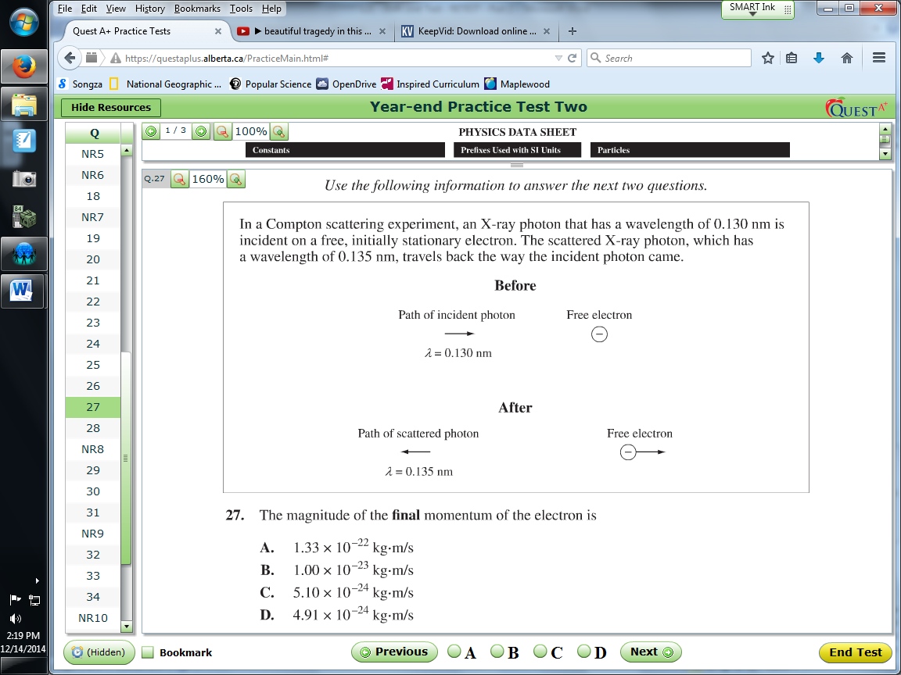

Q47: The magnitude of the final momentum of the electron is
- 1.33 x 10⁻²² kg*m/s
- 1.00 x 10⁻²³ kg*m/s
- 5.10 x 10⁻²⁴ kg*m/s
- 4.91 x 10⁻²⁴ kg*m/s

Use the following information to answer Q48:
In a photoelectric effect experiment, electromagnetic radiation (EMR) of varying frequencies is incident on each of four different metals. The intensity of EMR used for each of the metals is different. The resulting photocurrent is measured, and a graph of the results is shown below.
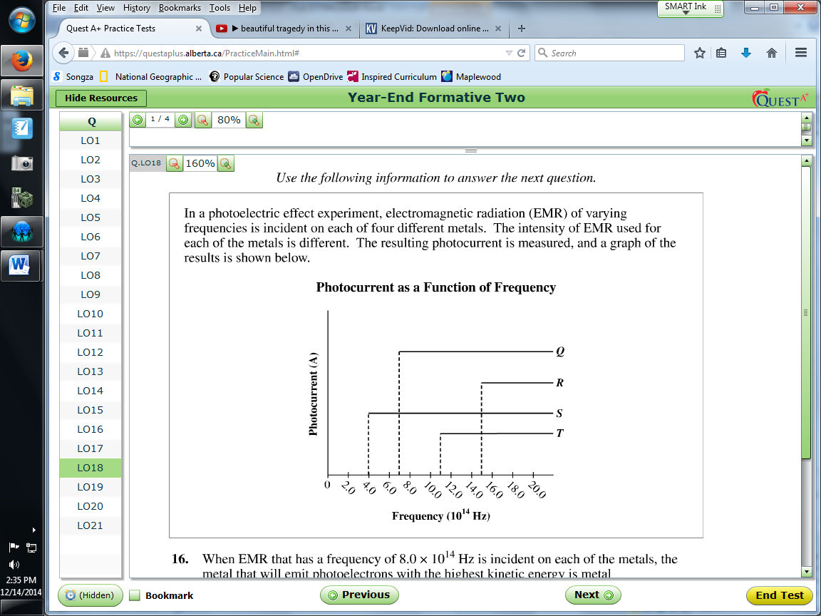

Q48: When EMR that has a frequency of 8.0 x 10¹⁴ Hz is incident on each of the metals, the metal that will emit photoelectrons with the highest kinetic energy is metal
- Q
- R
- S
- T

Use the following information to answer Q49:
One example of Compton scattering is shown below. The incident photon has a momentum of
1.83 x10⁻²³ Ns. It collides with a free electron that is initially at rest. The scattered photon has a momentum of 1.72 x 10⁻²³ Ns, 85.0° from the direction of the incident photon.
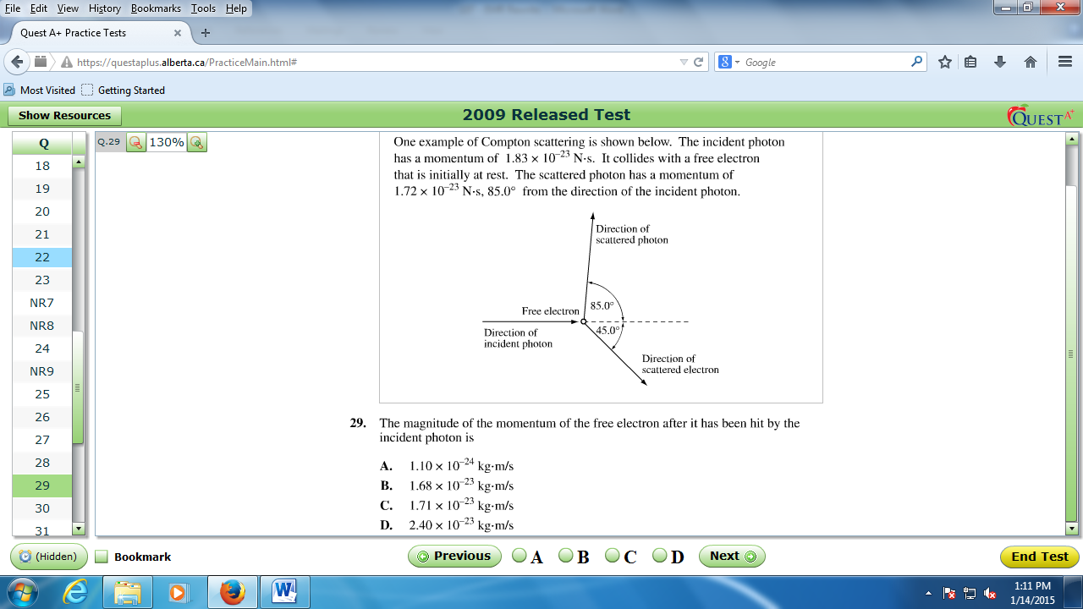

Q49: The magnitude of the momentum of the free electron after is has been hit by the incident photon is
- 1.10 x 10⁻²⁴ kg*m/s
- 1.68 x 10⁻²³ kg*m/s
- 1.71 x 10⁻²³ kg*m/s
- 2.40 x 10⁻²³ kg*m/s

Use the following information to answer Q50-Q51:
In a photoelectric effect experiment, electromagnetic radiation that has a wavelength of 4.00 x 10⁻⁷m is incident on a photocathode that has a work function of 2.50 eV.
The photocurrent produced in the experiment is 2.0 x 10⁻⁶ A.

Q50: The maximum speed of a photoelectron emitted in the experiment is
- 4.61 x 10⁵ m/s
- 9.37 x 10⁵ m/s
- 1.04 x 10⁶ m/s
- 1.40 x 10⁶ m/s

Q51: The minimum number of photons incident on the photocathode during 0.50 minutes of continuous operation is
- 4.2 x 10¹¹ photons
- 6.3 x 10¹² photons
- 1.3 x 10¹³ photons
- 3.8 x 10¹⁴ photons

Use the following information to answer Q52:
In a laboratory experiment, a microwave generator is used to produce a beam of monochromatic microwaves. These waves are incident on a series of metal tubes that forms a diffraction grating. The metal tubes are spaced 1.80 cm apart.
When the microwave signal passes through the grating, a receiver placed 52.0 cm from the grating detects a maximum signal. A first-order maximum signal is also detected at each of positions I and II, as labelled in the diagram below.
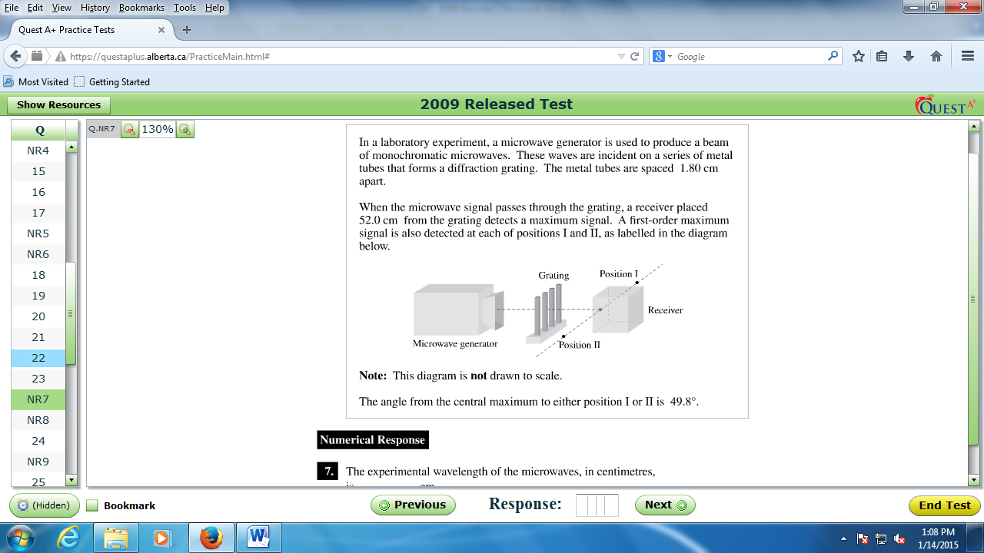
Note: This diagram is not to scale.
The angle from the central maximum to either position I or II is 49.8°.

Q52: The experimental wavelength of the microwaves, in centimeters, is _____ cm.
(Record your three digit answer in the Numerical Response boxes below)

Q53: Visible light that has a wavelength of 6.00 x 10⁻⁷ m in air is directed into fused quartz. The index of refraction of fused quartz is 1.46. The wvelength of this light inside the fused quartz, expressed in scientific notation, is _____ x 10^{-w} m.
(Record your four digit answer in the Numerical Response boxes below)

Q54: If a yellow light with a wavelength of 540 nm shines on a double slit with the slits cut 0.0100 mm apart, what is the angle between the central bright spot and the second order antinode?
- 6.19 x 10⁻³ deg
- 6.19 x 10⁻² deg
- 3.10 deg
- 6.20 deg

Use the following diagram to answer Q55:
X-Ray Production
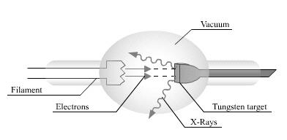
In the above diagram, X-Rays of frequency 5.2 x 10¹⁶ Hz are produced by high-energy electrons

Q55: The high-energy electrons have a velocity a.bc x 10^{d} m/s. The values of a, b, c, and d are ____, ____, ____, and ____. (1 mark)
(Record your four digit answer in the Numerical Response boxes below)

Use the following information to answer Q56:
Students use three of the optical apparatus illustrated below to produce a focused, real image in a darkened room. One of the apparatus has a focal length of 6.55 cm.
Optical Apparatus
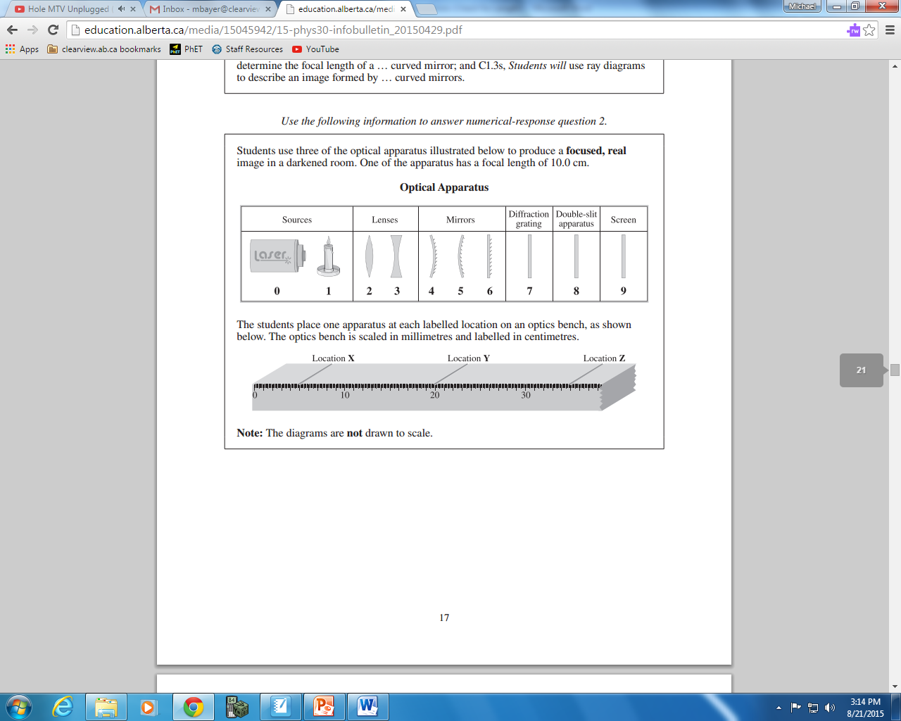
The students place one apparatus at each labelled location on an optics bench, as shown below. The optics bench is scaled in millimeters and labelled in centimeters.
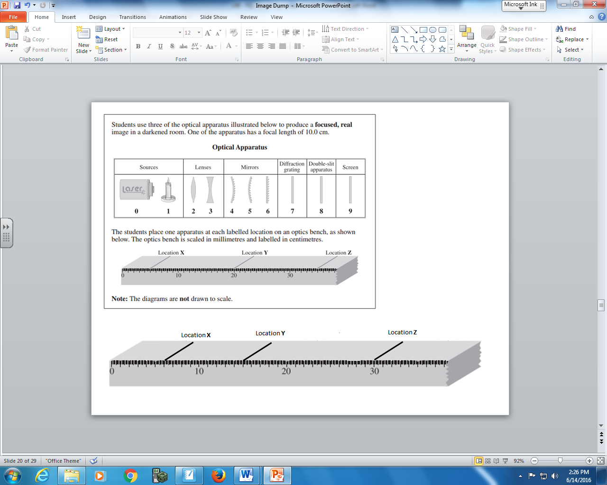
Note: The diagrams are not drawn to scale.

Q56: The apparatus placed at location
X is numbered _______ (Record in the first column)
Y is numbered _______ (Record in the second column)
Z is numbered _______ (Record in the third column)
(Record your four digit answer in the Numerical Response boxes below)

Use the following to answer Q57:
The Photoelectric Effect
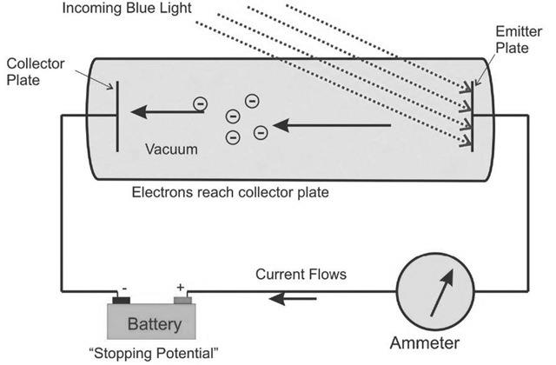
Blue light of wavelength 465 nm is incident on a Cesium surface. The electrons are stopped from reaching the collector plate by applying a Stopping Potential of 0.570 Volts.

Q57: What is the work function of the Cesium target, in eV?
(Record your three digit answer in the Numerical Response boxes below)

Use the following information to answer Q58:
When a girl who is 122 cm tall stands 40 cm in front of a particular mirror, her virtual image in the mirror is upright and 54 cm tall.

Q58: The mirror is __i__, and the girl’s image is located __ii__ away from the mirror.
 | i | ii
A. | convex | 18 cm
B. | convex | 90 cm
C. | concave | 18 cm
D. | concave | 90 cm

Q59: An electron is accelerated from rest using an accelerating voltage of a.bc x 10^{d} Volts and collides with a tungsten target to generate an X-Ray of energy 4.8 x 10⁻¹⁷ J. The values of a, b, c, and d are ____, ____, ____, and ____. (1 mark)
(Record your four digit answer in the Numerical Response boxes below)

