First Name:__________________________________ Last Name:______________________________

L24 – Worksheet – Buffer Day – Cumulative Review

All questions on this worksheet have been given to the students previously… but it is good to review. Questions have intentionally not been put in any particular order.
Cumulative Review
Use the following information to answer Q1:
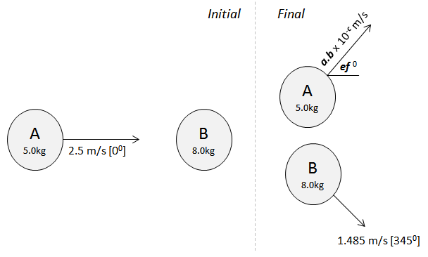

Q1: In an isolated system, Object A hits Object B inelastically. Object A then rebounds upward with a velocity of a.b x 10^{-c} m/s [ef ⁰], where a, b, e, and f are ___, ___, ___, and ___.
(Record your four digit answer in the Numerical Response boxes below)

Use the following information to answer Q2:
Charge by Induction
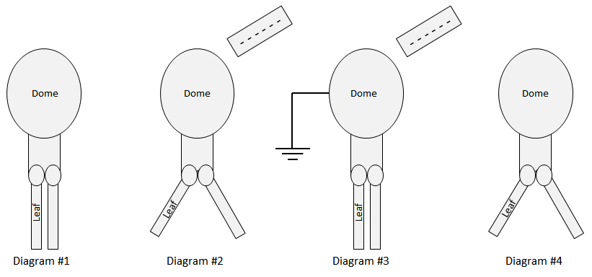
Nature of Charge
1 – Positive
2 – Negative
3 – Neutral

Q2: Match the numbers representing Nature of Charge with the regions given below.
Nature of Charge: ________ ________ ________ ________
Region: Dome in Leaves in Dome in Leaves in
Diagram #2 Diagram #2 Diagram #4 Diagram #4

(Record your four digit answer in the Numerical Response boxes below)

Use the following information to answer Q3-Q4:
Two positively charged spheres are held 1.00m apart. Once released, both charges electrostatically repel from each other, per the diagram below.
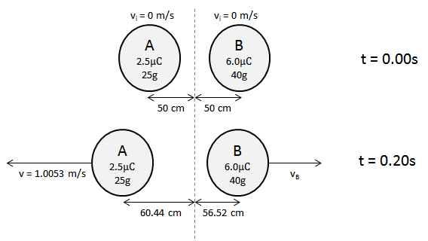

Q3: The instantaneous acceleration of Object A, the moment it is released, is
- 5.39 x 10⁻³ m/s²
- 2.16 x 10⁻² m/s²
- 5.39 m/s²
- 2.16 x 10¹ m/s²

Q4: What is the impulse experienced by Object A within the first 0.20 seconds?
- 2.35 x 10⁻² Ns
- 2.51 x 10⁻² Ns
- 2.70 x 10⁻² Ns
- 2.87 x 10⁻² Ns

Use the following information to answer Q5 and Q6:
Three Point Charges
Three point charges are arranged according to the diagram below. Charge 2 experiences a force due to the presence of Charge 1 and Charge 2.
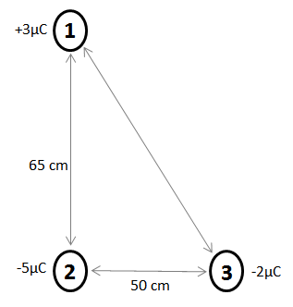
Directions
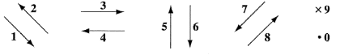

Q5: Use the vector directions above to fill in the blanks below.
Direction: __________ __________ __________
Description: Direction of Direction of Direction of
Force acting on Force acting on Net Force acting
Charge 2 due to Charge 2 due to on Charge 2
Charge 1 Charge 3

(Record your three-digit answer in the Numerical Response boxes below)

Q6: The magnitude of the net electrostatic force acting on Charge 2 is a.bc x 10^{-d} N, where a, b, c, and d are ___, ___, ___, and ___.
(Record your four-digit answer in the Numerical Response boxes below)

Use the following information to answer Q7-Q9:
Two conductive spheres are arranged per the diagram below.
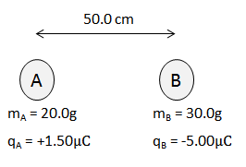
The conductive spheres are momentarily brought into contact, and then returned to their original position. Both items are then released simultaneously.

Q7: The acceleration of Object B is
- 3.67 m/s² [Right]
- 3.67 m/s² [Left]
- 8.99 m/s² [Right]
- 8.99 m/s² [Left]

Q8: When predicting the acceleration of Object B, state the two physics principles you used, in the order you used them.
(Record your two digit answer in the Numerical Response boxes below)

Q9: Which situation best describes the relative impulses experienced by each object at the moment of release?
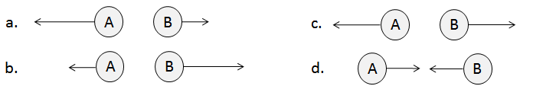
Use the following information to answer Q10:
The electrostatic attraction between a +3.00μC charge and an unknown charge is graphed below.
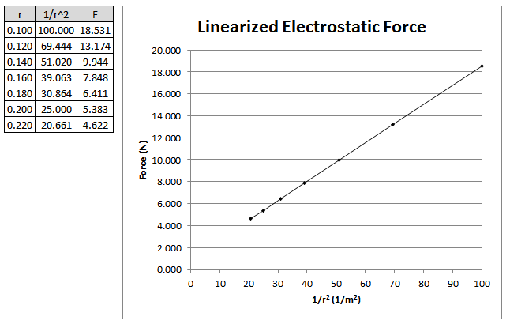

Q10: The unknown charge is
- +6.50μC
- -6.50μC
- +6.87μC
- -6.87μC

Use the following information to answer Q11:
A 50g rigid sphere, initially travelling at 1.5m/s [W], strikes a wall. The force-time graph is depicted below.
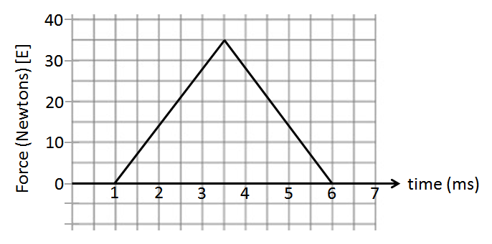

Q11: The ball rebounds with a velocity of _____ m/s [E].
(Record your three digit answer in the Numerical Response boxes below)

Use the following information to answer Q12:
Two parallel plates are 1.35m apart, with a Potential Difference of 40.5V, as shown below.
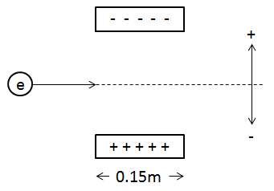
An electron is fired horizontally at 2.40 x 10⁵ m/s through the plates.

Q12: Upon exiting the plates, the electron will have experienced a vertical deflection of ____ m. (5 marks)
(Record your three digit answer in the Numerical Response boxes below)

Use the following information to answer Q13:
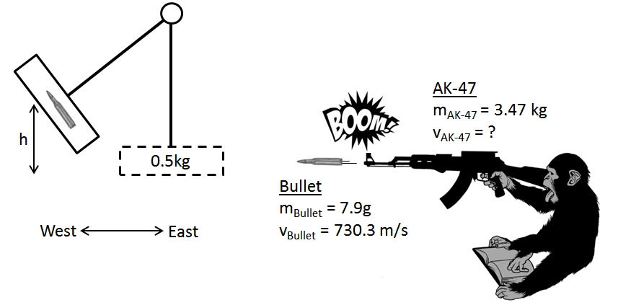

Q13: After impact, the pendulum swings forward and rises to what height, in meters?
(Record your three digit answer in the Numerical Response boxes below)

Use the following information to answer Q14-Q15:

An electron is injected into a parallel plate apparatus per the diagram below:
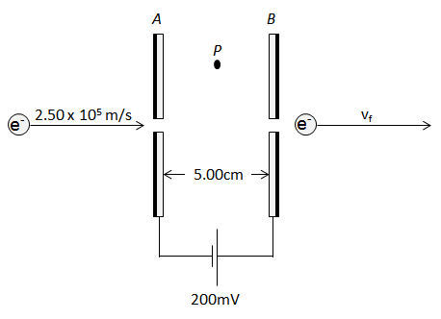

Q14: In the diagram above, Plate A is __i__ charged and the electric field at Point P is to the __ii__.

 | i. | ii.
A. | positively | right
B. | positively | left
C. | negatively | right
D. | negatively | left

Q15: Upon exiting the plates, the final velocity of the electron is a.bc x 10^{d} m/s, where a, b, c, and d are ___, ___, ___, and ___.

(Record your four digit answer in the Numerical Response boxes below)

Use the following information to answer Q16:
A proton is placed between two parallel plates.
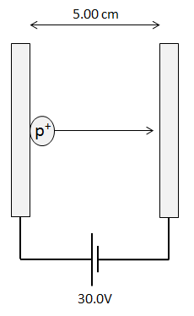

Q16: The impulse imparted to the proton is a.b x 10^{-cd} Ns, where a, b, c, and d are ___, ___, ___, and ___.
(Record your four digit answer in the Numerical Response boxes below)

Use the following information to answer Q17:
Moving electrons can be deflected by electric fields, gravitational fields, and magnetic fields. One electron is allowed to enter each type of field, as shown below.
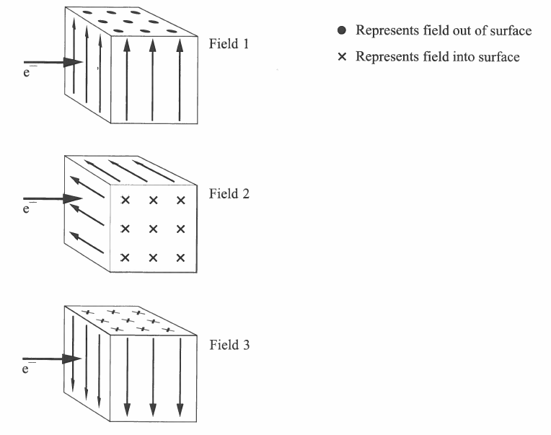

Q17: If the electron is deflected downward in each field, then field 1, field 2, and field 3 are, respectively,
- Electric, magnetic, and gravitational
- Gravitational, magnetic, and electric
- Magnetic, gravitational, and electric
- Magnetic, electric, and gravitational
Use the following information to answer Q18:

Magnetic Fields around Current in a Wire
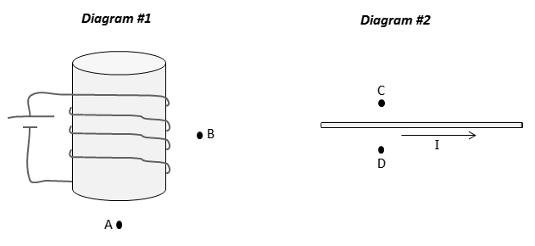
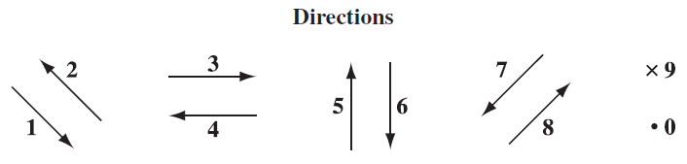

Q18: The directions of magnetic fields at various locations can be described using the numbers given above.
Direction: __________ __________ __________ __________
Field: Direction of Direction of Direction of Direction of
magnetic field magnetic field magnetic field magnetic field
at Position A at Position B at Position C at Position D
(Record your four digit answer in the Numerical Response boxes below)

Use the following information to answer Q19:
A loop of wire is rotated in a magnetic field, per the diagram below.
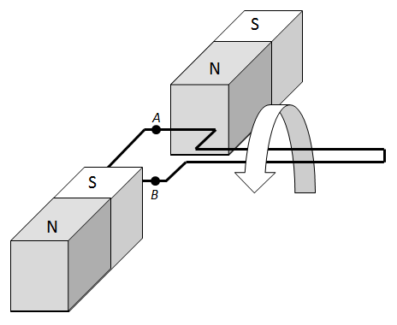

Q19: The directions of the motion of the wire, the magnetic field, and the induced current can be described using the numbers given above.
Direction: ____________ ____________ ____________
Field: Direction of Direction of the Direction of the
magnetic field motion of the induced current
at Position A wire at Position A at Position A
(Record your three digit answer in the Numerical Response boxes below)

