First Name:_______________________________ Last Name:______________________________

Physics 20 – Practice Final Exam

Competency 1: Kinematics (20%) – 11 marks
▪ Synthesis – 2 marks
Competency 2: Dynamics (20%) – 9 marks
Competency 3: Gravity and Circular Motion (20%) – 7 marks
Competency 4: Conservation of Energy and Oscillatory Motion (15%) – 11 marks
▪ Synthesis – 2 mark
Competency 5: Mechanical Waves (5%) – 5 marks
Competency 1 – Kinematics
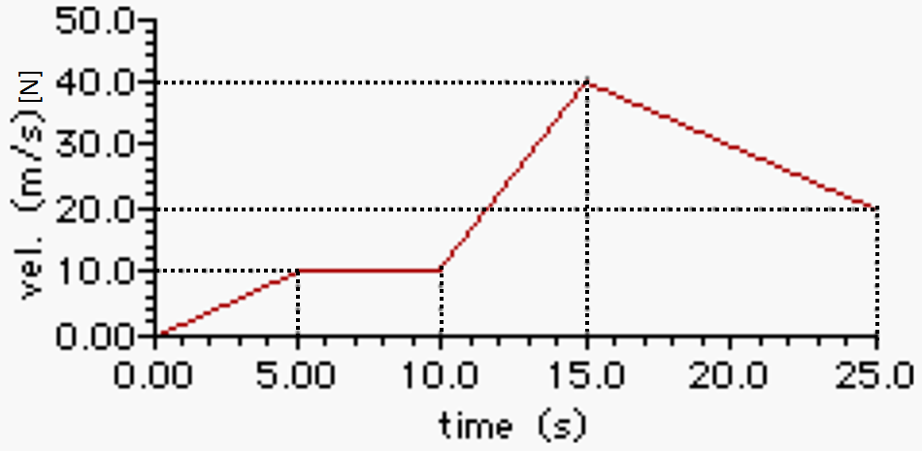
Use the following diagram to answer questions in this competency.

The above diagram represents the movement of a cheetah trying to catch an antelope.

Q1: What is the velocity of the cheetah at 15 seconds? (1 mark)

Q2: What is the acceleration of the cheetah between 16.25 and 23.4 seconds? (1 mark)

Q3: What is the displacement of the cheetah between 15 and 25 seconds? (1 mark)

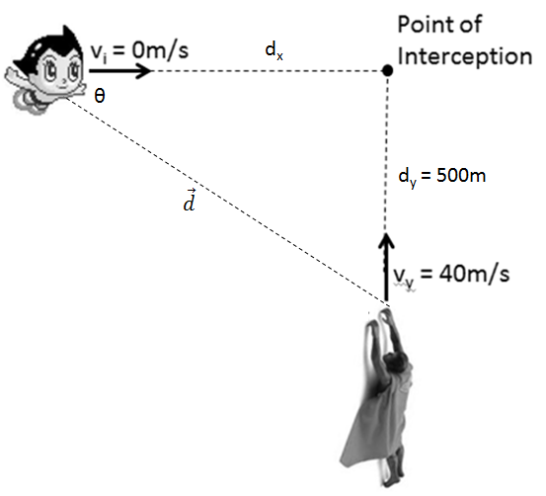
Q4: Superman is flying 40m/s [North] when a stationary Astroboy accelerates 3m/s² [East] to intercept. What is Superman’s initial displacement (Magnitude and Direction) from Astroboy? (4 marks)

Use the following diagram to answer question 5.
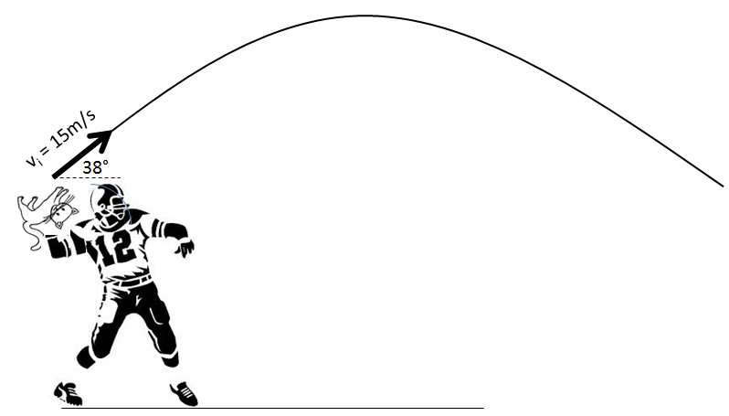
A football player throws a cat 15m/s [38°], as depicted above.
Q5: If the ball is caught by a stationary receiver of the same height, how far away is the receiver? (4 marks)

Competency 2 – Dynamics
Use the following diagram to answer questions in this competency.
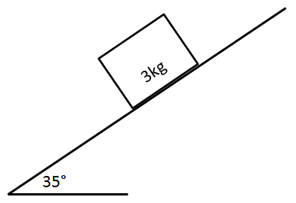
A mass of 3kg is on a 35° incline ramp. The block is currently stationary, but is just about to start slipping.
Q1: What is the coefficient of static friction $(µ_{s})$ between the block and the ramp? (3 marks)

Use the following diagram to answer questions 2 and 3.
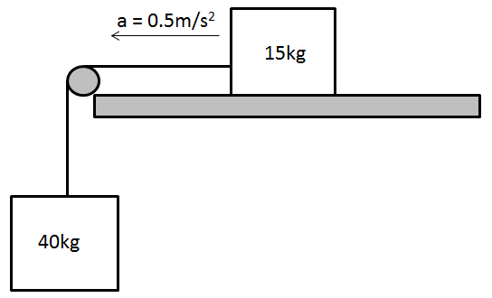
Q2: What is the coefficient of kinetic friction between the 15kg block and the table? (3 marks)

Q3: What is the tension in the rope? (3 marks)

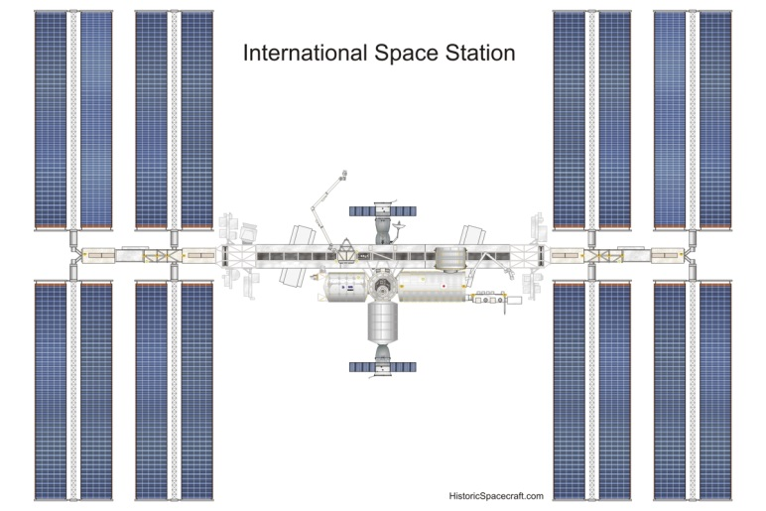
Competency 3 – Gravity and Circular Motion
Q1: The International Space Station is in a Low-Earth-Orbit, at a height of 400km (4.0x10⁵m) above the surface of the Earth. How long does it take the International Space Station to make one full revolution around the Earth? (4 marks)
HINT: Look up information in your Physics 30 Formula Sheet.
Use the following diagram to answer question 2.
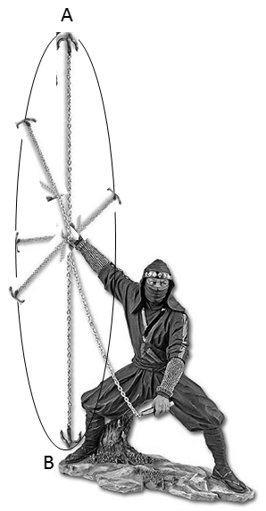
Q2: A ninja (depicted above) is swinging a 2kg grappling hook in a vertical circle of radius 1.2m and period 0.8 seconds. What is the tension at the top of the loop (Position A)? (3 marks)

Competency 4 – Conservation of Energy and Oscillatory Motion
Use the following diagram to answer questions in this competency. Assume that the surface is frictionless and mechanical energy is conserved. The object is initially stationary at Position 1.
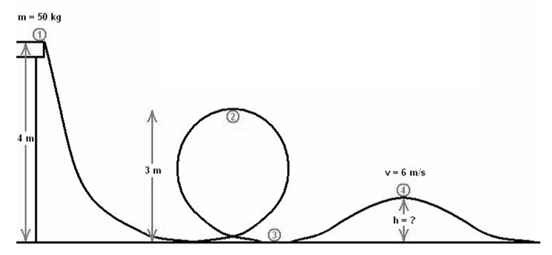
Q1: What is the speed of the object at Position 2? (3 marks)

Use the following diagram to answer questions in this competency.
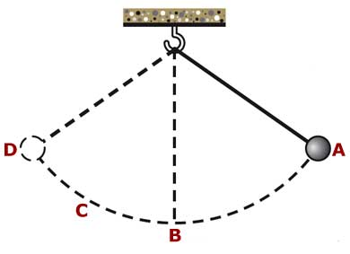
Q2: At which point(s) does the pendulum have the greatest restoring force? Explain. (1 mark)

Q3: At what point(s) does the pendulum have the greatest speed? Explain. (1 mark)

Q4: If the pendulum arm length is 0.85m, the mass attached is 6kg, and pendulum arm is raised 40°, how long does it take the pendulum to go from Position A to Position D? (3 marks)

Q5: A bow and arrow (m = 20g) of spring constant 420N/m is pulled back 0.61m and fired vertically upwards. How fast is the arrow travelling when it reaches 10m above the launch point, assuming energy is conserved? (3 marks)
Competency 5 – Mechanical Waves
Use the following diagram to answer questions in this competency.
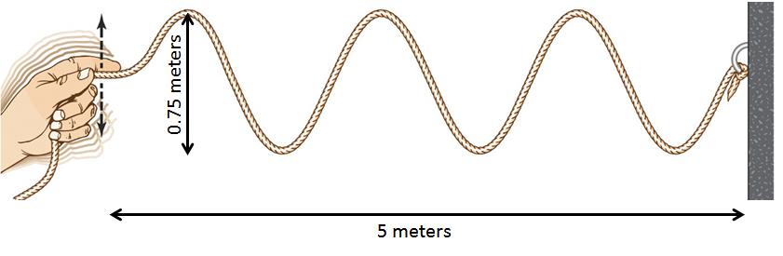
Q1: What is the amplitude of this wave? (1 mark)

Q2: What is the wavelength of this wave? (1 mark)

Q3: If 2.6 wave pulses reach the wall per second, how fast is the wave travelling? (3 marks)

Synthesis-Level Question
Q1: A 50kg pendulum falls 5m to hit a 65kg swimmer off of a 6m ledge, as depicted below. If only 20% of the kinetic energy of the pendulum is transferred to the swimmer, how far from the ledge does he land?
MARKING:
2 marks – Competency 4: Conservation of Energy and Oscillatory Motion
2 marks – Competency 1: Kinematics
ARE YOU STUCK?
You can use the swimmer’s v_{i} = 2m/s if you are unable to calculate their initial speed. MAXIMUM 2/4 marks.

