L01 – 6.0 Factoring Review
Part 1 – Polynomial Terminology
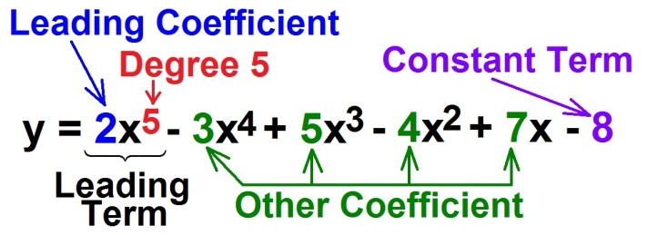
Q1: Complete the following table:
Polynomial | Leading Coefficient | Degree | Constant | Number of Terms | Type of Polynomial
$$2x^{2}-5x+6$$
$$x^{2}-49$$
$${-2x}^{3}+6x^{2}-8$$

Part 2 – Adding and Subtracting Polynomials without Tiles
Q2: Simplify $\left(x^{2}+5x+2\right)+\left({2x}^{2}-3x-5\right)$ Q3: Simplify $\left({2x}^{2}-2x+6\right)-\left(x^{2}+3x-2\right)$

Q4: Simplify $\left(2x-5\right)-\left(x^{2}-3\right)+\left(x^{2}+6\right)$ Q5: Simplify $\left({2x}^{2}\right)+\left(5x-2y\right)-\left(x^{2}-3x\right)$
Part 3 – Multiplying Polynomials without Tiles
Q6: Simplify $2x\left(3x+1\right)$ Q7: Simplify $\left(3x\right)\left(2x-1\right)$

Q8: Simplify $\left(x+1\right)\left(x+2\right)$ Q9: Simplify $\left(2x+1\right)\left(x-3\right)$

Q10: Simplify $\left(2x+1\right)\left(3x-1\right)$ Q11: Simplify $\left(3x+2\right)\left(2x-3\right)$

Part 4 – Harder Questions
Q12: Simplify $\left(x+2\right)\left(x^{2}-2x+5\right)$ Q13: Simplify ${\left(x+5\right)}^{2}$

Q14: Simplify ${\left(a-3\right)}^{2}+\left(a+4\right)\left(2a-3\right)$

Part 5: Perimeters and Areas

Use the following information to answer Q15-Q17:

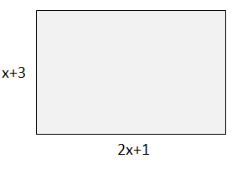

Q15: (Long Answer) Write an expression for the perimeter of the object.

Q16: The area of the object can be written as $ax^{2}+bx+c$, where a, b, and c are ___, ___, and ___.
(Record your three digit answer in the Numerical Response boxes below)

Q17: If the object has a perimeter of 32 meters, what is the area of the object, in m²?

(Record your two digit answer in the Numerical Response boxes below)

Part 6: Finding a Common Factor versus Common Factoring an Expression

Q18: What is the difference between a question that asks “What is the Common Factor” and a question that asks you to “Common Factor the Expression”?

Expression | What is the Greatest Common Factor (GCF)? | Common Factor the Expression
$$2x^{6}-8x^{4}$$
$$x^{3}-5x^{2}+3x$$
$${4x}^{3}-6x^{2}+8x$$
$$3x^{2}y^{5}-15x^{7}y^{3}$$
$$3x^{2}-6x+12$$
$$98x^{3}-18{xy}^{2}$$

Part 7: Factoring using the “Box Method”

Q19: Factor the following questions:

$x^{2}+5x+6$ $x^{2}+7x+12$ $x^{2}-x-6$

$x^{2}-9x+20$ $x^{2}+0x-25$ $x^{2}-16$

Part 8: Factoring using the “Box Method” and Common Factors

Q20: Factor the following questions:

${3x}^{2}+6x+3$ $x^{2}+0x-25$

$2x^{3}-12x^{2}+16x$ $3x^{3}y^{2}-6x^{2}y^{2}-45xy^{2}$

$2x^{3}-18x$ $3x^{3}y+6x^{2}y+12xy$

Part 9: Step #2: Factoring using Decomposition

Q21: Factor the following questions:

$2x^{2}+7x+3$ $2x^{2}+11x+15$ $6x^{2}-11x-10$

$3x^{2}+7x-20$ (Option #1) $3x^{2}+7x-20$ (Option #2)

Part 10: Alternate Method: Factoring using Algebra Tiles

Q22: Factor the following question:

$$2x^{2}+7x+3$$

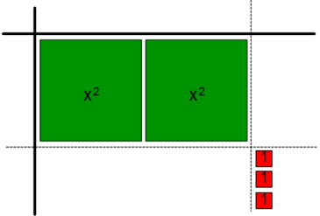
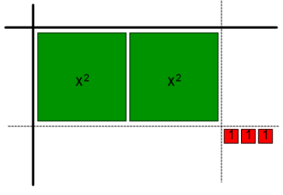
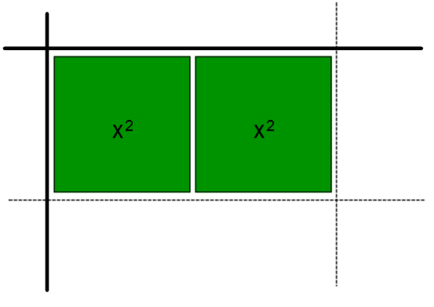

Part 11: (Harder) Factoring with both Common Factors and Decomposition

Q23: Factor the following question:

$${4x}^{3}+14x^{2}+6x$$

Part 12: Factoring Special Polynomials – No Middle Term

Q24: Factor the following:

$x^{2}-25$ ${4x}^{2}-49$

Part 13: Factoring Special Polynomials – Perfect Squares

Q25: Factor the following:

$x^{2}+10x+25$ $x^{2}-10x+25$

Part 14: Factoring Special Polynomials with “y” terms

Q26: Factor the following:

${4x}^{2}-9$ ${4x}^{2}-9y^{2}$

Part 15: Areas of Shapes

Use the following information to answer Q27-Q28:

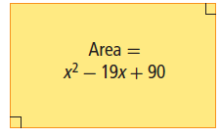

Q27: The length of the rectangle can be expressed as $\left(x-a\right)$ and the width as $\left(x-bc\right)$, where a, b, and c are ___, ___ and ___.

(Record your three digit answer in the Numerical Response boxes below)

Q28: If x=11 cm, what is the perimeter of the rectangle, in cm²?
(Record your three digit answer in the Numerical Response boxes below)

Use the following information to answer Q29:

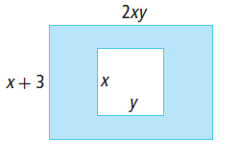

Q29: (Long Answer) Write and expression in fully factored form for the shaded area. (4 marks)

