L02 – Worksheet – Adding, Subtracting, Restrictions – Math 20-2 Section
Pg 188 #4: Write in mixed radical form, then simplify.
$\sqrt{8}-\sqrt{32}+\sqrt{512}$ $-\sqrt{27}+\sqrt{75}-\sqrt{12}$

Pg 188 #5acd: Simplify.
$\sqrt{72}+\sqrt{50}$ $\sqrt{32}+5\sqrt{2}+\sqrt{400}$ $3\sqrt{20}+4\sqrt{60}+\sqrt{125}$

Pg 188 #6acd: Simplify.
$\sqrt{40}-\sqrt{360}$ $5\sqrt{32}-7\sqrt{2}-\sqrt{484}$ $3\sqrt{18}-6\sqrt{45}-5\sqrt{108}$

Pg 188 #9: Express the perimeter of each figure in simplest form.
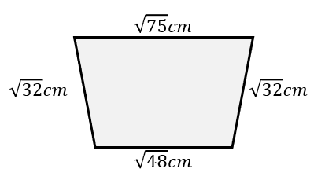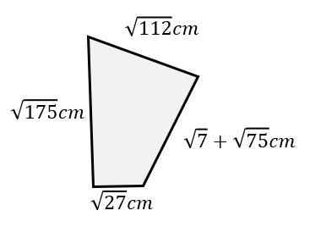

Pg 188 #11: A design for an overpass is shown. Determine the total length of steel needed to form the angled support section of the bridge. Express our answer as a radical in simplest form.
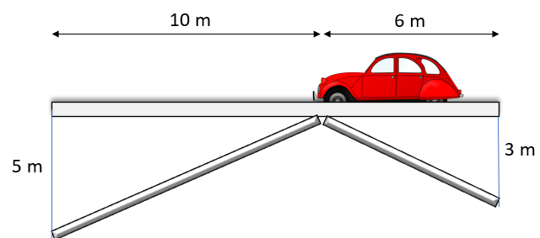

L02 – Worksheet – Adding, Subtracting, Restrictions – Math 20-1 Section
Pg 278 #15: A square is inscribed in a circle. The area of the circle is $38π$ m².
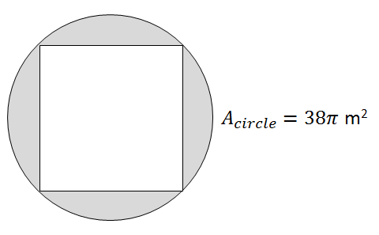
- What is the exact length of the diagonal of the square?
- Determine the exact perimeter of the square.

