L03 – Worksheet
Part 1 – Mixed and Entire Radicals
Q1: Convert the following entire radicals to mixed radicals.
$\sqrt{45}$ $\sqrt{48x^{2}y^{5}}$ $\sqrt[3]{250x^{5}}$

Q2: The entire radical $\sqrt{63x^{7}}$ simplifies to $ax^{b}\sqrt{cx^{d}}$ , where a, b, c, and d are ___, ___, ___, and ___.
(Record your four-digit answer in the Numerical Response boxes below)

Q3: The entire radical $\sqrt{50x^{5}}$ simplifies to $ax^{b}\sqrt{cx^{d}}$ , where a, b, c, and d are ___, ___, ___, and ___.
(Record your four-digit answer in the Numerical Response boxes below)

Q4: The entire radical $\sqrt[3]{384x^{8}}$ simplifies to $ax^{b} \sqrt[3]{cx^{d}}$ , where a, b, c, and d are ___, ___, ___, and ___.
(Record your four-digit answer in the Numerical Response boxes below)

Part 2 – Restrictions
Q5: State the restrictions for each expression.
$\sqrt{x}$ $\sqrt{x+2}$ $\sqrt{x-5}$

Q6: State the restrictions for each expression.
$\sqrt{2x+3}$ $\sqrt{5-2x}$ $\sqrt{2x-5}$

Q7: What are the restrictions on the expression $\sqrt{5x-2}$ ?
- $x≥\frac{2}{5}$ b. $x≤\frac{2}{5}$ c. $x≥\frac{5}{2}$ d. $x≤\frac{5}{2}$

Q8: What are the restrictions on the expression $\sqrt{4-3x}$ ?
- $x≥\frac{3}{4}$ b. $x≤\frac{3}{4}$ c. $x≥\frac{4}{3}$ d. $x≤\frac{4}{3}$

Part 3 – Adding and Subtracting Radicals
Q9: Simplify the expressions
$\sqrt{20}+\sqrt{45}$ $\sqrt{32}+\sqrt{98}$

Q10: Simplify the expressions
$\sqrt{27}+\sqrt{48}+\sqrt{12}$ $\sqrt{28}+\sqrt{63}-\sqrt{7}$

Q11: The expression $\sqrt{80}+\sqrt{18}+\sqrt{20}+\sqrt{32}$ simplifies to $a\sqrt{b}+c\sqrt{d}$ , where a, b, c, and d are ___, ___, ___, and ___.
(Record your four-digit answer in the Numerical Response boxes below; Multiple correct answers exist)

Q12: The expression $\sqrt{27}+\sqrt{50}-\sqrt{48}+\sqrt{2}$ simplifies to $a\sqrt{b}-c\sqrt{d}$ , where a, b, c, and d are ___, ___, ___, and ___.
(Record your four-digit answer in the Numerical Response boxes below)

Part 4 – Harder Questions
Use the following information to answer Q13:
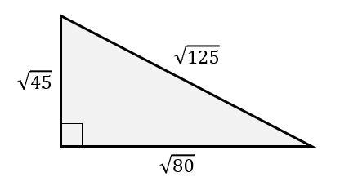
Q13: The perimeter of the shape, as a mixed radical, is $ab\sqrt{c}$ , where a, b, and c are ___, ___, and ___.
(Record your three-digit answer in the Numerical Response boxes below)

Use the following information to answer Q14:
A toy car is released down a bent ramp, as depicted below.
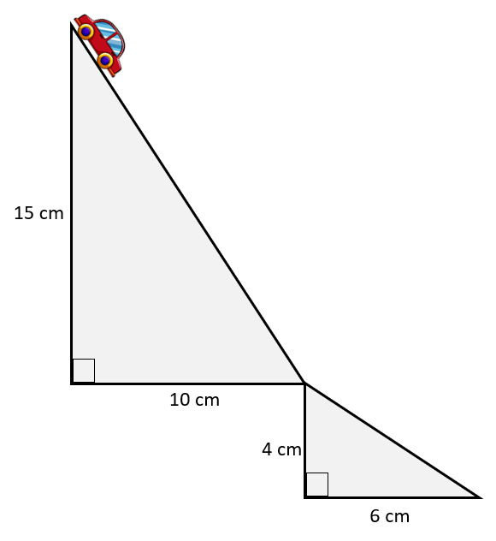
Q14: The total distance travelled by the toy car, from top to bottom, is $a\sqrt{bc}$ centimeters, where a, b, and c are ___, ___, and ___.
(Record your three-digit answer in the Numerical Response boxes below)

