L04 – Worksheet
Pg 198 #1acd: Write each expression in simplest form.
$\sqrt{5}*\sqrt{6}$ $2\sqrt{3}*\sqrt{24}$ $7\sqrt{32}*2\sqrt{48}$

Pg 198 #5ade: Expand each expression and simplify.
$7\left(3+\sqrt{12}\right)$ $2\sqrt{3}\left(\sqrt{18}+5\sqrt{2}\right)$ $\left(6+\sqrt{6}\right)\left(5+\sqrt{10}\right)$

Pg 198 #9a: Determine which figure covers the greater area (i) using radicals, and (ii) using decimals.
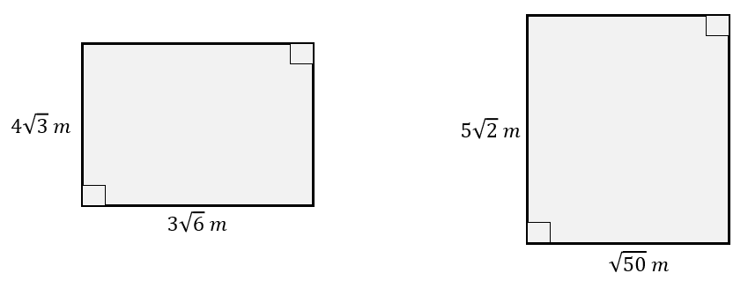

Pg 203 #10abc: Simplify. Express your answer in simplest form.
$\sqrt{7}*\sqrt{8}$ $\sqrt{12}*\sqrt{10}$ $3\sqrt{5}*\sqrt{15}$

Pg 203 #12acd: Expand and simplify.
$\sqrt{2}\left(4+5\sqrt{3}\right)$ $\left(\sqrt{3}+\sqrt{7}\right)\left(5+8\sqrt{10}\right)$ $\left(2\sqrt{3}+3\sqrt{5}\right)\left(2\sqrt{3}-3\sqrt{5}\right)$

