L07 –Radical Equations
Part 1 – Key Ideas
Extraneous Roots – A solution to an equation that appears to be correct, but when we attempt to verify it, we discover that it does not work.
To identify whether a root is extraneous, substitute the value into the original equation. Raising both sides of an equation to an even exponent may introduce an extraneous root.
When determining restrictions on the values for variables, remember:
- Denominators cannot be equal to zero.
- For radicals to be real numbers, radicands (the number under the root) must be non-negative if the index is an even number.
Part 2 – Examining Radical Equations in Math 20-2 using Graphing and Algebra
Q1: Consider the equations $f\left(x\right)=3$ and $g\left(x\right)=\sqrt{x+2}$.
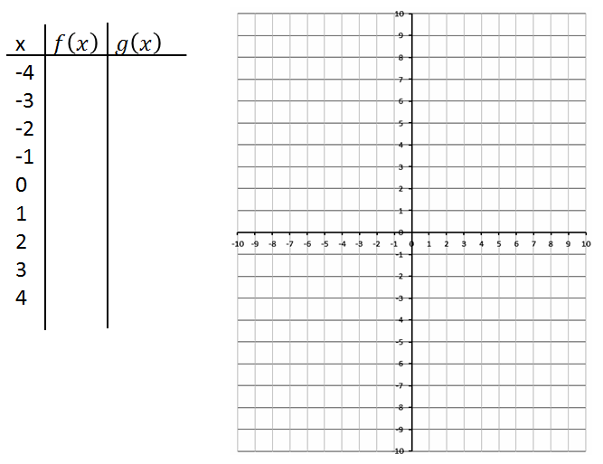
Q2: Consider the radical equation $\sqrt{x+4}=3$ as a system of equations. We can approach the question by graphing $f\left(x\right)=\sqrt{x+4}$ and $g\left(x\right)=3$, and look for the solutions to the system.
Create a table of values using your Graphing Calculator.

Now confirm your answer algebraically.

Q3: Consider the radical equation $\sqrt{\frac{x+10}{2}}=3$ as a system of equations. We can approach the question by graphing $f\left(x\right)=\sqrt{\frac{x+10}{2}}$ and $g\left(x\right)=3$, and look for the solutions to the system.
Create a table of values using your Graphing Calculator.

Now confirm your answer algebraically.

Q4: The equation $\sqrt{5x-4}=2$ can be simplified to $x=\frac{a}{b}$ , where a and b are ___ and ___.
(Record your two-digit answer in the Numerical Response boxes below)

Q5: The equation $\sqrt{2x+3}=6$ can be simplified to $x=\frac{ab}{c}$ , where a, b, and c are ___, ___, and ___.
(Record your three-digit answer in the Numerical Response boxes below)

Q6: Solve the equation $\sqrt{\frac{ax-b}{c}}=d$ for the variable $x$.

Part 3 – Examining Radical Equations in Math 20-1 using Graphing and Algebra
Q7: Solve the radical equation $\sqrt{x+5}=x+3$ and verify your solution(s).

Q8: Solve the radical equation $\sqrt{-2x+13}=x+1$ and verify your solution(s).

