First Name:______________________________ Last Name:______________________________

L09 – SQ – Radicals /20 marks

Comp. | Topic | Multiple Choice |  | Numerical Response |  | Long Answer |  | Total  Marks
Comp. | Topic | Questions | Marks | Questions | Marks | Questions | Marks | Total  Marks
Radicals  12 marks | Adding and Subtracting Radicals | Q1 | 1 | Q2 | 1 |  |  | 2
Radicals  12 marks | Multiplying Radicals |  |  | Q3 | 1 |  |  | 1
Radicals  12 marks | Dividing Radicals | Q4 | 1 |  |  |  |  | 1
Radicals  12 marks | Rationalizing the Denominator | Q5 | 1 | Q6 | 1 |  |  | 2
Radicals  12 marks | Radical Equations | Q7 | 1 |  |  | Q8 | 3 | 4
Radicals  12 marks | Word Problems |  |  |  |  | Q9 | 2 | 2
Radicals  12 marks | Student Generated Questions |  |  |  |  | Q10  Q11 | 4  4 | 8

PART 1 – MULTIPLE-CHOICE AND NUMERICAL RESPONSE (1 mark each; 7 marks)
Q1: Simplify $\sqrt{18}+\sqrt{50}$
- $8\sqrt{2}$
- $34\sqrt{2}$
- $\sqrt{68}$
- 30

Q2: The expression $\sqrt{50}+\sqrt{45}+\sqrt{20}-\sqrt{8}$ simplifies to $a\sqrt{b}+c\sqrt{d}$ , where a, b, c, and d are ___, ___, ___, and ___.
(Record your four-digit answer in the Numerical Response boxes below; Two correct answers exist)

Q3: The expression $(3\sqrt{2}+2)(5\sqrt{2}-1)$ simplifies to $a\sqrt{b}+cd$ , where a, b, c and d are ___, ___, ___, and ___.
(Record your four-digit answer in the Numerical Response boxes below)

Q4: Simplify the expression $\frac{\sqrt{8x^{2}}}{\sqrt{2x}}$
- $\sqrt{2x}$
- $2\sqrt{x}$
- $4\sqrt{x}$
- $\sqrt{16x^{3}}$

Q5: Given the expression $\frac{6\sqrt{2}}{\sqrt{3}}$ , rationalize the denominator.
- $18\sqrt{2}$
- $6\sqrt{2}$
- $2\sqrt{6}$
- $6\sqrt{6}$

Q6: Rationalizing the denominator in the expression $\frac{2\sqrt{3}+6}{\sqrt{3}}$ gives the simplified expression $a+b\sqrt{c}$ , where a, b, and c are ___, ___, and ___.
(Record your three-digit answer in the Numerical Response boxes below)

Q7: Determine the solutions to the equation $\sqrt{2x+5}=3$
- $x=-2$
- $x=-1$
- $x=1$
- $x=2$

PART 2 – LONG ANSWER (5 marks)
Q8: Solve the equation $3+2\sqrt{x+5}=9$ , and verify the solutions. (3 marks)

Use the following information to answer Q9:
A homemade sailboat has a triangular sail that measures $\sqrt{6}$ feet by $2\sqrt{10}$ feet.
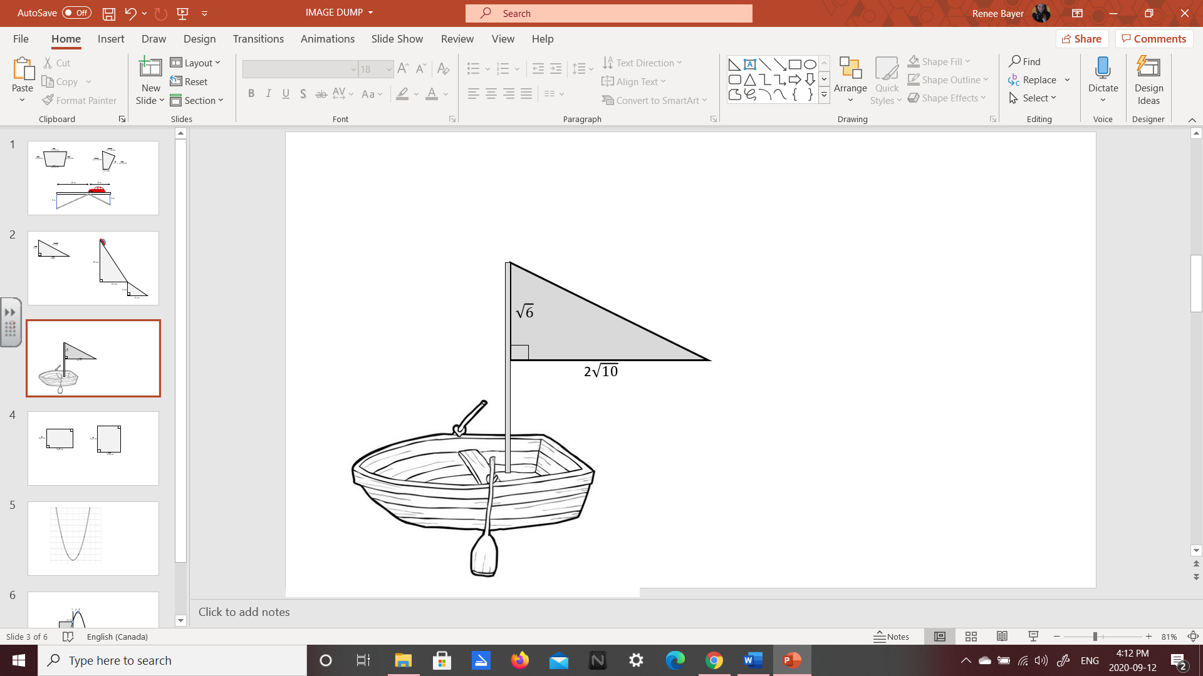
Q9: Determine the area of the sail, as a mixed radical. (2 marks)

PART 3 – STUDENT GENERATED QUESTIONS (4 marks each; 8 marks)
Q10: Follow the procedure listed below:
- Select four positive integers, ordered from least to greatest:
a =
Least

b =

c =

d =
Greatest

- Write a radical expression in the form $\sqrt{a^{2}b}+\sqrt{b^{2}c}+\sqrt{bc^{2}}+\sqrt{cd^{2}}$ , simplifying all the radicand (under the root):
Building the Question:
$$\sqrt{a^{2}b} +\sqrt{b^{2}c} +\sqrt{bc^{2}} +\sqrt{cd^{2}}$$
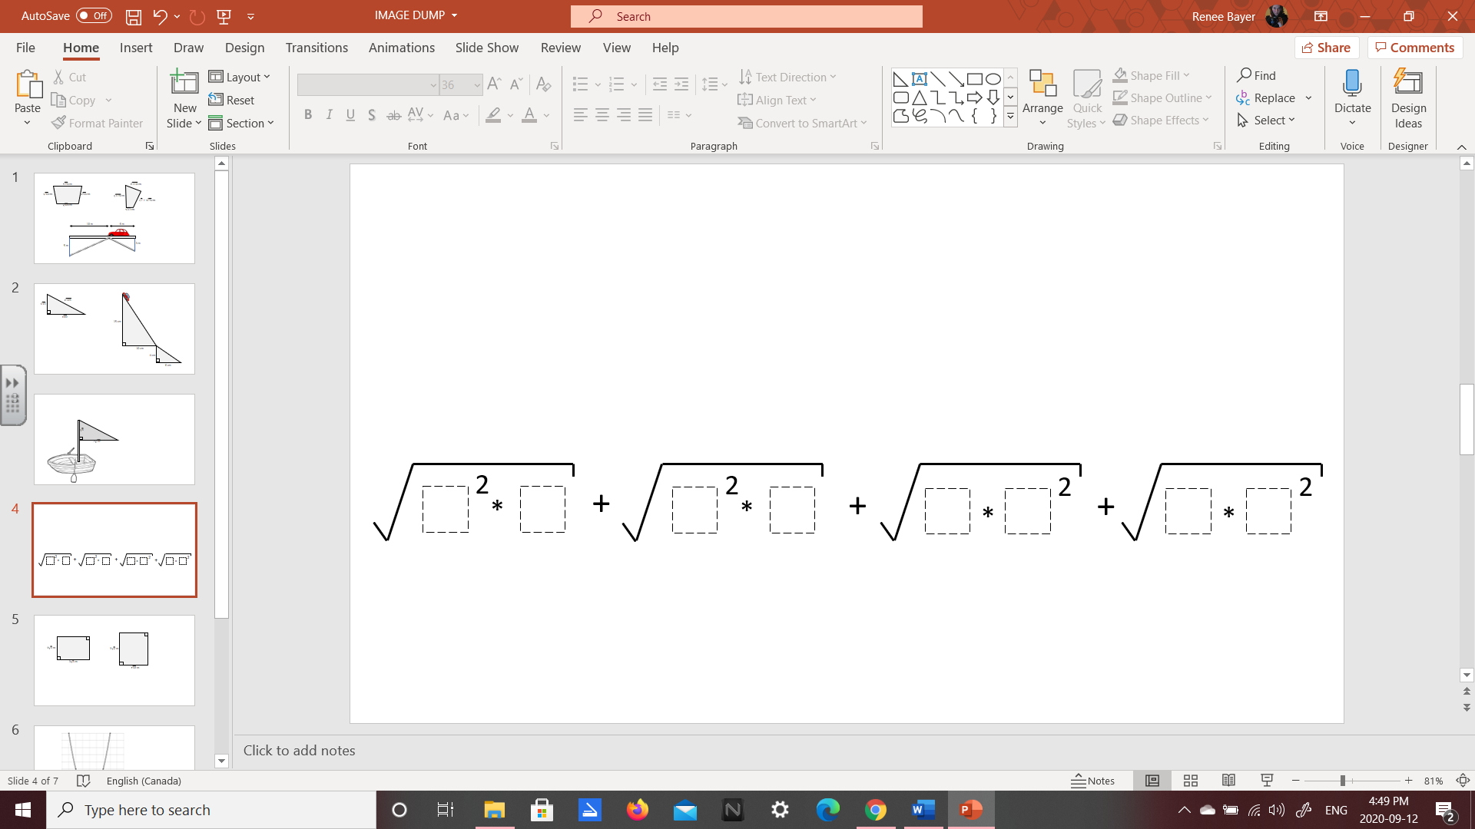
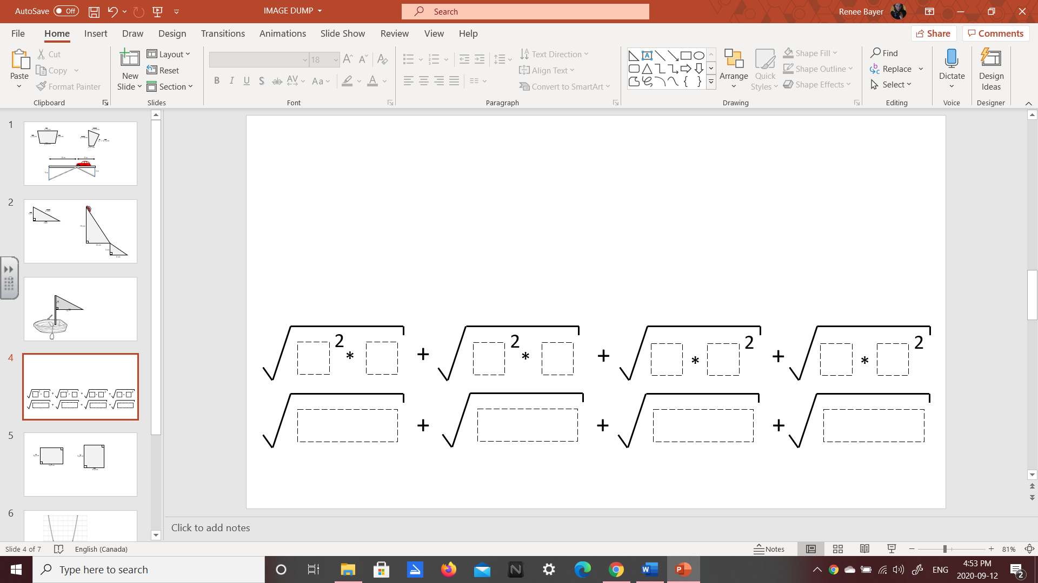

- Simplify the expression by converting each radical to a mixed radical, and adding like terms:
Answer Key:

Q11: Follow the procedure listed below:
- Select three positive integers between 2 and 9, ordered from least to greatest:
a =
Least

b =

c =
Greatest

- Write a radical equation in the form $\sqrt{ax+c}=b$
Building the Question:
$$\sqrt{ax+c}=b$$
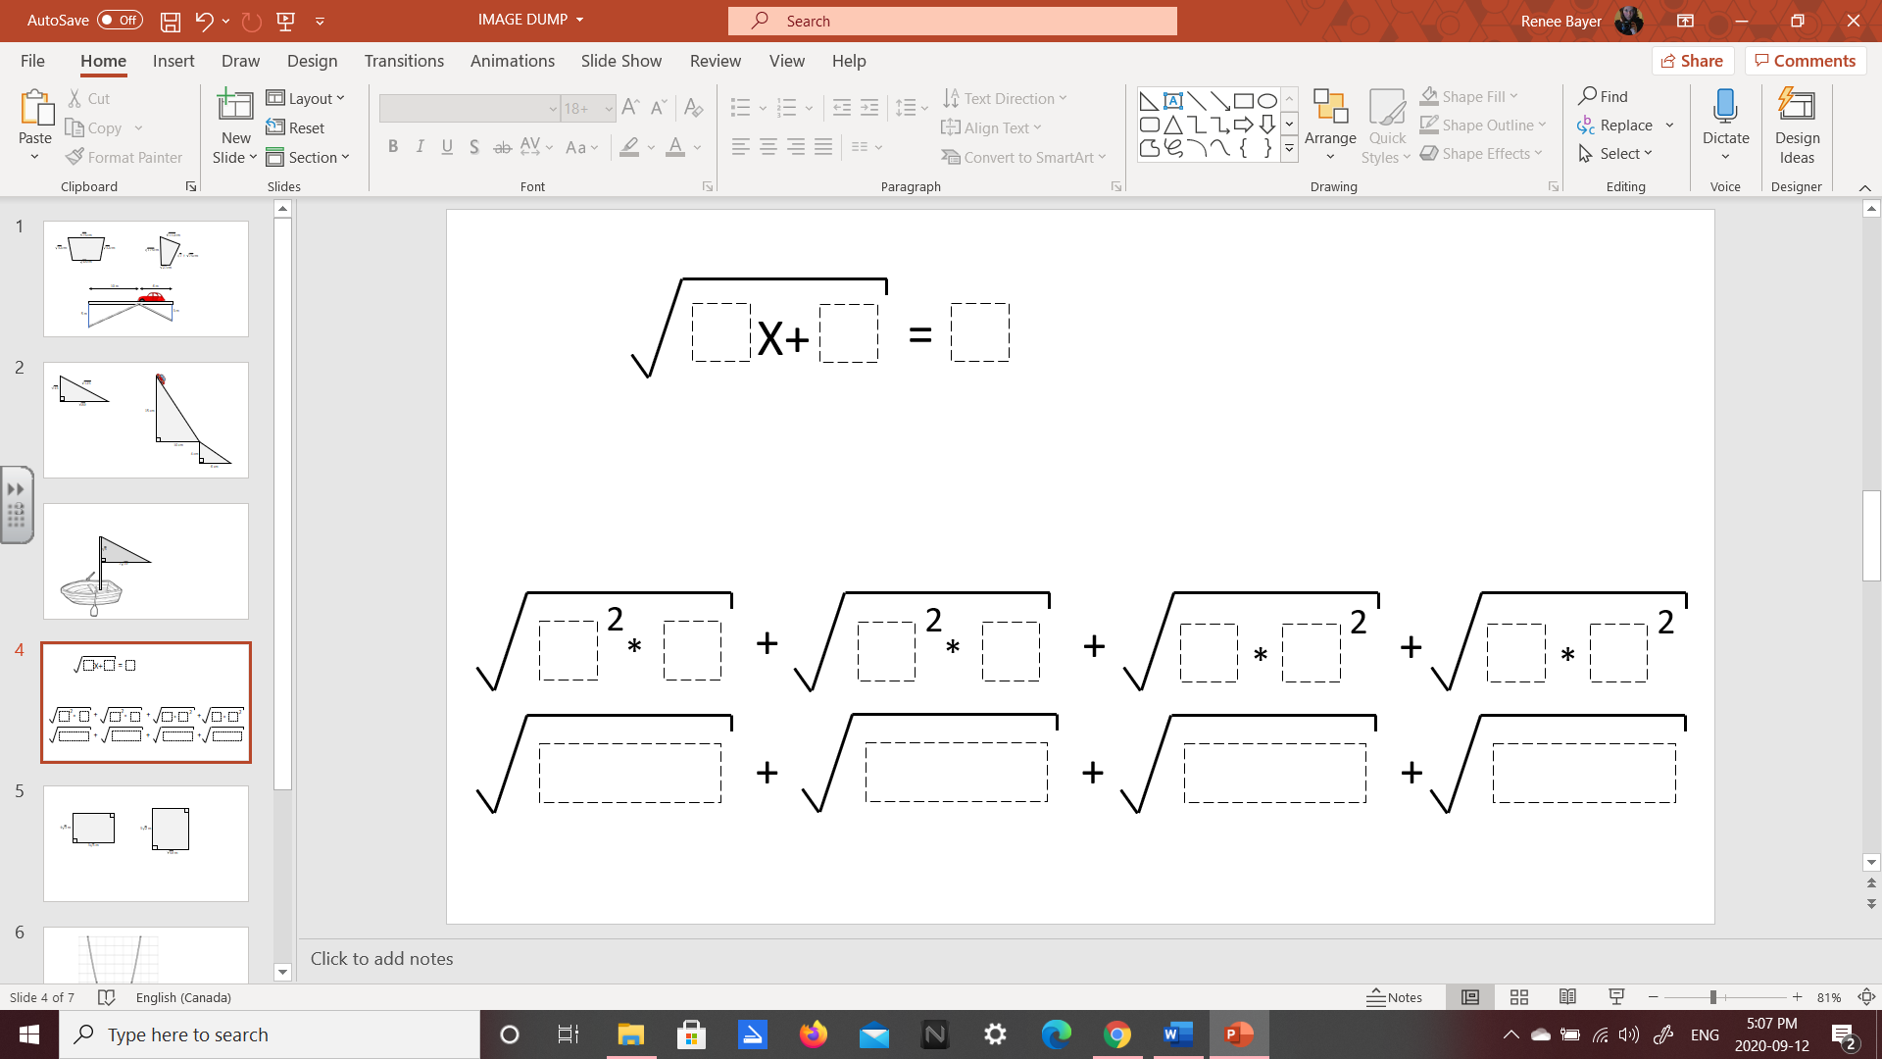

- Solve the radical equation in the space provided.
Answer Key:

PART 3 – STUDENT GENERATED QUESTIONS – ANSWER KEY
Q10: Follow the procedure listed below:
- Select four positive integers, ordered from least to greatest:
- Write a radical expression in the form $\sqrt{a^{2}b}+\sqrt{b^{2}c}+\sqrt{bc^{2}}+\sqrt{cd^{2}}$ , simplifying all the radicand (under the root):
- Simplify the expression by converting each radical to a mixed radical, and adding like terms
 | 3 | 2 | 1 | 0
Student-Generated Question |  |  | Student was able to follow the instructions to build their question correctly. | Student was unable to follow the instructions to build their question correctly.
Student’s Answer Key | Student’s answer key demonstrates a  correct and complete solution. | Student’s answer key includes a small algebraic or arithmetic mistake. | Student’s answer key displays a conceptual misunderstanding. | Student has not provided a sufficient answer key.

Q11: Follow the procedure listed below:
- Select three positive integers between 2 and 9, ordered from least to greatest:
- Write a radical equation in the form $\sqrt{ax+c}=b$
- Solve the radical equation in the space provided.
 | 3 | 2 | 1 | 0
Student-Generated Question |  |  | Student was able to follow the instructions to build their question correctly. | Student was unable to follow the instructions to build their question correctly.
Student’s Answer Key | Student’s answer key demonstrates a  correct and complete solution. | Student’s answer key includes a small algebraic or arithmetic mistake. | Student’s answer key displays a conceptual misunderstanding. | Student has not provided a sufficient answer key.

