L12 – Worksheet
Part 1: Math 20-2 Worksheet
Q1: Given the equation $f\left(x\right)=x^{2}+2x-3$ ,
- Use factoring to determine the Zeroes.

- Use the zeroes to determine the axis of symmetry.

- Use the method of your choice to determine the coordinates of the vertex.
  - Option #1: Use your T.I. Calculator
  - Option #2: Use the x-coordinate (from the axis of symmetry) to find y.

- Sketch a graph of the function, with clearly labelled (i) vertex, (ii) zeroes, (iii) axis of symmetry, and (d) y-intercept value.
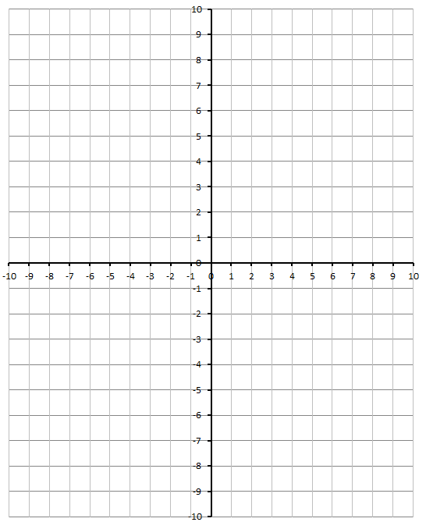
- State the Domain and Range for the function.

Q2: Given the equation $f\left(x\right)={4x}^{2}-1$ ,
- Use factoring to determine the Zeroes.

- Use the zeroes to determine the axis of symmetry.

- Use the method of your choice to determine the coordinates of the vertex.
  - Option #1: Use your T.I. Calculator
  - Option #2: Use the x-coordinate (from the axis of symmetry) to find y.

- Sketch a graph of the function, with clearly labelled (i) vertex, (ii) zeroes, (iii) axis of symmetry, and (d) y-intercept value.
- State the Domain and Range for the function.

Q3: Given the equation $f\left(x\right)={-x}^{2}-6x-8$ ,
- Use factoring to determine the Zeroes.

- Use the zeroes to determine the axis of symmetry.

- Use the method of your choice to determine the coordinates of the vertex.
  - Option #1: Use your T.I. Calculator
  - Option #2: Use the x-coordinate (from the axis of symmetry) to find y.

- Sketch a graph of the function, with clearly labelled (i) vertex, (ii) zeroes, (iii) axis of symmetry, and (d) y-intercept value.
- State the Domain and Range for the function.

Q4: Given the equation $f\left(x\right)={2x}^{2}+4x-6$ ,
- Use factoring to determine the Zeroes.

- Use the zeroes to determine the axis of symmetry.

- Use the method of your choice to determine the coordinates of the vertex.
  - Option #1: Use your T.I. Calculator
  - Option #2: Use the x-coordinate (from the axis of symmetry) to find y.

- Sketch a graph of the function, with clearly labelled (i) vertex, (ii) zeroes, (iii) axis of symmetry, and (d) y-intercept value.
- State the Domain and Range for the function.

