L14 – Worksheet
Part 1: Math 20-2 Worksheet
Q1: Given the equation $f\left(x\right)=1{\left(x-3\right)}^{2}-4$ ,
- Determine the coordinates of the vertex in the form (h,k).

- Determine the equation of the axis of symmetry.

- Determine the y-intercept by
Using Vertex Form Converting to Standard Form

- Determine the zeroes (x-intercepts) by

Using Vertex Form Converting to Standard Form

Q2: Given the equation $f\left(x\right)=1{\left(x+3\right)}^{2}-1$ ,
- Determine the coordinates of the vertex in the form (h,k).

- Determine the equation of the axis of symmetry.

- Determine the y-intercept by
Using Vertex Form Converting to Standard Form

- Determine the zeroes (x-intercepts) by

Using Vertex Form Converting to Standard Form

Q3: Given the equation $f\left(x\right)=1{\left(x-4\right)}^{2}-4$, create a table of values and graph the function.
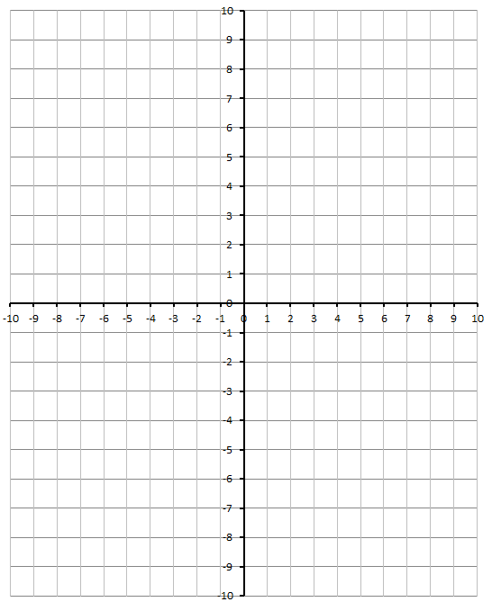
x y
0
1
2
3
4
5
6
7

Q4: Given the equation $f\left(x\right)=1{\left(x-1\right)}^{2}-9$, create a table of values and graph the function.
x y
-3
-2
-1
0
1
2
3
4
5

Q5: Graph the following functions.
$y=1{(x-2)}^{2}-3$ $y=1{(x+2)}^{2}-3$
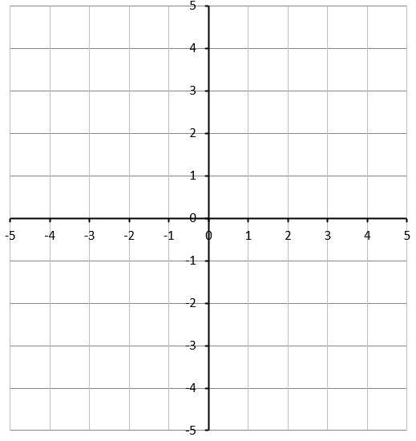

$y=1{(x-2)}^{2}+3$ $y=1{(x+2)}^{2}+3$

Q6: Graph the following functions.
$y=1{(x+0)}^{2}+0$ $y=2{(x+0)}^{2}+0$

$y=1{(x-1)}^{2}-2$ $y=\frac{1}{2}{(x-1)}^{2}-2$

Q7: Determine the function that has its vertex at (3,4) and goes through the point (1,8).

Q8: Determine the function that has its vertex at (2,-6) and goes through the point (4,2).

Q9: Determine the function that has its vertex at (-3,5) and goes through the point (1,-3).

Part 2: Math 20-1 Worksheet
Pg 157 #2ab: Describe how the graphs of the functions in each pair are related. Then, sketch the graph of the second function in each pair, and determine the vertex, the equation of the axis of symmetry, the domain and range, and any intercepts.
Equations | Graph of Second Function | Vertex | Equation of the Axis of Symmetry | Domain and Range | Intercepts
$$y=x^{2}$$  $$y=x^{2}+1$$ | 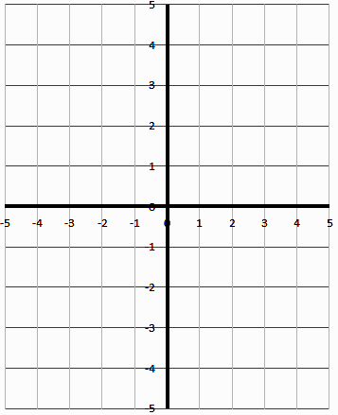
$$y=x^{2}$$
$$y={\left(x-2\right)}^{2}$$
Pg 157 #16ab: The main section of the suspension bridge in Parc de la Gorge de Coaticook, Quebec, has cables in the shape of a parabola. Suppose that the points on the tops of the towers where the cables are attached are 168m apart and 24m vertically above the minimum height of the cables.
- Determine the quadratic function in vertex form that represents the shape of the cables. Identify the origin you used.
- Choose two other locations for the origin. Write the corresponding quadratic function for the shape of the cables for each.
