L15 – Factored Form
Key Ideas
Key Ideas:
- If a quadratic equation is factorable, we can easily determine the zeroes of the function.
- We will be representing factored form as $y=(ax+b)(cx+d)$ rather than the traditional
$y=a(x-r_{1})(x-r_{2})$ form.
- If we can easily find the zeroes of the function, the axis of symmetry is exactly halfway between them, and the vertex lies on the axis of symmetry.
Part 1 – Factoring Polynomials
Q1: Factor the following questions:

$x^{2}+5x+6$ $2x^{2}+7x+6$ $2x^{2}+11x+15$

Part 2 – Factoring Quadratics to find the Vertex Coordinates

Q2: Factor the following quadratics:

${y=x}^{2}+5x+6$ $f\left(x\right)=2x^{2}+7x+6$ $y=2x^{2}+11x+15$

Q3: Use the factored form of each quadratic to find the coordinates of the Vertex:

${y=x}^{2}+5x+6$ $f\left(x\right)=2x^{2}+7x+6$ $y=2x^{2}+11x+15$

Part 3 – Putting it all Together
Q4: Given the equation $f\left(x\right)=x^{2}+6x+8$ , determine (a) the y-intercept, (b) the zeroes, (c) the equation of the axis of symmetry, and (d) the coordinates of the vertex. Finally, (e) sketch the graph on the paper provided.
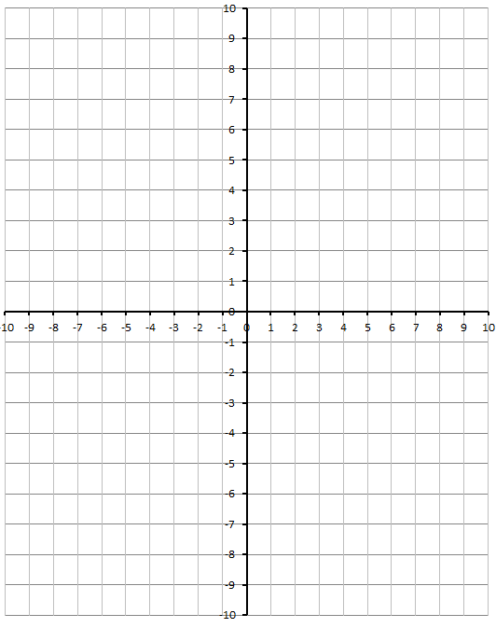

Q5: Given the equation $f\left(x\right)={2x}^{2}-5x-3$ , determine (a) the y-intercept, (b) the zeroes, (c) the equation of the axis of symmetry, and (d) the coordinates of the vertex. Finally, (e) sketch the graph on the paper provided

