L16 – Worksheet
Part 1: Working with Standard and Factored Forms
Use the following information to answer Q1-Q4:
$$f\left(x\right)=x^{2}+2x-3$$
Q1: The y-intercept is
- -3
- -2
- 2
- 3
Q2: Converting to Factored Form, the zeroes of the function are at -a and +b, where a and b are ___ and ___.
(Record your two-digit answer in the Numerical Response boxes below)

Q3: The axis of symmetry is given by the equation
- $x=-1$
- $x=+1$
- $y=-1$
- $y=+1$
Q4: The coordinates of the vertex is given by (-a, -b), where a and b are ___ and ___.
(Record your two-digit answer in the Numerical Response boxes below)

Q5: A student is working with a quadratic function, and has determined the following information:
- Y-Intercept of -6
- Zeroes of -2 and 6
- Axis of Symmetry is x = 2
- Vertex is located at (2, -8)
Sketch the quadratic function below.
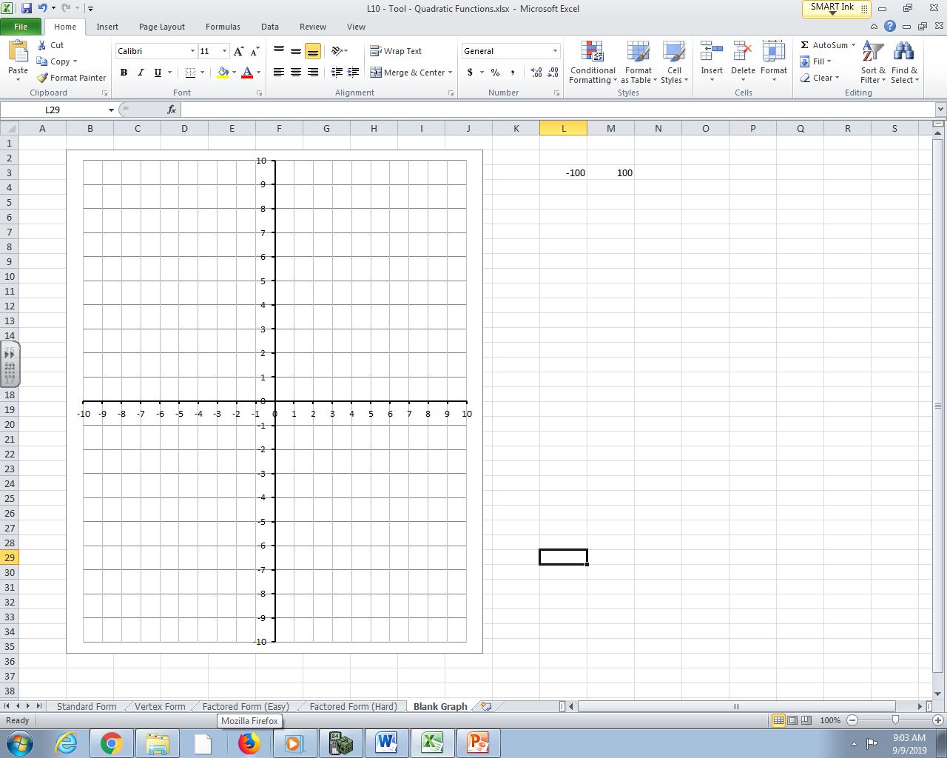

Use the following information to answer Q6-Q10:
$$f\left(x\right)={-x}^{2}+8x-12$$
Q6: The y-intercept is -ab, where a and b are ___ and ___.
(Record your two-digit answer in the Numerical Response boxes below)

Q7: Converting to Factored Form, the zeroes of the function are
- -6, -2
- -6, 2
- 6, -2
- 6, 2

Q8: Determine the equation for the axis of symmetry.

Q9: The coordinates of the vertex is given by (a, b), where a and b are ___ and ___.
(Record your two-digit answer in the Numerical Response boxes below)

Q10: A student is working with a quadratic function, and has determined the following information:
- Y-Intercept of 6
- Zeroes of -3 and 1
- Axis of Symmetry is x = -1
- Vertex is located at (-1, 8)
Sketch the quadratic function below.

Use the following information to answer Q11:
$$f\left(x\right)={2x}^{2}+9x+4$$
Q11: Determine the (a) y-intercept, (b) zeroes, (c) equation of the line of symmetry, and (d) coordinates of the vertex. Finally, (e) sketch the function below.

Part 2: Working with Vertex Form
Use the following information to answer Q12-Q14:
$$f\left(x\right)=1{(x-7)}^{2}-1$$
Q12: The coordinates of the vertex is
- (-7,1)
- (7,-1)
- (-1,7)
- (1,-7)
Q13: The zeroes of the function are a and b, where a and b are ___ and ___.
(Record your two-digit answer in the Numerical Response boxes below)

Q14: Convert the function to Standard Form.

Use the following information to answer Q15-Q17:
$$f\left(x\right)=-2{\left(x-3\right)}^{2}+8$$
Q15: Determine (a) the coordinates of the vertex, and (b) the zeroes.

Q16: Convert the function to Standard Form to determine the y-intercept.

Q17: Sketch the function below.
Q18: The function $f\left(x\right)={1(x-p)}^{2}+q$ is modelled below. Sketch the function $g\left(x\right)=\frac{1}{2}{\left(x-p\right)}^{2}+q$ on the same graph paper.
