L17 – Word Problems
Key Ideas
Most word problems involve the following steps:
- Read and interpret the question (and possibly diagram it). Build the basic equation.
- Factor to determine the zeroes, average to find the axis of symmetry, then find the Vertex.
- Solve for the Max/Min (Vertex), y-Intercept (starting amount), or zeroes.
Most word problems fall under one of three types:
- Maximizing area (solve for vertex)
- Maximizing profit (solve for vertex)
- Projectile motion (solve for maximum/vertex or solve for zeroes/landing position)
We will model how to set up each type of problem.
Part 1 – Maximizing Area
Q1: A house owner is building a fence against their barn for chickens to run around. They have 26m of fence. What is the maximum area they can build for their chicken coup?
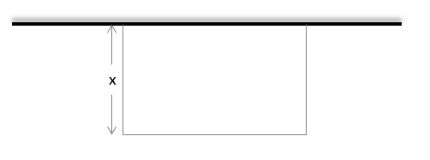

Q2: On the other side of the barn, the same house owners are building a duck coup for their ducks to run around. This time they have 50m of fence, because ducks taste better than chickens and deserve more area as a result. What is the maximum area of the pen?
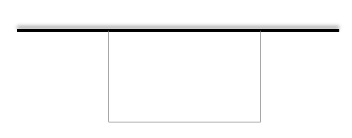

Q3: A large retaining wall against the back of the property can be used to house three identical areas for tasty, tasty geese. The farmer has 100m of fence. What is the maximum area of each section?
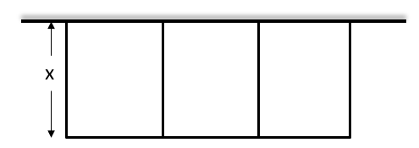

Note: Did you remember to calculate the area of each section?
Part 2 – Maximizing Profit
Q4: Bob sells tickets to see “Paw Patrol on Ice”. Bob can sell 500 tickets at a cost of $25, but Bob discovered that every time he increases the ticket price by $1, the ticket sales only reduce by 10 people. How much should Bob sell tickets for to maximize profits?

Q5: The next season Bob sells tickets for “Extreme SeaWorld: Orcas Attack!” Bob can sell 1200 tickets at a cost of $50, but Bob discovered that every time he decreases ticket cost by $1, ticket sales increase by 25. How much should Bob sell tickets for to maximize profits?

Part 3 – Projectile Motion
Q6: A cat jumps off a 10m tall ledge, reaching a maximum height of 15m after travelling a horizontal distance of 5m. What horizontal distance, d_{x} , does the cat cover before landing?
