L18 – Worksheet
Part 1: Working with Standard and Factored Forms
Use the following information to answer Q1-Q4:
$$f\left(x\right)={-x}^{2}+4x+5$$
Q1: The y-intercept is
- -5
- -4
- 4
- 5
Q2: Converting to Factored Form, the zeroes of the function are at -a and +b, where a and b are ___ and ___.
(Record your two-digit answer in the Numerical Response boxes below)

Q3: The axis of symmetry is given by the equation
- $x=-2$
- $x=+2$
- $y=-2$
- $y=+2$
Q4: The coordinates of the vertex is given by (a, b), where a and b are ___ and ___.
(Record your two-digit answer in the Numerical Response boxes below)

Q5: A student is working with a quadratic function, and has determined the following information:
- Y-Intercept of -8
- Zeroes of -8 and 4
- Axis of Symmetry is x = -2
- Vertex is located at (-2, -9)
Sketch the quadratic function below.
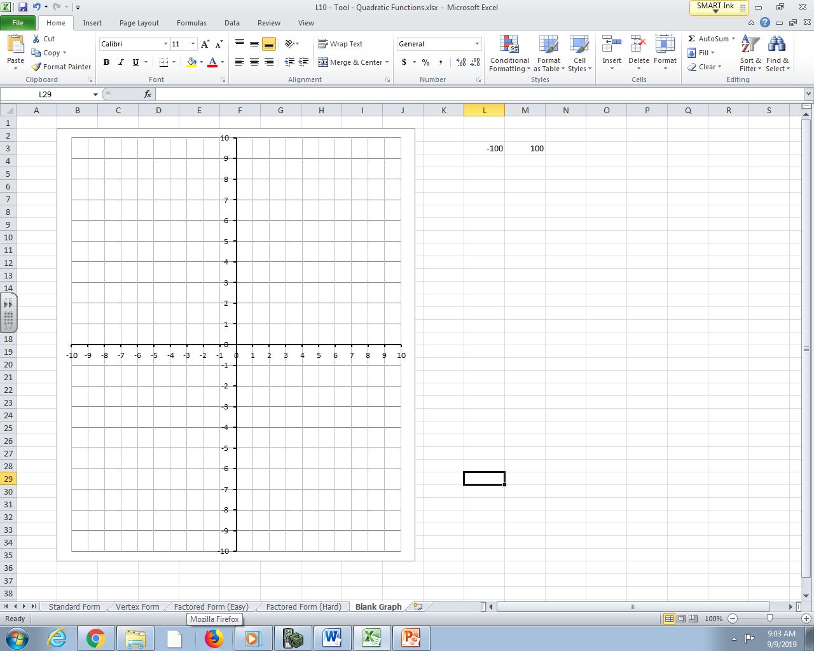

Part 2: Working with Vertex Form
Use the following information to answer Q6-Q8:
$$f\left(x\right)=\frac{1}{2}{\left(x+4\right)}^{2}-2$$
Q6: Determine (a) the coordinates of the vertex, and (b) the zeroes.

Q7: Convert the function to Standard Form to determine the y-intercept.

Q8: Sketch the function below.
Part 3: Word Problems involving Maximizing Area
Q9: A house owner is building a fence against their barn for chickens to run around. They have 40m of fence. What is the maximum area they can build for their chicken coup?
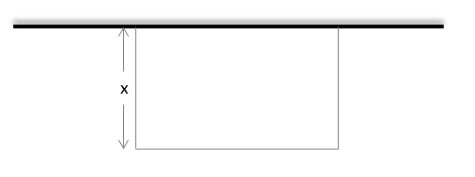

Part 4: Word Problems involving Maximizing Profit
Q10: Bob sells tickets to see the documentary “The Politics of the Lizard People”. Bob can sell 200 tickets at a cost of $15, but Bob discovered that every time he increases the ticket price by $1, the ticket sales only reduce by 4 people. How much should Bob sell tickets for to maximize profits?

Part 5: Word Problems involving Projectile Motion
Q11: A frog jumps off a 6cm tall rock, reaching a maximum height of 8cm after travelling a horizontal distance of 2cm. What horizontal distance, d_{x} , does the frog cover before landing?
