First Name:______________________________ Last Name:______________________________

L19 – SQ –Quadratic Functions /19 marks

Comp. | Topic | Multiple Choice |  | Numerical Response |  | Long Answer |  | Total Marks
Comp. | Topic | Questions | Marks | Questions | Marks | Questions | Marks | Total Marks
Algebra  ___/15 marks | Working with Standard Form | Q1 | 1 | Q3 | 1 | Q2  Q4 | 2  1 | 5
Algebra  ___/15 marks | Working with Vertex Form | Q5  Q7  Q8  Q9 | 1  1  1  1 | Q6 | 1 |  |  | 5
Algebra  ___/15 marks | Word Problem |  |  |  |  | Q10 | 4 | 4
Graphing  ___/5 marks | Graphs of Functions | Q11 | 1 |  |  | Q12 | 4 | 5

PART 1 – ALGEBRA
Use the following information to answer Q1-Q4:
$$y=x^{2}-2x-3$$
Q1: The y-intercept of this function is
- -3
- -2
- 2
- 3
Q2: (Long Answer) Factor the equation to determine the zeroes. Show all your work. (2 marks)

Q3: The coordinates of the vertex are (a, -b), where a and b are ___ and ___.
(Record your two-digit answer in the Numerical Response boxes below)

Q4: (Long Answer) Write the function in Vertex Form. (1 mark)

Use the following information to answer Q5:
A parabola has a vertex at (4,-2) and passes through the point (8,6).

Q5: Which equation, in Vertex Form, correctly describes this parabola?
- $f\left(x\right)=\frac{1}{18}{\left(x+4\right)}^{2}-2$
- $f\left(x\right)=\frac{1}{10}{\left(x+4\right)}^{2}-2$
- $f\left(x\right)=\frac{1}{2}{\left(x-4\right)}^{2}-2$
- $f\left(x\right)=\frac{5}{2}{\left(x-4\right)}^{2}-2$

Q6: The equation $y=\frac{1}{2}{\left(x+2\right)}^{2}+6$ converts to standard form as $=ax^{2}+bx+c$ , where b and c are ___ and ___.
(Record your two-digit answer in the Numerical Response boxes below)

Use the following information to answer Q7-Q9:
$$f\left(x\right)=-1{\left(x+1\right)}^{2}+4$$

Q7: The zeroes of this function are
- $x_{1}=-3$ and $x_{2}=+1$
- $x_{1}=-2$ and $x_{2}=+2$
- $x_{1}=-1$ and $x_{2}=+3$
- $x_{1}=-1$ and $x_{2}=+4$

Q8: The vertex is located at
- (-1, -4)
- (-1, 4)
- (1, -4)
- (1, 4)

Q9: They y-intercept of the function is
- 2
- 3
- 4
- 5
Use the following information to answer Q10:
A grasshopper jumps off a ledge of unknown height. After 4cm, the grasshopper reaches its maximum height of 9cm. The grasshopper lands 10cm from the base of the ledge.
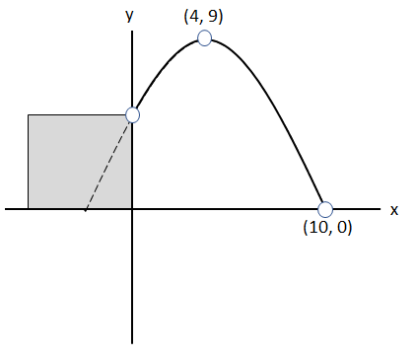
Q10: (Long Answer) How tall is the ledge, in centimeters? Show all your work. (4 marks)

PART 2 – GRAPHING
Use the following information to answer Q11:
The original function, $f\left(x\right)=1{(x-e)}^{2}+f$ is depicted below, where e and f are fixed values.
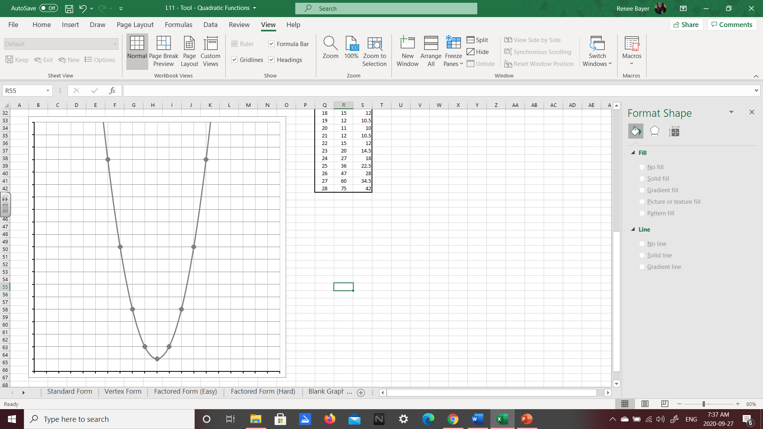
Q11: Which of the following best represents the function $\left(x\right)=2{(x-e)}^{2}+f$ ?
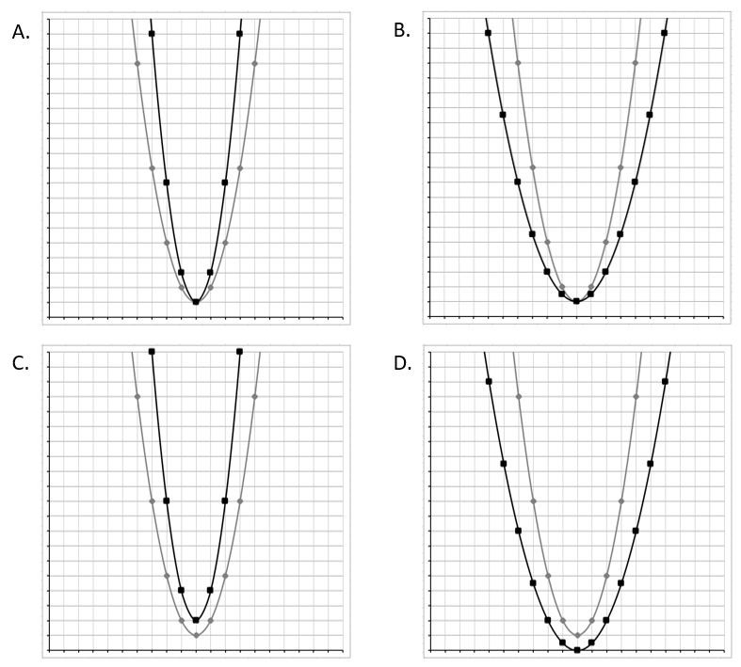
Q12: (Long Answer) Graph the function $f\left(x\right)=x^{2}+6x+5$ below, clearly showing: (4 marks)
- Zeroes
- Vertex
- Axis of Symmetry
- Y-Intercept
