L21 – Worksheet
Math 20-2: Solving Quadratic Equations by Graphing
Pg402 #1ab: Solve each equation by graphing the corresponding function and determining the zeroes.
$2x^{2}-5x-3=0$ $9x-4x^{2}=0$
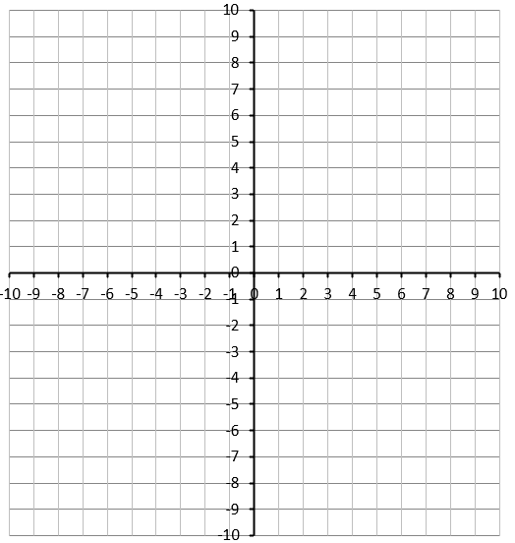

Pg402 #3b: Rewrite each equation in standard form. Then solve the equation in standard form by graphing.
$2p^{2}+3p=1-2p$
Pg403 #7ad: A ball is thrown into the air from a bridge that is 14m above a river. The function that models the height, h(t), in meters, of the ball over time, t, in seconds is
$$h\left(t\right)=-4.9t^{2}+8t+14$$
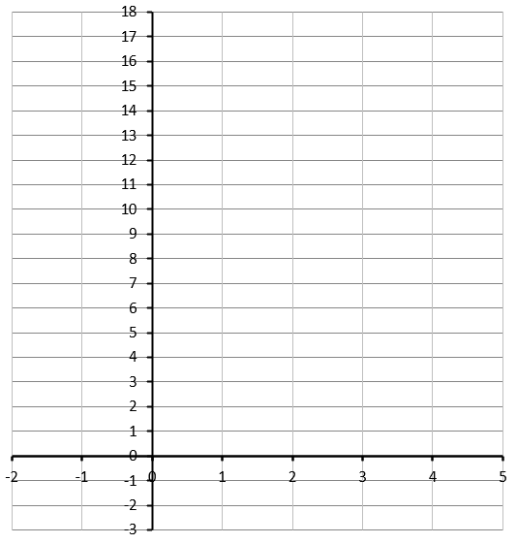
- When is the ball 16m above the water?

- When does the ball hit the water?

Math 20-1: Solving Quadratic Equations by Graphing
Pg 215 #6: Two numbers have a sum of 9 and a product of 20.
- What single-variable quadratic equation in the form $ax^{2}+bx+c=0$ can be used to represent the product of the two numbers?

- Determine the two numbers by graphing the corresponding quadratic function.
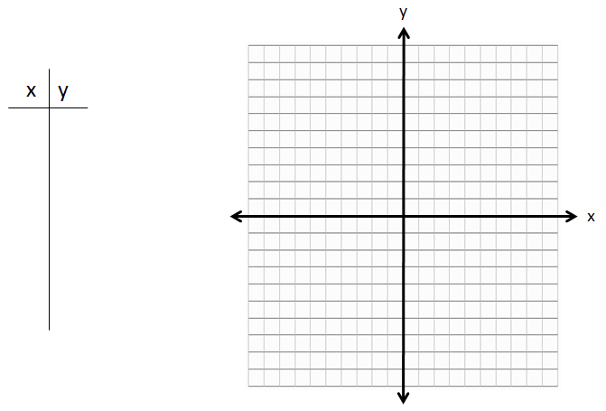

Pg 215 #12: Matthew is investigating the old Borden Bridge, which spans the North Saskatchewan River about 50km west of Saskatoon. The three parabolic arches of the bridge can be modelled using quadratic functions, where h is the height of the arch above the bridge deck and x is the horizontal distance of the bridge deck from the beginning of the first arch, both in meters.
First arch: $h\left(x\right)=-0.01x^{2}+0.84x$
Second arch: $h\left(x\right)=-0.01x^{2}+2.52x-141.12$
Third arch: $h\left(x\right)=-0.01x^{2}+4.2x-423.36$
- What are the zeroes of each quadratic function?
- What is the significance of the zeroes in this situation?
- What is the total span of the Borden Bridge?
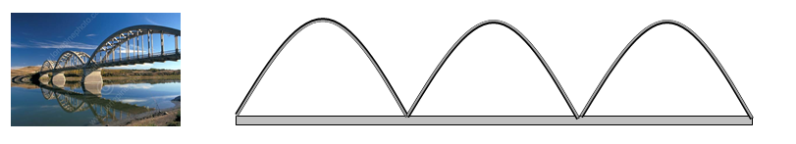
Pg 215 #13: For what values of k does the equation $x^{2}+6x+k=0$ have
- One real root?
- Two distinct real roots?
- No real roots?
