L22 – Worksheet
Math 20-2: Solving Quadratic Equations by Factoring
Pg411 #4ab: Solve each equation.
$12-5x=2x^{2}$ $4x^{2}=9-9x$

Pg413 #14: Samuel is hiking along the top of First Canyon on the South Nahanni River in the Northwest Territories. When he knocks a rock over the edge, it falls into the river, 1260m below. The height of the rock, h(t), at t seconds can be modelled by the following function:
$$h\left(t\right)=-25t^{2}-5t+1260$$
Bayer’s Note: This planet (definitely not Earth) has an acceleration due to gravity of 50 m/s², and Samuel threw the rock downward at 5m/s from the top of a 1260m tall ledge. This is a very poor question, but I included it anyways because I think it is hilarious. All the math will work out regardless of the ridiculous value.
- How long will it take the rock to reach the water?
- What is the domain of the function? Explain your answer.

Math 20-1: Solving Quadratic Equations by Graphing
Pg 230 #11: A rectangle has dimension $x+10$ and $2x-3$, where x is in centimeters. The area of the rectangle is 54 cm².
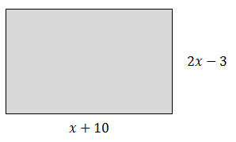
- What equation could you use to determine the value of x?
- What is the value of x?

Pg 230 #13: A flare is launched from a boat. The height, h, in meters, of the flare above the water is approximately modelled by the function $h\left(t\right)=150t-5t^{2}$, where t is the number of seconds after the flare is launched.
- What equation could you use to determine the time it takes for the flare to return to the water?
- How many seconds will it take for the flare to return to the water?

