L23 – Worksheet
Part 1: Solving Quadratics by Graphing
Q1a: Solve the equation $x^{2}=2x+8$ by graphing $f\left(x\right)=x^{2}$ and $g\left(x\right)=2x+8$
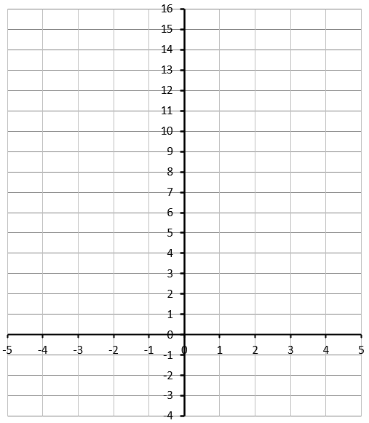
Q1b: Solve the equation $x^{2}=2x+8$ by converting to Standard Form and graphing that function.
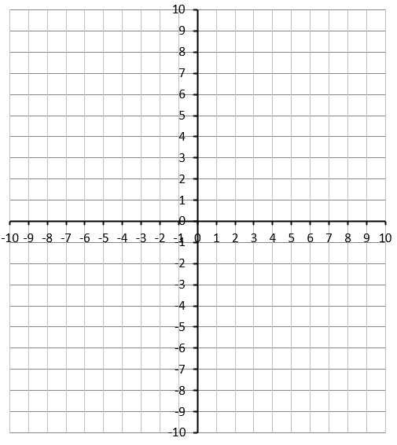
Q2: The solutions to the equation $\frac{1}{2}x^{2}-3x=\frac{7}{2}$ can be determined through graphing. The solutions are -a and +b, where a and b are ___ and ___.
(Record your two-digit answer in the Numerical Response boxes below)

Q3: The solutions to the equation $x^{2}+4x+21=14x$ can be determined through graphing. The solutions are +a and +b, where a and b are ___ and ___.
(Record your two-digit answer in the Numerical Response boxes below)

Part 2: Solving Quadratics by Factoring
Q4: Determine the solution to the equation $x^{2}+9x+20=0$ using factoring.

Q5: Determine the solution to the equation $x^{2}-18=3x$ using factoring.

Q6: Determine the solution to the equation $x^{2}+x=10-2x$ using factoring.

Q7: Determine the solution to the equation $2x^{2}+7x+6=0$ using factoring.

Q8: Determine the solution to the equation $2x^{2}+5x=3$ using factoring.

Q9: Determine the solution to the equation ${8x}^{2}+10x=2x^{2}-x+10$ using factoring.

