L25 – Worksheet
Part 1a – Finding Zeroes in Standard Form using Factoring
Q1: With the equation $f\left(x\right)=2x^{2}+4x-6$, the zeroes are located at x₁ = -a and x₂ = b, where a and b are ___ and ___.
(Record your two-digit answer in the Numerical Response boxes below)

Q2: With the equation $y=2x^{2}-3x-9$, the zeroes are located at x₁ = $-\frac{a}{b}$ and x₂ = c, where a, b, and c are ___, ___, and ___.
(Record your three-digit answer in the Numerical Response boxes below)

Part 1b – Solving Equations in Standard Form using Factoring
Q3: Solve $x^{2}=2x+15$ using factoring. (1 mark) Q4: Solve $x^{2}+x=6$ using factoring. (1 mark)

Part 2 – Finding Zeroes in Vertex Form
Q5: Determine the zeroes of the function $f\left(x\right)={\left(x-2\right)}^{2}-6$ algebraically. (1 mark)

Q6: Given the equation $y=-\frac{1}{2}{\left(x-2\right)}^{2}+3$ , determine the zeroes algebraically. (2 marks)

Part 3a – Finding Zeroes in Standard Form using Quadratic Equation
Q7: Determine the zeroes of the function $f\left(x\right)=2x^{2}+4x-1$ using the Quadratic Equation. Give your answer as an exact value. (2 marks)

Q8: Determine the zeroes of the function $f\left(x\right)=-3x^{2}-5x+6$ using the Quadratic Equation. Give your answer as an exact value. (2 marks)

Part 3b – Solving Equations in Standard Form using Quadratic Equation
Q9: Solve the equation $2x^{2}+4x=6$ using the Quadratic Equation. (2 marks)

Q10: Solve the equation $5x^{2}=x+2$ using the Quadratic Equation. (2 marks)

Part 4a – Finding Zeroes using Graphing
Q11: Determine the zeroes (approximate value) of the function $y=x^{2}-3x-6$ by graphing the function. (2 marks)
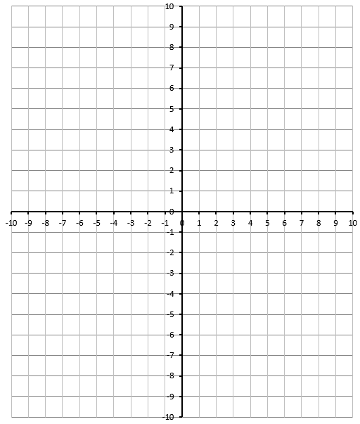
Part 4b – Solving Equations using Graphing
Q12: Solve the equation $2x^{2}=3x+4$ graphically. (3 marks)

Area Problems
Use the following information to answer Q13:
A patio has a total area of 33m², and is proportioned per the diagram below.
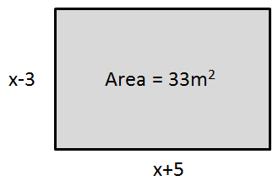

Q13: Set up a quadratic equation and solve to determine the value(s) of x. (1 mark)

Q14: A slightly smaller patio has the same proportions, but has a total area of 30m². Determine the value of x, to the nearest tenth. (1 mark)
(Record your answer in the Numerical Response boxes below)

Projectile Motion
Use the following information to answer Q15:
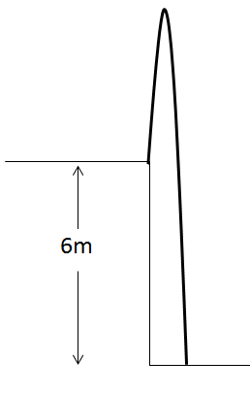
An object is launched vertically at 13m/s off a 6m tall ledge. The Physics 20 equation that can be used to determine time is given by:
$$∆d=v_{i}t+\frac{1}{2}at^{2}$$
Where the acceleration due to gravity is approximately -10 m/s². In Math 20-1, we can write this function as follows:
$$h\left(t\right)=-5t^{2}+13t+6$$

Q15: How long does it take the object to land? Support your work algebraically. (2 marks)
Using Factoring Using Quadratic

