First Name:______________________________ Last Name:______________________________

L26 – SQ#3 – Quadratic Equations /15 marks
Algebra ____/10 marks Graphing ___/5 marks
Comp. | Topic | Multiple Choice |  | Numerical Response |  | Long Answer |  | Total Marks
Comp. | Topic | Questions | Marks | Questions | Marks | Questions | Marks | Total Marks
Algebra | Solving a Quadratic Eqn. using Factoring | Q1 | 1 |  |  | Q2 | 2 | 3
Algebra | Solving a Quadratic Eqn. by Quadratic Formula | Q3 | 1 |  |  | Q4 | 2 | 3
Algebra | Word Problems |  |  | Q5 | 1 | Q6 | 3 | 4
Graphing | Solving a Quadratic Eqn. by Graphing |  |  | Q7 | 1 |  |  | 1
Graphing | Word Problems |  |  |  |  | Q8 | 4 | 4

Quadratic Formula
$x=\frac{-b±\sqrt{b^{2}-4ac}}{2a}$
PART 1 – ALGEBRA
Use the following information to answer Q1:
A student is trying to solve the following equation:
$$2x^{2}=x+6$$
The student decides to solve the equation by using factoring.

Q1: Which factored form could be used to determine the value of x?
- $\left(x-3\right)\left(x+2\right)=0$
- $\left(x-2\right)\left(2x+3\right)=0$
- $\left(x+3\right)\left(x-2\right)=0$
- $\left(x+2\right)\left(2x-3\right)=0$

Q2: Solve the quadratic equation $x^{2}+4x=32$ using factoring. (2 marks)

Q3: Using the Quadratic Formula to the equation $x^{2}+2x=2$ gives which of the following answers?
- $x_{1}=-2, { x}_{2}=0$
- $x_{1}=-1-\sqrt{3}, { x}_{2}=-1+\sqrt{3}$
- $x_{1}=-2-\sqrt{12}, { x}_{2}=-2+\sqrt{12}$
- No Solution

Q4: Solve the equation $2x^{2}-9x+4=0$ using the Quadratic Formula. (2 marks)
$x=\frac{-b±\sqrt{b^{2}-4ac}}{2a}$
Use the following information to answer Q5-Q6:
A rectangle, depicted below, has an area of 24m². The side lengths are (x+8) meters by (x-2) meters.
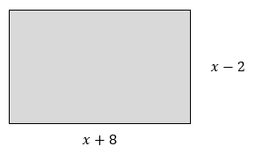

Q5: The quadratic equation that best models this problem is $ax^{2}+bx-cd=24$ , where the a, b, c, and d are ___, ___, ___, and ___.
(Record your four-digit answer in the Numerical Response boxes below)

Q6: Determine the value of x that solves this equation, showing all work. (3 marks)

PART 2 – GRAPHING
Use the following information to answer Q7:
A student is attempting to solve the quadratic equation $\frac{1}{2}x^{2}-2x=6$. The approach the problem by graphing the function $f\left(x\right)=-\frac{1}{2}x^{2}+2x+6$ , shown below.
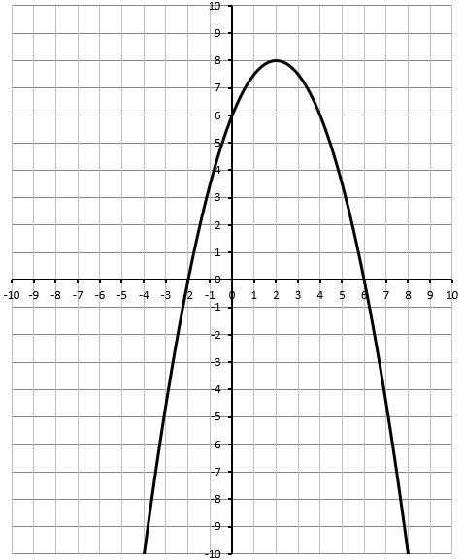
Q7: The solution to the problem is
- $(2,8)$
- $x=2$
- $x_{1}=0, x_{2}=4$
- $x_{1}=-2, x_{2}=6$

Use the following information to answer Q8:
A polar bear sees a tasty penguin on the ledge below it, and dives for his meal.
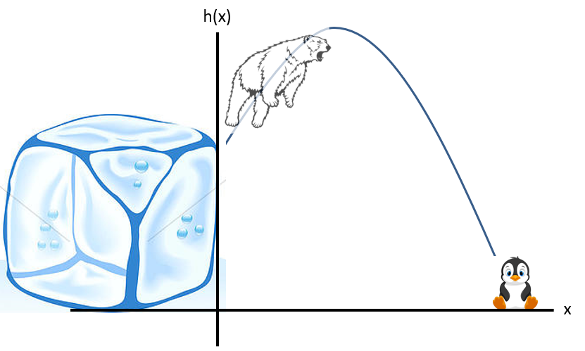
The equation that describes the polar bears path is given by $h\left(x\right)=-x^{2}+4x+5$ , where x and h(x) are both measured in meters.
Q8: Graph the function to determine the horizontal distance that the polar bear travels. Make sure to clearly label (a) y-Intercept, (b) Vertex, (c) Zeroes, and (d) your final answer to the question. (4 marks)
