L27&28 – Worksheet – Intro to Factored Form
Part 1 – Quick Overview (Q1-5)
Q1: Graph the equation $f\left(x\right)=x^{2}-4x-5$ below.
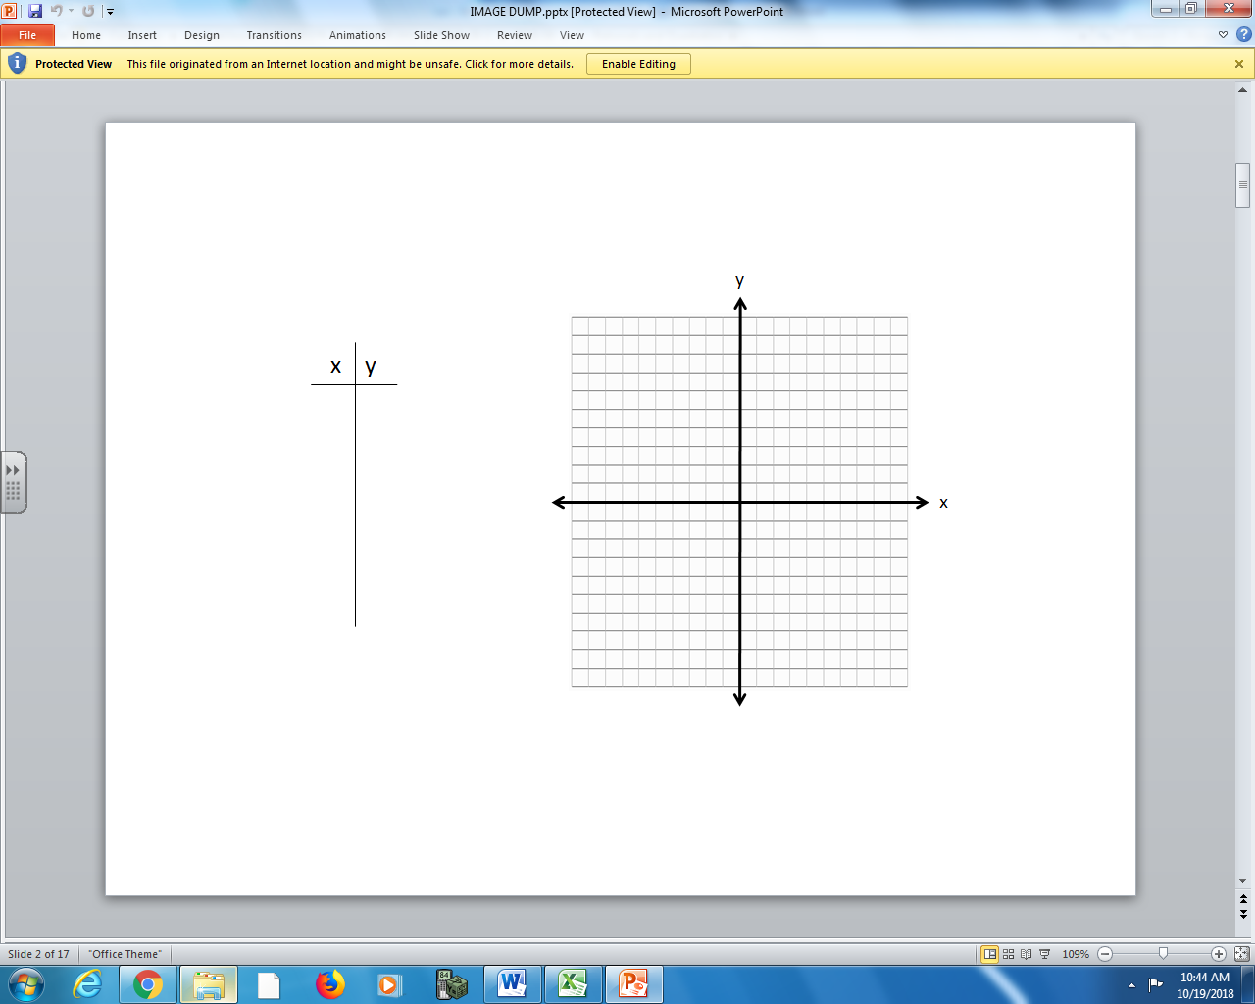
Q2: Evaluate $f(0)$. What is the significance of this point (a) on the graph, and (b) in the original equation?

Q3: Use the Quadratic Equation to determine the zeroes (x-intercepts).

Q4: The equation $f\left(x\right)=x^{2}-4x-5$ factors to $f\left(x\right)=(x-a)(x-b)$. Factor this equation, and determine the significance of these points.

Q5: Using the zeroes, determine the axis of symmetry. Plug this value back into the original equation to determine the coordinates of the vertex.

Part 2 – Standard, Vertex, and Factored (Q6-8)
Q6: The equation $f\left(x\right)=x^{2}+2x-8$ can be written in several different forms:
Standard Form Vertex Form Factored Form

Q7: Using each of form of the equation above, complete the table.
Equation Form | Information | How did you find this information?
Standard Form | y-Intercept
Vertex Form | Axis of Symmetry
Vertex Form | Vertex Coordinate
Factored Form | Zeroes
Factored Form | Axis of Symmetry
Factored Form | Vertex Coordinate
Q8: Using only your information from Q7, and without building a table of values, sketch the original equation.

Part 3 – Standard and Factored (Q9-11)
Q9: The equation $f\left(x\right)=x^{2}-2x-3$ can be written in several different forms:
Standard Form Factored Form

Q10: Using each of form of the equation above, complete the table.
Equation Form | Information | How did you find this information?
Standard Form | y-Intercept
Standard Form | Zeroes
Factored Form | Zeroes
Factored Form | Axis of Symmetry
Factored Form | Vertex Coordinate

Q11: Using only your information from Q10, and without building a table of values, sketch the original equation.

Part 3 – Standard and Vertex (Q12-14)
Q12: The equation $f\left(x\right)=-x^{2}-4x+5$ can be written in several different forms:
Standard Form Vertex Form

Q13: Using each of form of the equation above, complete the table.
Equation Form | Information | How did you find this information?
Standard Form | y-Intercept
Standard Form | Zeroes
Vertex Form | Zeroes
Vertex Form | Axis of Symmetry
Vertex Form | Vertex Coordinate
Q14: Using only your information from Q12, and without building a table of values, sketch the original equation.

