First Name:______________________________ Last Name:______________________________
L29 – Unit Test – Radicals and Quadratic Functions – Part 1
Comp. | Topic | Multiple Choice |  | Numerical Response |  | Long Answer |  | Total  Marks
Comp. | Topic | Questions | Marks | Questions | Marks | Questions | Marks | Total  Marks
Radicals  8 marks | Adding and Subtracting Radicals |  |  | Q1 | 1 |  |  | 1
Radicals  8 marks | Multiplying Radicals | Q2 | 1 |  |  |  |  | 1
Radicals  8 marks | Dividing Radicals | Q3 | 1 |  |  |  |  | 1
Radicals  8 marks | Rationalizing the Denominator |  |  | Q4 | 1 |  |  | 1
Radicals  8 marks | Radical Equations | Q5 | 1 |  |  | Q6 | 3 | 4
Graphing  Functions  4 marks | Identifying Vertex Form Equation from Graph | Q8 | 1 |  |  |  |  | 1
Graphing  Functions  4 marks | Identifying Points from a Graph |  |  | Q9 | 1 |  |  | 1
Graphing  Functions  4 marks | Graphing Standard Form |  |  |  |  | Q10 | 2 | 2
Graphing  Equations  4 marks | Solving a Quadratic Eqn. by Graphing | Q11 | 1 |  |  |  |  | 1
Graphing  Equations  4 marks | Word  Problems |  |  |  |  | Q12 | 3 | 3

Part 1 – Radicals (Algebra) ___ / 8 marks ___ / 100%
Part 2 –Quadratic Functions (Graphing) ___ / 4 marks ___ / 100%
Part 3 –Quadratic Equations (Graphing) ___ / 4 marks ___ / 100%

PART 1 – RADICALS
Q1: The expression $\sqrt{18}-\sqrt{20}-\sqrt{50}+\sqrt{80}$ simplifies to $a\sqrt{b}-c\sqrt{d}$ , where a, b, c, and d are ___, ___, ___, and ___.
(Record your four-digit answer in the Numerical Response boxes below)

Q2: The expression $\left(5+2\sqrt{3}\right)\left(3\sqrt{3}-4\right)$ simplifies to
- $7\sqrt{3}-2$
- $13\sqrt{3}-20$
- $15\sqrt{3}-10$
- $63-28\sqrt{3}$

Use the following information to answer Q3:
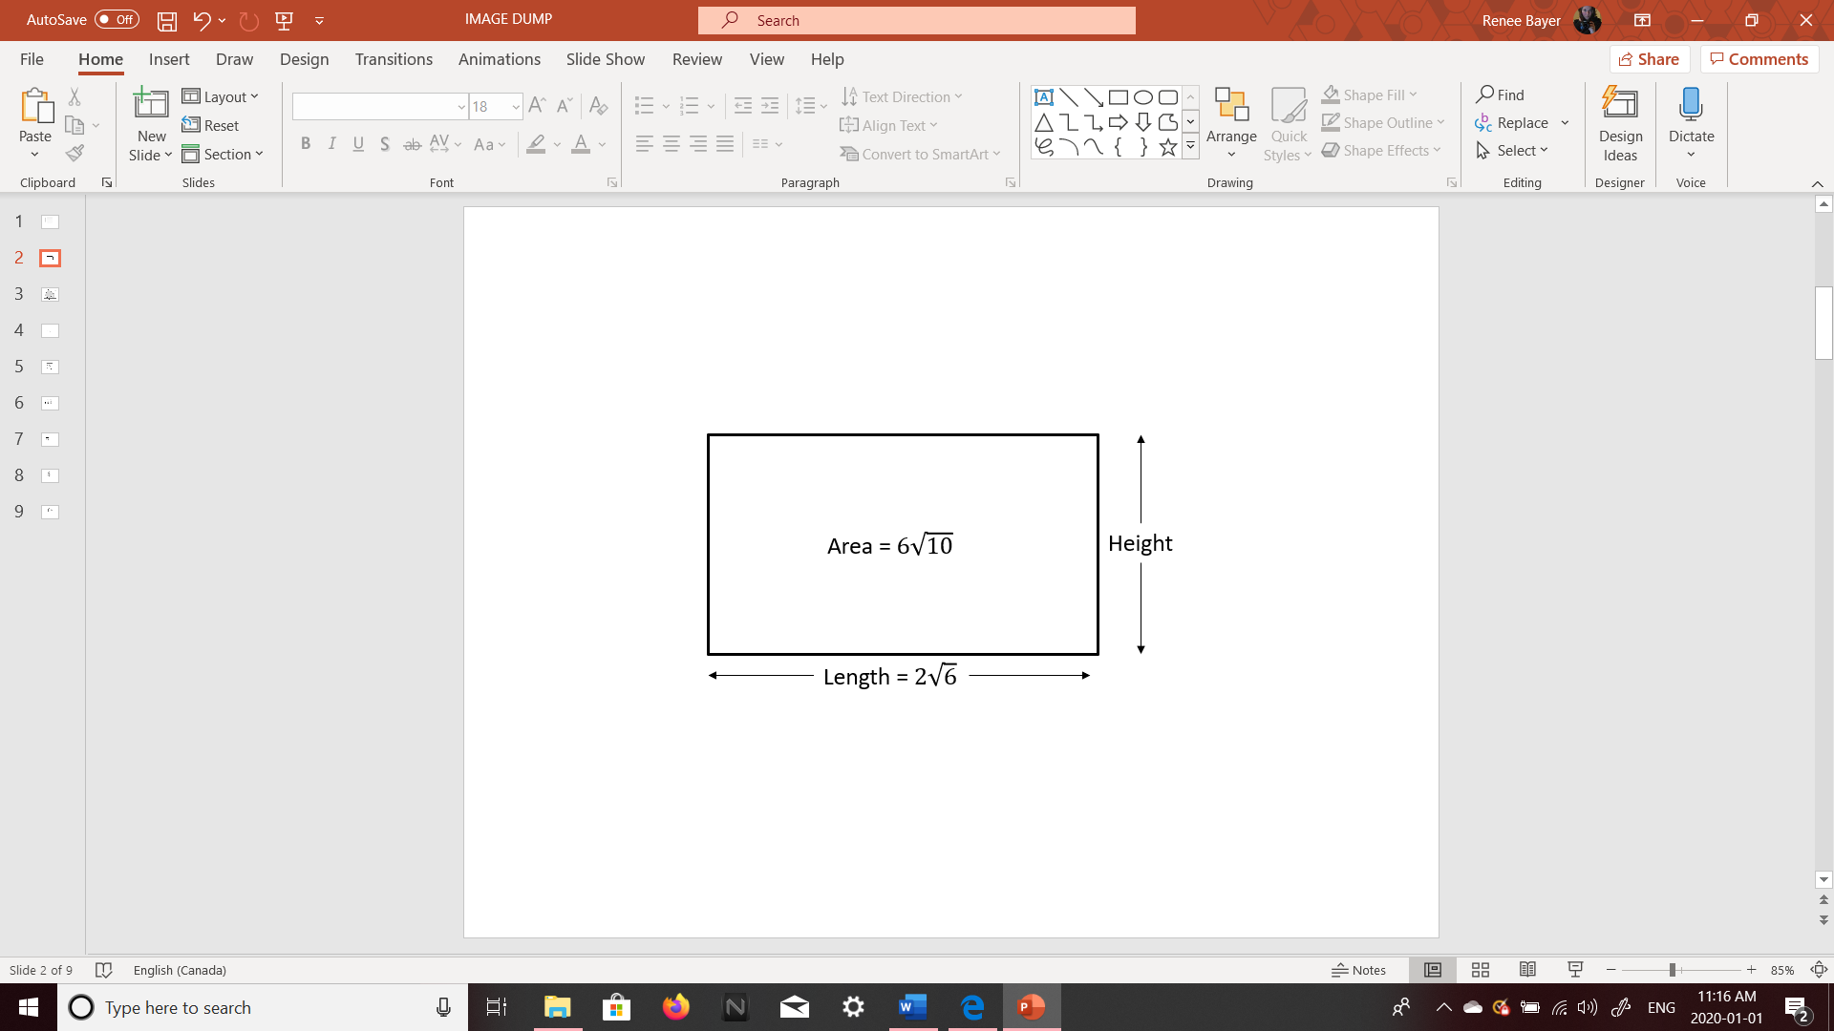
Q3: The height of the rectangle is
- $\frac{\sqrt{60}}{30}$
- $\sqrt{15}$
- $2\sqrt{10}$
- $24\sqrt{15}$

Q4: The expression $\frac{6+2\sqrt{3}}{\sqrt{3}}$ simplifies to $a\sqrt{b}+c$ , where a, b, and c are ___, ___, and ___.
(Record your three-digit answer in the Numerical Response boxes below)

Q5: Determine the solutions to the equation $\sqrt{x+5}=4$
- $x=-1$
- $x=11$
- $x=21$
- No Solutions

Q6: Solve the equation $1+\sqrt{2x-5}=3$ , and verify the solution(s). (3 marks)

PART 2 –GRAPHING QUADRATIC FUNCTIONS
Use the following information to answer Q8-Q9:
A graph for a particular function is given below:
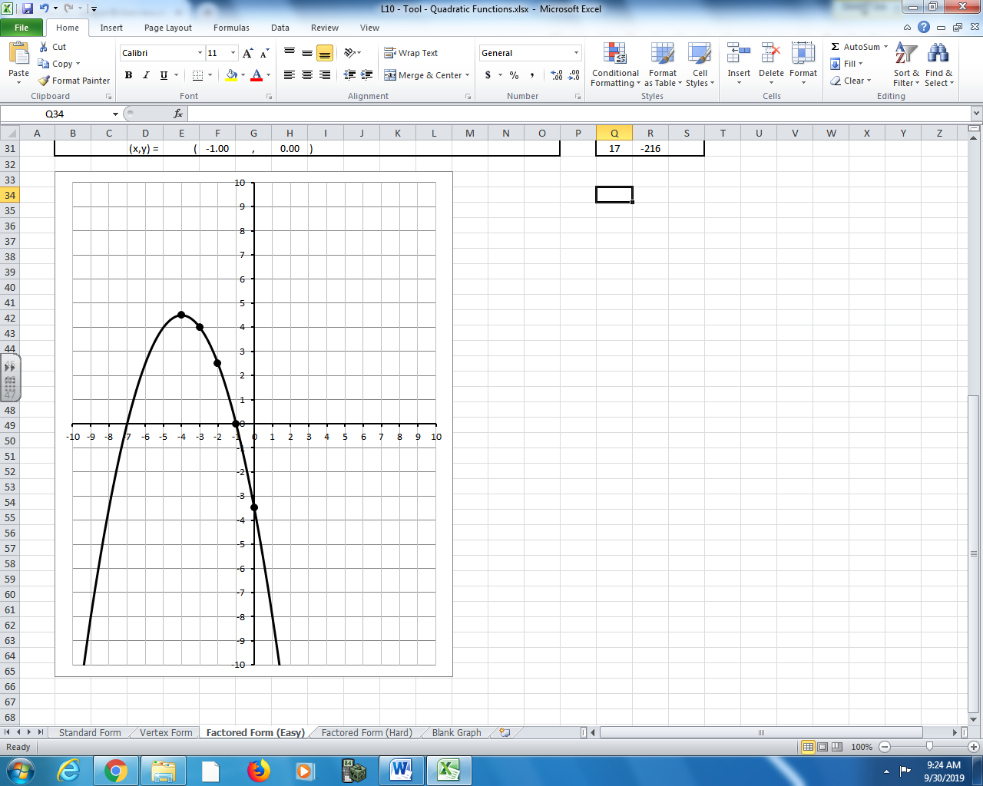

Q8: The equation which best describes the graph is
- $y=-\frac{1}{2}{\left(x-4\right)}^{2}+\frac{9}{2}$
- $y=-1{\left(x-4\right)}^{2}+\frac{9}{2}$
- $y=-\frac{1}{2}{\left(x+4\right)}^{2}+\frac{9}{2}$
- $y=-1{\left(x+4\right)}^{2}+\frac{9}{2}$

Q9: Determine the maximum value of the function, to the nearest tenth.
(Record your answer in the Numerical Response boxes below)

Q10: Graph the function $f\left(x\right)=x^{2}+2x-3$ below, clearly showing: (2 mark long answer)
- Zeroes
- Vertex
- Axis of Symmetry
- Y-Intercept
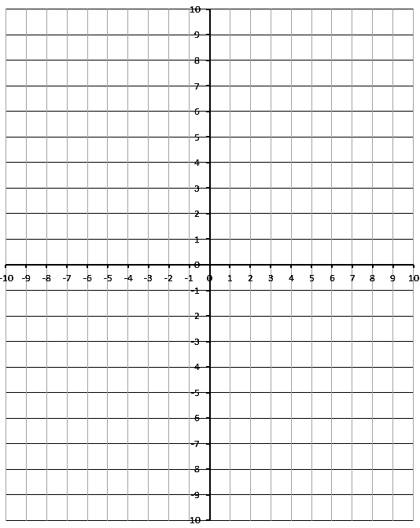

PART 3 –GRAPHING QUADRATIC EQUATIONS
Use the following information to answer Q11:
A student is attempting to solve the quadratic equation $x^{2}=2x+3$. The approach the problem by graphing the function $\left(x\right)=-x^{2}+2x+3$ , shown below.
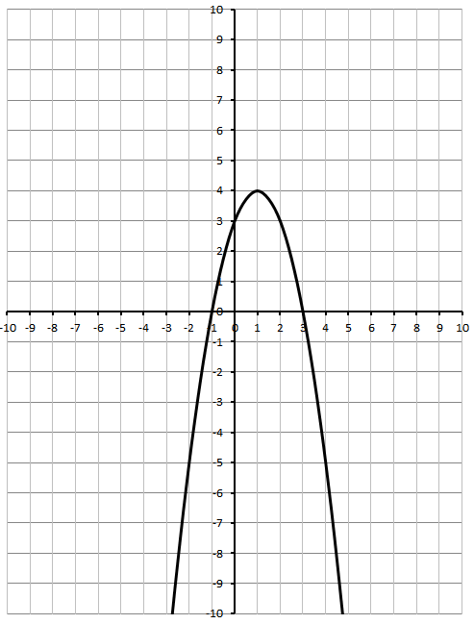
Q11: The solution to the problem is
- $(1,4)$
- $x=1$
- $x_{1}=-1, x_{2}=3$
- $x_{1}=0, x_{2}=2$

Use the following information to answer Q12:
A kangaroo jumps off a ledge of unknown height, and lands 6m from her starting point.
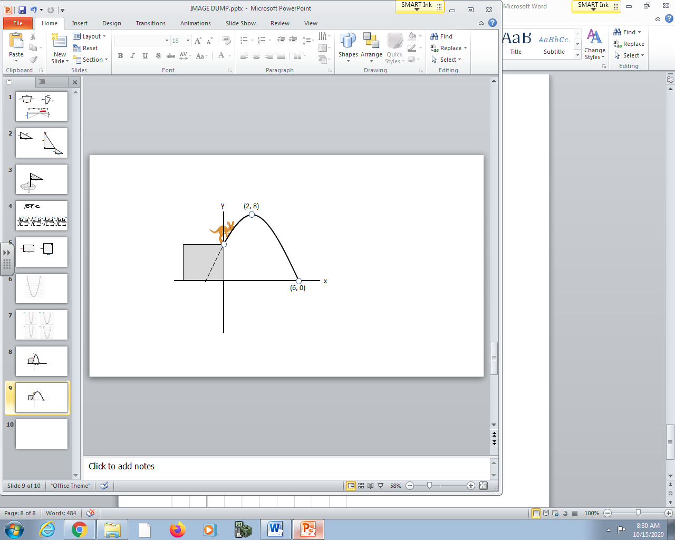
Q12: If the kangaroo reached a maximum height of 8m after travelling a horizontal distance of 2m, how tall was the ledge? (3 marks)
