L31 – Inductive Reasoning
Terminology
Conjecture: A testable expression that is based on available evidence but is not yet proved.
Inductive Reasoning: Drawing a general conclusion by observing patterns and identifying properties in specific examples.
Counter Example: An example that invalidates a conjecture.
Topic #1: Inductive Reasoning – Linear Relations
Q1: Georgia, a fabric artist, has been patterning with equilateral triangles. Georgia believes that the 10th figure in the pattern will have 100 upright triangles. Do you agree? Explain.
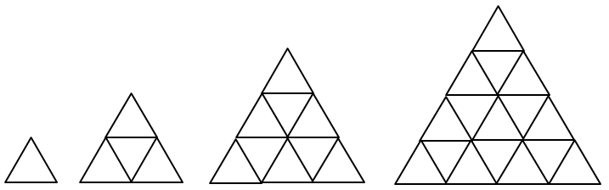
Figure | Fig 1 | Fig 2 | Fig 3 | Fig 4
Base 1 Triangles
Base 2 Triangles
Base 3 Triangles
Base 4 Triangles
Total Triangles

Q2: Bob likes blocks. Bob believes that the perimeter of the 10th set of blocks will be an even number. Do you agree? Explain.
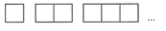

Q3: A series of triangles can be made using toothpicks, per the diagrams below. Make a conjecture about the next 10 diagrams. Is this testable? Do any counter-examples exist?
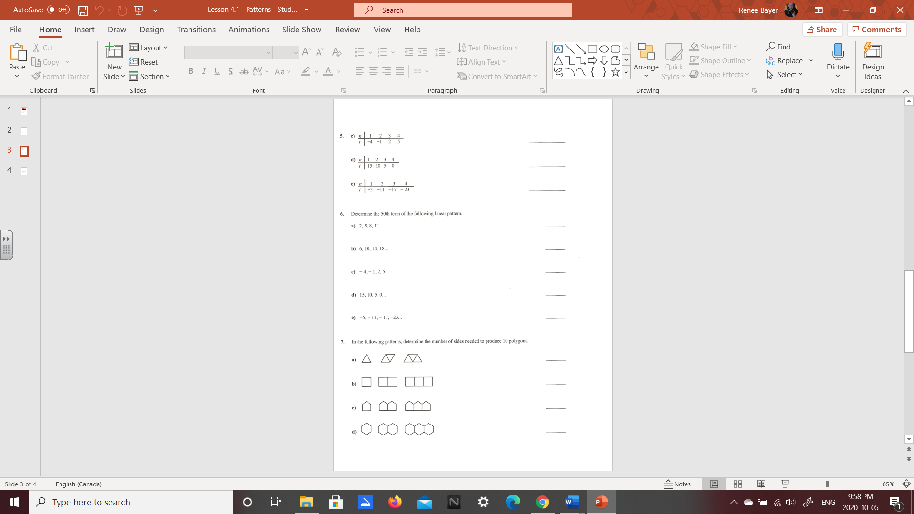

Topic#2: Inductive Reasoning – Non-Linear Patterns
Q4: Make a conjecture about the difference between two consecutive perfect squares.
Step 1: Find a pattern.


Step 2: Determine your conjecture. Is it testable? Do counter examples exist?

Step 3: If possible, generalize the pattern.


Q5: Make a conjecture about the pattern below, and determine the next 5 numbers.
