L32 – Deductive Reasoning
Terminology
Proof: A mathematical argument showing that a statement is valid in all cases, or that no counterexample exists.
Generalization: A principle, statement, or idea that has general application.
Deductive Reasoning: Drawing a specific conclusion through logical reasoning by starting with general assumptions that are known to be valid.
Inductive vs. Deductive Reasoning
: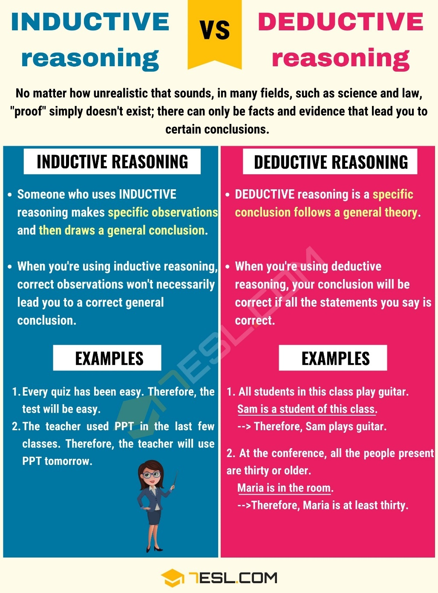
Expressing Even Numbers, Odd Numbers, and Consecutive Numbers
How do you express a number?
How do you express an even number?
How do you express an odd number?
How do you express consecutive numbers?
Topic #3: Deductive Reasoning – Even/Odd and Consecutive Numbers
Q1: Prove that the sum of two odd numbers is an even number.

Q2: Prove that the sum of two even numbers is an even number.

Q3: Prove that the sum of an even and an odd number is an odd number.

Q4: Prove that the product of an even and odd number is an even number.

Q5: Prove that the product of two odd numbers is an odd number.

Topic #3: Deductive Reasoning - Physics
Q6: The force of gravity, F, between two objects that are distance r apart can be modeled by the equation:
$$F=\frac{100}{{(r)}^{2}}$$
Prove that when the distance is tripled, the force is 1/9th of the original amount. (2 marks)
Math Explanation

Q7: The Kinetic Energy, E, of a particular object depends upon its mass, m, and its speed, v, per the equation below:
$$E=\frac{1}{2}m{(v)}^{2}$$
Prove that when the speed is halved, the kinetic energy is one quarter of the original amount. (2 marks)
Math Explanation

Topic #4: Deductive Reasoning – Invalid Proofs
Q8: Hossai is trying to prove the following number trick:
Choose any number. Add 3. Double it. Add 4. Divide by 2. Take away the number you started with.
Each time Hossai tries the trick, she ends up with 5. Her proof, however, does not give the same result.
Hossai’s Proof (as a “2-Column Proof”)
n | Choose any number
n + 3 | Add 3
2n + 6 | Double it
2n + 10 | Add 4
2n + 5 | Divide by 2
n + 5 | Take away the number you started with
Where is the error in Hossai’s proof?

Q9: Mr. Bayer believes that he just proved that 2 = 1.
Bayer’s Proof (as a “2-Column Proof”)
Let a = b | Set a = b
a² = ab | Multiply both sides by a
a² – b² = ab – b² | Subtract b² from both sides
(a + b)(a – b) = b(a – b) | Factor each side
a + b = b | Divide both sides by (a-b)
b + b = b | Replace a with b, since a = b
2b = b | Collect like terms on left side
2 = 1 | Divide both sides by b
Where is the error in Bayer’s proof?

Q10: Mr. Bayer claims that the cube of a number is always larger than the number itself. Give one counter-example to this claim. (1 mark)

Q11: Mr. Bayer makes the claim that Pythagoras Theorem (a² + b² = c²) works for every triangle. Using a ruler, create one counter-example where this is not true. Label the lengths of each side. (1 mark)

Q12: Mr. Bayer decides to show that the product of an odd number and 3 is always an odd number. However, he made a mistake somewhere. Find which line has the mistake, and correct his proof. (3 marks)
Line | Math | Explanation
1 | Let (2x+1) be my odd number. | Even number plus one, which makes it odd.
2 | (2x+1)(3) | Multiply my numbers
3 | 6x+4 | Simplify
4 | 2(3x+2) | Hold on… this is divisible by 2. Did I make a mistake?

Line | Math | Explanation
1
2
3
4

