L33 – Puzzles and Games involving Reasoning
Sudoku
Q1: Use a Chromebook to go to the website https://sudoku.com/
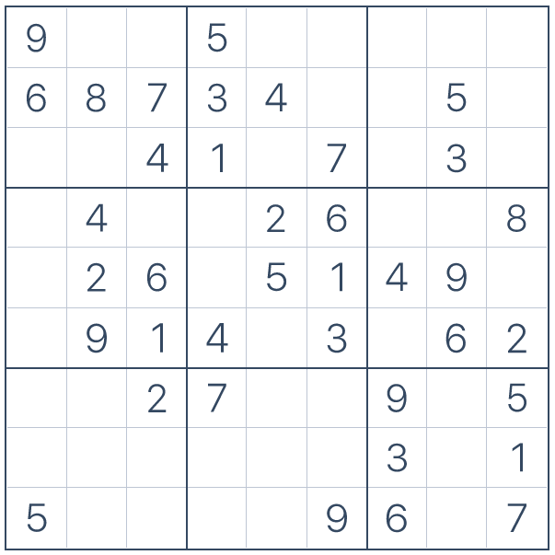

Among Us
Q2: Students will learn how to play Among Us.
