In “Unit 2 – Inductive and Deductive Reasoning”, students will select 4 of 6 assessments to complete, and submit their work via Google Classroom. This is Assignment #1 of 6.
Topic #1: Inductive Reasoning – Linear Relations
Q1: Create a conjecture regarding the pattern below. How many blocks would be in Fig 6? (2 marks)


Topic #2: Inductive Reasoning – Non-Linear Patterns
Q2: Create a conjecture regarding the pattern below. Fill in the appropriate numbers for Row 6.
(2 marks)
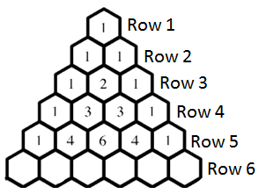

Topic #3: Deductive Reasoning – Even/Odd and Consecutive Numbers
Please use 2-columns for each proof. (2 marks)
Q3: Prove that the product of an even and an odd number is an even number.
Math Explanation

Topic #4: Deductive Reasoning – Invalid Proofs
Q4: Mr. Bayer decides to show that the sum of three consecutive numbers, if the first number is even, results in an odd number. However, he made a mistake somewhere. Find which line has the mistake and correct his proof. (2 marks)
Line | Math | Explanation
1 | Use 2x, 2x+1, 2x+2 | 2x is even, the others are consecutive.
2 | (2x) + (2x+1) + (2x+2) | Add the three numbers together.
3 | 6x+2 | Collect like terms.
4 | 2(3x+1) | Take out the common factor of 2. Because this number is divisible by 2, it is even.

Line | Math | Explanation
1
2
3
4

