In “Unit 2 – Inductive and Deductive Reasoning”, students will select 4 of 6 assessments to complete, and submit their work via Google Classroom. This is Assignment #5 of 6.
Topic #5: Inductive Reasoning – Sudoku
Q1: Solve for the number that goes into the highlighted grey square. (2 marks)
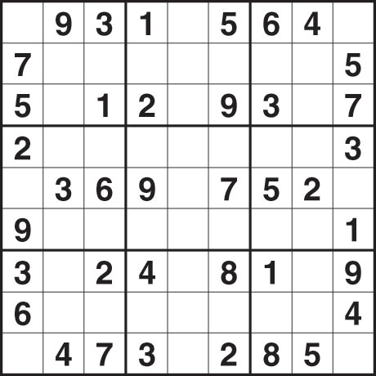

Q2: Solve for the number that goes into the highlighted grey square. (2 marks)

Q3: Solve for the number that goes into the highlighted grey square. (2 marks)
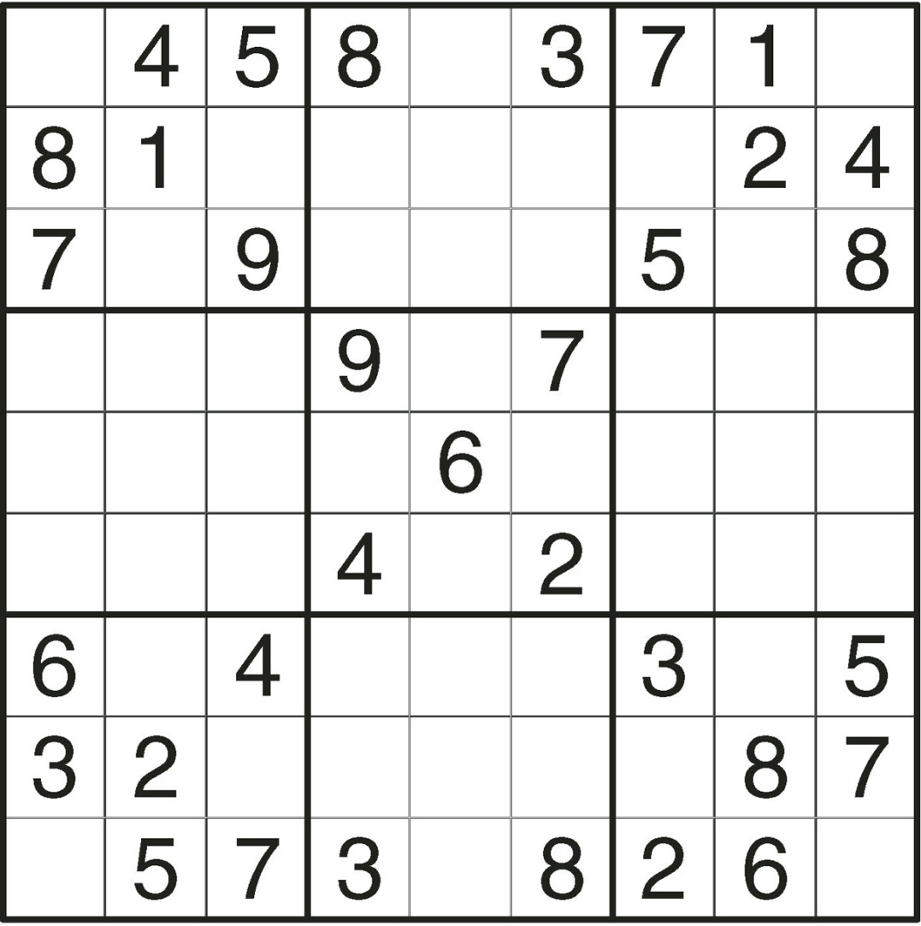

Q4: Solve for the number that goes into the highlighted grey square. (2 marks)
