In “Unit 2 – Inductive and Deductive Reasoning”, students will select 4 of 6 assessments to complete, and submit their work via Google Classroom. This is Assignment #6 of 6.
Assessment #6: Inductive Reasoning – Among Us
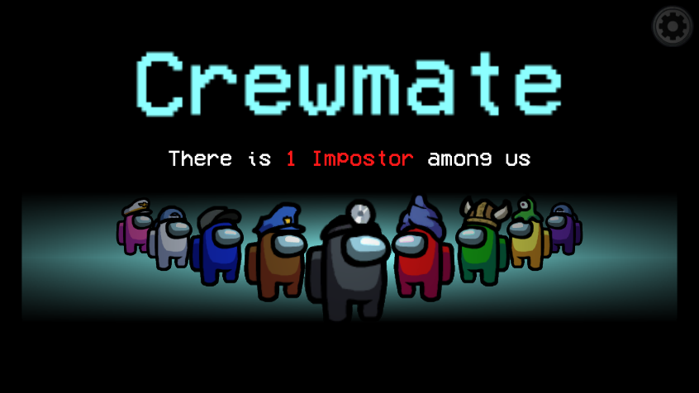
Q1: Play a match where:
- You were a Crewmate
- There was 1 Imposter
- You successfully voted out the imposter
How did you use Inductive Reasoning to determine who the Imposter was? (2 marks)

Q2: Play a match where:
- You were a Crewmate
- There was 1 Imposter
- You successfully voted out the imposter
How did you use Inductive Reasoning to determine who the Imposter was? (2 marks)

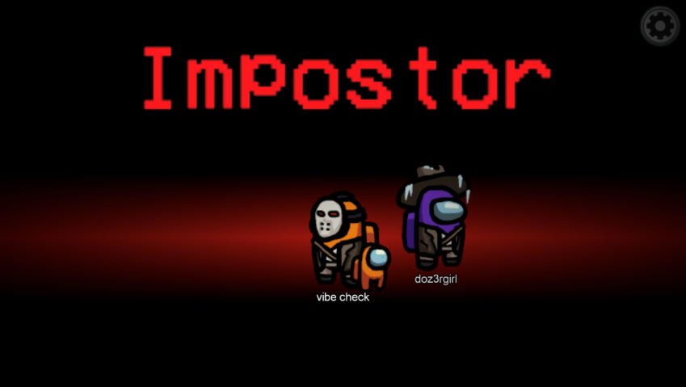
Q3: Play a match where:
- You were a Crewmate
- There were 2 Imposters
- You successfully voted out both imposters
How did you use Inductive Reasoning to determine who the Imposters were? (2 marks)

Q4: Play a match where:
- You were a Crewmate
- There were 2 Imposters
- You successfully voted out both imposters
How did you use Inductive Reasoning to determine who the Imposters were? (2 marks)

