L36 – Mean, Median, Range
Part 1 – Statistics Cheat Sheet
Sample | Population
n - Sample size | N - Population size
$\overline{x}$ - Mean  $$\overline{x}=\frac{\sum_{i=1}^{n}{x_{i}}}{n}=\frac{x_{1}+x_{2}+…+x_{n}}{n}$$ | µ - Mean  $$μ=\frac{\sum_{i=1}^{N}{x_{i}}}{N}=\frac{x_{1}+x_{2}+…+x_{N}}{N}$$
$s$ - Standard deviation  $$s=\sqrt{\frac{\sum_{i=1}^{n}{{(x_{i}-\overline{x})}^{2}}}{n-1}}$$  (Note, TI uses sx for Standard Deviation of a sample of a larger population, using Bessel’s Correction) | $σ$ - Standard deviation  $$σ=\sqrt{\frac{\sum_{i=1}^{n}{{(x_{i}-μ)}^{2}}}{N}}$$  (Note, TI uses σx for Standard Deviation for the data representing the entire population)
$s^{2}$ - Variance | $σ^{2}$ - Variance
R - Range

Part 2 – Measures of Central Tendency
When examining data, examining the Central Tendency of the data can be incredibly useful to understanding the data. Central Tendency can be measured by looking at the mean, median, or mode.
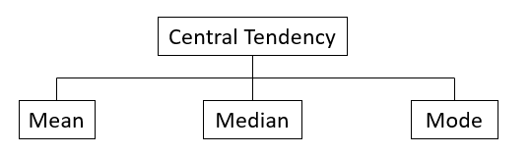
Mean – The average of a data set; Found by adding all numbers in the data set and then dividing by the number of values in the set.
Median - The middle value when a data set is ordered from least to greatest.
Mode - The number that occurs most often in a data set.

Use the following information to answer Q1:
1 2 3 4 4 4 5 6 6
Q1: Complete the table for this data set:
Mean | Median | Mode

Use the following information to answer Q2:
8 8 8 9 10 12 15
Q2: Complete the table for this data set:
Mean | Median | Mode

Use the following information to answer Q3:
4 5 5 5 6 8 8 9
Q3: Complete the table for this data set:
Mean | Median | Mode

Part 3 – Measures of Variation
When examining data, examining Dispersion of the data is also important to understanding the data. Dispersion can be measured by looking at the range, variation, or standard deviation.
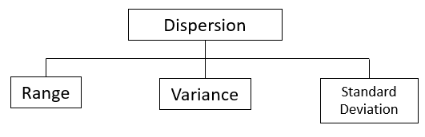
Range – The difference between the highest and lowest numbers.
Variance – A measure of how far a set of numbers is spread out from their average value.
Standard Deviation – A measure of how far a set of numbers is spread out from their average value.
(We’ll cover Variance and Standard Deviation in L38)

Use the following information to answer Q4:
Mr. Bayer is examining student marks on an 8-mark quiz. The results are as follows:
3 4 5 5 5 6 7 7 8 8
Q4: Complete the table for this data set:
Mean | Median | Mode | Range

Part 4 – Mean, Median, Mode, and Range using a T.I. Calculator
https://www.youtube.com/watch?v=dL43joOJang
Notes:

