L37 – Frequency Tables, Histograms
Part 1 – What is a Histogram?
Histogram - a diagram consisting of rectangles whose area is proportional to the frequency of a variable and whose width is equal to the class interval.
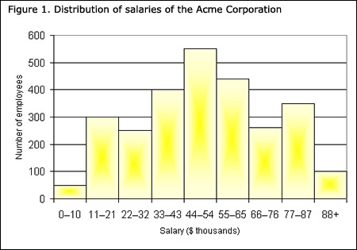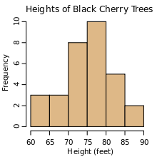

https://phet.colorado.edu/en/simulation/plinko-probability
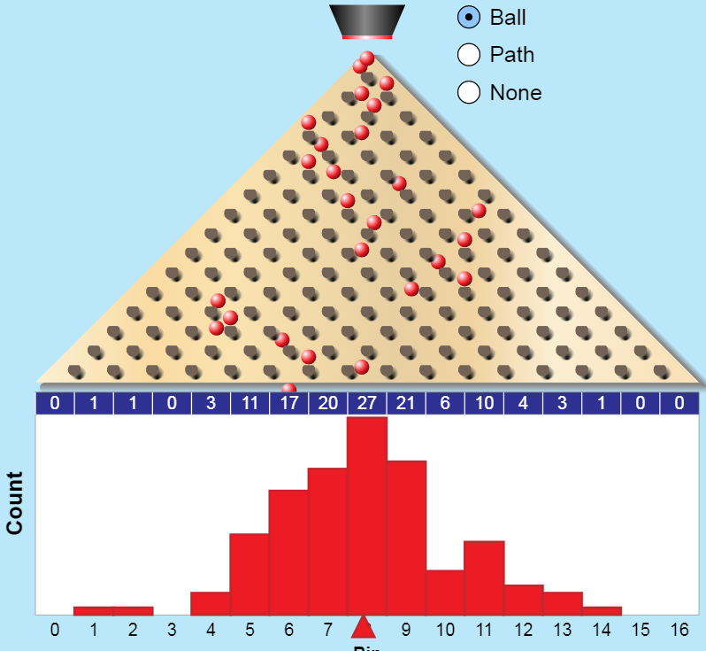
Part 2 – Building Frequency Tables and Histograms
Use the following information to answer Q1-Q2:
Marks on a 12 question quiz are as follows:
2 4.5 5 5 5.5 6 6 6.5 6.5 7
7 7 7.5 7.5 7.5 7.5 8 8 8.5 8.5
8.5 8.5 9 9 9.5 10 10 10.5 11 12

Q1: Build a Frequency Table Q2: Draw a Histogram
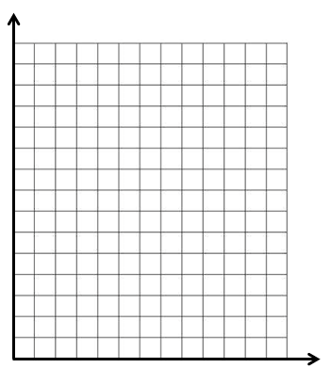
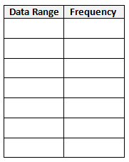

Use the following information (from L36) to answer Q3-Q4:
Measured Lifespans of 30 Car Batteries (years)
Brand X |  |  |  |  | Brand Y
5.1 | 7.3 | 6.9 | 4.7 | 5.0 | 5.4 | 6.3 | 4.8 | 5.9 | 5.5
6.2 | 6.4 | 5.5 | 5.7 | 6.8 | 4.7 | 6.0 | 4.5 | 6.6 | 6.0
6.0 | 4.8 | 4.1 | 5.2 | 8.1 | 5.0 | 6.5 | 5.8 | 5.4 | 5.1
6.3 | 7.5 | 5.0 | 5.7 | 8.2 | 5.7 | 6.8 | 5.6 | 4.9 | 6.1
3.3 | 3.1 | 4.3 | 5.9 | 6.6 | 4.9 | 5.7 | 6.2 | 7.0 | 5.8
5.8 | 6.4 | 6.1 | 4.6 | 5.7 | 6.8 | 5.9 | 5.3 | 5.6 | 5.9
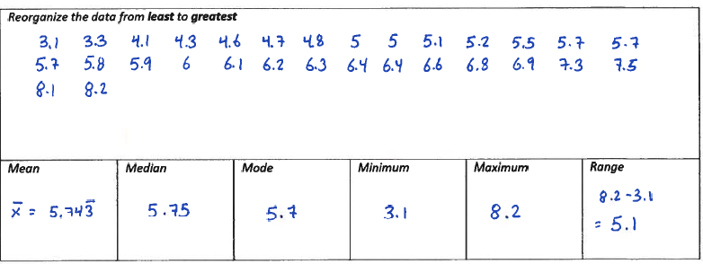
Q3: Create a Histogram for Brand X.
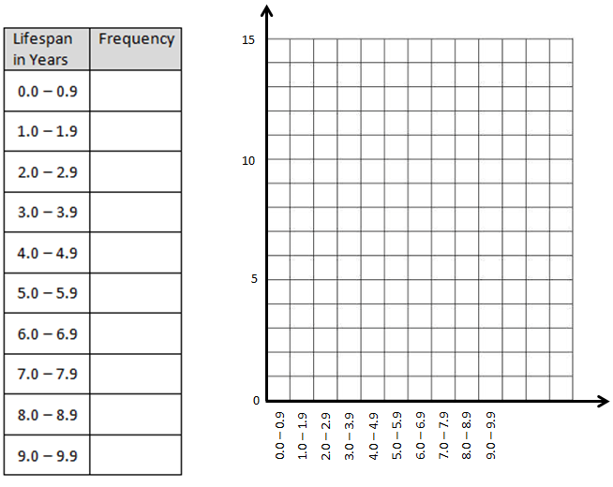
Use the following information (from L36) to answer Q3-Q4:
Measured Lifespans of 30 Car Batteries (years)
Brand X |  |  |  |  | Brand Y
5.1 | 7.3 | 6.9 | 4.7 | 5.0 | 5.4 | 6.3 | 4.8 | 5.9 | 5.5
6.2 | 6.4 | 5.5 | 5.7 | 6.8 | 4.7 | 6.0 | 4.5 | 6.6 | 6.0
6.0 | 4.8 | 4.1 | 5.2 | 8.1 | 5.0 | 6.5 | 5.8 | 5.4 | 5.1
6.3 | 7.5 | 5.0 | 5.7 | 8.2 | 5.7 | 6.8 | 5.6 | 4.9 | 6.1
3.3 | 3.1 | 4.3 | 5.9 | 6.6 | 4.9 | 5.7 | 6.2 | 7.0 | 5.8
5.8 | 6.4 | 6.1 | 4.6 | 5.7 | 6.8 | 5.9 | 5.3 | 5.6 | 5.9
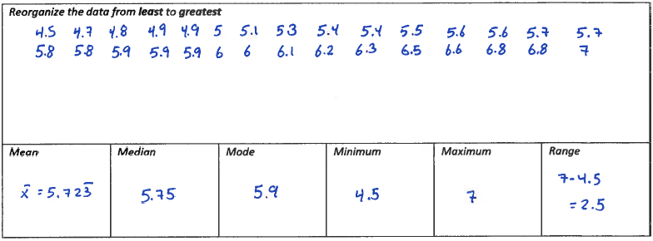
Q4: Create a Histogram for Brand Y.
Part 3 – Calculating Mean, Median, and Mode from a Histogram
Q5: How do we calculate the mean, median, and mode for the average height of a cherry tree?

