L37 – Worksheet – Frequency Tables, Histograms
Part 1 – Review of Mean, Median, Mode, Range, Frequency Tables, and Histograms
Mr. Hopper teaches Grade’s 5 and 6, and is comparing the success of his students at each grade. The students’ marks are listed below.
Marks per Class
Grade 5 |  |  |  |  | Grade 6
67 | 74 | 12 | 69 | 93 | 77 | 65 | 80 | 45 | 6
80 | 91 | 66 | 78 | 55 | 83 | 94 | 78 | 71 | 16
79 | 96 | 83 | 83 | 48 | 24 | 77 | 81 | 63 | 28
67 | 68 | 55 | 93 | 76 | 67 | 89 | 54 | 81 | 67
24 | 24 | 64 | 29 |  | 89 | 54 | 81 | 67 | 82
 |  |  |  |  | 57 | 85 | 73
Q1: For Grade 5, reorganize the data to determine mean, median, mode, and range, and draw a Histogram.
Reorganize the data from least to greatest
Determine the mean | Determine the median | Determine the mode | Determine the range

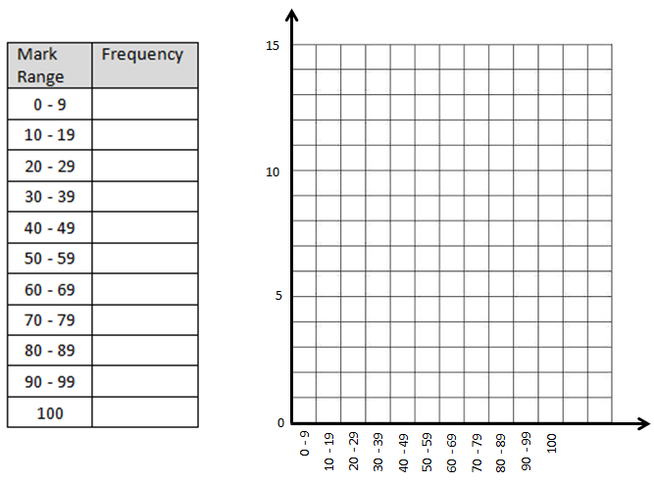
Mr. Hopper teaches Grade’s 5 and 6, and is comparing the success of his students at each grade. The students’ marks are listed below.
Marks per Class
Grade 5 |  |  |  |  | Grade 6
67 | 74 | 12 | 69 | 93 | 77 | 65 | 80 | 45 | 6
80 | 91 | 66 | 78 | 55 | 83 | 94 | 78 | 71 | 16
79 | 96 | 83 | 83 | 48 | 24 | 77 | 81 | 63 | 28
67 | 68 | 55 | 93 | 76 | 67 | 89 | 54 | 81 | 67
24 | 24 | 64 | 29 |  | 89 | 54 | 81 | 67 | 82
 |  |  |  |  | 57 | 85 | 73
Q2: For Grade 6, reorganize the data to determine mean, median, mode, and range, and draw a Histogram.
Reorganize the data from least to greatest
Determine the mean | Determine the median | Determine the mode | Determine the range

Q3: Which class is the more academic class? Explain.

