L38 – Standard Deviation
Part 1 – Statistics Cheat Sheet
Sample | Population
n - Sample size | N - Population size
$\overline{x}$ - Mean  $$\overline{x}=\frac{\sum_{i=1}^{n}{x_{i}}}{n}=\frac{x_{1}+x_{2}+…+x_{n}}{n}$$ | µ - Mean  $$μ=\frac{\sum_{i=1}^{N}{x_{i}}}{N}=\frac{x_{1}+x_{2}+…+x_{N}}{N}$$
$s$ - Standard deviation  $$s=\sqrt{\frac{\sum_{i=1}^{n}{{(x_{i}-\overline{x})}^{2}}}{n-1}}$$  (Note, TI uses sx for Standard Deviation of a sample of a larger population, using Bessel’s Correction) | $σ$ - Standard deviation  $$σ=\sqrt{\frac{\sum_{i=1}^{n}{{(x_{i}-μ)}^{2}}}{N}}$$  (Note, TI uses σx for Standard Deviation for the data representing the entire population)
$s^{2}$ - Variance | $σ^{2}$ - Variance
R - Range

Part 2 – Calculating the Standard Deviation of an Entire Population
Q1: The ages of 5 children in a family are recorded below. These represent the entire population of children in that family.
4, 5, 8, 11, 17

Calculate the mean and standard deviation of the ages, using the table for assistance.
$$x_{i}$$ | $$μ$$ | $$x_{i}-μ$$ | $${\left(x_{i}-μ\right)}^{2}$$

Use the following information to answer questions #2-5. You may use technology (T.I. Calculator) to get your answers.
Students were asked how many times they looked at the clock during a Math 20-2 class. Their responses are recorded below:
0 0 1 2 3
3 3 4 5 8
8 9 11 12 54

Q2: What is the mean of the data?

Q3: What is the median of the data?

Q4: What is the mode of the data?

Q5: What is the standard deviation of the data?

Q6: Which datapoint(s) would you consider outliers?

Q7: Build a frequency table using the data, and graph as a Histogram.
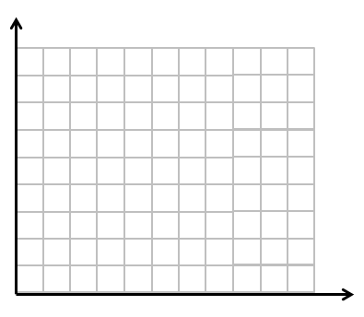
Interval Frequency

Sample | Population
n - Sample size | N - Population size
$\overline{x}$ - Mean  $$\overline{x}=\frac{\sum_{i=1}^{n}{x_{i}}}{n}=\frac{x_{1}+x_{2}+…+x_{n}}{n}$$ | µ - Mean  $$μ=\frac{\sum_{i=1}^{N}{x_{i}}}{N}=\frac{x_{1}+x_{2}+…+x_{N}}{N}$$
$s$ - Standard deviation  $$s=\sqrt{\frac{\sum_{i=1}^{n}{{(x_{i}-\overline{x})}^{2}}}{n-1}}$$  (Note, TI uses sx for Standard Deviation of a sample of a larger population, using Bessel’s Correction) | $σ$ - Standard deviation  $$σ=\sqrt{\frac{\sum_{i=1}^{n}{{(x_{i}-μ)}^{2}}}{N}}$$  (Note, TI uses σx for Standard Deviation for the data representing the entire population)
$s^{2}$ - Variance | $σ^{2}$ - Variance
R - Range

Part 2 – Calculating the Standard Deviation of an Entire Population
Q8: The heights of a few randomly selected Grade 11 students are given below, in centimeters:
160 162 185 188 165 168 143
Calculate the mean and standard deviation of the ages, using the table for assistance.
$$x_{i}$$ | $$\overline{x}$$ | $$x_{i}-\overline{x}$$ | $${\left(x_{i}-\overline{x}\right)}^{2}$$

