L39 – Project – Statistics Project 1 /20 marks
Students will (a) collect 20 points of continuous data from a population, (b) calculate the central tendency of the data, (c) calculate the standard deviation, and (d) graph the data in a histogram.
Step 1: Collect Data ___/5 marks
Students will collect a sample of continuous data¹ from a population and record it below. Be specific (e.g. Heights of Gr11 students).
¹Data collected from a population can be described as continuous (heights) or discrete (dominant hand).
What is the data that you collected?
Unsorted data (20 points)
Data sorted from least to greatest (20 points)

 | 3 | 2 | 1 | 0
Data Collection | Student collected  (a) 20 points of unsorted data,  (b) continuous data, and  (c) specific data. | Student met 2 of the 3 requirements. | Student met 1 of the 3 requirements. | Student met 0 of the 3 requirements.
Data Sorting |  | Student correctly sorted data from least to greatest. | Student sorted data from least to greatest, but is missing some data. | Student was unable to sort data from least to greatest.

Step 2: Calculate Mean, Median, and Mode ___/6 marks
Students will determine the Mean, Median, and Mode for the data.
Showing work for calculation of the Mean
Mean | Median | Mode

 | 3 | 2 | 1 | 0
Work for Calculating Mean | Student’s work  (a) starts with the equation for mean,  (b) uses proper notation,  (c) follows a logical progression. | Student’s work meets 2 of the 3 requirements. | Student’s work meets 1 of the 3 requirements. | Student’s work meets 0 of the 3 requirements.
Mean, Median, and Mode | Student arrived at the correct answer for 3 of the 3 measures of central tendency. | Student arrived at the correct answer for 2 of the 3 measures of central tendency. | Student arrived at the correct answer for 1 of the 3 measures of central tendency. | Student arrived at the correct answer for 0 of the 3 measures of central tendency.

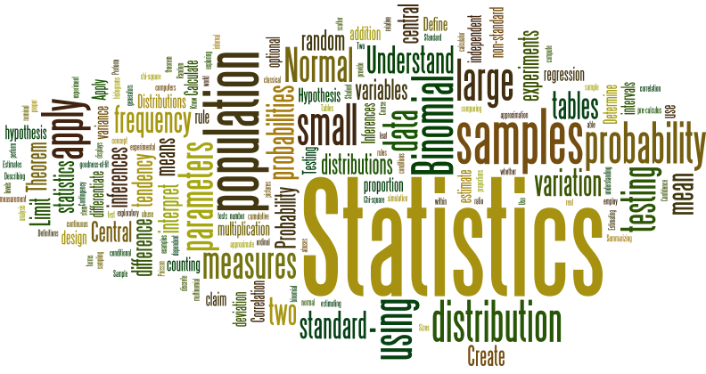
Step 3: Calculate Standard Deviation ___/5 marks
Students will calculate the Standard Deviation, using the table below to help show their work.
$$x_{i}$$ | $$\overline{x}$$ | $$x_{i}-\overline{x}$$ | $${\left(x_{i}-\overline{x}\right)}^{2}$$ |  | $$x_{i}$$ | $$\overline{x}$$ | $$x_{i}-\overline{x}$$ | $${\left(x_{i}-\overline{x}\right)}^{2}$$

Calculate Standard Deviation using $s=\sqrt{\frac{\sum_{i=1}^{n}{{(x_{i}-\overline{x})}^{2}}}{n-1}}$

 | 3 | 2 | 1 | 0
Completing table for ${\left(x_{i}-\overline{x}\right)}^{2}$ |  | Student has completed the table for use in calculating the Standard Deviation, with no errors. | Student has completed the table for use in calculating the Standard Deviation, with some errors. | Student has not completed the table for use in calculating the Standard Deviation.
Calculating the Standard Deviation | Student’s work  (a) starts with the equation for stdev,  (b) uses proper notation,  (c) follows a logical progression to the correct answer. | Student’s work meets 2 of the 3 requirements. | Student’s work meets 1 of the 3 requirements. | Student’s work meets 0 of the 3 requirements.
Step 4: Create a Histogram ___/4 marks
Students will create a Frequency Table and Histogram for their data.
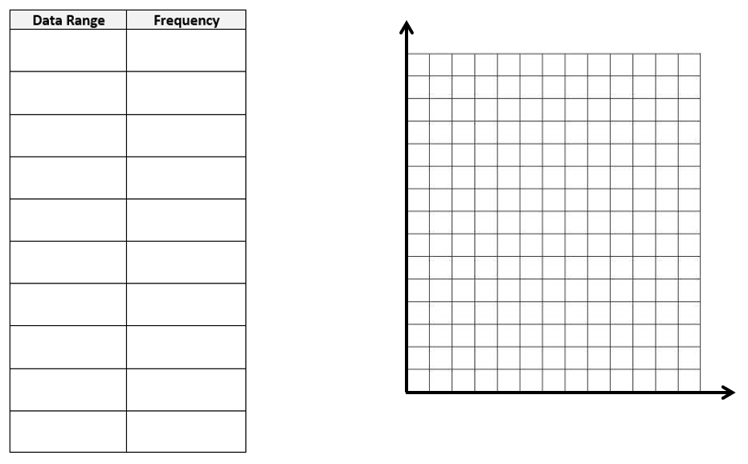
 | 3 | 2 | 1 | 0
Frequency Table |  | Student has  (a) created logical data ranges, and  (b) correctly determined frequency for each data range. | Student has met 1 of the 2 requirements. | Student has met 0 of the 2 requirements.
Histogram |  | Student has  (a) correctly labelled the x- and y-axis on the graph, and  (b) correctly graphed the frequency data. | Student has met 1 of the 2 requirements. | Student has met 0 of the 2 requirements.

