L40 – Normal Distribution
Part 1 – Introduction to the Normal Distribution (Normal Curve, Bell Curve, Gaussian Distribution)
https://phet.colorado.edu/en/simulation/plinko-probability
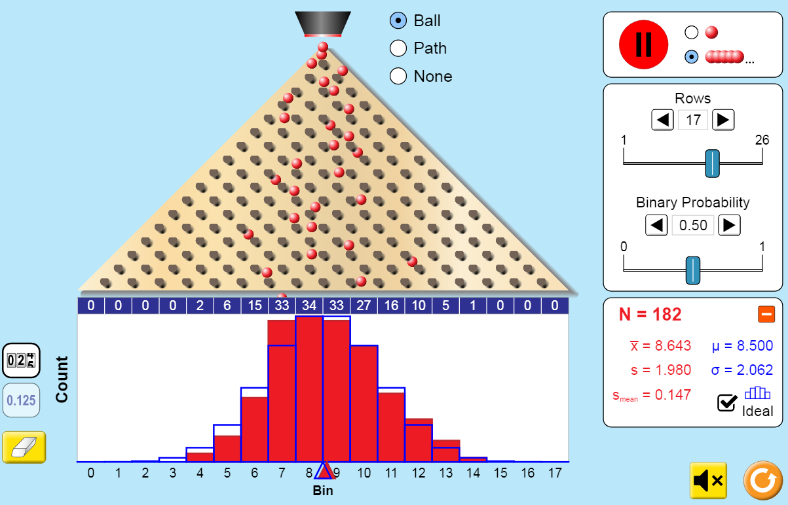
https://www.youtube.com/watch?v=mtbJbDwqWLE
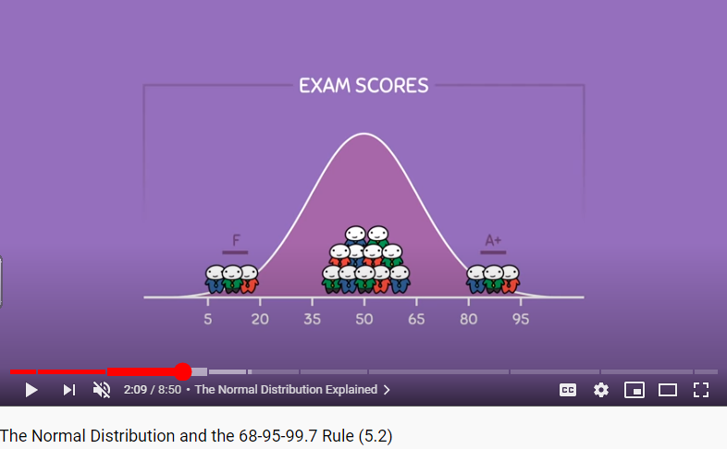

Part 2 – Normal Distribution Simulation
https://academo.org/demos/gaussian-distribution/
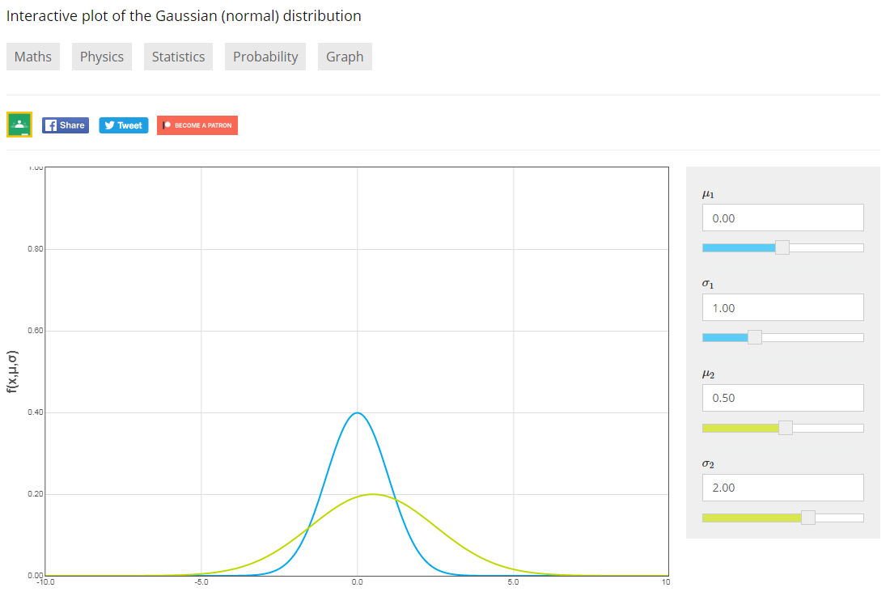
Q1: What happens when we increase our mean value?

Q2: What happens when we increase our standard deviation value?

Use the following information to answer Q3:
The blue line represents a population with a mean of 0 and a standard deviation of 1.
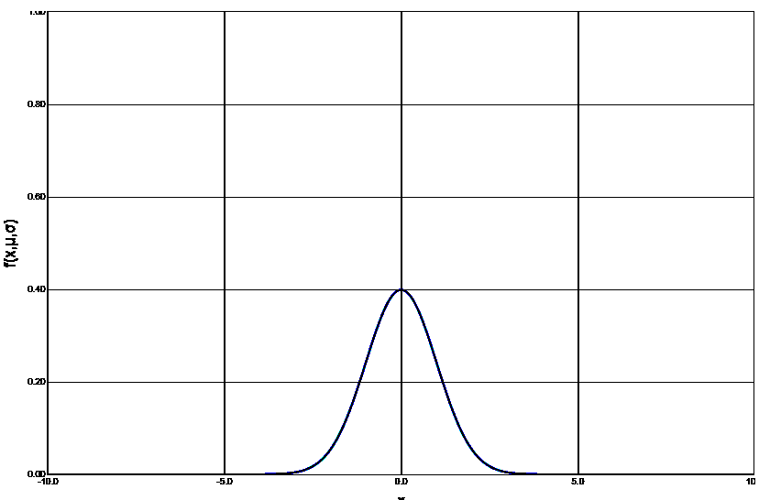

Q3: Which graph best represents a population with a mean of 3 and a standard deviation of 2?
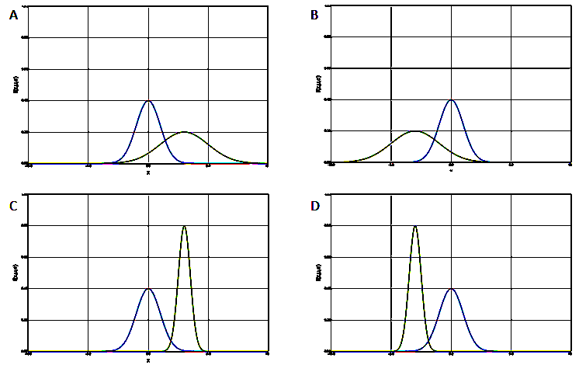

Part 3 – Normal Distribution Equation
The equation for a Gaussian Distribution is given by the following:
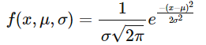
Where µ is the mean, ơ is the standard deviation, and e is the Euler’s Number (2.71828…).
We will not be using this formula in Ma20-2.
Part 4 – The Normal Distribution and Standard Deviations
The Normal Distribution is a symmetric curve where:
- 68.3% of the population falls within ±1ơ of the mean.
- 95.5% of the population falls within ±2ơ of the mean.
- 99.7% of the population falls within ±3ơ of the mean.
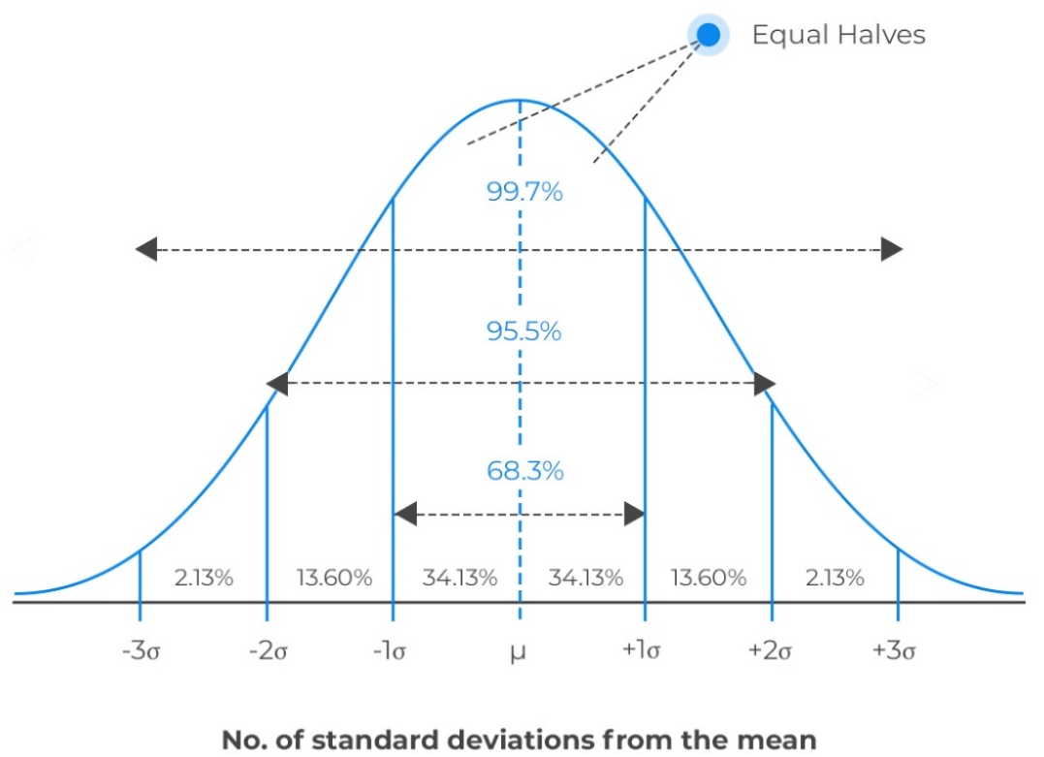
Use the following information to answer Q4-Q5:
Heights of adult women are approximately normally distributed with a mean of 64.5” and a standard deviation of 2.5”.
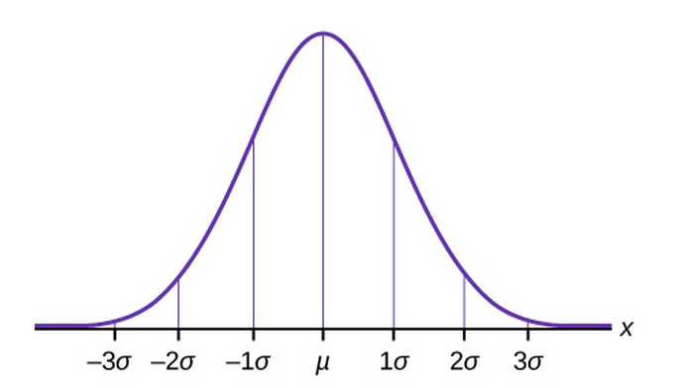

Q4: 68.3% of women fall between which heights?

Q5: What percentage of adult women are taller than 59.5” (4ft 11.5 inches)?

Part 5 – Intelligence Quotients
https://courses.lumenlearning.com/suny-lifespandevelopment/chapter/extremes-of-intelligence-intellectual-disability-and-giftedness/
The results of studies assessing the measurement of intelligence show that IQ is distributed in the population in the form of a Normal Distribution (or bell curve), which is the pattern of scores usually observed in a variable that clusters around its average. In a normal distribution, the bulk of the scores fall toward the middle, with many fewer scores falling at the extremes. The normal distribution of intelligence shows that on IQ tests, as well as on most other measures, the majority of people cluster around the average (in this case, where IQ = 100), and fewer are either very smart or very dull (see Figure 5.13). Because the standard deviation of an IQ test is about 15, this means that about 2% of people score above an IQ of 130, often considered the threshold for giftedness, and about the same percentage score below an IQ of 70, often being considered the threshold for an intellectual disability.
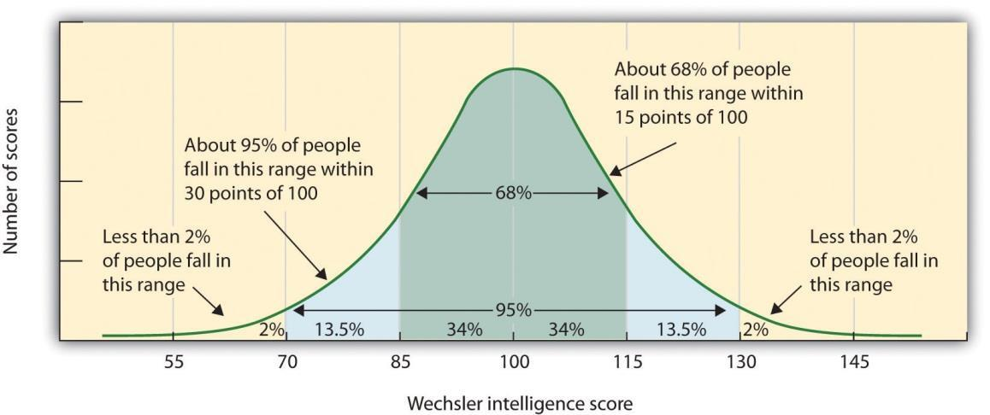
Q6: What is the mean IQ for this population?

Q7: What is the standard deviation for this population?

Q8: If our school has 700 students, how many students would have an IQ above 130?
https://www.youtube.com/watch?v=7HRmfIEWtyo

