L41 – z-Scores
Part 1 – Review of Normal Distribution
Below is a Gaussian Distribution (Bell Curve, Normal Distribution):
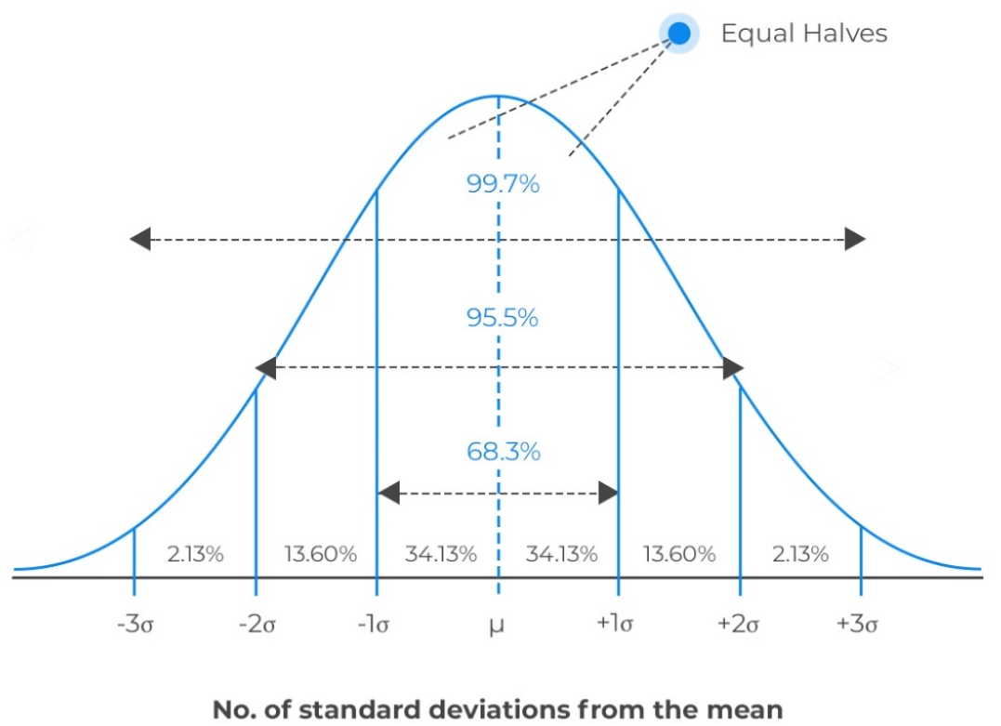
And here is a distribution of a population’s intelligence quotients (IQ):
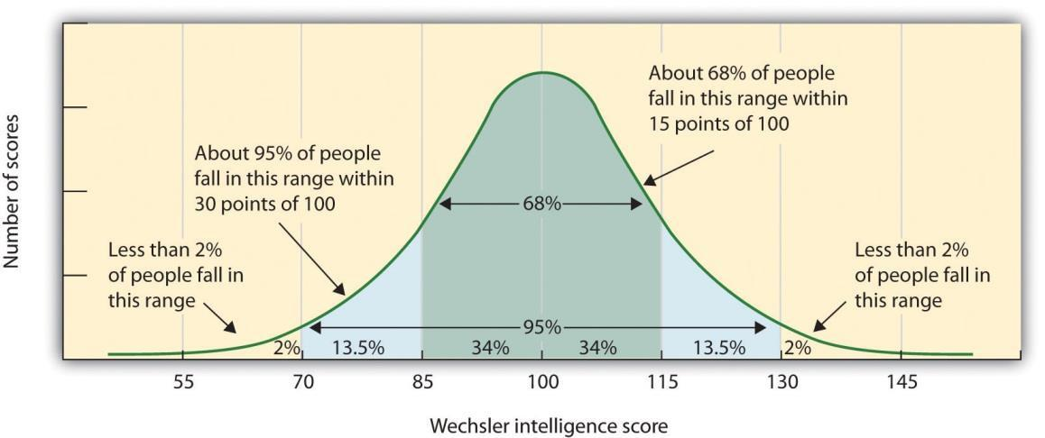
Part 2 – What is a z-score? How do we use a z-score table?
A z-score can best be described as “how many” standard deviations a value is away from the mean. Using IQ as an example, lets work with the accepted mean of 100 and standard deviation of 15.
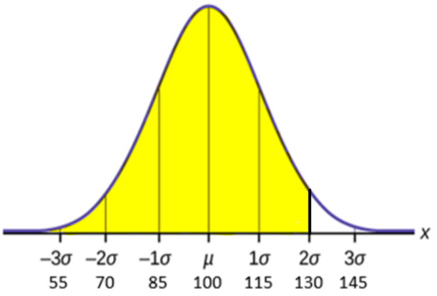
Assuming someone has an IQ of 130, we can see that means they are 2 standard deviations above the mean.
$x=μ+zσ$ $z=\frac{x-μ}{σ}$

When using a z-score table, keep in mind that this identifies the percentage of the population that is below this value.
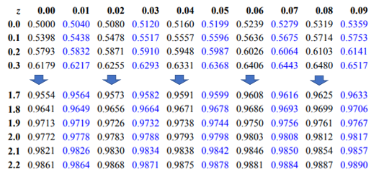

Part 3 – Finding z-Scores from Raw Values
Q1: Given a mean of 100 and a standard deviation of 15, determine the percentage of the population with IQs below (a) 115, (b) 70, and (c) 122.
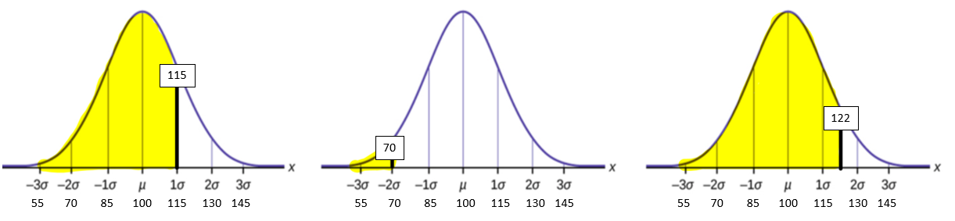
This data point can be represented as
$x=μ+zσ$ or $115=100+z(15)$
We can solve for z, or “how many”
standard deviations the value is away
from the mean.
$z=\frac{x-μ}{σ}$ or $z=\frac{115-100}{15}$
And we find that x = +1, so this value
is 1 standard deviation above the mean.
Consulting our z-score table, we find
that this puts the value above 84.13%
of the population.

Q2: What percentage of the population has an IQ between 115 and 145?
