L41 – Worksheet – z-Scores
Part 1 – Intelligence Quotient
Q1: What percentage of the population has an IQ below 85?
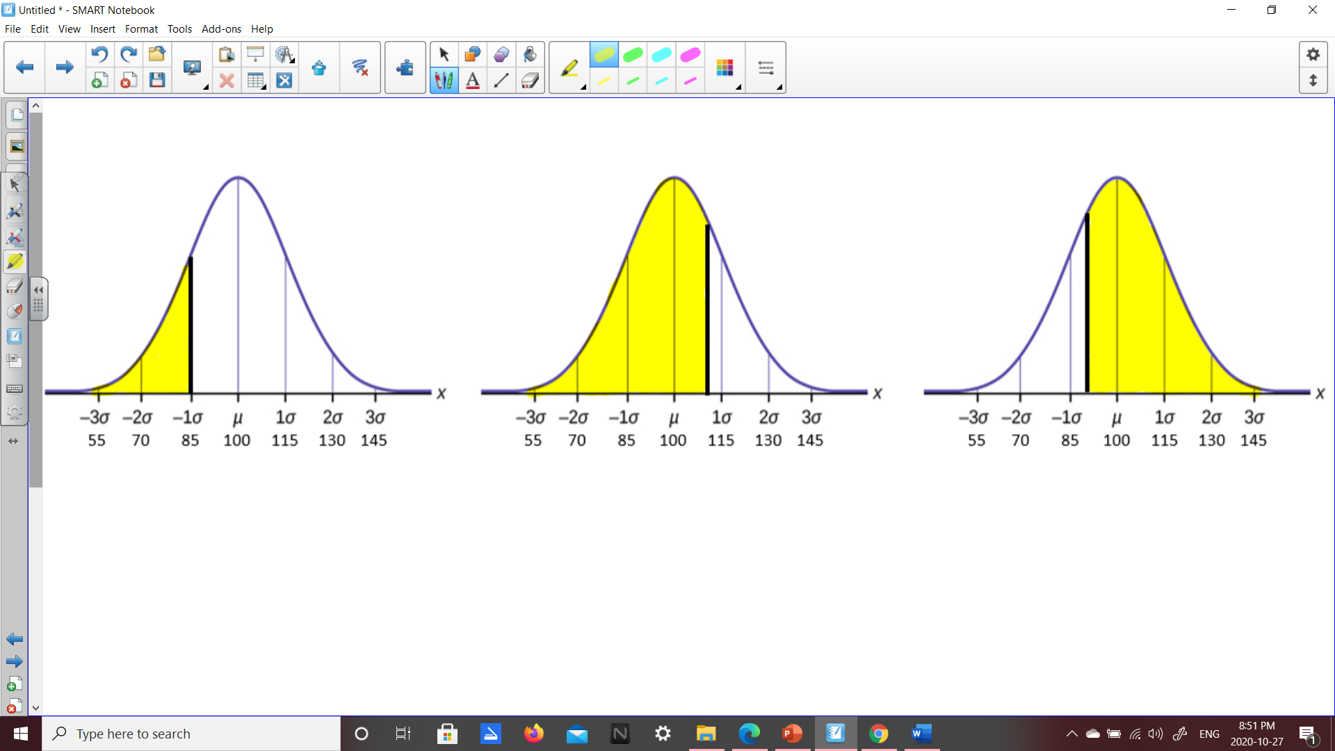

Q2: What percentage of the population has an IQ below 113?

Q3: What percentage of the population has an IQ above 90?

Q4: What percentage of the population has an IQ between 80 and 120?
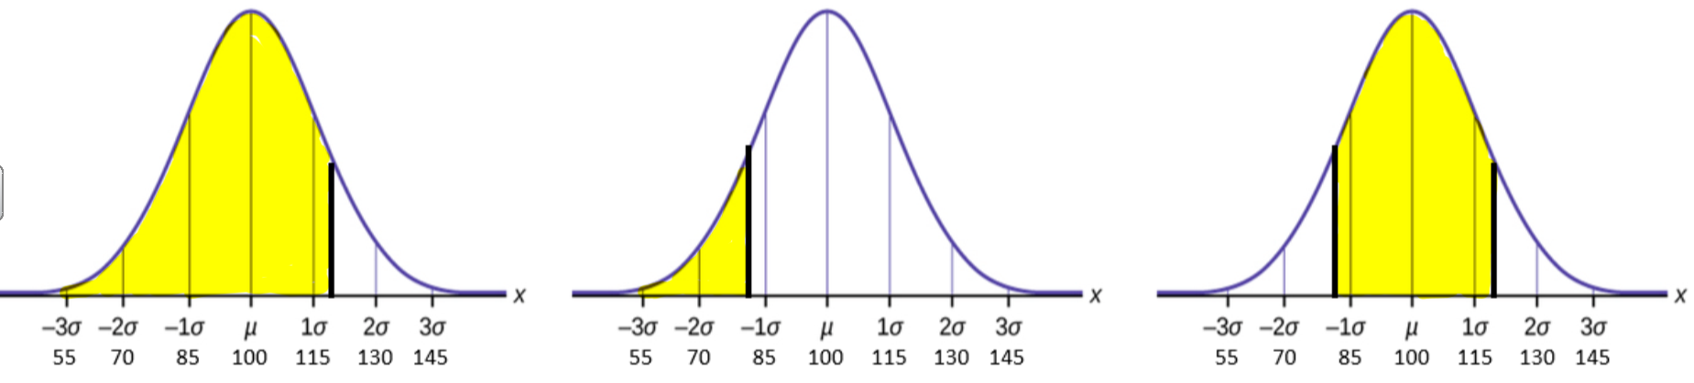
Part 2 – Test Scores
Use the following information to answer Q5-Q8:
Mr. Hopper’s Grade 5 class marks have a mean of 65% and a standard deviation of 9%.

Q5: Fill in the horizontal axis will all relevant values.
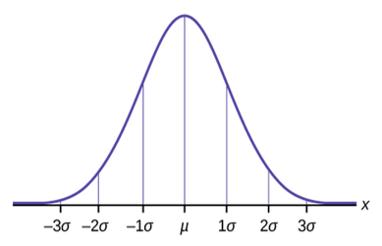

Q6: If Mr. Hopper’s Grade 5 class has 43 students, how many students are currently passing?

