L42 – Project – Statistics Project 2 /14 marks
Students will (a) collect 50 points of continuous data from a population, (b) graph the data in a histogram, (c) calculate the mean and standard deviation using technology, and (d) correctly label a Normal Distribution template. Finally, students will (e) explain whether they believe their data to be Normally Distributed.
Step 1: Collect Data ___/5 marks
Students will collect a sample of continuous data¹ from a population and record it below. Be specific (e.g. Heights of Gr11 students).
¹Data collected from a population can be described as continuous (heights) or discrete (dominant hand).
What is the data that you collected?
Unsorted data (50 points)
Data sorted from least to greatest (50 points)

 | 3 | 2 | 1 | 0
Data Collection | Student collected  (a) 50 points of unsorted data,  (b) continuous data, and  (c) specific data. | Student met 2 of the 3 requirements. | Student met 1 of the 3 requirements. | Student met 0 of the 3 requirements.
Data Sorting |  | Student correctly sorted data from least to greatest. | Student sorted data from least to greatest, but is missing some data. | Student was unable to sort data from least to greatest.
Step 2: Create a Histogram ___/4 marks
Students will create a Frequency Table and Histogram for their data.
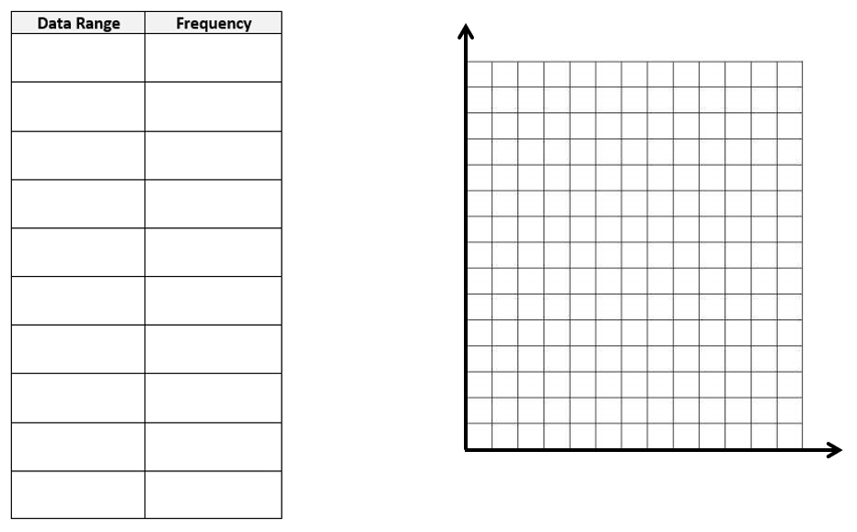
 | 3 | 2 | 1 | 0
Frequency Table |  | Student has  (a) created logical data ranges, and  (b) correctly determined frequency for each data range. | Student has met 1 of the 2 requirements. | Student has met 0 of the 2 requirements.
Histogram |  | Student has  (a) correctly labelled the x- and y-axis on the graph, and  (b) correctly graphed the frequency data. | Student has met 1 of the 2 requirements. | Student has met 0 of the 2 requirements.

Step 3: The Normal Distribution ___/5 marks
Students will use technology to determine the Mean and Standard Deviation for their data.
Mean | Standard Deviation

Next, they will record the appropriate values on the Normal Distribution template below.
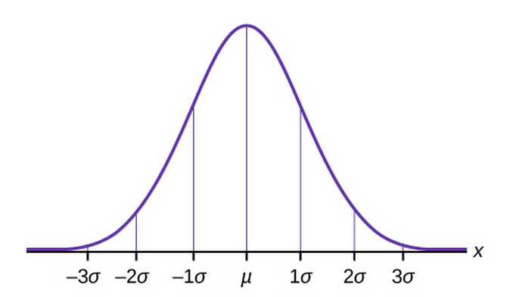

Is your data Normally Distributed? Explain.
Explanation

 | 3 | 2 | 1 | 0
Normal Distribution Template | Student has  (a) correctly calculated the mean,  (b) correctly calculated the Standard Deviation,  (c) correctly recorded the values on the template. | Student has met 2 of the 3 requirements. | Student has met 1 of the 3 requirements. | Student has met 0 of the 3 requirements.
Histogram |  | Student has identified their data as Normally Distributed or not, and given a sufficient reason as to why. | Student has identified their data as Normally Distributed or not, but without sufficient reason as to why. | Student has not identified whether their data is Normally Distributed or not.

