L43 – Confidence Intervals
Part 1 – Terminology
Margin of Error: The possible difference between the estimate of the value you’re trying to determine, as determined from a random sample, and the true value for the population; the margin of error is generally expressed as a plus or minus percent, such as ±5%.
Confidence Interval: The interval in which the true value you’re trying to determine is estimated to lie, with a stated degree of probability; the confidence interval may be expressed using ± notation, such as 54.0% ± 3.5%, or ranging from 50.5% to 57.5%.
Confidence Level: The likelihood that the result for the “true” population lies within the range of the confidence interval; surveys and other studies usually use a confidence level of 95%, although 90% or 99% is sometimes used.
Part 2 – Introduction using the 2020 U.S. Election Polling Results by CNN
Use the following information to answer Q1-Q4:
From http://cdn.cnn.com/cnn/2020/images/10/28/rel15.pdf
The study was conducted for CNN via telephone by SSRS, an independent research company. Interviews were conducted from October 23 - 26, 2020 among a sample of 1,005 respondents. The margin of sampling error for total respondents is +/- 3.6 at the 95% confidence level.
P1. Suppose that the presidential election were being held today and you had to choose between Joe Biden and Kamala Harris as the Democratic Party’s candidates, and Donald Trump and Mike Pence as the Republican Party’s candidates. Who would you be more likely to vote for? P1a. As of today, do you lean more toward...
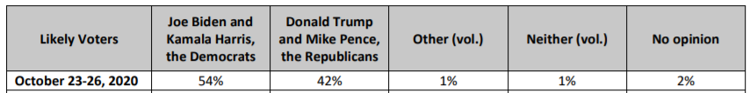
Q1: What is the Confidence Interval and Confidence Level regarding the number of Votes that Joe Biden will receive?

Use the following additional information to answer Q2:
From http://cdn.cnn.com/cnn/2020/images/10/28/rel15.pdf
The study was conducted for CNN via telephone by SSRS, an independent research company. Interviews were conducted from October 23 - 26, 2020 among a sample of 1,005 respondents. The margin of sampling error for total respondents is +/- 3.6 at the 95% confidence level.
(Respondents who are registered to vote and would vote for Biden, N=493) P2B. Is that more a vote FOR Joe Biden or more a vote AGAINST Donald Trump?
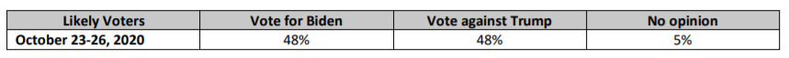
Q2: Explain these results, using Confidence Intervals and Confidence Levels.

Use the following additional information to answer Q3:
From http://cdn.cnn.com/cnn/2020/images/10/28/rel15.pdf
The study was conducted for CNN via telephone by SSRS, an independent research company. Interviews were conducted from October 23 - 26, 2020 among a sample of 1,005 respondents. The margin of sampling error for total respondents is +/- 3.6 at the 95% confidence level.
(Respondents who are registered to vote and would vote for Trump, N=394) P2T. Is that more a vote FOR Donald Trump or more a vote AGAINST Joe Biden?
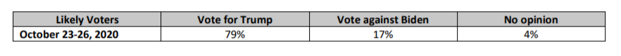
Q3: Explain these results, using Confidence Intervals and Confidence Levels.

From your Grade 9 Mathematics lesson on “Population versus Sample”:
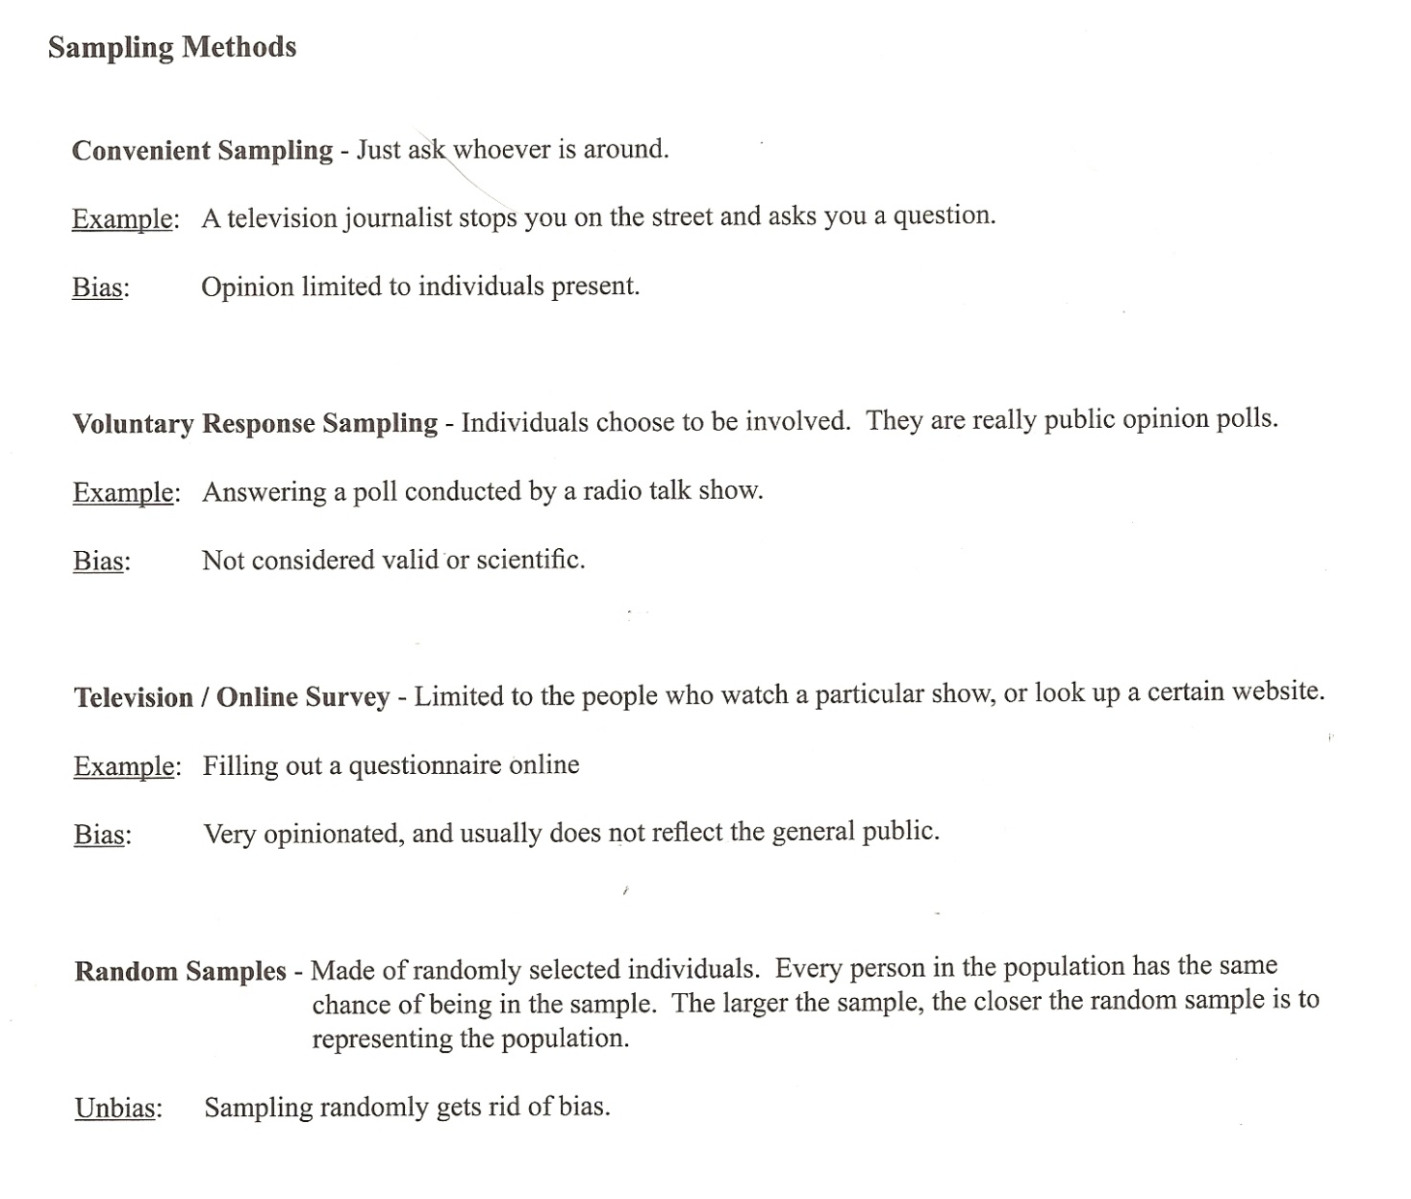
Q4: What type of sampling was used by SSRS (on behalf of CNN) to collect this survey data?

Q5: Determine how many people were in each category:
Voting for Biden (n = 493) |  | Voting for Trump (n = 394)
Vote for Biden | Vote against Trump | Vote for Trump | Vote against Biden
Part 3 – Why do Confidence Intervals Exist?
https://www.youtube.com/watch?v=tFWsuO9f74o
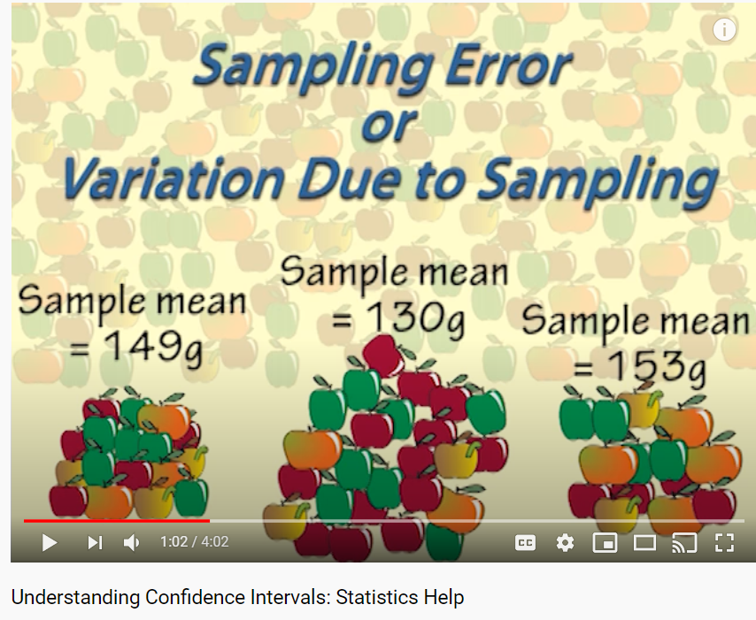

Part 4 – Additional Data for Discussion
Data regarding opinions of the Democratic Opinion:
FV1. We'd like to get your overall opinion of some people in the news. As I read each name, please say if you have a favorable or unfavorable opinion of these people - or if you have never heard of them.
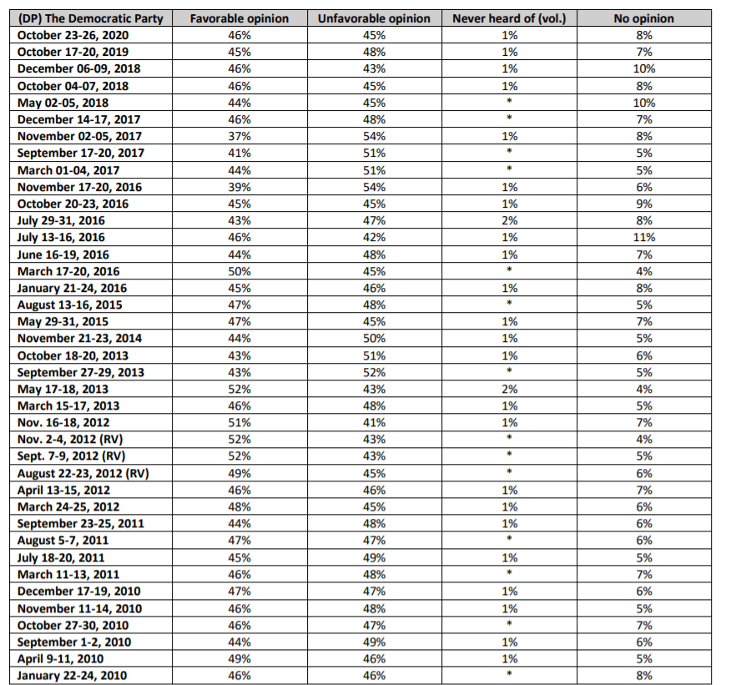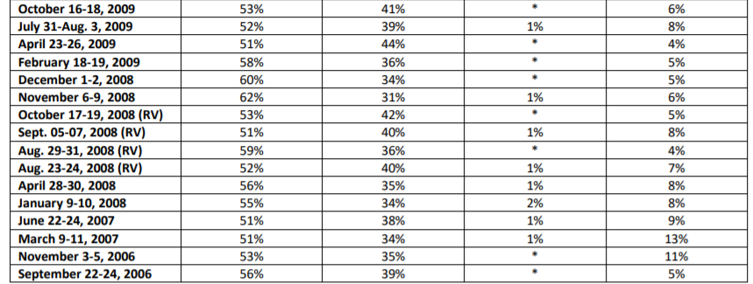
Data regarding opinions of the Republican Opinion:
FV1. We'd like to get your overall opinion of some people in the news. As I read each name, please say if you have a favorable or unfavorable opinion of these people - or if you have never heard of them.
