L44 – Assessment – Statistics Final Assessment /25 marks
Statistics Cheat Sheet

Sample | Population
n - Sample size | N - Population size
$\overline{x}$ - Mean  $$\overline{x}=\frac{\sum_{i=1}^{n}{x_{i}}}{n}=\frac{x_{1}+x_{2}+…+x_{n}}{n}$$ | µ - Mean  $$μ=\frac{\sum_{i=1}^{N}{x_{i}}}{N}=\frac{x_{1}+x_{2}+…+x_{N}}{N}$$
$s$ - Standard deviation  $$s=\sqrt{\frac{\sum_{i=1}^{n}{{(x_{i}-\overline{x})}^{2}}}{n-1}}$$  (Note, TI uses sx for Standard Deviation of a sample of a larger population, using Bessel’s Correction) | $σ$ - Standard deviation  $$σ=\sqrt{\frac{\sum_{i=1}^{n}{{(x_{i}-μ)}^{2}}}{N}}$$  (Note, TI uses σx for Standard Deviation for the data representing the entire population)
$s^{2}$ - Variance | $σ^{2}$ - Variance
R - Range

Negative z-Scores  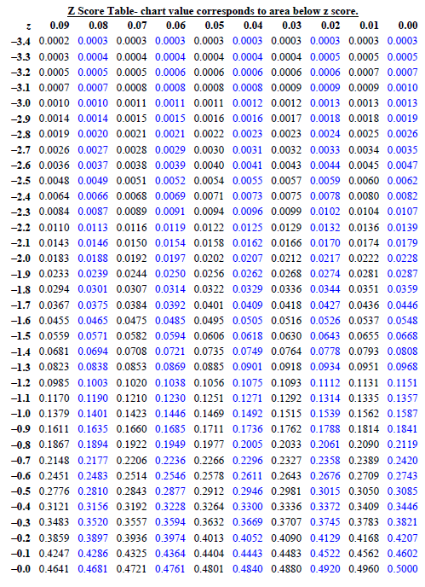 | Positive z-Scores  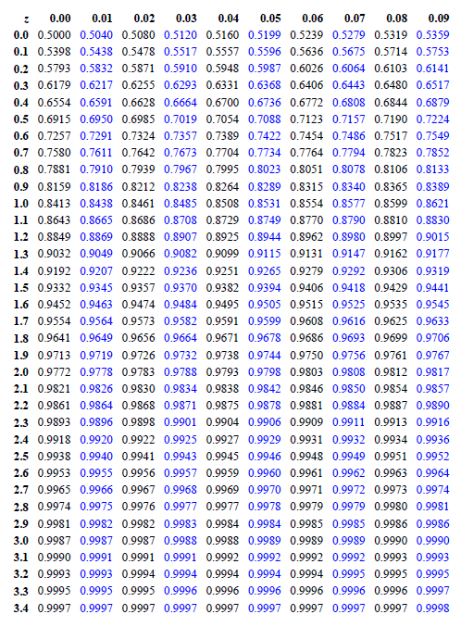

Part 1 – Mean, Median, Mode ___ / 5 marks _
Q1: Calculate the measures of central tendency, giving a comprehensive explanation for the calculation.
Sample

5 6 8 10 10 11 12 15 19 21
Central Tendency | Explanation for the Calculation
Mean, $\overline{x}$ | How did you calculate this?
Median | How did you calculate this?
Mode | How did you calculate this?

 | 3 | 2 | 1 | 0
Calculations of Central Tendency | Student correctly determined 3 of the 3 measures of central tendency. | Student correctly determined 2 of the 3 measures of central tendency. | Student correctly determined 1 of the 3 measures of central tendency. | Student correctly determined 0 of the 3 measures of central tendency.
Explanation |  | Student provided a comprehensive explanation for this calculation, showing both work and giving explanatory statements. | Student provided an overly simplified and case-specific explanation. | Student did not provide an explanation, or provided one that is misleading or incorrect.

Part 2 – Sample versus Population ___ / 5 marks
Q2: Students will determine the Mean and Standard Deviation for both a Sample of a Population and for the Entire Population. They will then answer a series of questions contrasting the two.
Sample of the Population |  |  |  |  |  |  |  |  |  | Entire Population
 | 6 | 6 | 6 | 7 | 9 | 10 | 11 |  |  | 5 | 5 | 5 | 6 | 6 | 7 | 7 | 7 | 7 | 7
 |  |  |  |  |  |  |  |  |  | 8 | 8 | 8 | 9 | 9 | 9 | 9 | 10 | 10 | 11
Mean, $\overline{x}$ |  |  |  |  |  |  |  |  |  | Mean, $μ$
Standard Deviation, s |  |  |  |  |  |  |  |  |  | Standard Deviation, $σ$
Compare and contrast the two sets of data. Is this sample of the population representative of the entire population? Explain in terms of mean and standard deviation.

 | 3 | 2 | 1 | 0
Calculations of Mean and Standard Deviation |  | Student correctly calculated mean and standard deviation for each data set. | Student correctly calculated mean and standard deviation for only one of the data sets. | Student did not correctly calculate mean and standard deviation for either data set.
Comparing and Contrasting the Data Sets | Student contrasted the two data sets using multiple methods, possibly including histograms or normal distributions. | Student contrasted the two data sets in terms of the mean and standard deviation numerical values only. | Student struggled to compare the two data sets in any meaningful way. | Student did not attempt to compare the two data sets, or drew inaccurate conclusions.
Part 3 – Histograms ___ / 3 marks
Q3: Students will create a Frequency Table and a Histogram for sample data.
Unsorted Data of Test Scores in Mr. Hopper’s Grade 5 class:
 | 38 | 82 | 87 | 45 |  | 65 | 68 | 62 | 99 | 72
 | 76 | 85 | 79 | 62 |  | 55 | 49 | 23 | 67 | 82
 | 58 | 75 | 88 | 71 |  | 67 | 86 | 74 | 74 | 66
Data Sorted Least to Greatest
Frequency Table  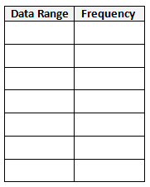 |  |  |  |  | Histogram  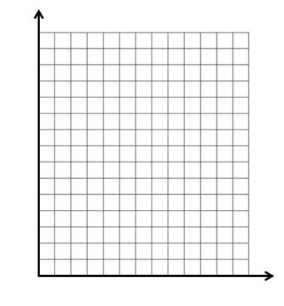

 | 3 | 2 | 1 | 0
Histogram | Student has correctly  (a) sorted data from least to greatest,  (b) created a frequency table, and  (c) created a histogram. | Student has met 2 of the 3 requirements. | Student has met 1 of the 3 requirements. | Student has met 0 of the 3 requirements.

Part 4 – Normal Distribution and z-Score Tables ___ / 7 marks
Q4: Students will compare two populations using a Normal Distribution
Population 1: Heights of Females  $$μ=64.5 inches$$  $$σ=2.5 inches$$ | Population 2: Heights of Males  $$μ=70 inches$$  $$σ=3 inches$$
Label the Normal Distribution by filling in all the boxes.  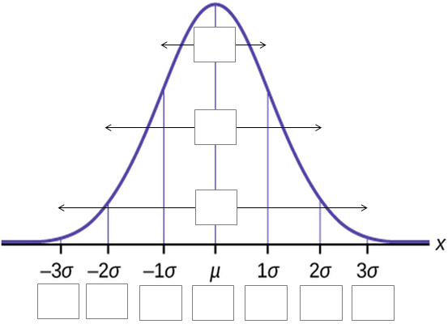 | Label the Normal Distribution by filling in all the boxes.
What percentage of females is taller than 68 inches? Explain how you got this value. | What percentage of males is taller than 68 inches? Explain how you got this value.

 | 3 | 2 | 1 | 0
Labelling the Normal Distribution | Student has:  (a) correct confidence intervals for each,  (b) correct $μ$ and $σ$ for female heights, and  (c) correct $μ$ and $σ$ for male heights. | Student has met 2 of the 3 requirements. | Student has met 1 of the 3 requirements. | Student has met 0 of the 3 requirements.
Females taller than 68 inches |  | Student has calculated the correct percent, with supporting work. | There is a small error in the student’s work. | There is a substantial error in the student’s work.
Males taller than 68 inches |  | Student has calculated the correct percent, with supporting work. | There is a small error in the student’s work. | There is a substantial error in the student’s work.

Part 5 – Confidence Levels and Confidence Intervals ___ / 5 marks
Q5: Two candidates, Doug the Democrat and Rob the Republican, are in a race for a senate seat. The poll states that, of 1000 people surveyed, Doug receives $43±3\%$ of the vote, and Rob receives $48±3\%$ of the vote, with a 95% confidence level.
Margin of Error | Confidence Interval for Doug the Democrat | Confidence Interval for Rob the Republican | Confidence Level
Does Doug the Democrat have a chance of winning? Explain.

 | 3 | 2 | 1 | 0
Terminology | Student correctly  (a) identified Margin of Error and Confidence Level,  (b) determine the Confidence Interval for Doug the Democrat,  (c) determined the Confidence Interval for Rob the Republican. | Student has met 2 of the 3 requirements. | Student has met 1 of the 3 requirements. | Student has met 0 of the 3 requirements.
Could Doug Win? |  | Student has given a detailed answer, explaining 2 different reasons why Doug could win. | Student has given a simplified answer, explaining 1 reason why Doug could win. | Student has not provided a sufficient answer.

